Hiti-aws-root/Samyraisborn@2019

Hiti-aws/hiti1/1qazZAQ!

AWS is a cloud provider. They provide you with servers and services which you can use on demand and scale easily which was a big big difference from what you used to do

on premises in your data center where you have to order your servers physically

and install them before being able to use them.

On the cloud we can get them whenever we want, so on demand

and we can have as many as we want so we can scale easily.

All AWS services are linked and interconnected with one another.

AWS is truly is global.

And we can leverage the infrastructure of a cloud provider to make ourselves, our application global.

The first important concept in AWS are regions. Region is cluster of data centers.

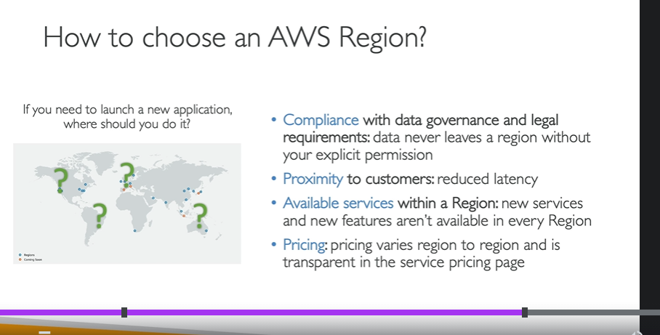

So each region will have many availability zones.

Usually three, the minimum is two, and the max is six.

But, really the usual is three.

So, let's take the Sydney region as an example.

The Sydney region code is ap-southeast-2.

So, we can have two,

have three availability zones in

Sydney, ap-southeast-2a,

ap-southeast-2b,

and ap-southeast-2c.

Each availability zone (AZ) is one or more discrete data centers with redundant power, networking, and connectivity

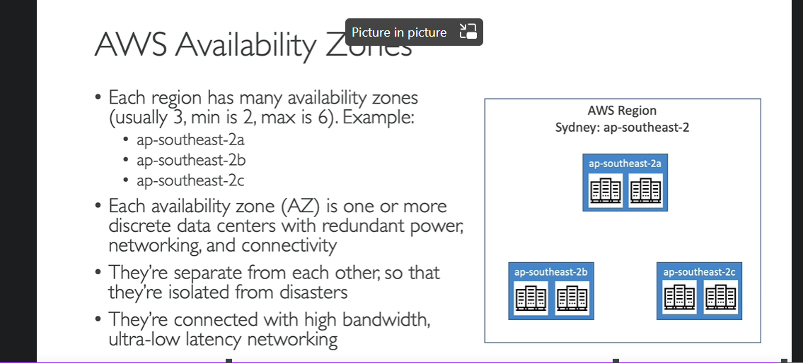

IAM stands for identity and access management. It is a global service because in IAM,

we are going to create our users and assign them to group.

users or groups can be assigned

what's called a JSON document.(Policy document)

Using policy document - We are allowing our users to use some services in AWS. So the policies define permissions for a user. And so in AWS, you don't allow everyone to do everything

that would be catastrophic,

because a new user could basically launch so many services

and they will cost you a lot of money

or would be valid for security.

So in AWS, you apply a principle called

the least privilege principle.

So you don't give more permissions than a user needs. Okay, so if a user just needs access to three services,

just create a permission for that user.

IAM is a global service which means for IAM, users and groups are created

in a global fashion.

Why create users?

The root user has all the permissions

you want in your account, okay?

It can do anything you want.

But therefore it's a very dangerous account to use. The better way is to create a administrator account that we're going to create right now. And this admin account will be able to do everything the root account does or almost, and we will let the root go. And we use the root account only if we really, really ever need to. This is from a security perspective, the best setup.

Tags - And they're just information that can help you track, organize or control access for users. And this is just information you want to add

regarding that specific user. It is in key value pair. E.g  "Department: Engineering".

A password policy is a set of rules that define complexity requirements and mandatory rotation periods for your IAM users' passwords

three different options to access AWS.

So the first one is a Management console,

as we've seen, and is protected by your username,

password, maybe multifactor authentication.

Then there is the CLI, Command Line Interface,

and this is something we will set up on our computer,

and this is protected by access keys,

and access keys our credentials we're going to download

in a few seconds that will allow us

to access AWS from our terminal.

Then, finally, there is the SDK,

the AWS Software Development Kit,

which is used whenever you want to call APIs from AWS

from within your application code.

three different options to access AWS.

So the first one is a Management console,

as we've seen, and is protected by your username,

password, maybe multifactor authentication.

Then there is the CLI, Command Line Interface,

and this is something we will set up on our computer,

and this is protected by access keys,

and access keys our credentials we're going to download

in a few seconds that will allow us

to access AWS from our terminal.

Then, finally, there is the SDK,

the AWS Software Development Kit,

which is used whenever you want to call APIs from AWS

from within your application code.

So to give you an example of what you can build

with the SDK, well the AWS CLI that we're going to be using

in this course is actually built

on the AWS SDK for Python named Boto.

So the takeaway from this lecture

is that you can access AWS using the management console

or using access key and secret access key

that you can configure and then use into the CLI.

So these IAM role will be just like a user,

but they are intended to be used not by physical people,

but instead they will be used by AWS services.

the two most common use cases is to create a role

for an EC2 instance or for Lambda function.

if we want to give permissions,

to an AWS service to do something else,

on another AWS service,

then we have to create IAM roles.

Knowing how to use EC2 in AWS is fundamental

to understand how the cloud works.

Because as I said from before,

the cloud is to be able to rent these compute

whenever you need, on demand, and EC2 is just that.

you can choose pretty much how you want your visual machine

to be and you can rent it from AWS.

So the EC2 User Data has a very specific purpose.

It is to automate boot tasks, hence the name bootstrapping.

So what tasks do you want to automate?

the more you add into your User Data script,

the more your instant has to do at boot time.

the EC2 User Data scripts runs with a root user.

So any command you have will have the pseudo rights.

a security group attached to our instance

which is going to control the traffic

from and to our instance, and therefore we can add rules.

User data is when we pass a script,

so some comments, to our EC2 instance

to execute on the first launch of our E2 instance

and only the first launch.

 you need to choose a base image

for your EC2 instance.

This is the operating system of your instance.

e.g amazon linux, ubuntu, windows etc.

So we have an EC2 instance, and it has a security group,

what I call group number one,

and the inbound rules is basically saying,

I'm authorizing security group number one inbound

and security group number two.

well, by using the security group (indistinct) rule

that we just set up,

we basically allow our EC2 instance

to go connect straight through on the port we decided

onto our first EC2 instance.

Similarly, if we have another EC2 instance

with a security group one attached,

while we've also authorized this one

to communicate straight back to our instances.

And so regardless of the IP of our EC2 instances

because they have the right security group attached to them

they're able to communicate straight through

to other instances.

And if you have another EC2 instance

maybe with security group number three attached to it,

well, because it group number three

wasn't authorized in the inbound rules

of security group number one,

then it's being denied and things don't work.

SSH

how do you connect

inside of your servers

to perform some maintenance or action.

So for this, for Linux servers,

we can use SSH to do a secure shell into our servers.

So based on the operating system you have on your computer,

you have different ways of achieving it.

So the SSH is a command line interface utility

that can be used on Mac or Linux

as well as Windows over version 10.

And putty is valid for any version of Windows.

They do the exact same thing, they allow you to

use the SSH protocol to connect into your EC2 instances.

EC2 Instance Connect,

which is going to use your web browser.

So not a terminal not putty ,your web browser

to connect to your EC2 instance.

And I like it a lot because it is valid

for Mac, Linux, Windows, all versions.

The cool thing about EC2 Instance Connect is that it works,

but it only works for now with Amazon NX2

SSH command into EC2 instance

Here 3.110.194.225 is the public IP of EC2 instance which changes on every run of the instance.

ssh -i .\mykeypairname.pem ec2-user@3.110.194.225

we had created an IAM role.

So let's go back into the Roles.

We had this demo role for EC2

that had one policy attached called IAMReadOnlyAccess.

So we are going to attach this role

onto our EC2 Instance to provide it with credentials.

 EC2 Instances Purchasing Options.

So we've been using so far, on-demand EC2 instances.

They allow us to run instances on demands,

that means they're good for short workloads,

we get predictable pricing,

and we're going to pay by the second.

But if you have different kind of workloads,

you can optimize your discounts and your pricing

by specifying it to AWS.

For example, you can use reserved instances

and you have one year or three years term,

and they're meant for long workloads.

So if you know you're going to run a database

for a long time, then a reserved instance is great.

And if you want to have a flexible instance type,

so for example, you want to change

the instance type over time,

then convertible reserved instances are for you.

And by the way, don't worry,

I'm going to do a deep dive in all of those over time.

Okay, next we have savings plan

and savings plan are one and three years term,

and they're more modern

because instead of committing to a specific instance type,

you commit to a specific amount of usage in dollars,

and they again, for long workloads.

Spot instances instead are meant

for very short workloads,

they're very, very cheap,

but at any time you can lose these instances

and that makes them less reliable.

Dedicated host allows you to book an entire physical server

and control instance placements.

And dedicated instances means that

no other customers will share your hardware.

Finally, capacity reservations allow you to reserve capacity

in a specific AZ for any duration.

**An important difference between a Dedicated Host and a Dedicated Instance is that a Dedicated Host gives you additional visibility and control over how instances are placed on a physical server, and you can consistently deploy your instances to the same physical server over time.”**

While Dedicated Instances are extremely valuable from a compliance perspective, Dedicated Hosts also give you the visibility into the physical host that is required for a Bring Your Own License (BYOL) model — i.e., if you want to use your own Windows Server, SQL Server, SUSE, or RHEL licenses that are provided on a CPU core basis.

So that gives you a little bit of time to do these things.

And the options can be either you're stopping your instance,

that means that you shut down everything you were doing,

then you stop your instance.

And so if one day, the spot price goes below your max price,

then you can restart your instance

and continue where you left it off.

Or if you don't need the state on your EC2 instance,

you can just choose to terminate your instance

and let it go.

And then that would assume

that anytime you would restart your work,

you can start with a fresh new EC2 instance.

Next, how do you terminate a spot instance?

So we have to first understand how a spot request works.

For this, let's consider a spot request.

With a spot request,

you are defining how many instances you want,

your maximum price you're going to pay,

the launch specification, so the AMI and so on,

and when your request is valid from and until,

but it could be infinite, and then the request type.

It's very important to understand

there's two types of requests.

You can do one-time request for spot instances

or a persistent request for post instances.

Let's have a look at the difference.

If it's a one-time request,

as soon as your spot request is fulfilled,

your instances are going to be launched.

And then your spot request will go away

because it was a one-time request type.

So in this case, your spot request is going to go away

and you're fine.

But if it's a persistent request type,

that means that we want this number of instances to be valid

as long as the spot request is valid from to valid until.

That means that if somehow your instances do get stopped,

or interrupted based on the spot price,

then your spot requests will go back into action.

When things can be validated

we'll restart spot instances for you.

So if somehow you stop a spot instance, in persistent mode,

and your spot request is still active,

your spot request automatically will be smart enough

to restart a launch instance for you.

And this is something you can also see in this diagram,

but I won't spend too much time on it.

So what you understand out of it

is that if you want to cancel a spot request,

it needs to be in the open state,

the active state, or the disabled state.

That means that basically, it's not failed,

it's not cancelled or it's not closed.

When you want to cancel a spot request,

so if you take the spot request on the left hand side

and you cancel it, it's not going to terminate any instances

that you have launched from before.

So it is still your responsibility

to terminate these instances

and not the responsibility of AWS.

So as such, if you want to terminate spot instances

for good and not have them relaunched,

you need to first cancel the spot request,

and then you terminate the associated spot instances.

Because if you were to terminate the spot instances first,

remember, it goes back into the spot request

and a spot request says, okay, you wanted six instances,

but I can see you have zero right now,

I'm going to launch six instances for you.

So again, the right order to cancel

and to terminate spot instances is

to first cancel the spot request to make sure

that no new instances will be launched by AWS.

Then you terminate the associated spot instances.

Okay, next spot fleets.

So this is the ultimate way to save money.

Spot fleets is going to be a way to define for you

to get a set of spot instances, and optionally,

On-Demand instances of what's called a fleet.

And the spot fleet will try its best

to meet the target capacity

with the price constraints you defined.

So it will launch from possible launch pools.

It can have different instance types,

different OS and availability zones.

You're going to define multiple launch pools,

a multiple instance size, multiple everything,

and then the fleet will choose the best

and most appropriate launch pool for you.

When your spot fleet either reaches your budget

or reaches the capacity you wanted,

then it will stop launching instances.

And **so you define a strategy**

**to allocate spot instances in your spot fleet**.

That's something to remember.

The first one is lowest price,

and that's going to be the most popular one

going into the exam,

which is that the spot fleets will launch instances

from the pool that has the lowest price

and that gives you a lot of cost optimization.

This is a great option if you have a very short workload.

It can also have a diversified way

to launch your spot instances, in which case,

the spot instances will be distributed

across all the pools that you have defined from before,

which is great for availability and long workloads

because if one pool goes away,

then your other pools are still active.

And then finally, you have capacityOptimized

to launch with the optimal capacity based on the number

of instances and choose the right pool for that.

The idea is that spot fleets can be complicated,

but what you have to remember is that using the spot fleet,

you're able to define multiple launch pools,

multiple instance types

until you're just interesting in real power.

And then if you use the lowestPrice discounts,

or the lowest price rate strategy for spot fleets,

then the spot fleets will automatically request

the spot instances with the lowest price for us.

So spot fleet gives us an extra saving

based on spot instances, because it's smart enough

to choose the right spot instance pools

to allow us to get the maximum amount of savings.

This is the benefit of spot fleets.

Again, you need to understand the difference here

of doing a very simple spot instance request

or you know exactly the type of instance you want

and the AZ you want, to using the spot fleet and saying,

okay, you can choose all these instance types

and all these AZ and what I need from you

is to give me the lowest price, for example.

That's hopefully is giving you a lot of insights

into how spot fleets and spot instances are different.

Savings Plan will allow you to dedicate

a specific amount of dollar per hour you spend

on a one to three-year term and gives you flexibility

of how you want to launch your instance.

It gives you flexibility in terms of instance type,

AZs and so on.

capacity reservations,

this is when you want to ensure that capacity is available

within your EC2 instance launch.

So for example, we're saying, hey, I want to make sure

that I have enough M5 2X large available to me.

So I want them to be in EU central one.

And I want them to have four EC2 instance

of type M5 2X large available to me no matter what, okay?

And then you can say when the reservation ends manually

on a specific time and then this will guarantee

that the instances will be available to you

but you will have to pay for this reservation

regardless whether or not you are launching

your instances in it, okay?

Compute Optimized EC2 instances are great for compute-intensive workloads requiring high-performance processors (e.g., batch processing, media transcoding, high-performance computing, scientific modeling & machine learning, and dedicated gaming servers).

EC2 User Data is used to bootstrap your EC2 instances using a bash script. This script can contain commands such as installing software/packages, download files from the Internet, or anything you want.

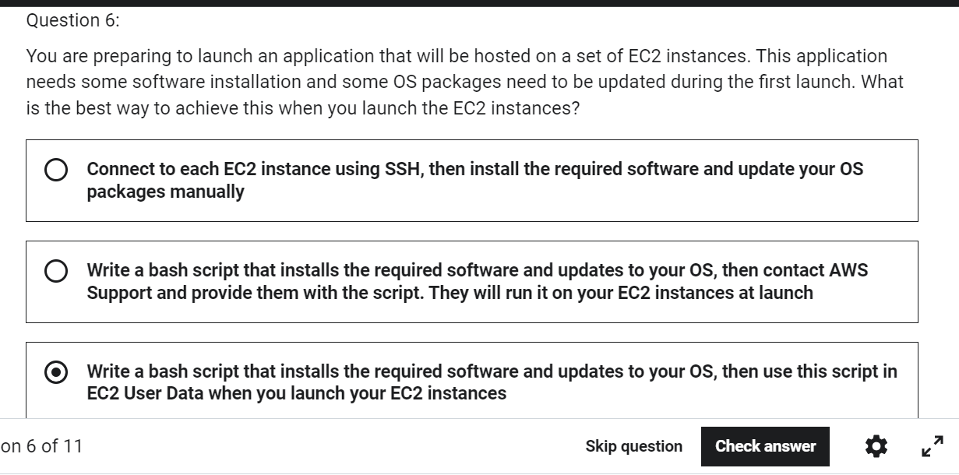

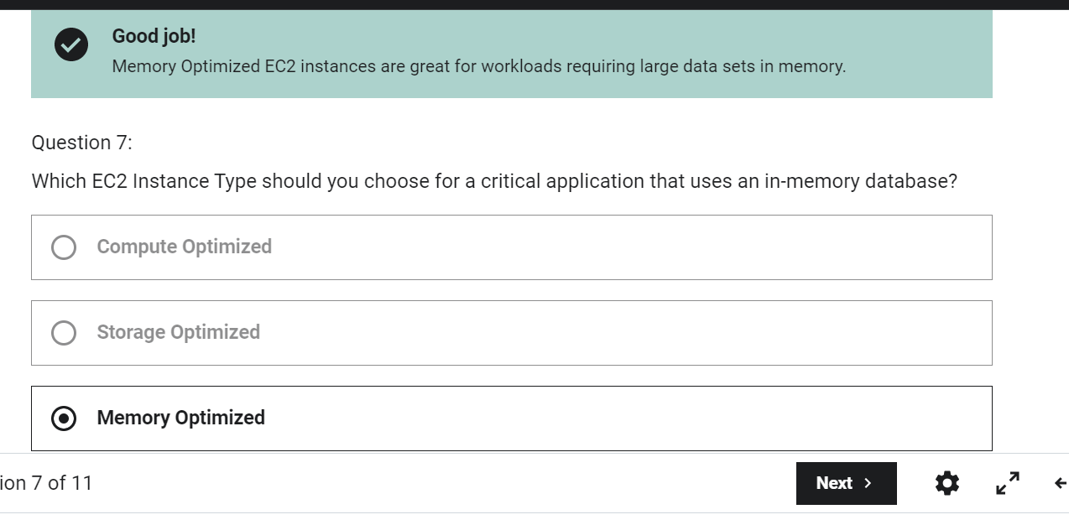

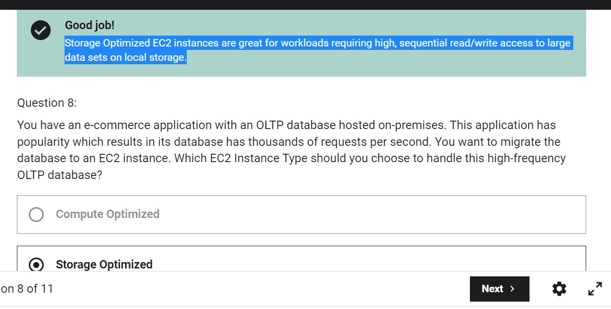

Dedicated Hosts are good for companies with strong compliance needs or for software that have complicated licensing models. This is the most expensive EC2 Purchasing Option available.

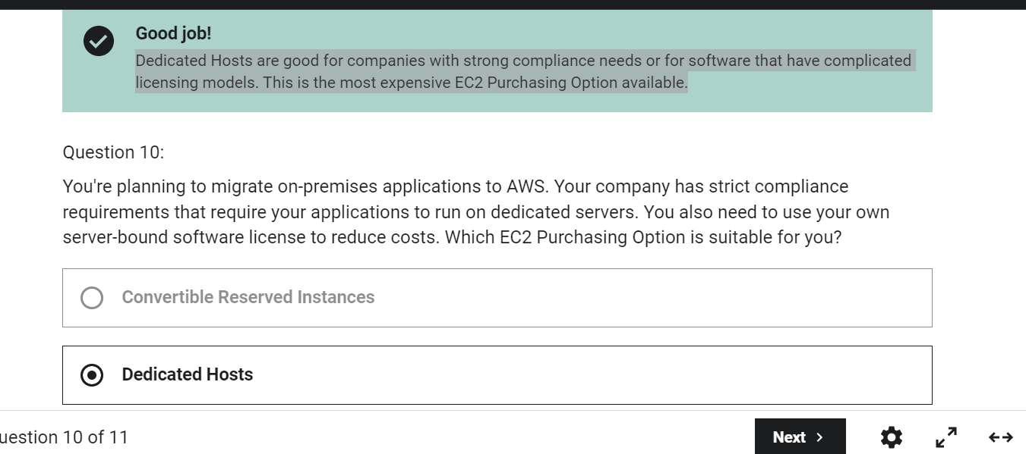

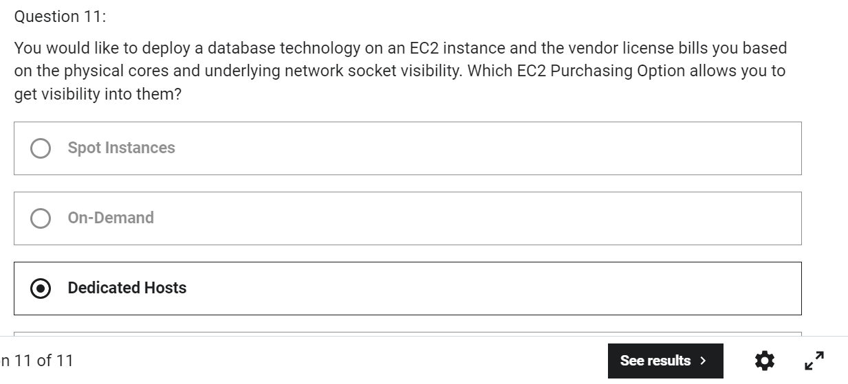

So we don't get direct interaction with the hardware of AWS,

but we let AWS know how we would like our EC2 instance

to be placed compared to one another.

So when you create a placement group,

you have three strategies available for you.

You have the cluster placement group

in which your instances will be grouped together

in a low-latency hardware setup

within a single availability zone.

This is going to give you high performance, but high risk.

Spread, means that your instances

are going to be spread across different hardware.

And that is a restriction on this,

that means you can only have seven EC2 instance

per placement group that's spread per AZ.

So you would use a spread placement group

when you have critical applications.

Finally, the last one is a new kind of placement group

that is really helpful, it's called partition.

It's similar to the spread,

meaning that you want to spread your instances

but here they're spread across many different partitions.

And these partitions rely on different

sets of racks of hardware within an AZ.

What does that mean is that, they're still spread,

but they're not isolated one from another failure,

but a partition should be isolated

from another partition of failure.

The idea with this, is that you can scale

through hundreds of EC2 instances per group

and that allows you to run applications

such as Hadoop, Cassandra, or Kafka.

ENI -So they're what gives EC2 Instances access to the network,

this will provide your EC2 Instance network connectivity

and for example, a private IP.

So for example we have an availability zone

and we have one EC2 Instance

and to it is attached on eth0, your primary ENI

and this will provide your EC2 Instance network connectivity

and for example, a private IP.

So each ENI can have the following attributes.

Number one it can have a Primary private IPv4

and one or more secondary IPv4. Okay.

So in this example, I have one of zero but

you are more than welcomed to add a secondary ENI to EC2

and that will be eth1

and this will give you another private IPv4 as well, okay. `

Each ENI can also have an elastic IPv4 per private IPv4

or one or more public IPv4,

so it gives you a private and a public IP

as will see in the hands-on.

You can have one or more security groups attached

to your ENI.

You can have a Mac address attached to it

and other things but I've just give you

the most important bits right now in this lecture.

And you can create ENI's independently from

your EC2 instances

and attach them on the fly

or move them from EC2 instances for failover.

So, let's have a look at what it looks like.

And by the way, they're bounded

to a specific availability zone or AZ.

So that means that if you create a ENI in the specific AZ,

you can only have it bound to that specific AZ.

So here's another EC2 instance

and it has another ENI attached to it.

And for example, we can do is we can move eth1

from the first EC2 instance into the second EC2 Instance

to move that private IP.

And what it means is that that private IP will change

from the first EC2 instance

and will be attached to the second EC2 Instance.

And it's very very helpful for failovers.

For example, if you're EC2 instance is accessed

by a private static IP,

then you can move the IP around between

these two instances for failover purposes, okay.

But the idea is that with Hibernate,

we want to achieve a new state.

So when we hibernate an instance, whatever was in RAM,

the in-memory state is going to be preserved.

So the use cases for hibernation is

if you want to have long-running processes

and never actually stop them,

or if you want to save the RAM state,

or if you just want to reboot, like boot up fast,

and you have services that take time to initialize.

So you actually don't want them to initialize,

you want them to stay up and running

even if you hibernate your instance.

So, some good things to know about EC2 Hibernate is that

it supports a lot of different families.

The instance RAM size must be less than 150 gigabytes.

Now, that can change,

and again, you're not tested on limits at the exam,

but I'm just putting this as an indication for you

to get an idea of how that works.

It doesn't work for bare metal instances.

It works for many different operating systems,

including Linux and Windows.

It works for the root volume,

so the root volume must be an EBS volume,

it must be encrypted, okay?

And it must be large to contain the RAM

that you dump onto it.

It's available for all kind of instances,

such as on-demand, reserved, and spot instances.

And hibernation is meant to be no more than 60 days.

So the idea is that even though we have stopped,

quote unquote stopped the instance by hibernating it,

and restarted it from an operating system perspective,

the instance was never stopped.

It was hibernated.

And therefore the uptime command gives you two

or three minutes because it has never quote unquote

been stopped from an operating system perspective

which is the whole idea behind hibernation.

 EC2 capacity reservations ensure that you have capacity

when you need to launch EC2 instances.

And this is to plan in advance for extra capacity.

And so there is a manual

or a plant end date for the reservation,

but the idea of this reservation

is that it's a short reservation.

You don't need to commit

for one or three years of usage in that reservation,

you just respecify the capacity reservation.

The access to that capacity is reserved for you.

So it is immediate

and you get bill as soon as it starts

because you're reserving capacity.

So if you need to reserve capacity for a region in three AZ,

you need to do three capacity reservations.

Elastic IP is a public IPv4 that you own as long as you want and you can attach it to one EC2 instance at a time.

Spot Fleet is a set of Spot Instances and optionally On-demand Instances. It allows you to automatically request Spot Instances with the lowest price.

Cluster Placement Groups place your EC2 instances next to each other which gives you high-performance computing and networking.

Spread Placement Group places your EC2 instances on different physical hardware across different AZs.

Elastic Network Interfaces (ENIs) are bounded to a specific AZ. You can not attach an ENI to an EC2 instance in a different AZ.

To enable EC2 Hibernate, the EC2 Instance Root Volume type must be an EBS volume and must be encrypted to ensure the protection of sensitive content.

The feature gives us 30 GBs of free EBS storage

of type General Purpose or SSD or Magnetic per month.

an EBS snapshot archive.

So it allows you to move your snapshots

to another storage tier called an archive tier,

and that tier is 75% cheaper.

So your snapshot is going to be moved,

you know, manually or whatever, however you set

to the archive tier.

But if you have it in the archive,

it takes you between 24 to 72 hours

to restore from the archive.

So these are for snapshot

that are not very important to you

to restore it in a rush, okay,

but you wanna save some cost on them.

So the idea is that thanks to snapshots

we can quote end quote

copy EBS volumes across different availability zones.

And that's very handy.

EC2 Instance store

So we've seen a way to attach a network drive

onto our EC2 Instances

but they have limited performance

and I said with cause because it's a really good performance

but sometimes you want something even higher performance

and that is going to be a hardware disk

attached onto you EC2 Instance.

So the EC2 Instance is a virtual machine

but it is obviously attached to a real hardware server.

And some of these servers do have disk space

that is attached directly you know,

with a physical connection onto the server.

And so a special type of EC2 Instance can leverage

something called an EC2 Instance Store,

which is the name of the hardware,

the hard drive attached to the physical server.

what powers our EC2 instances which is an **AMI**,

so AMI stands for Amazon machine image

and they represent a customization of an EC2 instance.

So you can use AMIs you created by AWS

or you can customize it into your own and what is in an AMI?

Well we have our own software configuration,

we can define and set up the operating system,

we can set up any monitoring tool

and if we create our own AMI

we're going to get a faster boot time and configuration time

**because all the software that we want to install**

**onto our EC2 instance**

**is going to be prepackaged through the AMI.**

So we have to build our own AMIs

and they can be built for a specific region

and then they can be copied across region

if we wanted to use it

and leverage the AWS global infrastructure.

Okay so the AMI process from an EC2 instance,

how does it work?

Well we'll start an EC2 instance and we'll customize it.

Then we will stop the instance

to make sure the data integrity is correct,

then we can build an AMI from it

so this will also create EBS snapshots behind the scenes

and then finally we can launch instances from other AMIs

so this is what we'll be doing

in the demo and the next lecture.

So we have US-EAST-1A,

and we can create the same instance as US-EAST-1B,

so the process is we launch the instance in US-EAST-1A,

we're going to customize it

then we're going to create an AMI from it

this will be our custom AMI.

And then in US-EAST-1B

we will be able to launch from that AMI

and we'll effectively create a copy of our EC2 instance.

cold HDD, so sc1.

This is for archive data.

So data that is infrequently accessed.

And this is when you would use it,

when you need to have the lowest possible cost.

You can attach an EBS form

to multiple EC2 instances,

only if it is part of the io1 and io2 family.

Snapshot from unencrypted volume is also unencrypted

Volume from unencrypted snapshot will give you an option – if you want to encrypt it.

Volume from encrypted snapshot is always encrypted.

snapshot from encrypted volume is always encrypted.

Other option is from unencrypted snapshot create an encrypted snapshot using copy option and then create volume out of it.

An EBS (Elastic Block Store) Volume is a network drive you can attach

to your instances while they run

EFS: • Managed NFS (network file system) that can be mounted on many EC2

EBS is bound to specific AZ, whereas EFS works with EC2 instances in multi AZ

And the cool thing about EFS

is that you don't need to plan the capacity in advance.

The file system will scale automatically and its pay-per-use

for each gigabyte of data you use in EFS.

EFS is really for a network file system

to be mounted across multiple instances.

EBS is for a network volume,

then it should be mounted only on one instance

and it is locked to an AZ.

An Instance Store is to get the maximum amount of IO

onto an EC2 instance,

but is something you lose, if you lose that instance,

so it is an ephemeral drive, okay.

• If you need a high-performance hardware disk, use EC2 Instance Store

EBS Volumes are created for a specific AZ. It is possible to migrate them between different AZs using EBS Snapshots.

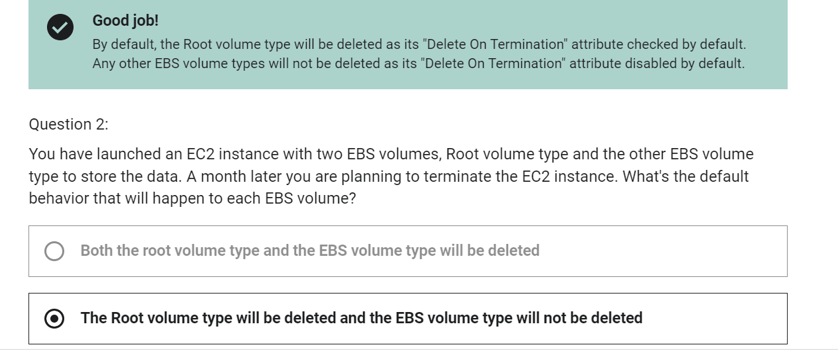

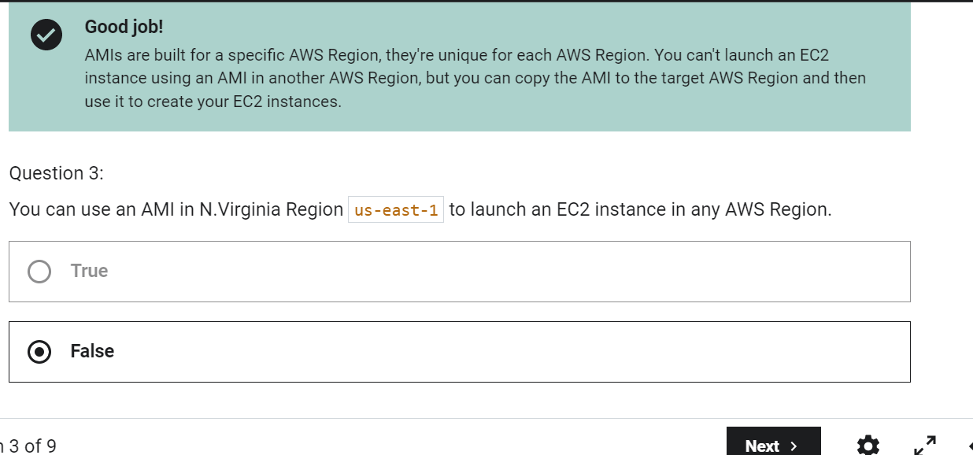

When creating EC2 instances, you can only use the following EBS volume types as boot volumes: gp2, gp3, io1, io2, and Magnetic (Standard).

Using EBS Multi-Attach, you can attach the same EBS volume to multiple EC2 instances in the same AZ. Each EC2 instance has full read/write permissions.

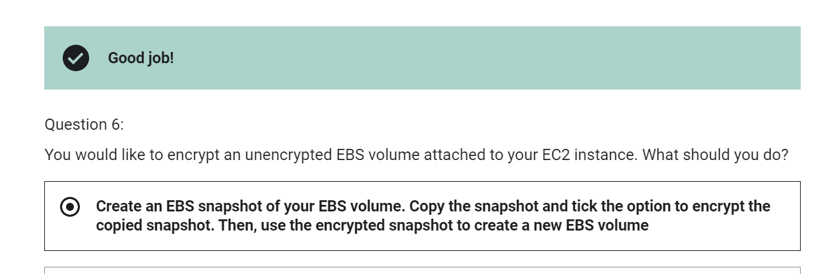

EFS is a network file system (NFS) that allows you to mount the same file system on EC2 instances that are in different AZs.

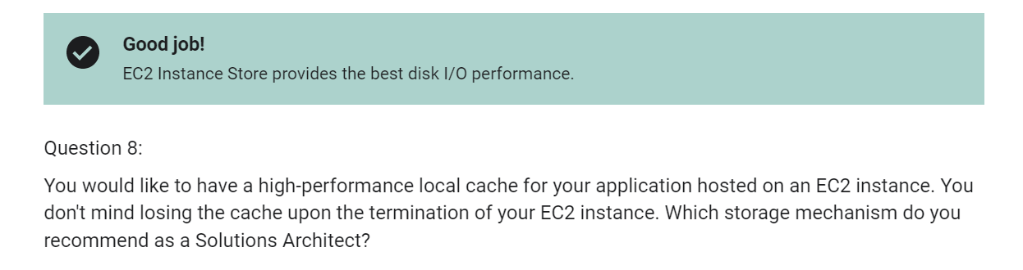

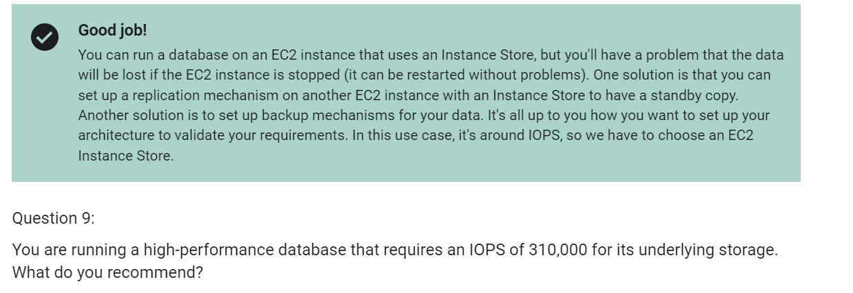

 NLB is layer 4 (TCP) and below and is not designed to take into consideration anything at the application layer such as content type, cookie data, custom headers, user location, or the application behavior. It is context-less, caring only about the network-layer information contained within the packets it is directing this way and that.

* Application Load Balancer (as the name implies) works at the Application Layer (Layer 7 of the OSI model, Request level). Network Load Balancer works at Transport layer (Layer 4 of the OSI model, Connection level). NLB just forward requests whereas ALB examines the contents of the HTTP request header to determine where to route the request. So, application load balancer is performing content based routing.
* NLB cannot assure availability of the application. This is because it bases its decisions solely on network and TCP-layer variables and has no awareness of the application at all. Generally a NLB determines availability based on the ability of a server to respond to ICMP ping, or to correctly complete the three-way TCP handshake. ALB goes much deeper, and is capable of determining availability based on not only a successful HTTP GET of a particular page but also the verification that the content is as was expected based on the input parameters.
* When considering the deployment of multiple applications on the same host sharing IP addresses (virtual hosts in old school speak), NLB will not differentiate between Application A and Application B when checking availability (indeed it cannot unless ports are different) but ALB will differentiate between the two applications by examining the application layer data available to it. This difference means that NLB may end up sending requests to an application that has crashed or is offline, but ALB will never make that same mistake.

So what can Network Load Balancer send traffic to?

Well, we can have different target groups.

The first one is EC2 instances.

So we can register EC2 instances with target groups,

and then the Network Load Balancer will know

how to send traffic to them.

That's very intuitive.

The second one is by IP addresses.

So we can specify fixed, static, private IP addresses,

and have the NLB send traffic directly to them.

Why would we do that?

Well, for EC2 instances, it's a bit of an overkill,

but if you had a server

on your own data center, for example,

you could use a network balancer,

preferably a server with a private IP

and use that as is.

So this is the second option.

And the third option is Application Load Balancer.

So it is possible for you to chain together

a Network Load Balancer and an Application Load Balancer.

So why would you do that?

Well, maybe you want to leverage the feature of the NLB

to have fixed static IPs.

And so therefore

you want to have fixed static IP at the NLB level,

but you want to leverage the ALB

for all its HDP related features,

such as rules and so on, okay.

 now for each rule

we can have a different SSL certificate

and that would allow us using server name indication SNI,

to have multiple SSL certificates

on different target groups.

CLB is the old way of doing things,

it does not support SNI

and ALB and NLB do support SNI and multiple SSL certificates.

First of all you can have Scaling policies for your ASG,

and it can be anything you want.

So it could be CPU Network,

it could be a Custom Metric or define,

or even based on the schedule if you know in advance,

how your visitors are going to visit

for example your website.

If you know they are logging very early in 9:00 AM,

may be you can be proactive,

and add more instances proactively before users arrive,

so they have a better experience.

Quiz-

Only Network Load Balancer provides both static DNS name and static IP. While, Application Load Balancer provides a static DNS name but it does NOT provide a static IP. The reason being that AWS wants your Elastic Load Balancer to be accessible using a static endpoint, even if the underlying infrastructure that AWS manages changes.

ELB Sticky Session feature ensures traffic for the same client is always redirected to the same target (e.g., EC2 instance). This helps that the client does not lose his session data.

When using an Application Load Balancer to distribute traffic to your EC2 instances, the IP address you'll receive requests from will be the ALB's private IP addresses. To get the client's IP address, ALB adds an additional header called "X-Forwarded-For" contains the client's IP address.

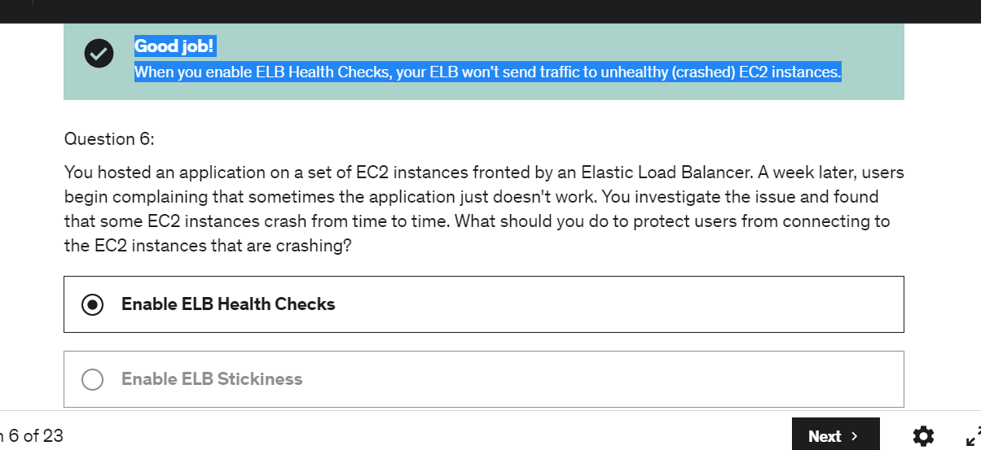

Network Load Balancer provides the highest performance and lowest latency if your application needs it.

Application Load Balancers support HTTP, HTTPS and WebSocket

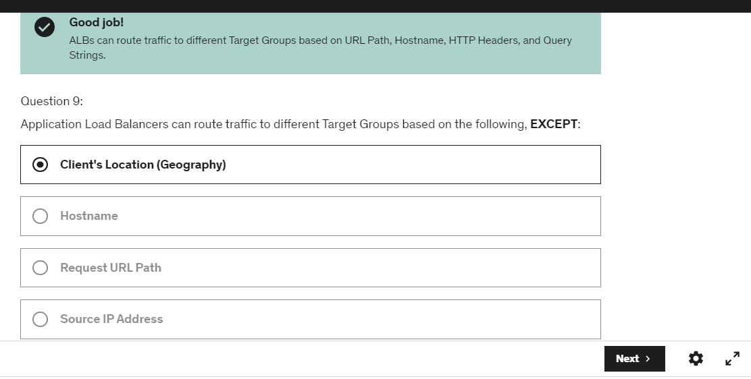

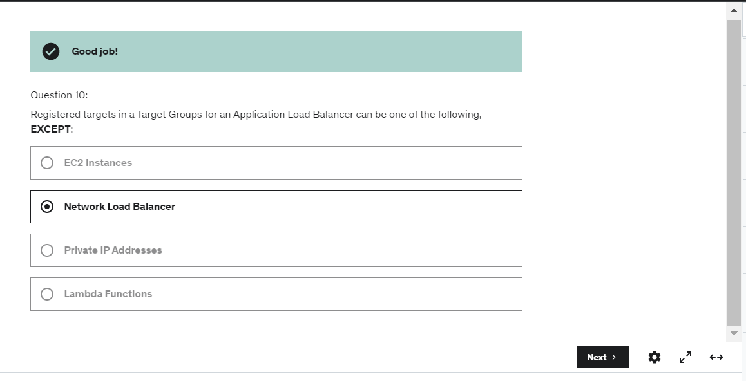

Network Load Balancer has one static IP address per AZ and you can attach an Elastic IP address to it. Application Load Balancers and Classic Load Balancers have a static DNS name.

The following cookie names are reserved by the ELB (AWSALB, AWSALBAPP, AWSALBTG).

When Cross-Zone Load Balancing is enabled, ELB distributes traffic evenly across all registered EC2 instances in all AZs.

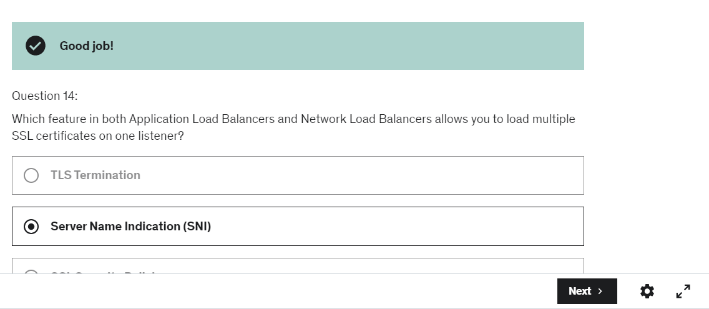

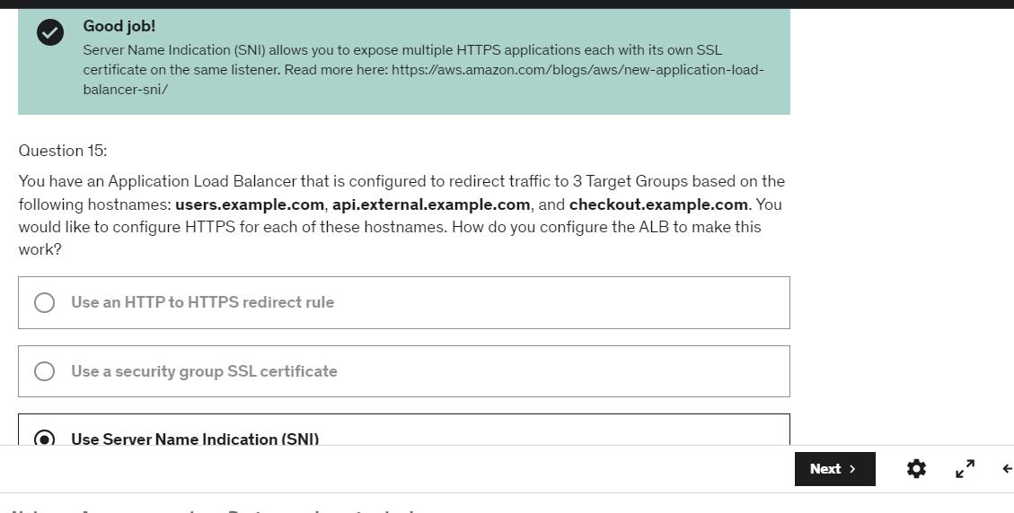

The Auto Scaling Group can't go over the maximum capacity (you configured) during scale-out events.

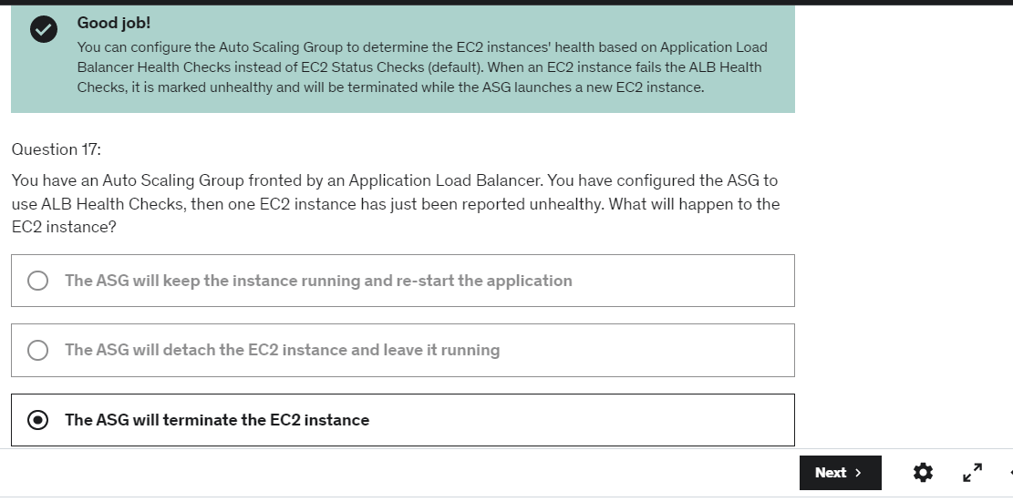

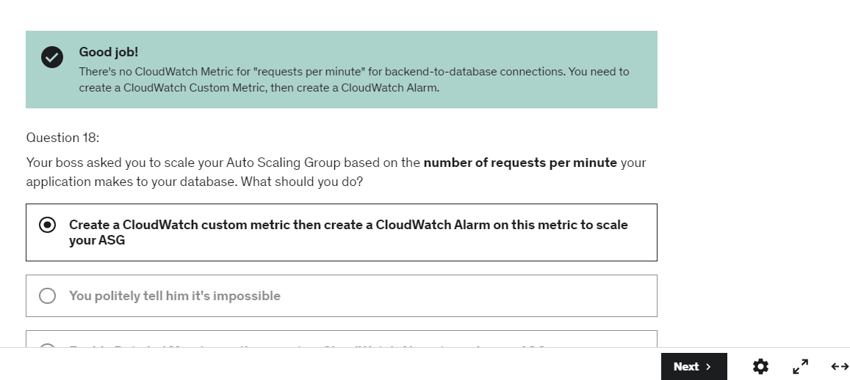

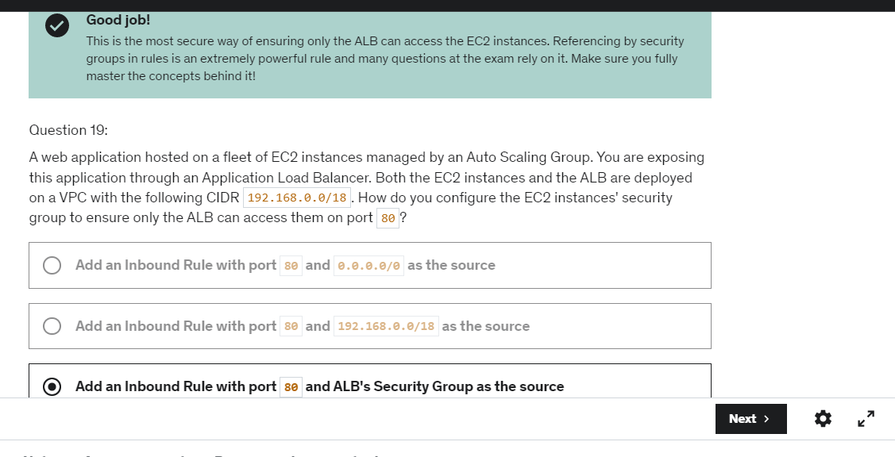

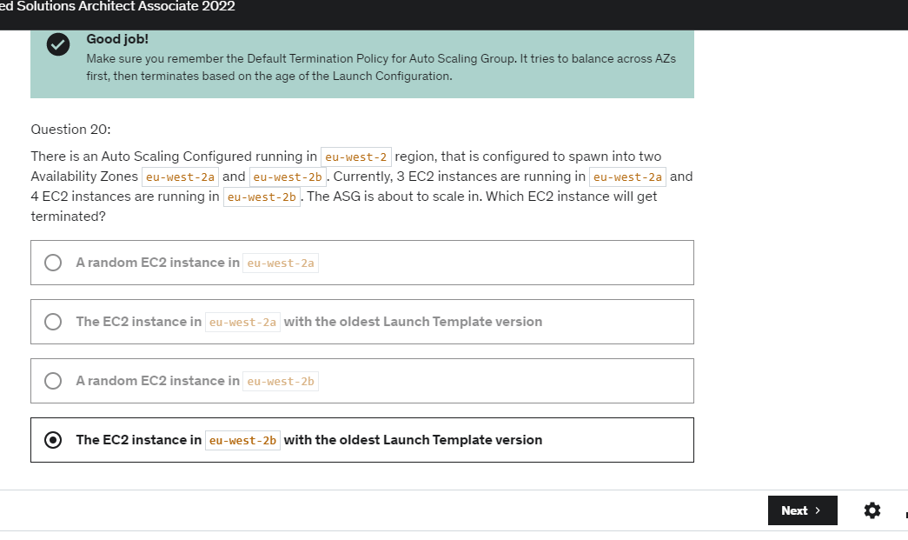

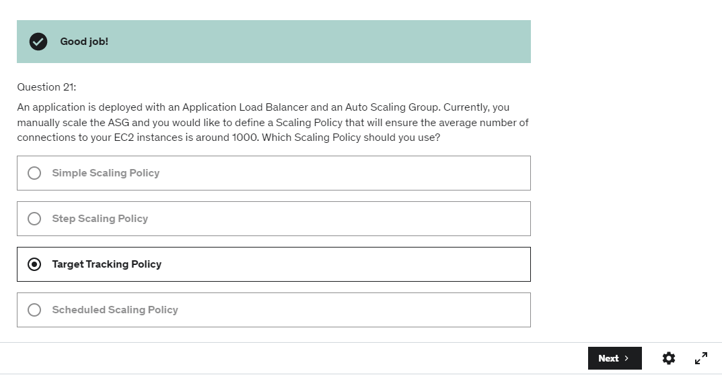

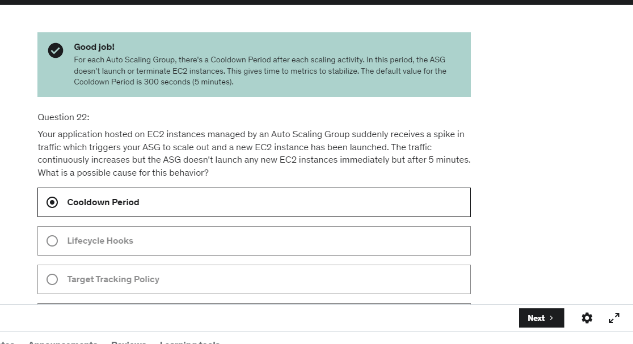

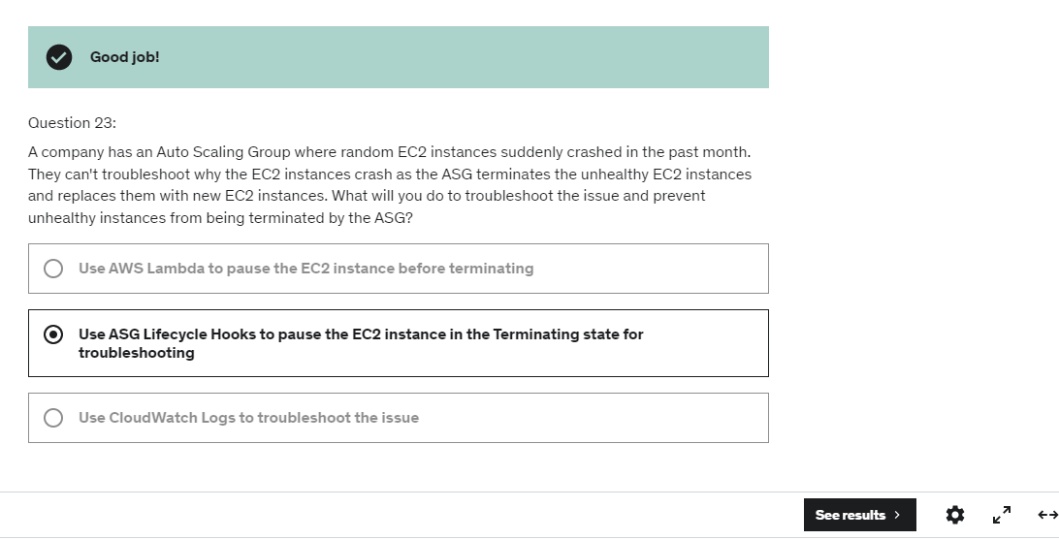

There is some kind of self healing process that happens

which is quite cool.

Which is that if some data is corrupted or bad,

then it does self healing with peer-to-peer replication

in the backend and it's quite cool.

And you don't rely on just one volume,

you rely on hundreds of volumes.

Again, not something for you to manage.

It happens in the back end,

but that means that you just reduced the risk by so much.

RDS supports MySQL, PostgreSQL, MariaDB, Oracle, MS SQL Server, and Amazon Aurora.

Multi-AZ helps when you plan a disaster recovery for an entire AZ going down. If you plan against an entire AWS Region going down, you should use backups and replication across AWS Regions.

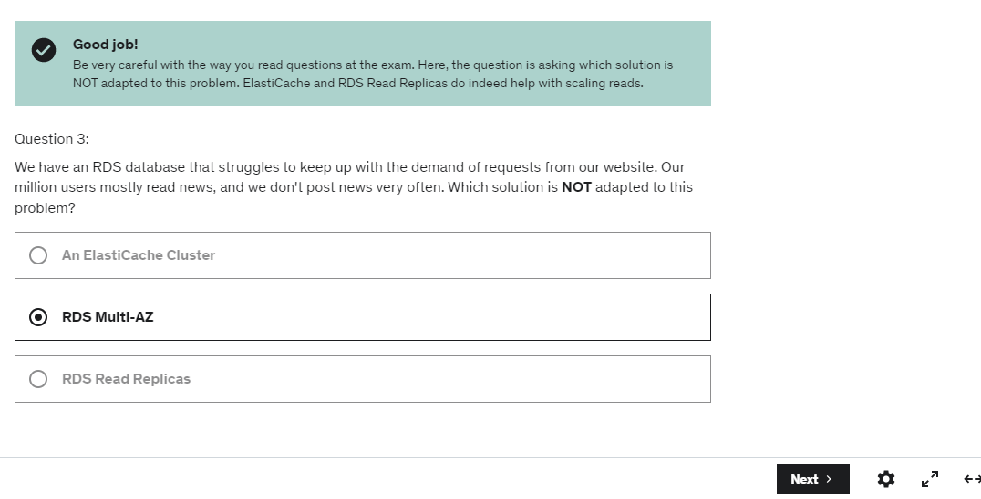

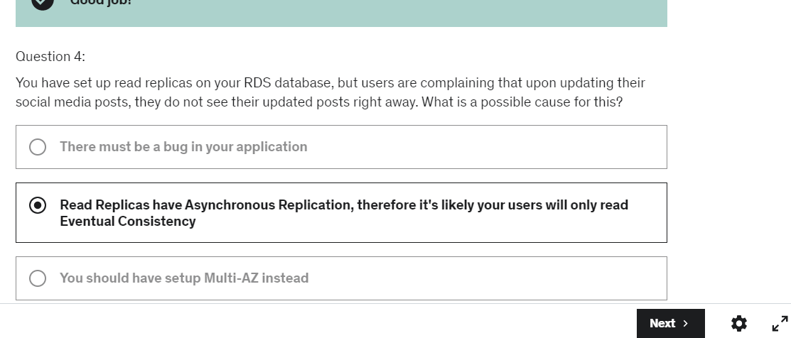

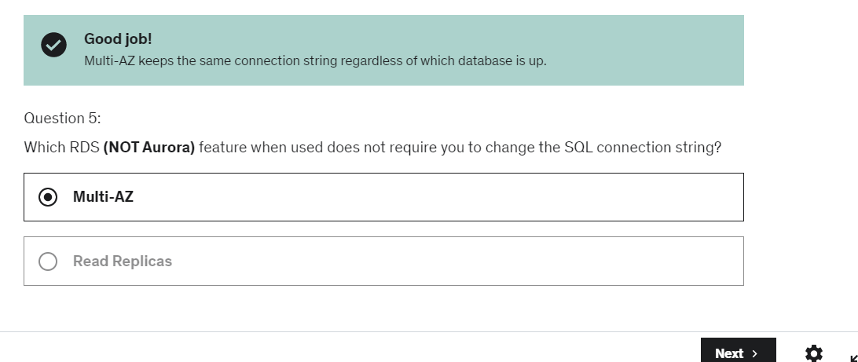

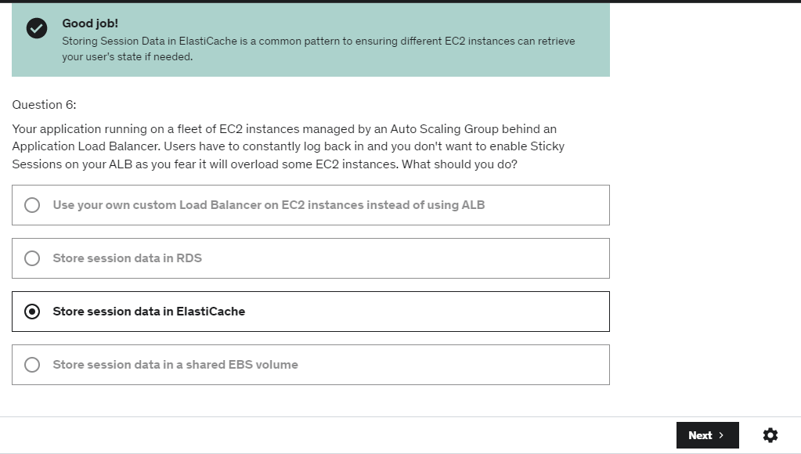

Read Replicas will help as your analytics application can now perform queries against it, and these queries won't impact the main production RDS database.

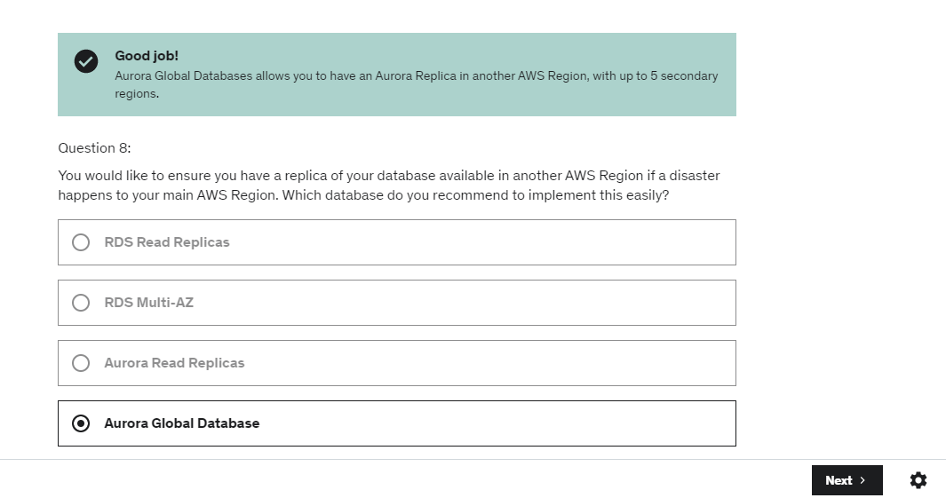

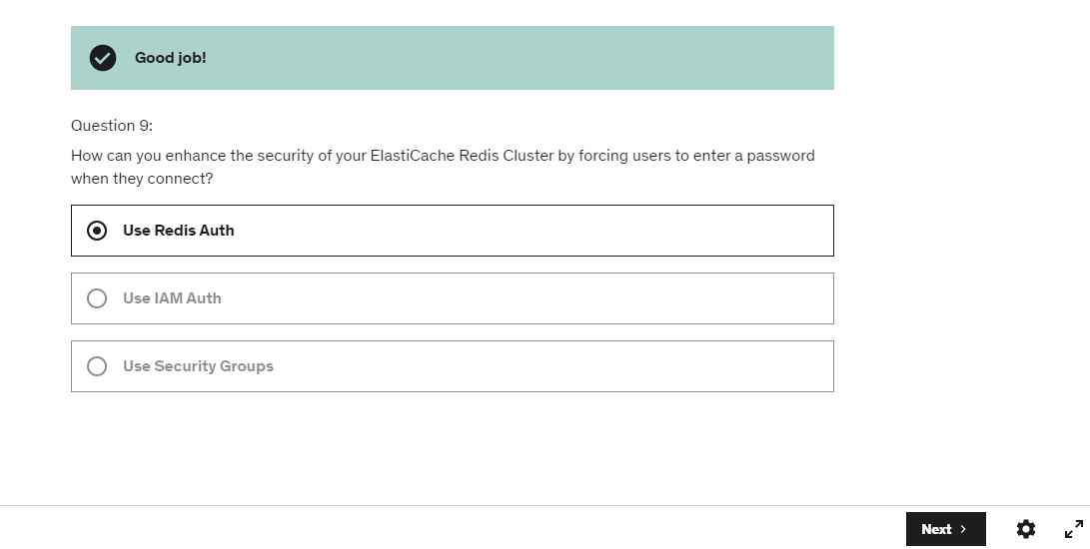

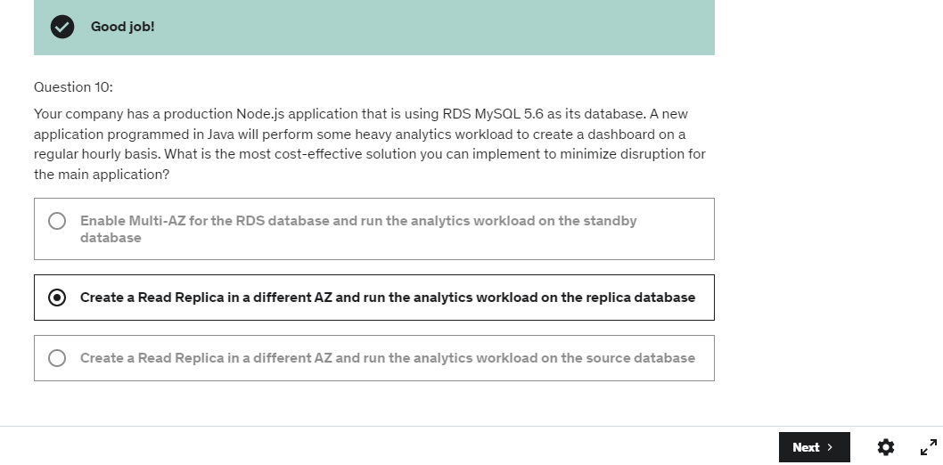

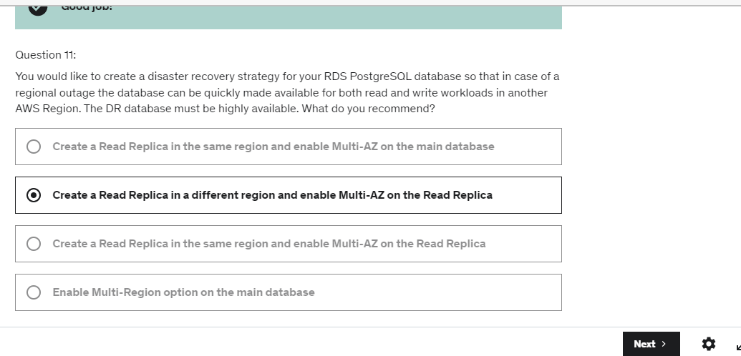

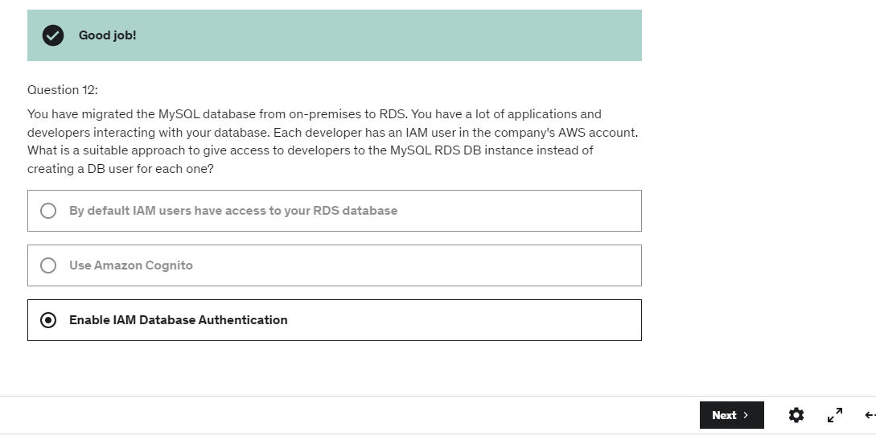

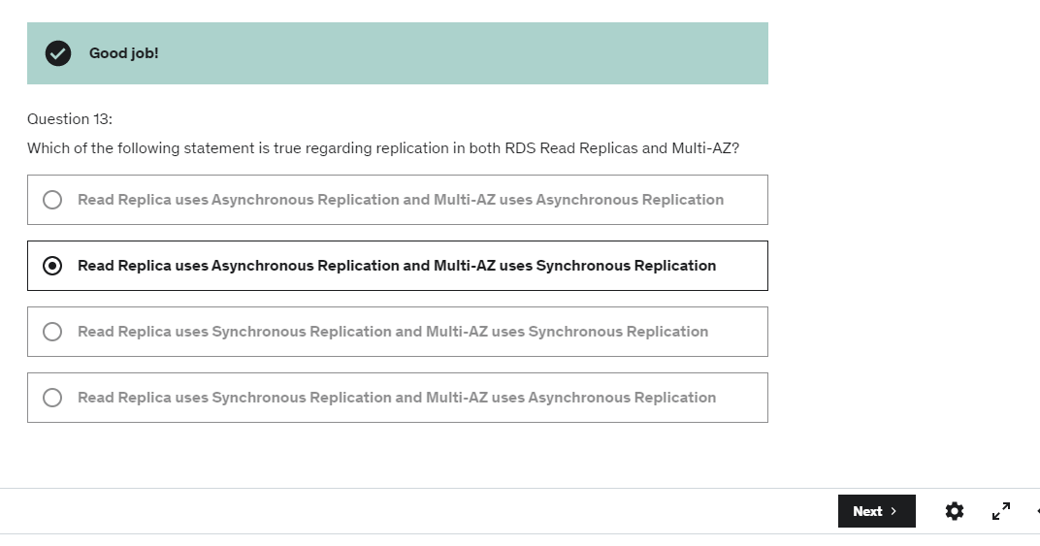

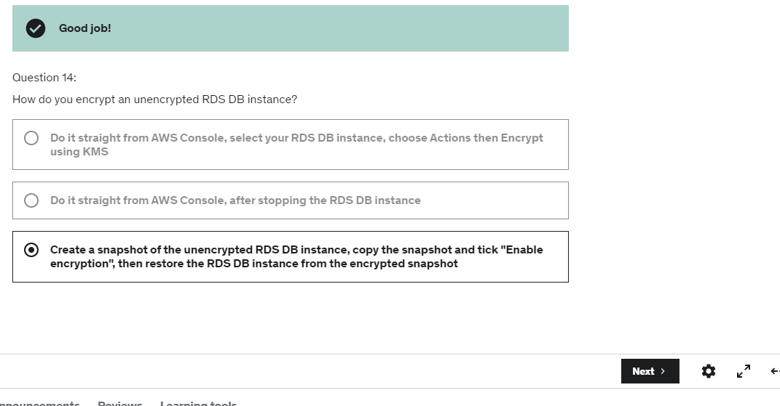

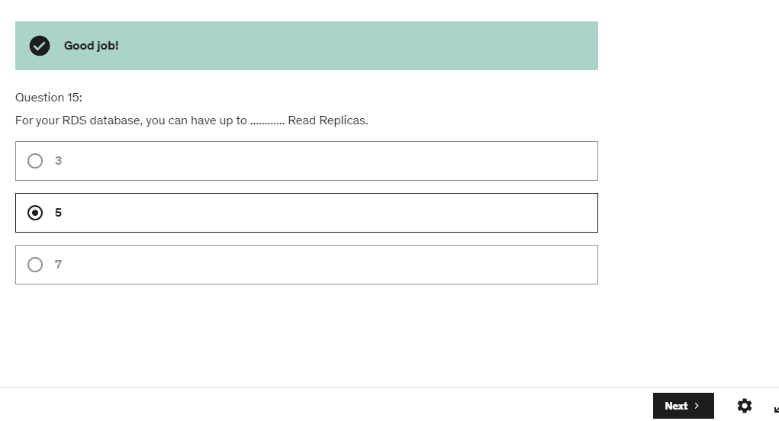

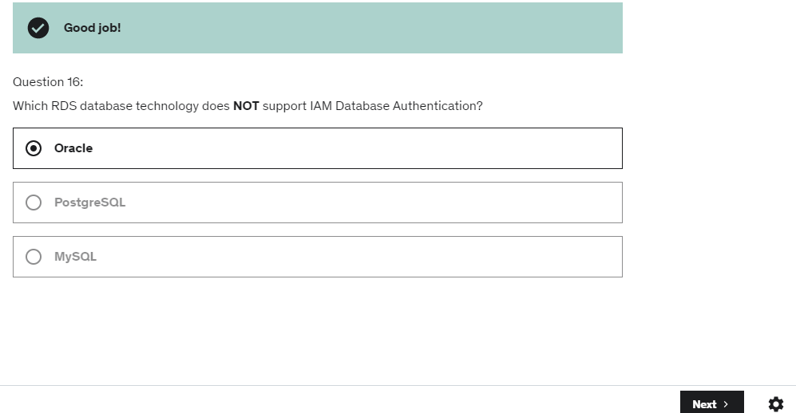

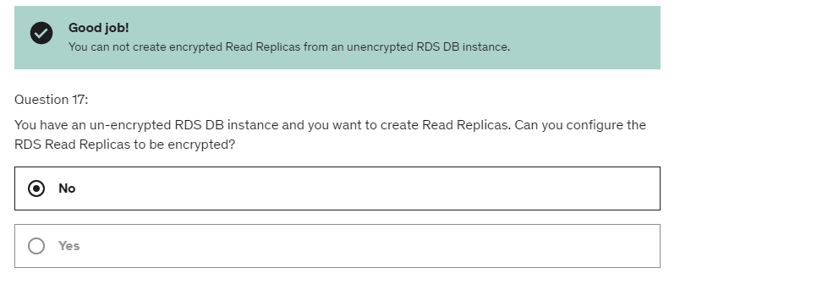

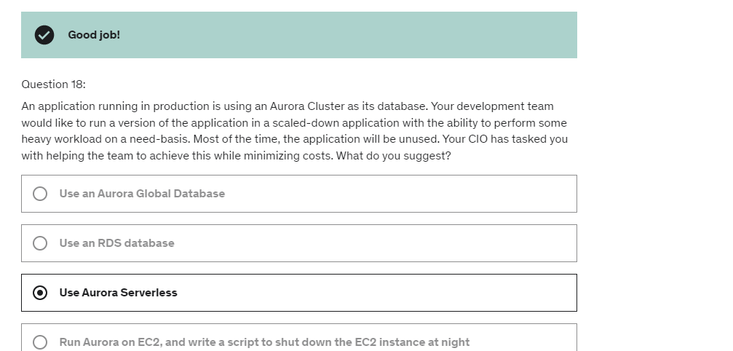

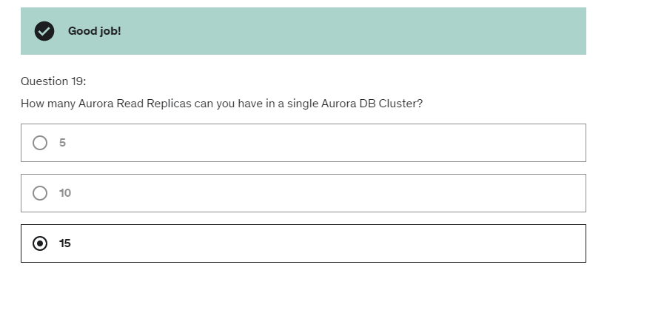

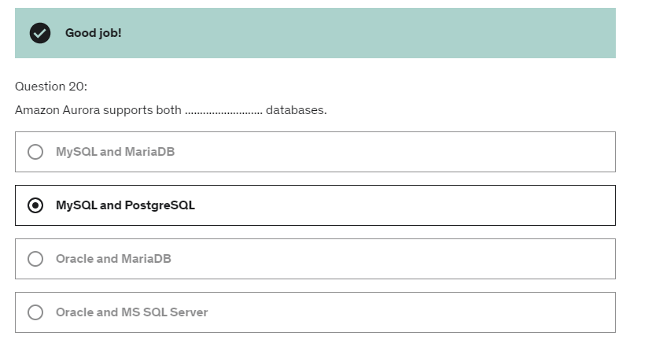

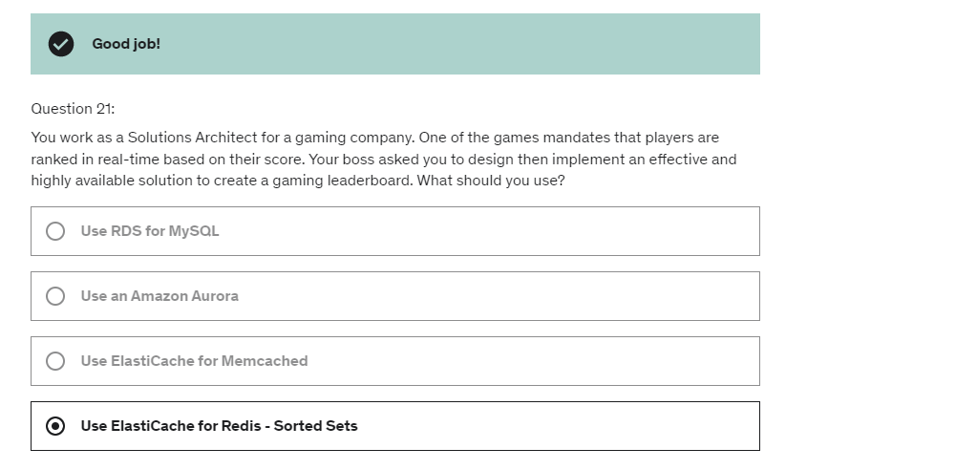

So the DNS just helps translate host names

into actual endpoints that the clients can use.

the idea is that instead of writing the records

one by one in your DNS management system in Route 53

we're going to just manage all of them visually.

And the cool thing about it is that it's going to be saved

as a Traffic Flow Policy,

and it can be versioned,

So up to eight healthy records are going to be returned

for each Multi-Value query.

And although it looks like an ELB,

it's not a substitute for having an ELB.

The idea is that it's the client-side load balancing.

This is going to be different, for example,

when you have a simple routing with multiple values in it,

because as you know, the simple routing policy

does not allow for Health Checks,

and therefore it's possible

that one of the resources returned in the query

of a simple routing policy will be unhealthy.

This is why Multi-Value are a little bit more powerful

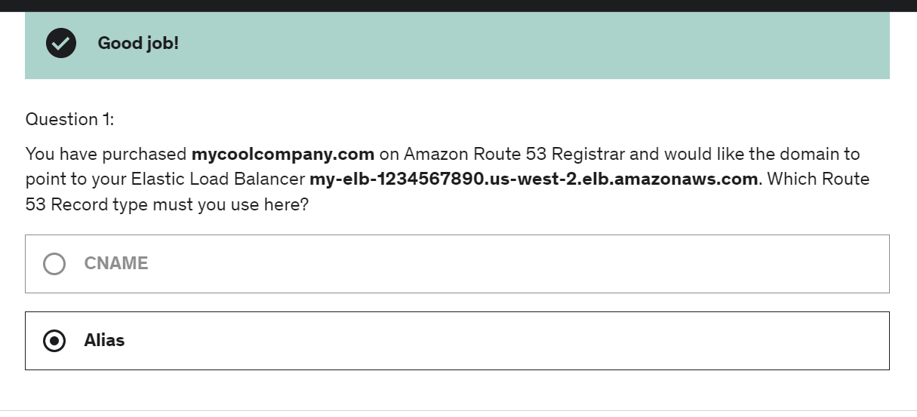

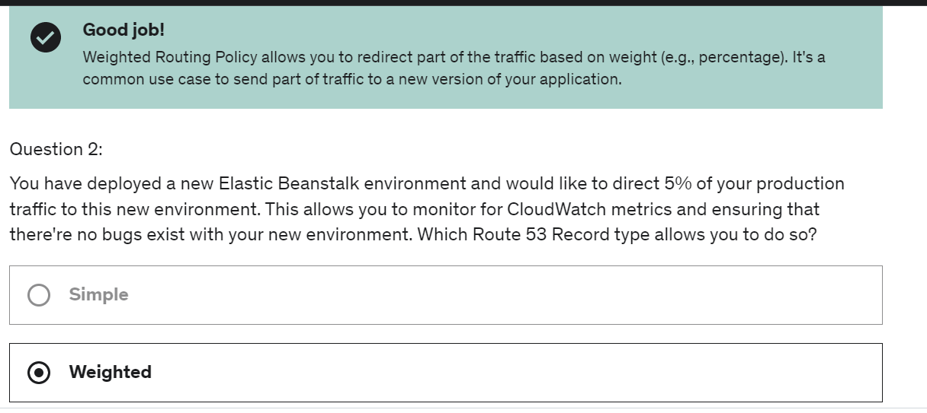

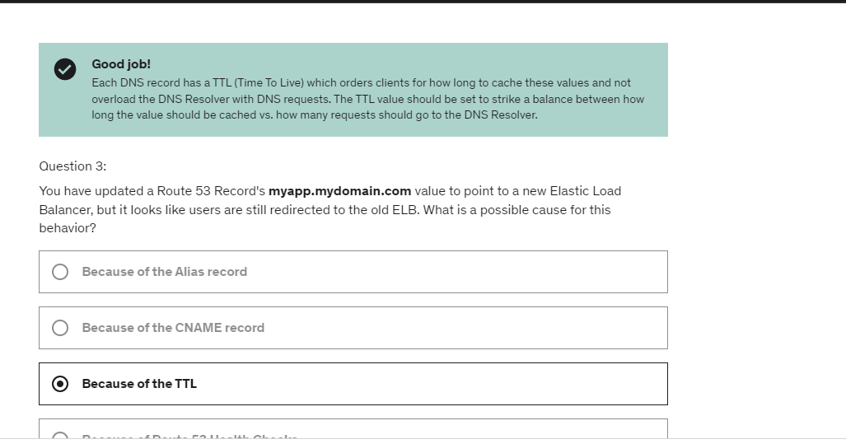

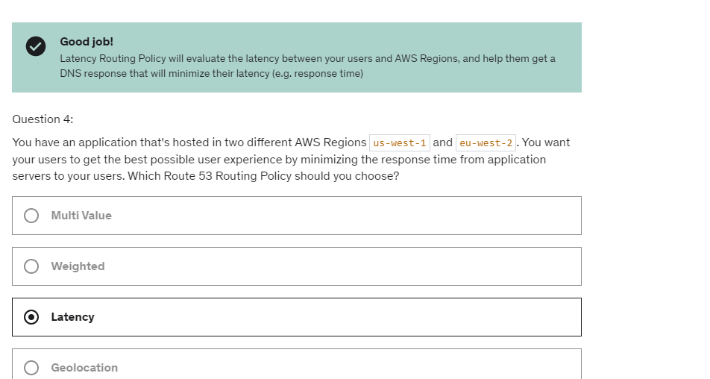

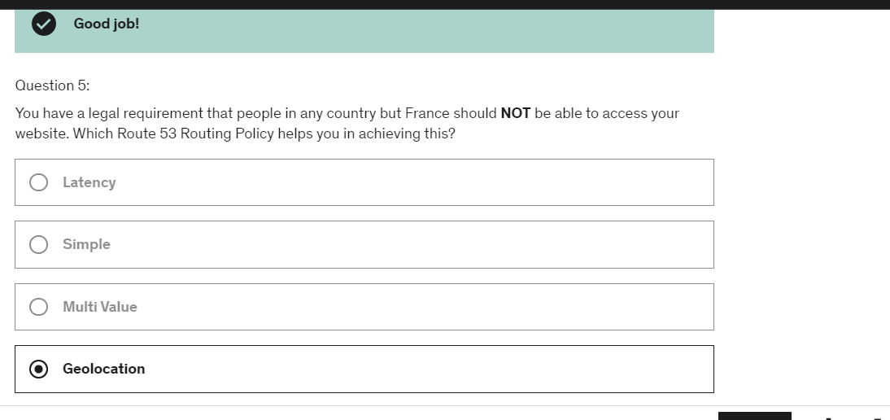

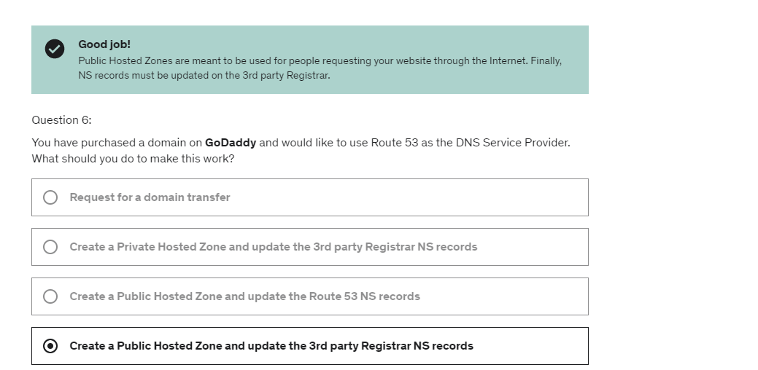

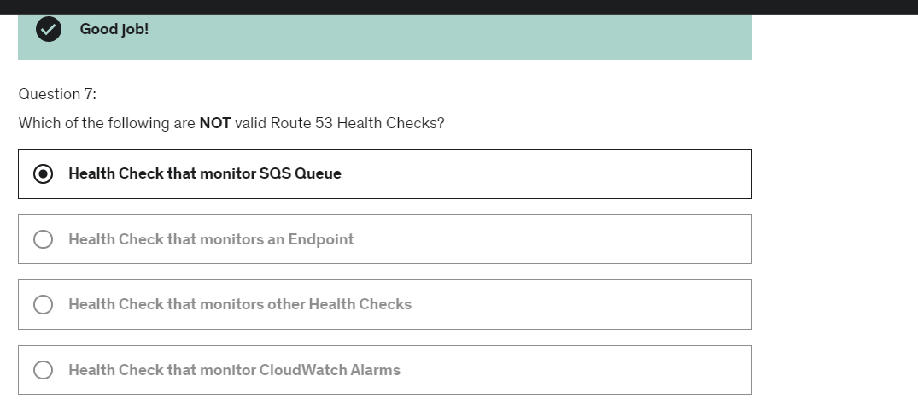

Each instance, each server knows what time it is,

and we want to start small.

We're willing to accept downtime, but overall,

maybe our app will get more and more popular.

People really wanna know the time around the world,

and so we'll need to scale vertically and horizontally,

maybe remove downtime,

and let's go through

the Solutions Architect journey for this app.

You'll see, we'll see a lot of things on how we can proceed.

So let's start really simple.

Okay, let's start from the very beginning.

You're a solution architect and you say,

you know what would be great?

You have a t2.micro instance and you have a user,

and the user says what time it is,

and say okay, it's 5:30 p.m.

Done, this is my app.

So we have a public EC2 instance,

and because we wanna make the EC2 instance

have a static IP address in case something happens

and we need to restart it,

then I will attach an elastic IP address to it.

So this is my first PoC.

It's written really great.

Our users are able to access our application,

and we're getting great feedback.

So now, what's happening is that our users

are really having a good time using our application,

so they said to their friends,

hey, you should also use the application.

So another friend comes in and says what time is it?

And 7:30 p.m.,

and another friend comes in, what time is it?

6:30 p.m.,

and so we realize here that

our application is getting more and more traffic,

and certainly, the t2.micro instance isn't enough,

and so, as a solution architect, we say, wait a minute.

Maybe we should replace that t2.micro instance

by something a little bit bigger

to handle the load, so that's called **vertical scaling**.

Maybe we'll make it an m5.large type of instance.

So what we do is that we stop the instance,

we change the instance type,

and then, we start again the instance,

and here we go.

This is an M5 type of instance.

So what happened here is that is has the same public IP

because it has an elastic IP address,

so people are still able to access our application,

but we have experienced downtime

while upgrading to an M5,

and so, our users were not really happy.

During that moment,

they were not able to access our application.

So this works, but this isn't great, right?

So next, we're going really popular,

and it's time **to scale horizontall**y,

so we get, remember, this application M5

has one public IP, elastic IP attached to it,

and now, we're getting tons of users,

and so, they're all asking what time is it?

And so now, we wanna scale horizontally,

so we start adding EC2 instances.

They're all m5.large,

and they all have an elastic IP attached to it.

So now, on top of having three EC2 instance,

we have three elastic IP,

and **so our users, they need to be aware of the,**

**the exact values of these three elastic IP**

**to talk to our instances,**

and so, that's called horizontal scaling.

We're doing not bad, but we see we starting kinda

reach some limits.

Now the users need to be aware of more and more IPs,

and we have to manage more infrastructure,

and it's, it's pretty tricky, right?

So okay, let's change the approach.

Now we have three EC2 instances, M5,

and let's remove elastic IP

because it's something that we can't really manage.

There's only five elastic IP per region per account

by default so it's not real lot,

and so, instead, our users, what they're going to do

is that they're going to **leverage Route 53,**

so we've set up Route 53,

and the website URL is api.whatisthetime.com,

and we've decided it's going to be an A Record

with a TTL of one hour.

An A Record means that from a DNS like this,

it's going to **give me a list of IPs,**

so remember, Route 53, A Record is IP.

So great, so the users query Route 53,

and then, they get the IP addresses of our EC2 instances,

and they can change over time.

It doesn't really matter

because Route 53 will get updated.

We'll update it and keep it in sync,

and so, our users are now able to access our EC2 instances,

and we don't have any elastic IP to manage anymore,

so using Route 53, we've done some good improvement,

but what happens is that now, we wanna be able to scale,

you know, and be able to add and remove

instances on the fly,

and so, when we do remove an instance, aw, what happens?

Well, it seems like these users at the top,

they were talking to this m5.large instance,

but now, it's gone,

and it turns out that if they do a Route 53 query,

because the TTL was one hour,

they're using the same response for one hour.

So for one hour, they'll try to connect to that instance,

and that instance is gone,

and so, here, it's not really great

because even though these users are having a good time,

and maybe after one hour,

these user will be able to connect to these two instances,

they're not having a good time right now

'cause they think that our application is down,

and that's really, really bad.

So okay, so this is an architecture,

and we see the limit of it.

So how can we push this a little bit further?

So let's talk about adding a **load balancer**.

So instead, now having,

we don't have public instances anymore.

We have private EC2 instances,

and we're going to launch them in the same Availability Zone

because we don't know any better.

So we've launched them manually.

We have three m5.large instances,

and we are following this course,

and we said okay, let's use a load balancer,

and you know what?

On top of it, it's going to have health checks

such as if one instance is down or not working,

at least we won't send traffic

from our users to the instance.

So okay, we're linking the two together,

so my ELB is going to be public-facing,

whereas my private EC2 instances are in the back,

and so, they restrict traffic between these two

using maybe a security group rule that we've seen before,

using security group as a reference.

Okay, that sounds pretty good.

So now, our users, they're going to query

for WhatIsTheTime.com,

but this time, it cannot be a A Record

because a load balancer has its IP changing all the time,

and so, instead, because it's a load balancer,

we can use an **Alias Record**,

and this Alias Record is perfect

because it will point from **Route 53 to the ELB**,

and everything will work really great,

and so, here we change our DNS, but now,

the users connect to our load balancer,

and our load balancers redirects us to our EC2 instances

and balances the traffic out and it's really great

'cause now we can add and remove these instances,

and we just sort them with our load balancer,

and we won't have any downtime for our users

thanks to the health checks feature.

So really, really good,

but now, **adding and removing instances manually**

**is pretty, pretty hard to do,**

so what about, we just leverage something

we just learned in this class,

and we'll launch **an auto-scaling group.**

So now, we have our API on the left-hand side.

It's the same thing, a Route 53, ELB,

but on the right-hand side now,

we're gonna have an Availability Zone,

and we're going to launch private EC2 instances,

but this time, they're going to be managed

by an auto-scaling group,

and so, this allows our auto-scaling group

to basically scale on demand.

Maybe in the morning, no one wants to know the time,

and maybe at night, when people want to leave work,

they wanna know the time.

So we're able to scale based on the demand,

scale in and scale out,

and this is really, really great

because now, we have an application, no downtime,

auto-scaling, load-balanced.

It seems like a really stable architecture, and it is,

but what happens is that, ugh!

There's an earthquake that happens,

and **Availability 1 goes down, Zone 1 goes down,**

**and guess what?**

**Our application is entirely down**.

Our users are not happy,

and so, Amazon comes to us and says,

yes, it's because you haven't

implemented a multi-AZ application,

and we recommend you **to implement multi-AZ**

to be highly available.

So okay, we say all right.

Let's change a little bit the things.

Now we're gonna have to ELB,

and on top of having health checks,

it's also going to be multi-AZ,

and it's going to be launched on AZ 1 to 3,

so three AZs for this ELB,

and our auto-scaling group as well

is going to span across multiple AZ,

and this allows us maybe to have

two instances in AZ 1,

two instances in AZ 2, and one instance in AZ 3,

and so, the cool thing now is that,

ah, great, like, if AZ 1 goes down,

well, we'll still have AZ 2 and AZ 3

to serve our traffic to our users,

and we've effectively made our app multi-AZ

and highly available and resilient to failure.

Pretty awesome, right?

Okay, how far can we go with this?

Let's keep on going.

So we have two AZ,

and **we know that at least one instance**

**will be running in each AZ,**

**so why don't we reserve capacity?**

Why don't we start basically

diminishing the cost of our application

because we know that for sure,

two instances must be running at all time during the year?

**And so, by reserving instance,**

**maybe for the minimum capacity of our auto-scaling group,**

**then we're going to save a lot of cost in the future**

whereas the new instances that get launched,

maybe they're gonna be temporary, so on demand is fine,

or if we're a bit crazy, we could even use spot instances

for a less, less cost,

but we might have the instances being terminated,

and so, it's really interesting, right,

because we've seen an architecture

going from a very small application

all the way to a, you know,

load-balanced, auto-scaling group,

multi-AZ, health checks,

reserved instances that with our application,

and so, to me, that's,

as a solutions architect, your journey.

It's up to understand what are the requirements?

And what should we architect

in returns to these requirements?

And this is where the exam will test you.

Now this is the first architecture discussion.

Trust me, there will be many others in the next lecture,

but for now, let's just review what we've discussed.

What we've discussed, for example,

what it is to, for an EC2 instance,

to have a public IP and a private IP.

You know, where does it fit in our architecture diagram?

We also seen what is the benefit of having an elastic IP

versus using Route 53 versus maybe using a load balancer

for our application.

We've also seen that thanks, because of the Route 53 TTL,

we couldn't really use A Records,

so we had to use an load balancer and Alias Record

and so that we'll be able to see

how Route 53 can fit in this whole picture.

We've seen how to maintain EC2 instances manually,

and then, we say, all right, it's too much maintenance.

Let's use auto-scaling groups, and you know what?

It's actually gonna provide us even better costing

because it will just scale on demand,

and we'll just have the perfect amount

of EC2 instances at any time,

and then, we said okay, let's go into multi-AZ.

We can survive disasters this way,

and let's enable ELB health checks

such as only the instances that are correctly responding

do get traffic,

and we've seen how to set up security group rules

so that the EC2 instances will only receive traffics

coming from the ELB,

and finally, we said, you know what?

Let's look at capacity.

Let's do some cost-saving.

We always know that we want two EC2 instances

running at any time,

so let's reserve these instances,

and they will bring lots of cost savings,

and so, all this discussion right here,

there's the thing called

the Well-Architected Framework in AWS,

and we'll be talking about it

at length as well in the dedicated section,

but there's five pillars to it,

and there's cost, performance, reliability,

security, and operational excellence,

and so, through these discussion,

I want to educate you

that we have actually seen these five pillars.

So **cost**, cost has many different purpose,

so maybe we're scaling up our instance vertically.

Maybe we're using ASG to just have

the right amount of instances based on the load,

and maybe we wanna reserve instances as well

to optimize cost.

In terms of **performance**, well, we've seen vertical scaling.

We've seen ELBs, we've seen auto-scaling groups,

basically how we can adapt to performance over time.

**Reliability**, we'll seen how Route 53 can be used

to basically reliably direct the traffic

to the right EC2 instances,

and maybe using multi-AZ for the ELB

and multi-AZ for the ASG as well.

For **security**, we've seen how we can use security groups

to basically link the load balancer

to our instances reliably,

and **operational excellence**,

how we can evolve from a very clunky, manual process

all the way to having it fully automated

with auto-scaling groups, et cetera, et cetera.

So really awesome.

I think this is a good discussion,

and we'll have many others,

but as a solutions architect,

start understanding what other technology we've seen

and how they fit together and how they solve problems

all together when, when configured correctly.

So that's it.

we've seen an architecture

going from a very small application

all the way to a, you know,

load-balanced, auto-scaling group,

multi-AZ, health checks,

reserved instances that with our application,

there's the thing called

the Well-Architected Framework in AWS,

and we'll be talking about it

But now we are going to get into a stateful

web application called MyClothes.com

And MyClothes.com allows people to buy clothes online.

And there is a shopping cart when you navigate MyClothes.com

and we're having hundreds of users at the same time

so all these users are navigating the website

and we wanna be able to scale,

maintain horizontal scalability

and keep our application web tier as stateless as possible.

So even though there is a state of shopping cart,

we want to be able to scale our web application

as easily as possible.

So **users, that means that they should not lose**

**their shopping cart while navigating our website,**

**that would be really bad.**

And maybe also have their details such as address, etcetera,

in a database that we can store effectively

and make accessible from anywhere.

So let's see how we can proceed.

You'll see it's going to be yet another fun

but challenging discussion.

Okay, so this is our application and I'm going to go fast.

Here's the kind of architecture we've seen

in the previous lecture.

**So we have our user, Route 53, Multi AZ ELB,**

**Auto Scaling group three AZ, very basic.**

So our application is accessing our ELB and our ELB says

"Alright, you're gonna talk to this instance."

And you create a shopping cart,

and then the next request is going to go

not to the same instance but to another instance,

so now the shopping cart is lost

and the user says "Oh, there must just be a little bug,

I'm going to try again."

**So he adds something into the shopping cart**

**and it gets redirected to the third instance**

**which doesn't have their shopping cart**.

So basically the user is going crazy and say,

"Wait, I'm losing my shopping cart

every time I do something.

This is really weird, MyClothes.com is a bad website.

I don't wanna shop on it, it will lost money."

So how do we fix this?

Well, we can introduce Stickiness or **Session Affinity**

and that's an **ELB feature so we enable ELB Stickiness**

and now our user talks to our first instance,

adds something into the shopping cart

and then the second request goes

to the same instance because of Stickiness

and the third request also goes to the same instance

and actually every request will go

to the same instance because of Stickiness.

**This works really well but if an ec2 instance**

**gets terminated for some reason,**

**then we still lose our shopping cart**.

But there is definitely some kind of improvement here,

thanks to Stickiness and Session Affinity.

So now, let's look at the **completely different approach**

and introduce **user cookies.**

So basically, instead of having the ec2 instances

**store the content of the shopping cart**,

let's say that the user is the one storing

the shopping cart content and so every time it connects

to the load balancer, it basically is going to say

"By the way, in my shopping cart I have all these things."

and that's done through web cookies.

So now if it talks to the first server,

the second server or the third server,

each server will know what the shopping cart content is

because the user is the one sending

the shopping cart content directly into our ec2 instances.

So it's pretty cool right?

We achieved stateless test because now each ec2 instance

doesn't need to know what happened before.

The user will tell us what happened before

but the **HTTP request, they are getting heavier**.

So because we sent the shopping cart content in web cookies

we're sending more and more data every time

we add something into our shopping cart.

Additionally, there is some level **of security risk**

because the cookies, they can be altered

by attackers maybe and so maybe our user may have

a modified shopping cart all of a sudden.

So, when we do have this kind of architecture

make sure that your ec2 instances

do validate the content of the user cookies.

And then, the cookies overall, they can only be so big.

They can only be less **than four kilobytes total**

**so there's only a little information**

**you can store in the cookies**.

You cannot store big data sets, okay?

So this is the idea.

So, this works really well.

This is actually a pattern that

many web application frameworks use

but what if we do something else?

Let's introduce this concept **of server session**.

So now, instead of **sending a whole shopping carts**

**in web cookies, we're just going to send a session ID.**

That is just this one for the user.

So we're gonna send this and in the background,

we're gonna have to maybe in the ElastiCache cluster

and what will happened is that when we send a session ID,

we're gonna talk to ec2 instance

and say we're going to add this thing to the cart

and **so the ec2 instance will add the cart content**

**into the ElastiCache and the ID to retrieve**

**this cart content is going to be a session ID.**

So when our user basically does the second request

with the session ID and it goes to another ec2 instance,

that other ec2 instance is able using that session ID

to look up the content of the cart from ElastiCache

and retrieve that session data.

And then, for last request, the same pattern.

The really cool thing with ElastiCache,

remember, it is sub-millisecond performance

so all these things happen really quickly

and that's really great.

An alternative, by the way, for storing session data

we haven't seen it yet, it's called **DynamoDB.**

But I'm just putting it out here

just in case you know what DynamoDB is.

So, it's a really cool pattern here.

It's more secure because now ElastiCache is a source

of truth and **no attackers can change what's in ElastiCache.**

So we have a much more secure type

of pattern and it's very common.

So now, okay we have ElastiCache, we figured this out.

We wanna store user data in the database,

we wanna store the user address.

So again, we're gonna talk to our ec2 instance

and this time, it's going to talk to an RDS instance.

And RDS, it's going to be great because it's

for long term storage and so we can store

and retrieve user data such as address, name,

etcetera directly by talking to RDS.

And each of our instances can talk

to RDS and we effectively get, again,

some kind of Multi AZ stateless solution.

So our traffic is going great.

Our website is doing amazing

and now we have more and more users

and **we realized that most of the thing they do**

**is they navigate the website.**

**They do reads, they get product information,**

**all that kind of stuff.**

**So how do we scale reads?**

Well we can use an RDS Master

which takes the writes but we can also have

**RDS Read Replicas** with some replication happening.

And so anytime we read stuff,

we can read from the Read Replica

and we can have **up to five Read Replicas in** RDS.

And it will allow us to scale the reads of our

RDS database.

There's an **alternative pattern** called **Write Through**

where we use the cache and so the way it works is that

our user talks to an ec2 instance.

It looks in the cache and said,

"Do you have this information?"

If it doesn't have it then it's going to read from RDS

and put it back into **ElastiCache**

so just this information is cached.

And so the other ec2 instances,

they're doing the same thing but this time

when they talk to ElastiCache,

they will have the information and they get a cache hit

and so, they directly get the response right away

because it's been cached.

And so this pattern allows us **to do less traffic on RDS.**

Basically, **decrease the CPU usage on RDS**

**and improve performance at the same time.**

But we need to do cache maintenance now

and it's a bit more difficult and again

this has to be done application side.

So pretty awesome now, we have our application,

it's scalable, it has many many reads

but **we wanna survive disasters**,

we don't wanna be stricken by disasters.

So how do we do?

Our user talks to our Route 53

but now we have **a Multi AZ ELB.**

And by the way, Route 53 is already highly available.

You don't need to do anything.

Well so far, a load balancer,

we're going to make it Multi AZ.

Our **auto scaling group is Multi AZ and then RDS,**

**there's a Multi AZ feature.**

The other one is going to be a standby replica

that can just takeover whenever there's a disaster.

And **ElastiCache also has a Multi AZ feature**

**if you use Redis.**

So really cool.

Now we basically have a Multi AZ application

all across the board and we know for sure

that we can survive unavailabilities on in AWS going down.

Now for **security groups**, we wanna be super secure.

So maybe we'll open HTTP, HTTPS traffic

from anywhere on the ELB side.

For the ec2 instance side, we just wanna restrict traffic

coming from the load balancer and maybe for my ElastiCache,

we just wanna restrict traffic coming

from the ec2 security group and from RDS, same thing.

We want to restrict traffic coming directly

from the ec2 security group.

So, that's it!

So now, let's just talk

about this architecture for web application.

So we have discussed ELB sticky sessions,

web client for storing cookies

and making our web app stateless

or using maybe a session ID and a session cache

for using ElastiCache and as an alternative,

we can use DynamoDB.

We can also use ElastiCache to cache data from RDS

in case of reads and we can use Multi AZ

to be surviving disasters.

RDS, we can use it for storing user data,

so more durable type of data.

Read replicas can be used for scaling reads

or we can also use ElastiCache

and then we have Multi AZ for disaster recovery.

And on top of it, Tight Security

for security groups referencing each other.

So this is a more complicated application

just three tier because there's the web tier,

the client tier, the web tier, and the database tier.

But this is a very common architecture overall.

And yes, it may start to increase in cost but it is okay,

at least we know the trade-offs we're making.

If we want Multi AZ, yes for sure we have to pay more.

If we want to scale the reads,

yes for sure we'll have to pay more as well.

But it gives us some good trade-offs

in architecture decisions that we have to make.

Okay, so yet another Stateful Web application

and we are going to name this MyWordPress.com

so here we are trying to create a fully scalable

WordPress website and WordPress is a very, very

common way of creating a website it is very popular.

There is hosted WordPress available

but people like to deploy WordPress on AWS

and so we want to access that website

and we want to correctly display picture uploads,

so that it works that WordPress will store the pictures

somewhere on some drive and then basically

all your instances must access that data as well.

We'll see this in the solution architecture discussions

anyway. And so our user data, the blog content

and everything should be stored in a MySQL database

and we want this to scale globally

so let's see how we can achieve this.

So the first thing we have to do is to create a layer

that has RDS so we are now very familiar

with this kind of architecture with RDS in the back end

its Multi AZ it's going to be kind of

get through all of these 2 instances

but **what if I just wanna go and go big**

**and really scale up, maybe I want to replace this layer**

**with Aurora MySQL an I can have Multi AZ, read replicas**

**even global databases if I wanted to.**

Right here we're just basically getting less operations

by using Aurora, it's just a choice I'm making

as a solutions architect you don't have to

make that choice but I like Aurora,

I like the fact that it scales better

and I like the fact that it is easier to upwrite.

Okay, excellent, so now lets talk about **storing images**

so let's go back to the very simple

solution architecture when we have one EC2 instance

and it has one EBS volume attached to it

so it's in one AZ and so we're gonna get to

our loaded answer and so our user wants to

send an image to our loaded answer

and that image makes it all the way through to EBS

so the image is stored on EBS so now it works really well

we only have one EC2 instance

and so it goes straight the the EBS Volume

and we're happy. If we wanted to read that image,

same thing, the image can be read from the EBS Volume

and sent back to the user so very good, right?

The problem arrives when we start scaling

**so now we have two EC2 instances and two different AZ**

**and each of these EC2 instances have their own**

**EBS Volumes and so what happens is that if I send**

**an image right here from this instance**

**and it gets stored on that EBS Volume**

if I want to read that image maybe I'll make it this way

and yes, I can read it or, very common mistake

I can read that image and it will go here

and here on the bottom there is no image present

and so because it's not the same EBS Volume

and so **here I won't be able to access my image**

**and so that's really, really bad**.

**So the problem with EBS Volumes is that it works really well**

**when you have one instance but when you start scaling**

**across multiple AZ or multiple instances**

**then it's starting to become problematic.**

So for this we have seen it and how to store it basically

we can use **EFS** so let's use the exact same architecture

but now we are recording in EFS Network File System Drive

so **EFS is NFS and so EFS basically creates ENI's**

**for Elastic Network Interface**

**and it creates these ENI's into each AZ**

**and this ENI can be used for all our EC2 instances**

**to access our EFS drive and the really cool thing here**

**is that the storage is shared between all the instances**

so if we send an image to the M5 instance

to the ENI, to EFS so the image is stored in EFS

now if you wanna read the image,

it goes all the way to the bottom

and through the ENI and it's going to read on EFS

and yes EFS has that image available

so we can send it back and so this is a very common way

of scaling website storage across many different

EC2 instances to allow them all to have access to

the same files regardless of their availability zone

and how many instances we have.

So that's it that's that little subtlety

for WordPress but I wanted to discuss EBS vs EFS.

So we talked about Aurora Database

to basically have less operations

and have multi AZ and read replicas

and we've talked about storing data in EBS

which works great when we're in a single instance

application but it doesn't work really great when we have

many, and so maybe we can use EFS then

to have a distributed application

across multi AZ and that kind of stuff

**now the costing aspect of it is that EBS is cheaper**

**than EFS but we do get a lot of advantages by using EFS**

**especially in these kind of use cases**

**so again, it's up to you as a solution architect**

**to really understand the trade offs for doing**

and why you're doing things and the cost

implications of what you're doing.

when we've been deploying an application,

we've had the same architecture.

So we have a load balancer

that is taking all the requests from our users,

and then we have an auto scaling group

with multiple availability zones.

And in each AZ,

there will be some EC2 instances being deployed there.

And then in the backend, we have maybe some DATA subnets,

so we have an RDS database.

We take the reads and the writes.

Maybe we'll have some root up you guys and so on.

And then if we need a caching layer, we, the caching layer,

we need to look at elastic cache. Okay.

So they've,

**there are so many applications for us to deploy and they**

**follow the same architecture.**

**It may be a pain to recreate it every single time.**

So as a developer,

it's complicated to manage infrastructure,

to deploy code it don't,

we don't want to be configuring all the databases,

the load balancers, et cetera, et cetera.

And of course we want everything to be scaling.

So as we can see,

most of the web applications will have the same architecture

with a load balancer and an auto scaling group.

And as a developer,

all I want to do is for my code to run, okay?

I don't want to worry about everything else.

So, also if I develop in different programming languages and

have different applications and environments,

**I possibly want a single way of deploying my application.**

And this is where **Beanstalk** comes into play.

So Beanstalk is a developer centric view of

deploying on application on AWS.

The idea is that from one single interface is going to reuse

all the components we've had seen before,

such as EC2, ASG, ELB, RDS,

but it's going to be a managed service that will deploy all

these things for you.

So it will handle the capacity provisioning.

It will handle the configuration, load balancer,

the scaling, the application, health monitoring,

the instance configuration and so on.

**And the only responsibility for you as a developer is going**

**to be the code itself.** Okay.

**You still have full control over the configuration of each**

**component, but at least it comes**

**bundled as one single interface in Beanstalk and the idea**

**is that Beanstalk also as a really cool way of updating**

**applications**. So the Beanstalk service is free on its own,

but you're going to pay for the underlying instances that

are going to be leveraged by

Beanstalk or your ASG or your ELB, these kind of things.

So components of Beanstalk consist of an application,

which is a collection of Beanstalk components,

which has environments, versions and configurations.

A version of the application itself is an iteration of your

application code. So you can have version one, version two,

version three, et cetera, et cetera.

Then an environment, it's just a collection of your

resources running the specific application version.

So you can only have one application version at a time in an

environment where we can see, we will see,

we can actually update an application version within an

environment from version one to version two, we have tiers.

**So we can have two different tiers in Beanstalk.**

**We have the web server environment tier and the worker**

**environment tier, we'll see those very quickly.**

**And we can also create multiple environments in Beanstalk,**

**such as dev, test and prod and whatever environment you**

**have in mind really.**

**So the process is to create an application.**

**Then we upload a version.**

**Then we are going to launch an environment,**

**and then we're going to manage the environment life cycle**.

And if you wanted to iterate on that,

we could update the version by uploading a new version and

then deploy that new version again

in our environment to update our application stack.

So Beanstalk supports many programming languages such as Go,

Java SE, Java with Tomcat, .NET Core on Linux,

.NET Core on Windows Server, Node.js, PHP,

Python, Ruby, Packer Builder, Single Docker Container,

Multi Docker Container, Preconfigured Docker.

And if your programming language is not here,

you can create your own custom platform, which is advanced.

So the idea is that on Beanstalk,

you should be able to deploy pretty much anything.

Now to finish,

what do I mean **by server tier and worker tier,**

well **the web tier is** looking like this,

this is the traditional architecture that we know.

Well, we have **a load balancer**,

and then it's sending traffic to an **auto scaling group** that

has multiple EC2 instances that

are going to be your web servers.

This is the architecture number one with Beanstalk.

And the **architecture number two with Beanstalk is going**

**to be around a worker environment.**

**So this time there's no clients accessing directly your**

**EC2 instances, we're going to use an SQS queue,**

**which is a message queue,**

**and the message will be sent into the SQS queue.**

**And the EC2 instances are going to be workers because**

**they're going to pull messages from the SQS queue to process**

**them.**

**And in this case, the,**

**or the worker environment is going to scale based on the**

**number of SQS messages. So the more messages,**

**the more EC2 instances.**

**And then the cool thing is that you can put the web**

**environment and the work environment together by having the**

**web environment**

**push some messages into the SQS queue of the worker**

**environment.**

So that's it for an overview of Beanstalk.

I will see you in the next lecture for some hands-on.

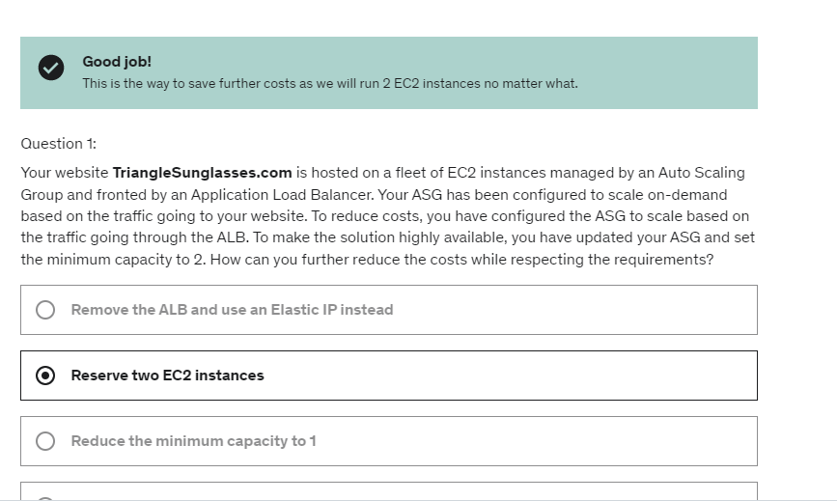

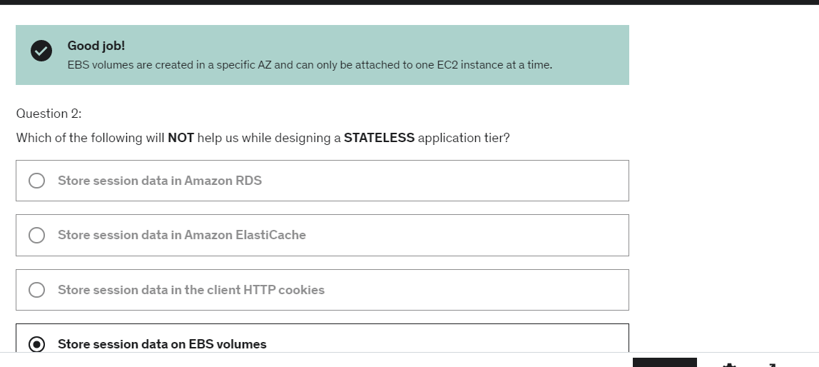

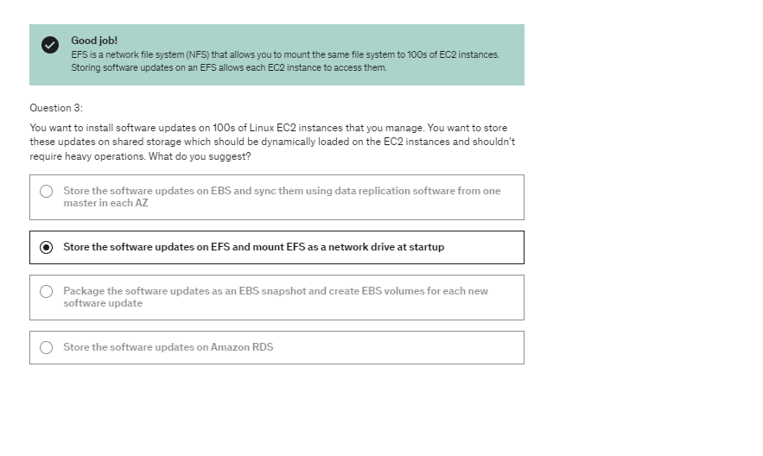

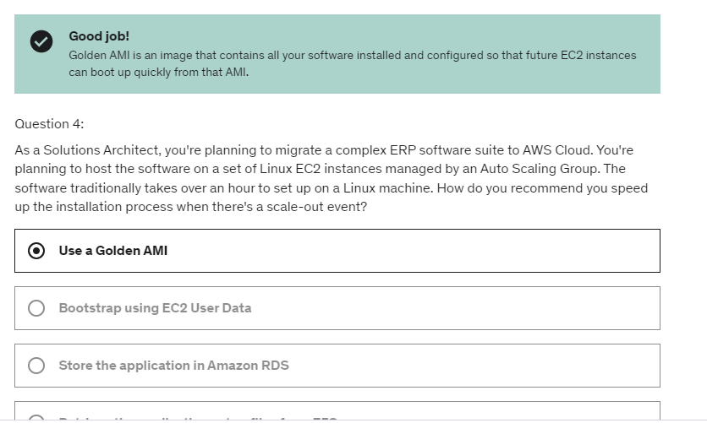

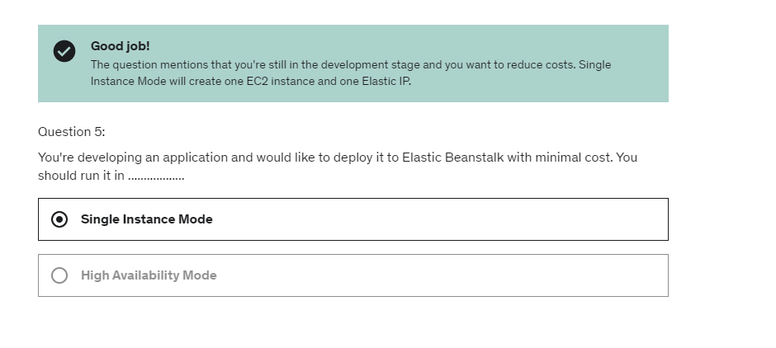

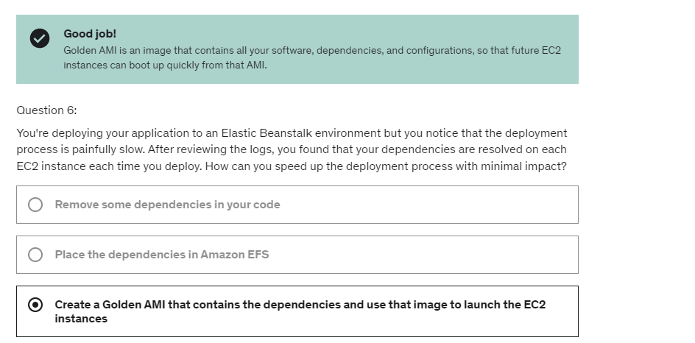

So what is an origin?

An origin is a scheme, so a protocol,

a host, a domain, and a port.

In English, what that means is that

for example, if you do https://www.example.com,

this is an origin where the scheme is HTTPS,

the host is www.example.com,

and the port is port 443.

Why?

Because as soon as you have HTTPS, it is port 443

as an implied port.

**Okay, so CORS means Cross-Origin Resource Sharing.**

**So that means we want to get resources**

**from a different origin**.

The Web Browser are having this security in place

**CORS basically saying as soon as you visit a website,**

**you can make request to other origins**

**only if the other origins allow you to make these request.**

**This is a browser-based security.**

So what is the same origin and what is a different origin?

Well for example, same origin is this,

where you go on example.com/app1

or example.com/app2.

This is the same origin, so we can make requests

from the web browser from the first URL to the second URL

because this is the same origin.

But if you visit, for example,

www.example.com and then you're asking your web browser

to make a request to other.example.com,

this is what's called a cross-origin request

and your web browser will block it

unless you have the correct CORS headers

and we'll see what these are in a second.

So now that we now what is the same origin

and what is a different origin,

we know that the request will not be fulfilled

unless the other origin allows for the request

using the CORS Headers.

And the CORS Headers is this one you will see

in the hands-on called **Access-Control-Allow-Origin**.

Okay, so that's just for the theory,

now let's go in the **diagram**

and it will make a lot more sense.

So here's our web browser

and it visits our first web server.

And because this is the first visit we do,

it's called the origin.

So for example, our web server is at https://www.example.com

Okay, great.

And there is a second web server called a cross-origin

because it has a different url,

which is https://www.other.com.

**So a web browser visits our first origin**

**and it's going to be asked from the files**

**that are uploaded from the origin**

**to make a request to the cross-origin.**

So what the web browser will do,

is that it will do what is called a **preflight request.**

And this preflight request is going to ask

the cross-origin if it is allowed to do a request on it.

So it's going to say,

**"Hey cross-origin, the website https://www.example.com**

**is sending me to you, can I make a request**

**onto your website?"**

and the origin is saying, "yes, here is what you can do."

so the Access-Control-Allow-Origin is saying

is this website allowed or not?

So yes, it is allowed because now we have

the same origin here, the green one,

as we had on the left hand side.

And the methods that are authorized

is GET, PUT, and DELETE.

So we can get a file, delete a file, or update the file.

Okay, so this is what the cross-origin

is allowing our web browser to do.

So this is the CORS method, and therefore,

because our web browser has been authorized to do so,

then it can issue, for example,

a GET to this url, and it will be allowed

because the CORS Headers received previously

allowed the web browser to make this request.

Okay, so this may be new to you,

this may be a lot, but you need to understand this

before we go into the next use case,

which is the S3 CORS.

**So if a client does a cross-origin request**

**on our S3 bucket enabled as a website,**

**then we need to enable the right CORS headers.**

It's a very popular exam question, okay?

So you need to understand

when we need to enable CORS headers,

and where we need to enable CORS headers.

So we'll see this in the hands-on as well.

So we can allow for a specific origin by specifying

the entire origin name,

or as star * for all origins.

So let's have a look.

The web browser for example, is getting HTML files

from our bucket.

And our bucket is enabled as a website.

But there is second bucket that is going to be

our cross-origin bucket,

also enabled as a website,

that contains some files that we want.

**So, we're going to do GET index.html**

**and the website will say, okay here is your index.html**

**and that file is going to say you need to perform**

**a GET for another file on the other origin.**

**And if the other bucket is configured**

**with the right CORS headers,**

**then web browser will be able to make the request,**

**if not it will not be able to make that request**

**and that is the whole purpose of CORS**.

**So as we can see here, the CORS headers have to be defined**

**on the cross-origin bucket,**

**not the first origin bucket, okay?**

So this is just for theory,

we're going to go into the hands-on

to see how we can explain these concepts

in a much more practical way.

Now, deleting a delete marker

or deleting a specific version ID

is called a permanent delete.

if someone goes and deletes a file,

and we have enabled versioning

as long as it deletes a specific object version,

we have prevented against unintended delete.

why will you use KMS over SSE S3?

Well, it gives you control over

who has access to what keys

and also gives you an audit trail.

encryption setting

is just for a specific file and its specific version ID,

encryption can be done either at object level or at bucket level using default encryption option.

Another one we have learned is (SSE-C).

And we can only do this through the CLI

because we have to pass in an encryption key

into AWS securely to encrypt that object.

So if your user through IAM is allowed to access

your S3 bucket but your bucket policy is explicitly denying

your user to access it,

then you will not be able to access it, okay?

But if you visit, for example,

www.example.com and then you're asking your web browser

to make a request to other.example.com,

this is what's called a cross-origin request

and your web browser will block it

unless you have the correct CORS headers

And the CORS Headers is this one you will see

in the hands-on called Access-Control-Allow-Origin.

Just remember that if website number one

needs to access a resource on website number two,

through a web browser, then website number two

needs to have a CORS setting, okay,

to allow the request to be done.

Otherwise the web browser is going to block it.

And these headers are what is allowing the browser

to load the second URL from the second bucket.

To make s3 as website- remove block public access setting, enable static website option and under permissions add bucket policy to allow getobject to all

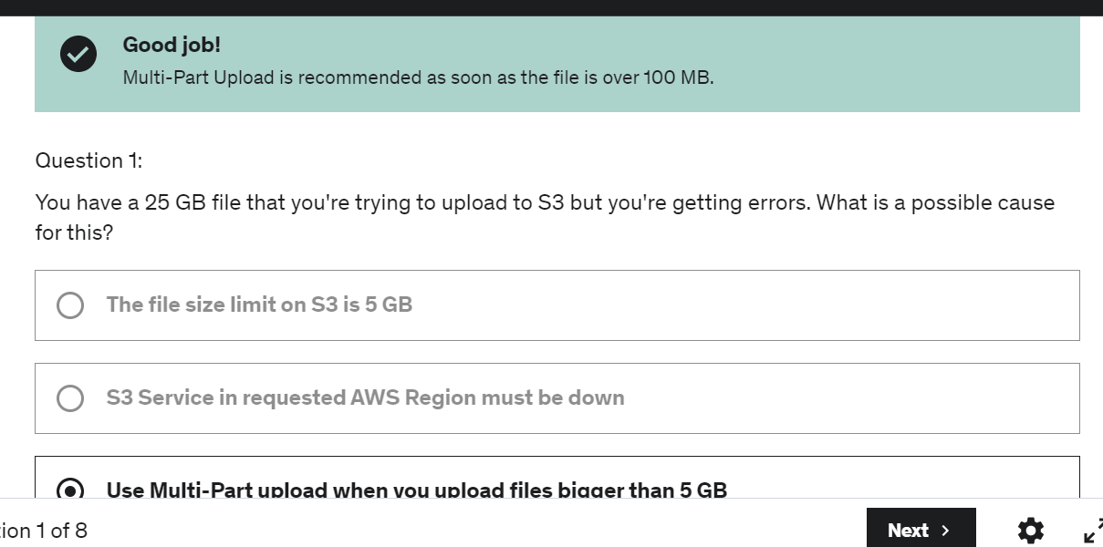

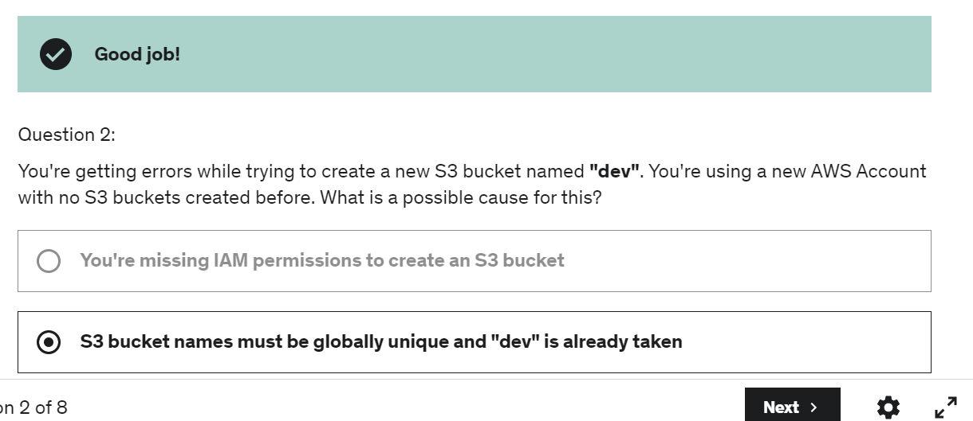

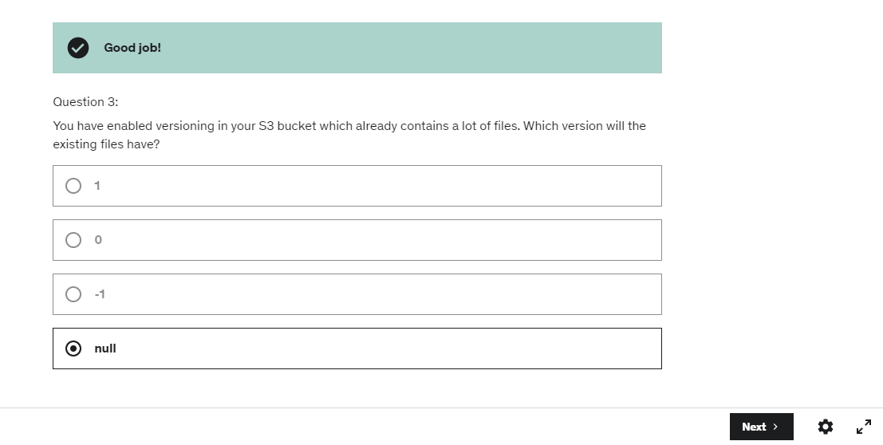

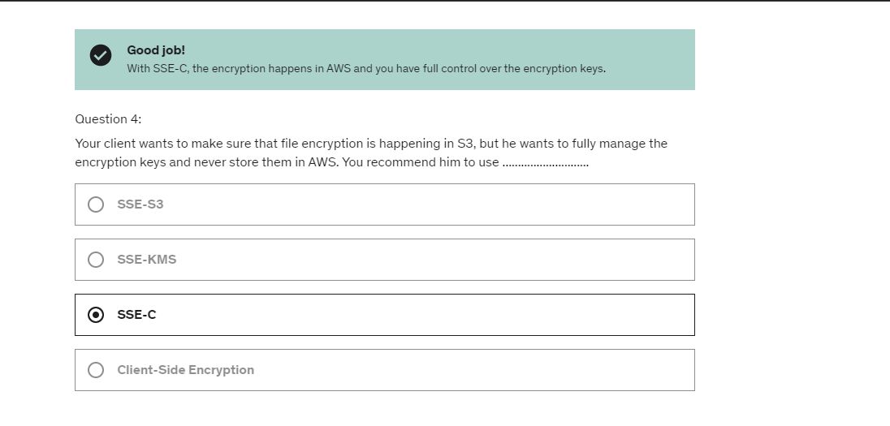

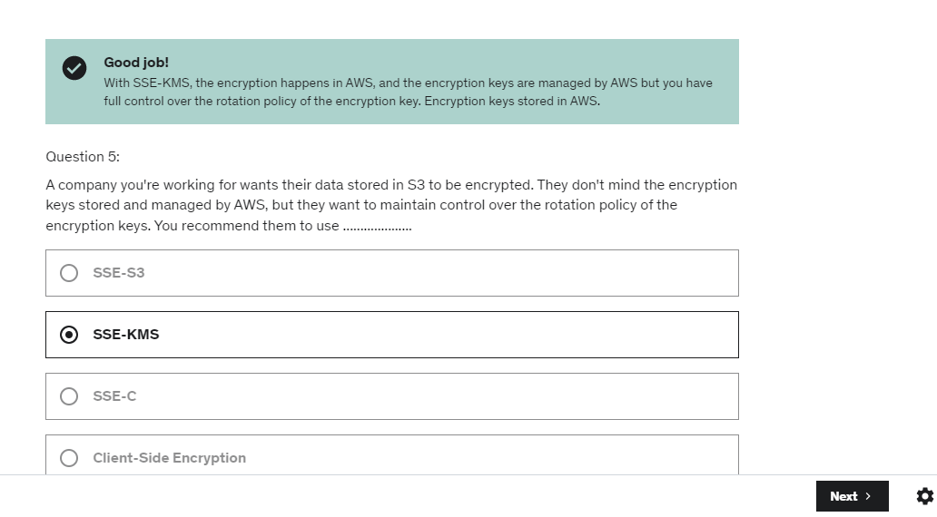

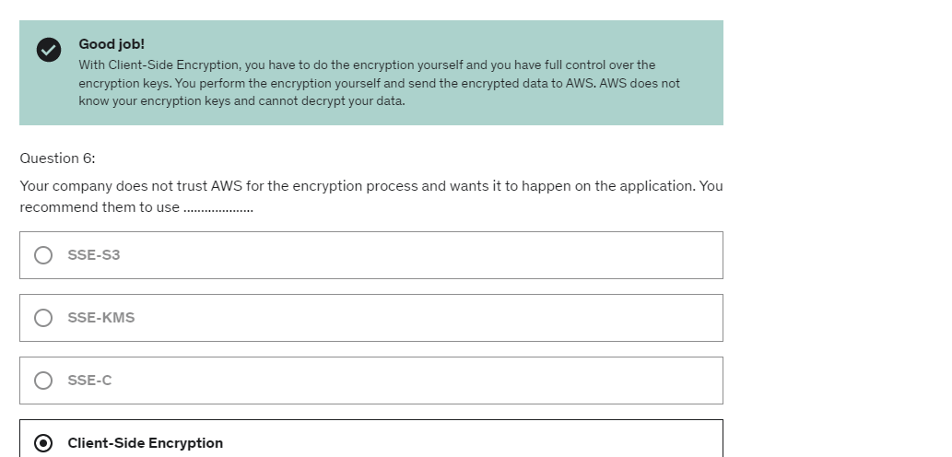

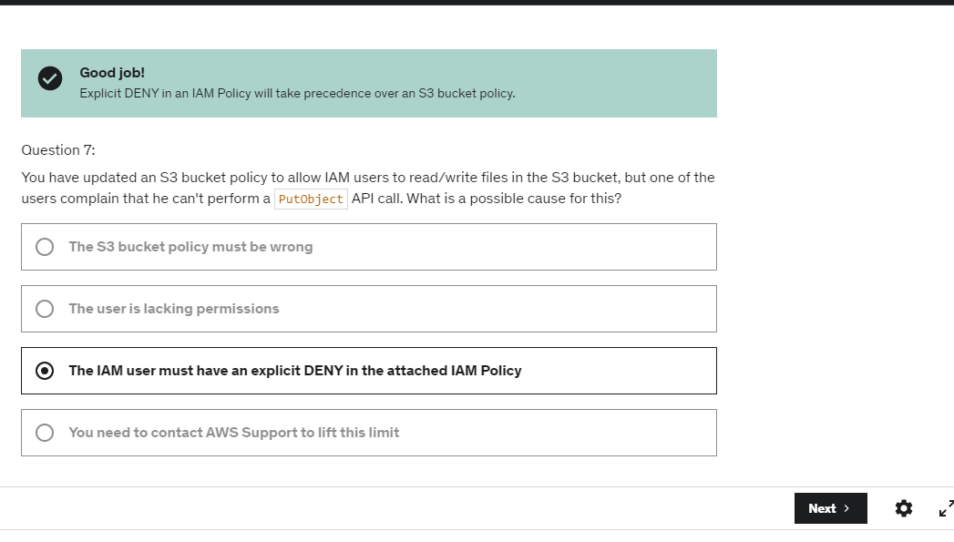

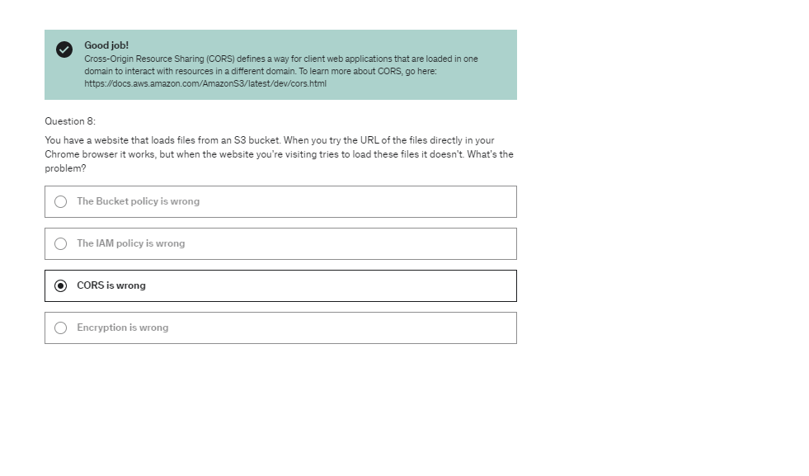

so now I think Amazon

wants you to most likely use the visual editor

we've had in the IAM console.

But just so you know, there is also

this policy generator tool right here.

AWS policy simulator.-is basically a tool online to test your policies.

EC2 meta-data information:

what you noticed here is that

we haven't been authorized through an IM role

to get this information, This comes for free.

Any EC2 instance without an IM role can request all

this information

so the idea is that your EC2 instance

gets temporary credentials through the IAM role that

it got attached to it.

So this is basically how the IAM roles work

So we've been using the Python SDK when we are using the CLI

because the CLI is actually written in Python

and it uses the Boto3 SDK.

so we use the SDK when we issue API calls

against AWS services, for example DynamoDB or Amazon S3.

So good to know, if you don't specify a region

and you don't configure a default region,

then the us-east-1 will be chosen by default

by your SDK to issue API calls

and that is something the exam can test you on as well

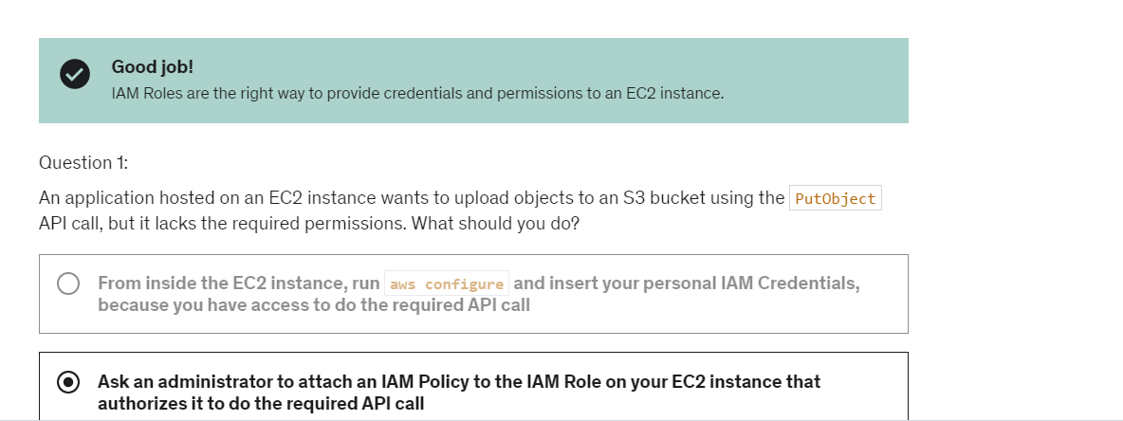

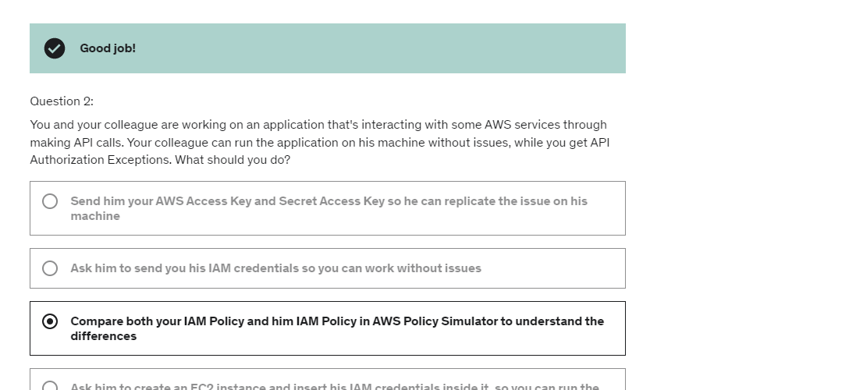

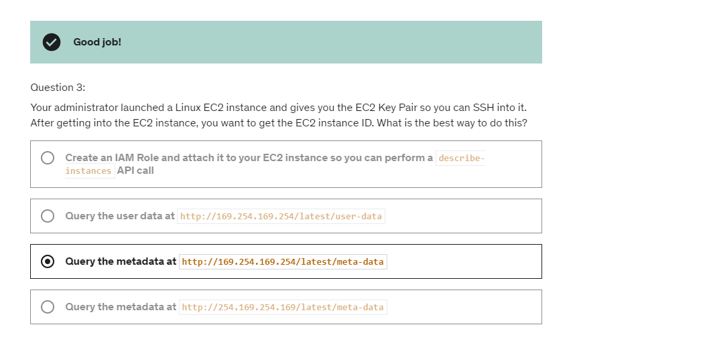

S3 Intelligent-Tiering automatically stores objects in three access tiers: a Frequent Access tier, an Infrequent Access tier, and a Archive Instant Access tier. Objects that are uploaded or transitioned to S3 Intelligent-Tiering are automatically stored in the Frequent Access tier. S3 Intelligent-Tiering works by monitoring access patterns and then moving the objects that have not been accessed in 30 consecutive days to the Infrequent Access tier. With S3 Intelligent-Tiering, any existing objects that have not been accessed for 90 consecutive days will automatically move to the Archive Instant Access tier. You can configure S3 Intelligent-Tiering as your default storage class for newly created data, or you can choose to activate one or both of the archive access tiers using the API with [PutBucketIntelligentTieringConfiguration](https://docs.aws.amazon.com/AmazonS3/latest/API/API_PutBucketIntelligentTieringConfiguration.html), the CLI, or the Amazon S3 console. After you activate one or both of the archive access tiers, S3 Intelligent-Tiering automatically moves objects that haven’t been accessed for 90 consecutive days to the Archive Access tier, and after 180 consecutive days of no access, to the Deep Archive Access tier.

Bucket policy vs default encryption of s3 objects:

So for example, if you want to force an encryption mechanism

of SSE S3, for example,

you would need to use a bucket policy.

But if you requirement's is just to make sure

that every single object in your bucket

is encrypted for this, you could use default encryption.

remember the default encryption

is not applying the same encryption to all files.

It is just making sure that if you upload the object

in an unencrypted way,

then you will automatically be encrypted using the default

encryption mechanism

when logging is enabled for source bucket, bucket policy of target(logging) bucket is updated

The bucket policy was updated

to allow the logging service of Amazon S3

to put objects into these buckets.

So durability represents how many times an object

is going to be lost by Amazon S three.

how we can automate moving these objects

between the different storage classes. => lifecylcle rules(for buckets)

So this is called Transfer Acceleration

because we minimized the amount

of public internet that we go through.

And we maximized the amount of

private AWS network that we go through.

So the use case for event notification would be for example,

to automatically react to certain events

happening in Amazon S3.

For example, you want to generate thumbnails

of all the images upload to Amazon S3.

the whole power, here, of Athena

is that we're able to literally query data on Amazon S3,

do some complex queries directly,

without setting up any servers,

without transforming our data,

just by setting up the right data formats,

and specifying what the data is,

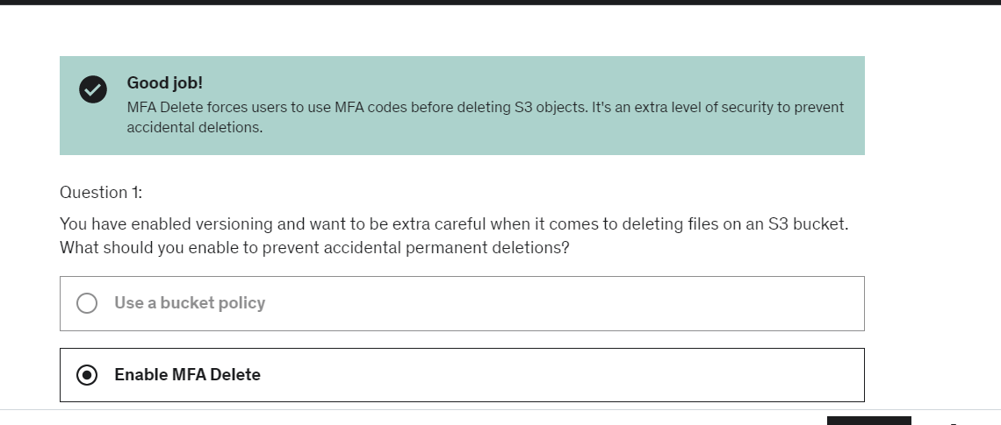

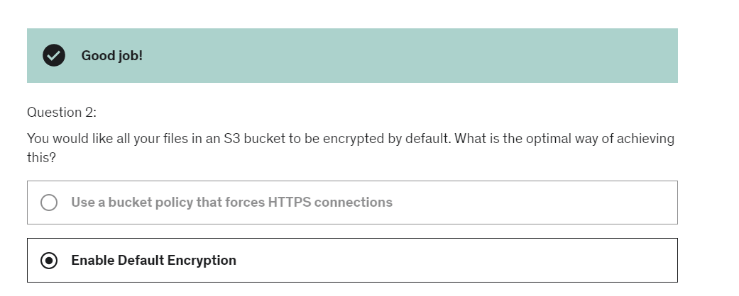

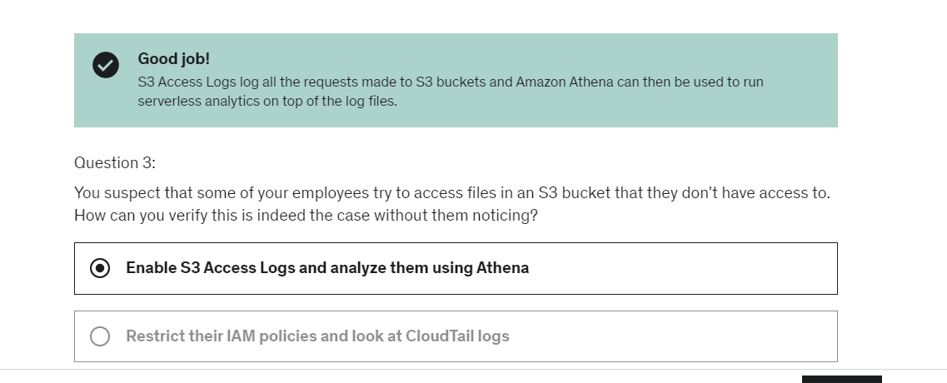

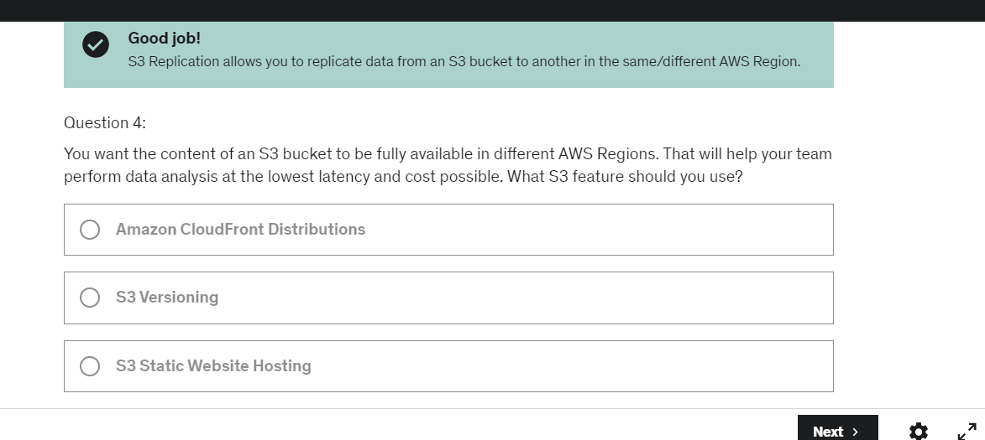

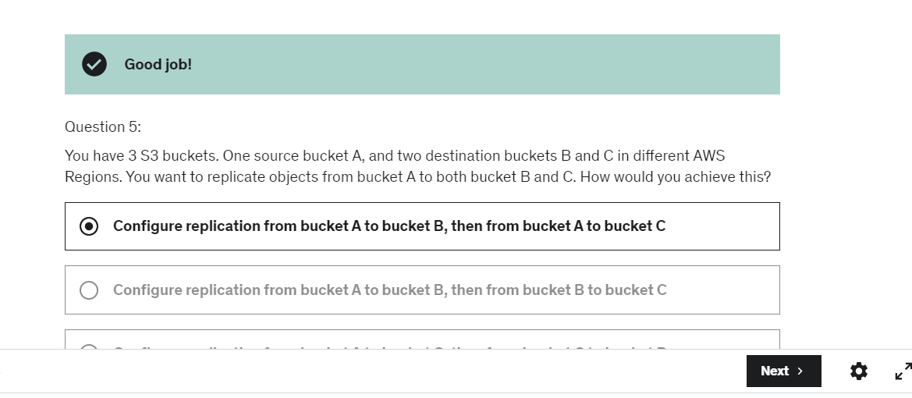

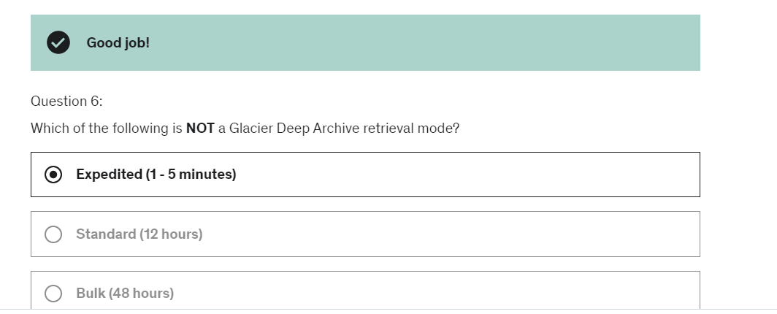

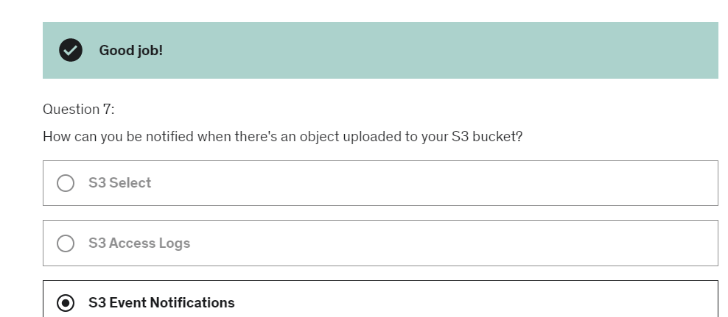

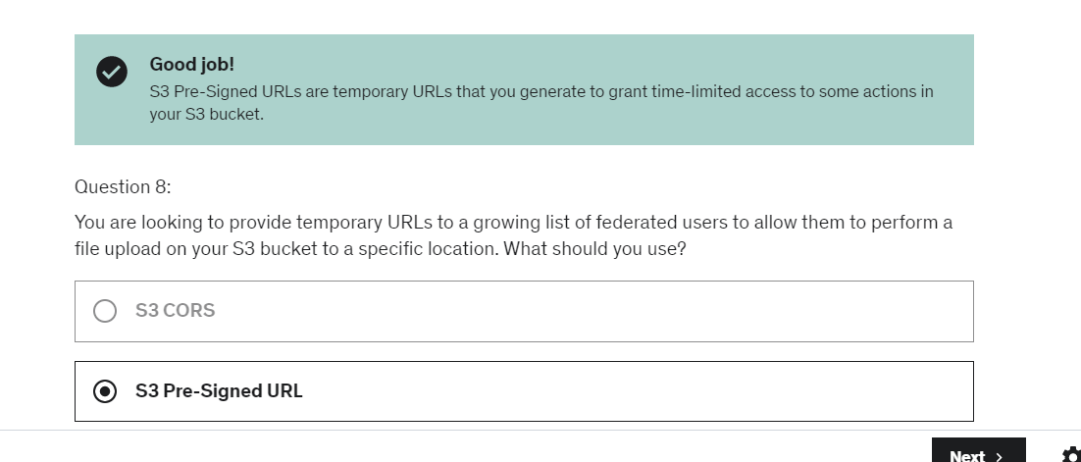

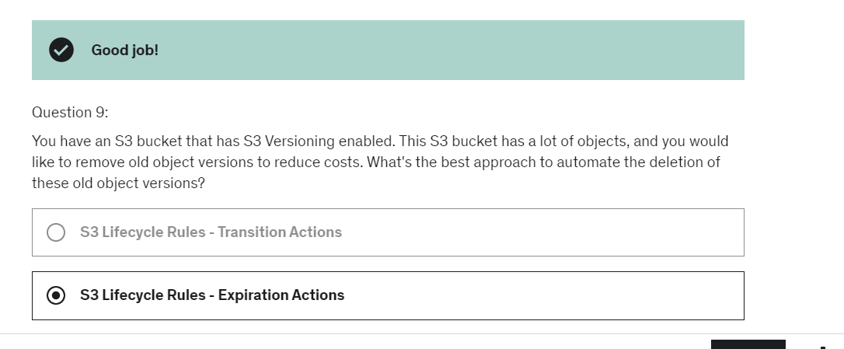

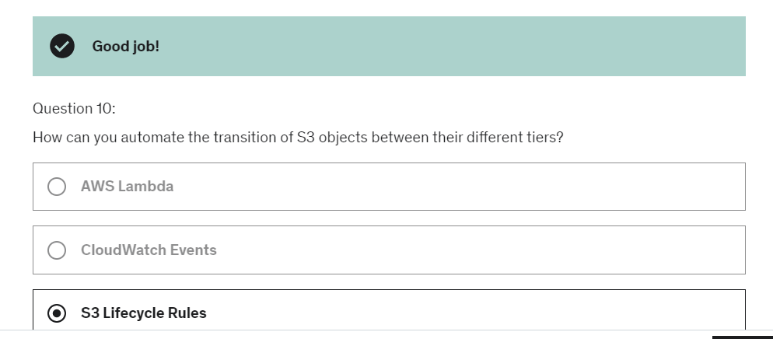

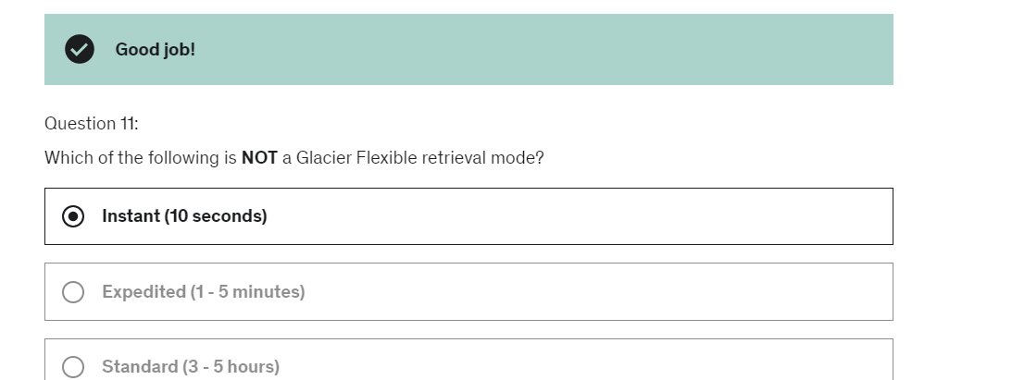

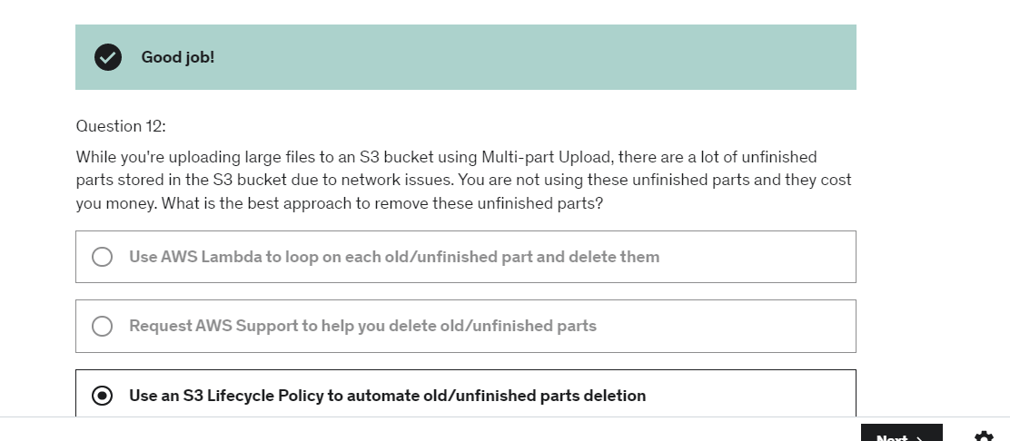

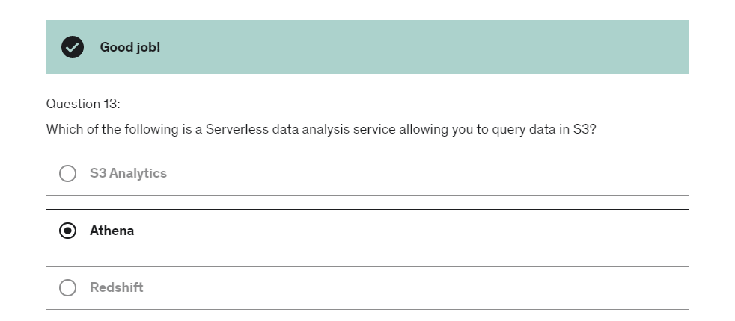

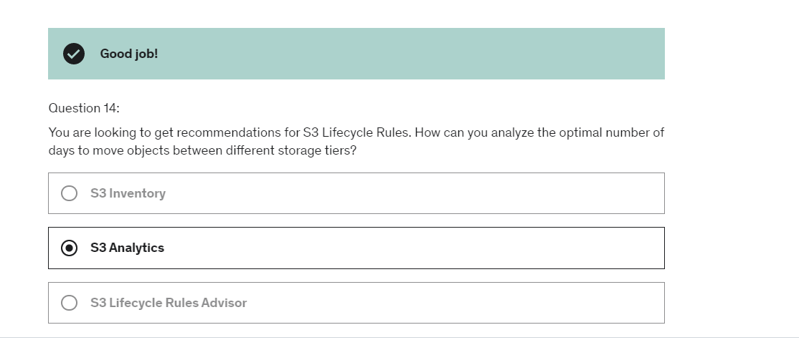

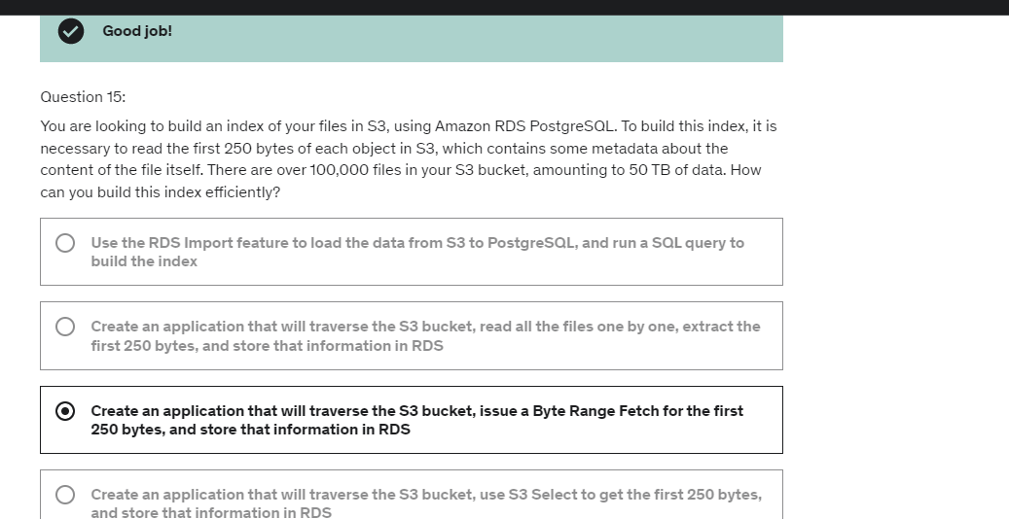

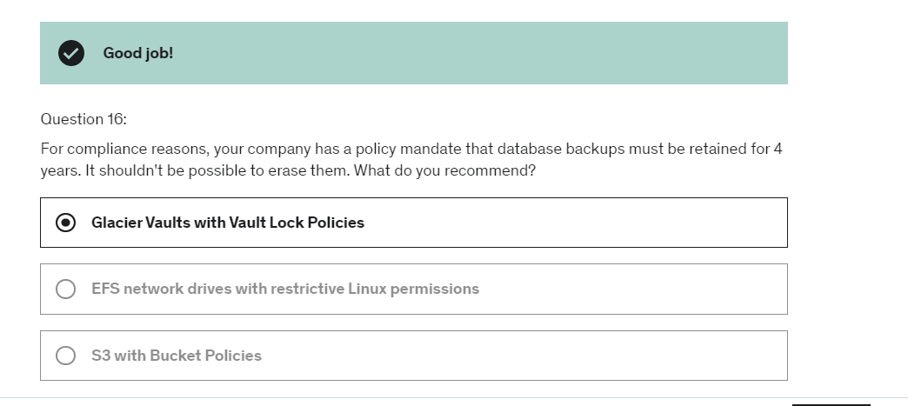

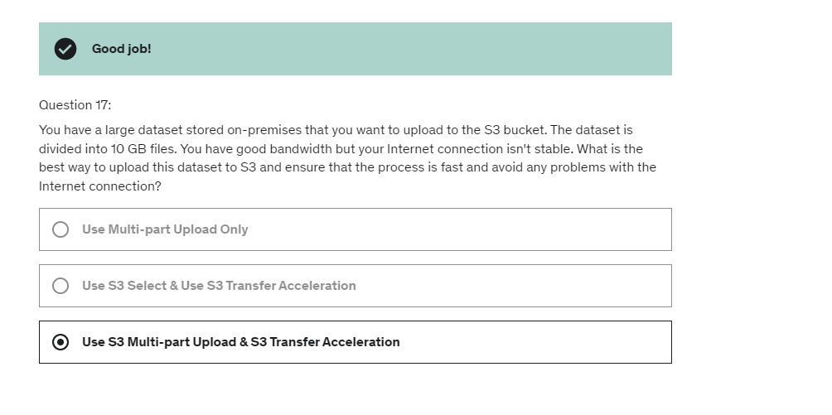

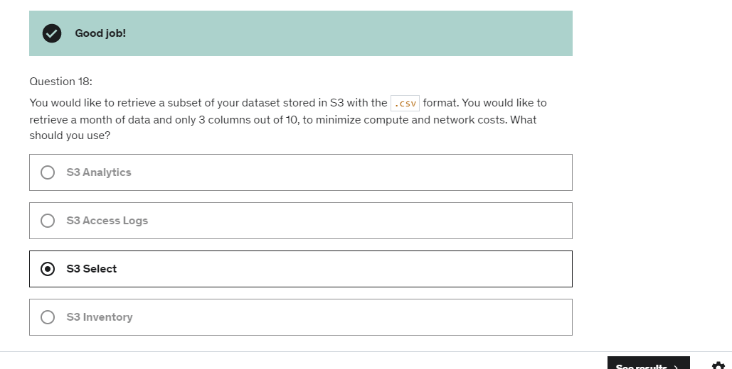

the idea is that anytime

a sensitive information is sent by the user

the edge location is going to encrypt it

and they will be only be able to be decrypted

if someone has access to a private key.

And therefore,

this will be using asymmetric encryption.

And is going to happen is that instead of sending it

through the public internet in America,

it's going to come to the closest edge location.

And from edge location,

it's going to go all the way straight to our ALB

through the internal AWS network.

Same for Australia, so it goes to closest edge location

near to Australia

and then it goes over the private AWS network

to get to the ALB and same for Europe.

So the idea with this is that,

we're going to use an Anycast IP

and there's actually going to be two of those

that are going to be created for your application

and they're global.

And the Anycast IP will send the traffic directly

to the closest edge location of your users.

And this is the power of Anycast IP.

So the edge location will then send the traffic

to you application, (mumbles)

For example,

through the private AWS network which is much more stable,

has less latency and so on.

So the Global Accelerator is absolutely unique

because it really allows to give two static IP addresses

all around the globe for the users

for whatever application you may have.

And right now I'm showing one ALB in one region

but it could be global as well

it could be multiple ALBs in multiple regions.

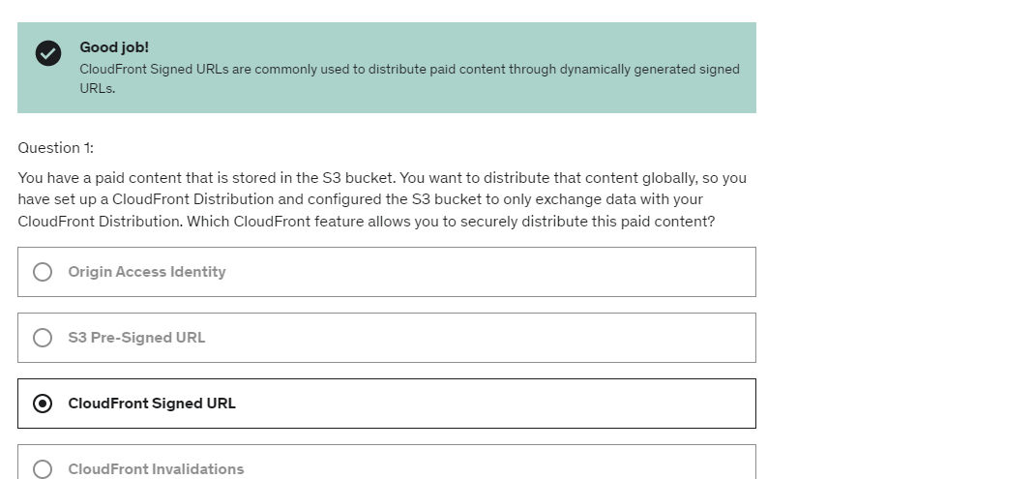

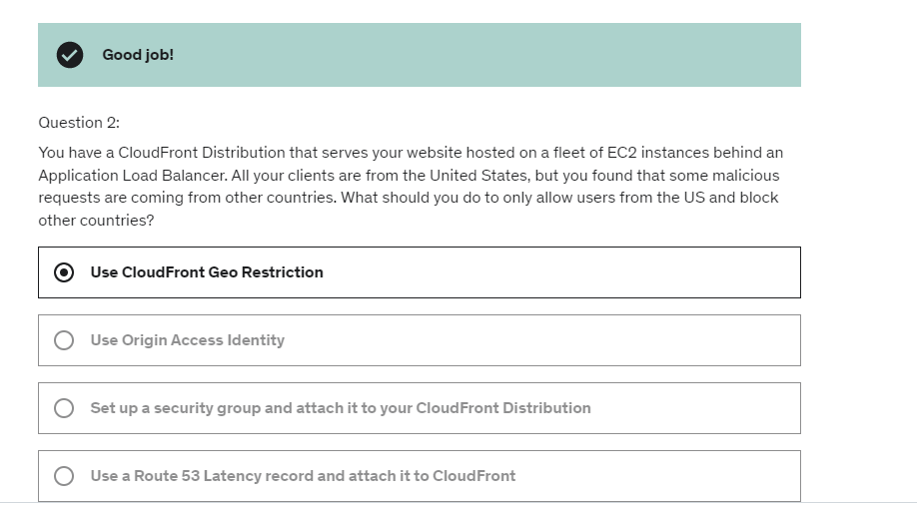

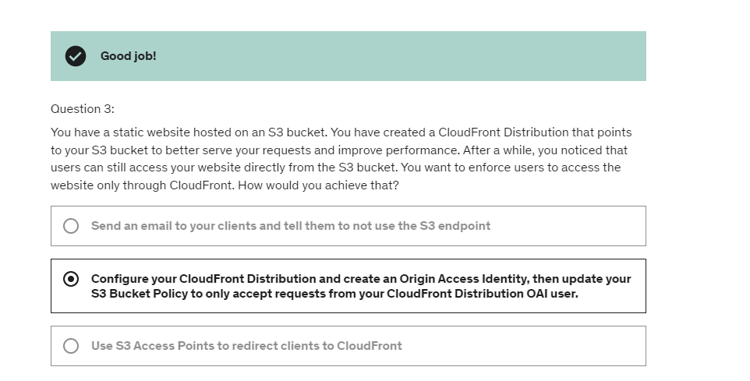

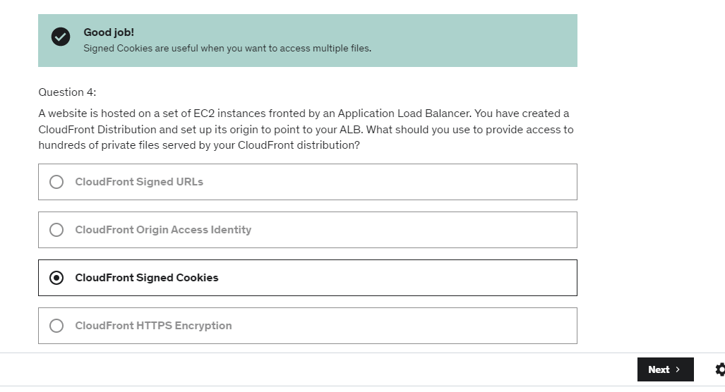

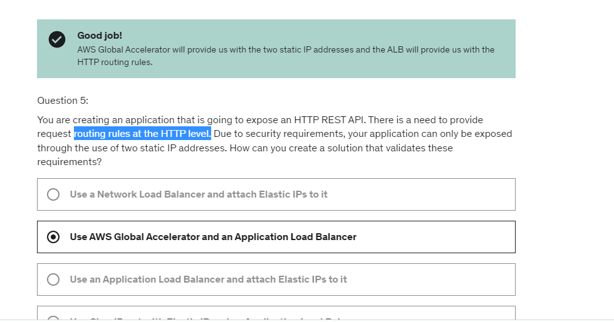

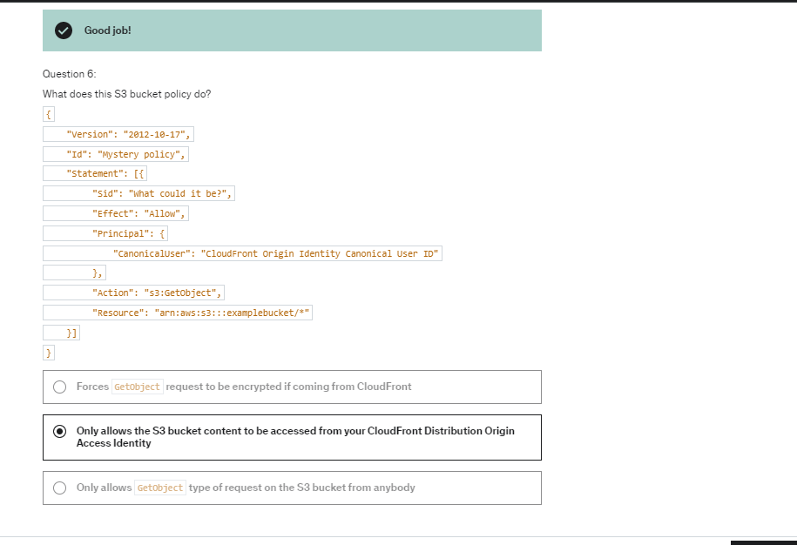

Snowball family devices

it is a way to transfer data to AWS,

but through the physical, not the network route.

the interface within the Snowball Edge

is going to provide a block storage

or Amazon S3-compatible object storage.

the use case for a Snowball Edge

for data transfers so far

is to do a large data cloud migration

to decommission a data center,

or maybe to do disaster recovery

by backing up your data into AWS.

Edge computing using snowball device:

So really you start processing the data very, very close

to where it's being created,

and then you ship it back to AWS.

By creating a snowjob you grant permissions to use your s3 bucket and SNS on your behalf.

For example Lustre,

or Windows File Server or NetApp ONTAP.

All these things are third party file systems

that you can launch directly on AWS

important to understand is Windows File Server

for multi-AZ and Lustre

for persistence of versus crutch file system.

File Gateway:

So this gives you a lot more storage for your file system.

And on top of it, the most commonly used files

are going to be cached onto the File Gateway

which is going to be helpful to have low-latency access

to some files.

So this really gives you a way to expand the size

of your NFS on-premises by leveraging Amazon S3

in the backend.

Volume Gateway:

the goal of the Volume Gateway

really is to back up your volumes

of your on-premises servers.

Amazon transfer family:

The usage of this is obviously to have an FTP interface

into Amazon S3 or EFS.

S3 has some deep integration with so many database services.

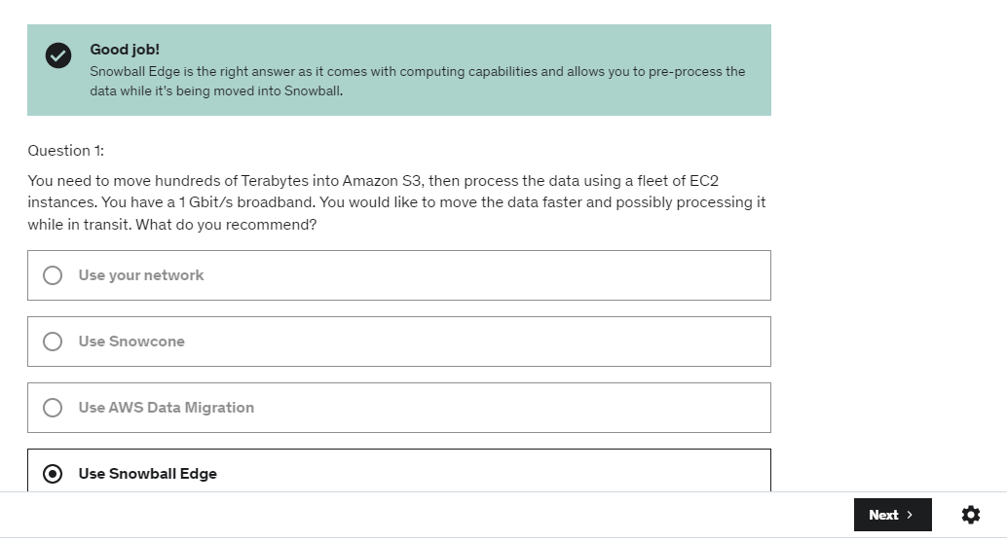

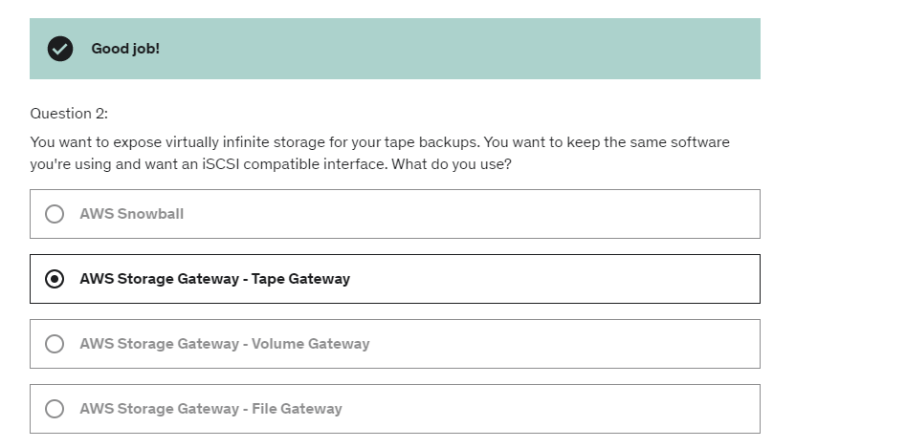

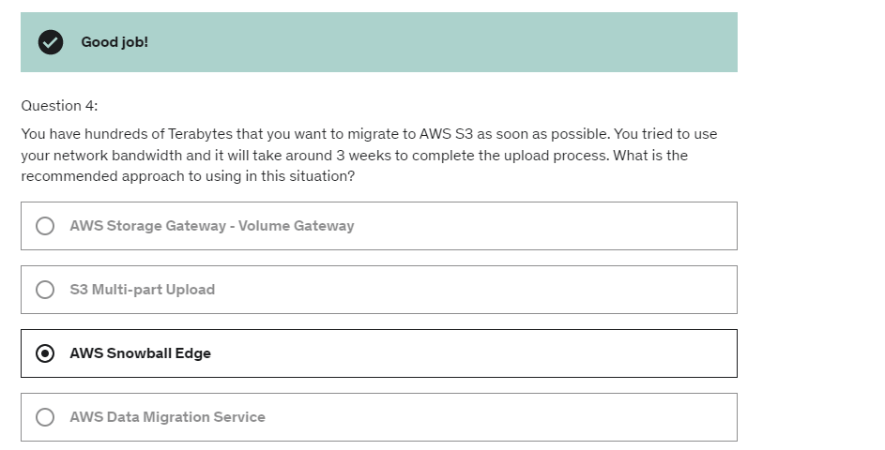

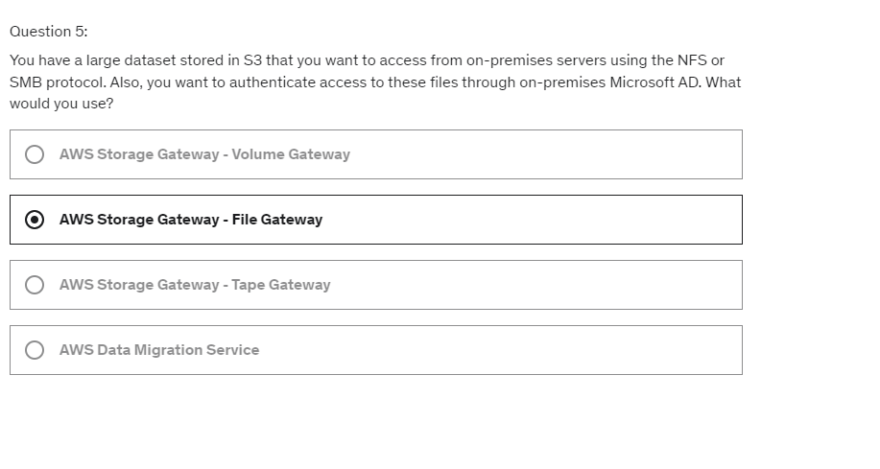

a queuing service is here to be a buffer

to decouple between your producers and your consumers.

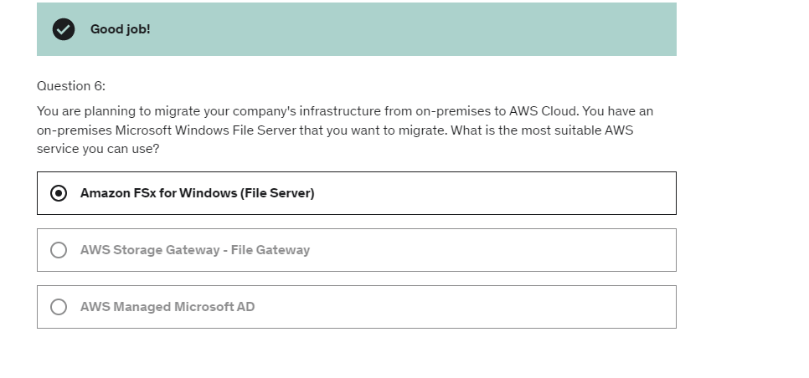

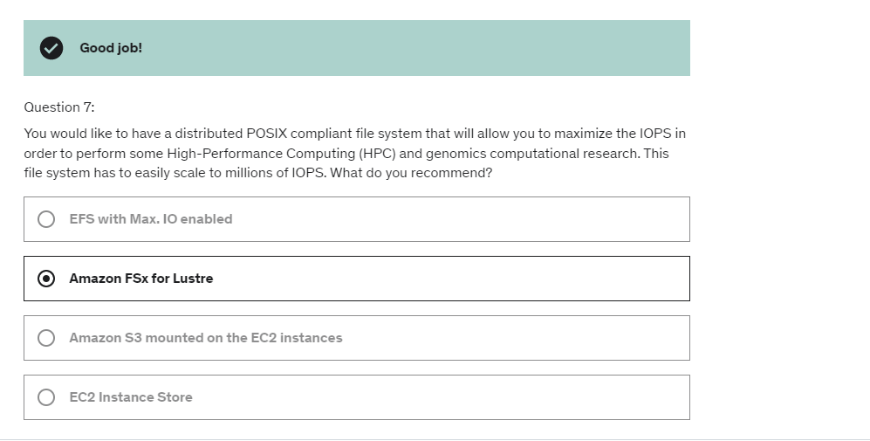

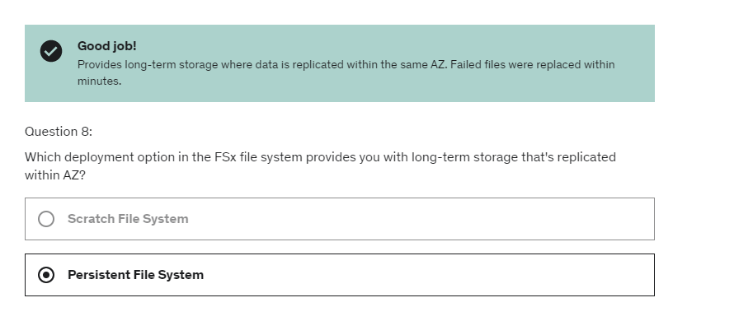

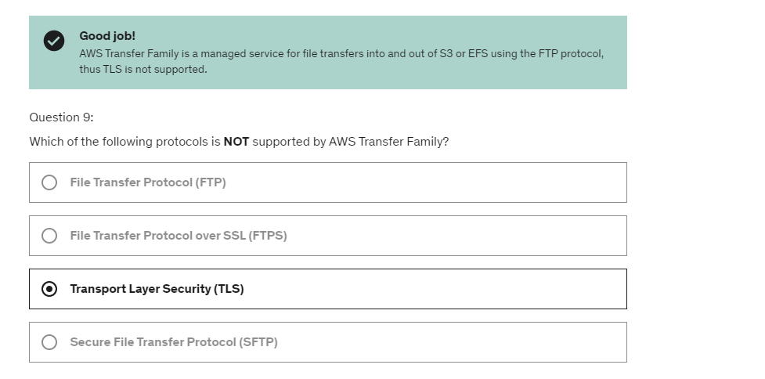

we can see that the message has been received twice

because we didn't process it in enough time.

So after 30 seconds, the lowest,

the message went back into the queue,

and we received it again.

the idea is that the visibility timeout

should be set to something reasonable for your application

and your consumer should be programmed

that if they know they need a bit more time,

then they should call the ChangeMessageVisibility API

to get more time and increase the timeout

of that visibility window.

if a consumer needs more time to process a message,

you should just call the ChangeMessageVisibility API

to edit the visibility of that one message

and increase the value

so that another consumer will not see that message

and the first consumer will get enough time

to process that message accordingly.

Either you configure it at the queue level

such as any consumer doing a poll from the consumer

will have long polling enabled

or the consumer itself can choose to do long polling

by specifying the wait timeout seconds.

So anytime at the exam you see

a way to optimize the number of API calls

made to an SQS queue and decrease of latency,

think about long polling.

 the only thing that can subscribe

to a FIFO SNS topic is an SQS FIFO queue.

Kinesis- So data that's created right away

and sent into our applications for analysis or processing.

The more shards you have in a Kinesis Data Stream,

the more throughputs is going to be allowed

to go through that stream,

And in terms of consumption,

we can have multiple consumers room

for the Kinesis Data Streams.

So we have sort of, again, a found out pattern

it's called pub-sub pattern

happening in Kinesis Data Streams, okay.

And so we have two different types

of consumption mechanism.

If you use the shared consumption mechanism,

you get two megabytes per second

per shard across all the consumer applications you have.

Or if you're using the enhanced consumer,

you get two megabytes per second, per shard per consumer.

So obviously the second mode to read is more expensive

So for this, you're going to have Kinesis Data Analytics

reading from sources, and these sources

can be Kinesis Data Streams or Kinesis Data Firehose.

And then you will write your own SQL statement

to process the data in real time.

And then Kinesis Data Analytics can send the result

of that query in real time to destinations,

the first one being Kinesis Data Streams,

and the second one being Kinesis Data Firehose.

So from Firehose, as we know, we can send it

to Amazon S3, to Redshift,

or to other Firehose destinations.

And if you want to send that data instead

to Kinesis Data Streams,

it's for you to write your own application

to use, for example Lambda,

or your own application running on EC2

to process the data in real time.

Amazon opensearch service and amazon elastic search are same.

Demo

CLI-> Kinesis data stream-> Kinesis Data Firehose-> S3 bucket

Kinesis data firehose is also called kinesis delivery stream.

The idea is though that as soon

as we have a stable partition key,

then each truck will be sending this data to the same shard

and therefore we will have the data in order

for each truck at the shard level.

based on the use case, sometimes is going

to be better to use SQS FIFO.

If you want to have a dynamic number of consumers

based on the number of group IDs,

and sometimes it could be better to use Kinesis Data Stream

if you have say 10,000 trucks and you need

to send it lot of data,

and also **have data ordering per shard**

in your Kinesis Data Stream.

And so when you migrate an application

from on-premises to the cloud,

instead of re-engineering everything

for the applications you use SQS and SNS,

sometimes you just want to move your message queue

into the cloud.

And for that, we can use Amazon MQ.

So Amazon MQ is to get to manage Apache ActiveMQ

 if the exam is asking you

to migrate an application from on-premises to the cloud

without rearchitecting it,

and that application is using some standard protocols

such as MQTT or MQP,

then Amazon MQ is going to be the answer.

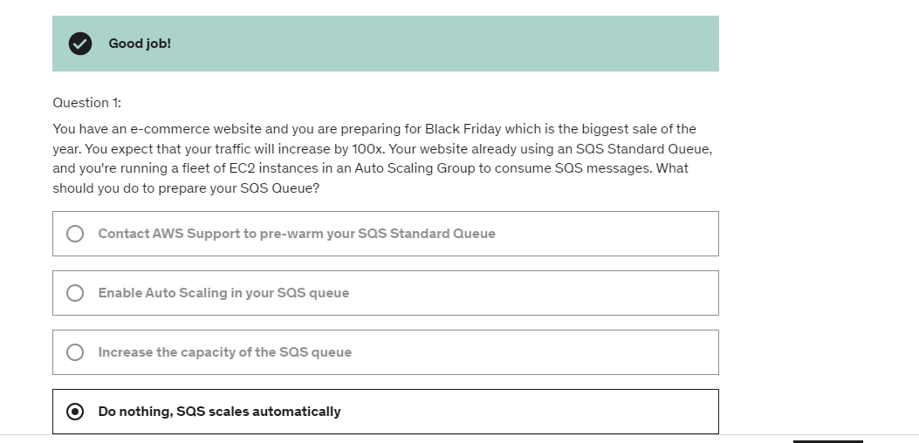

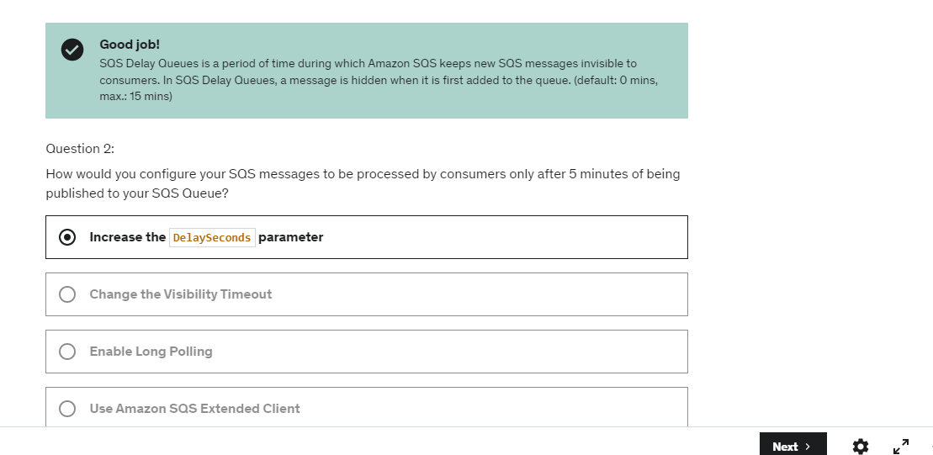

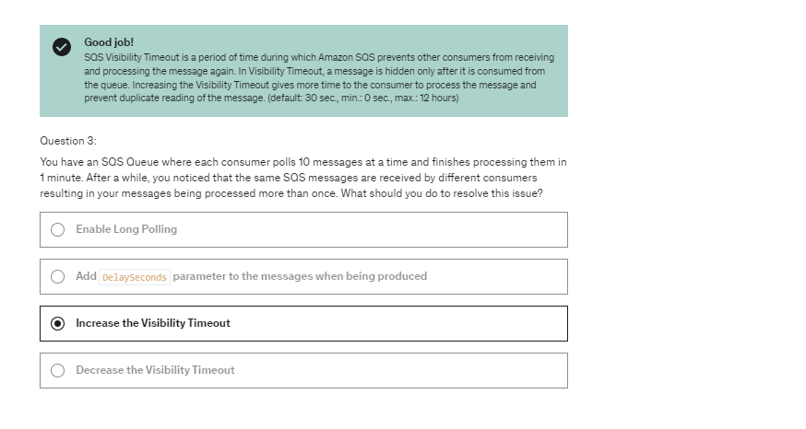

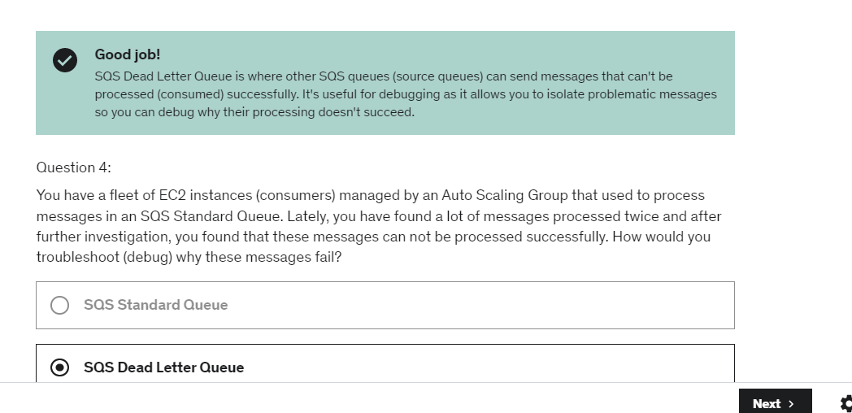

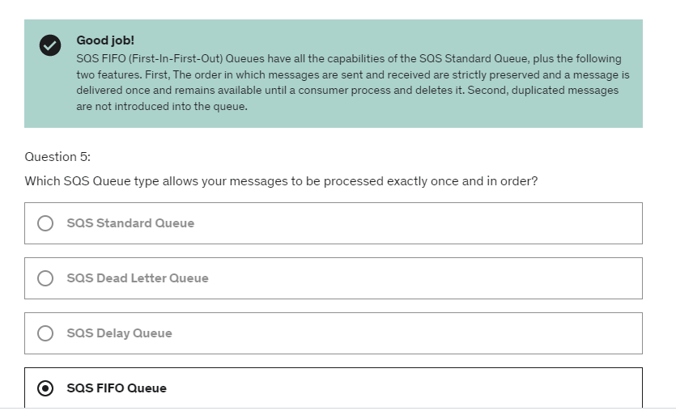

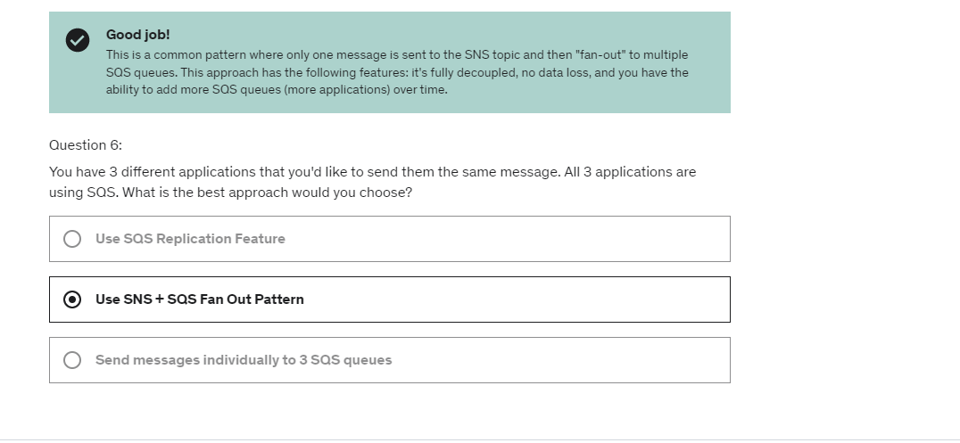

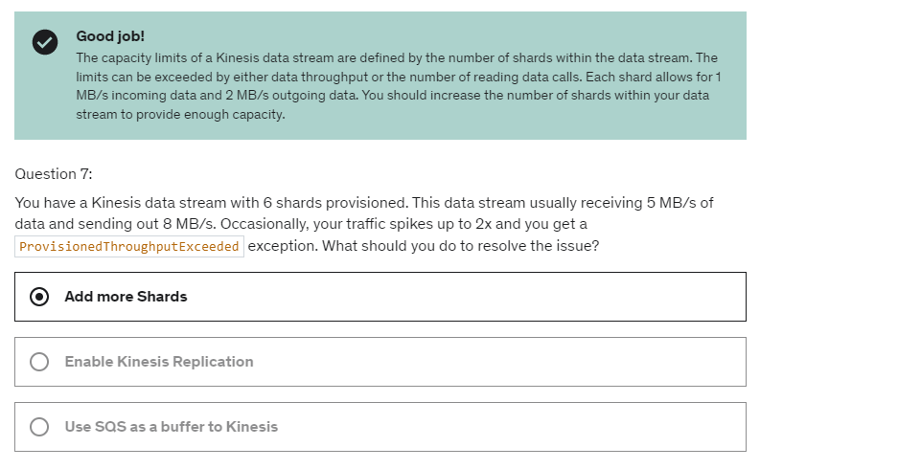

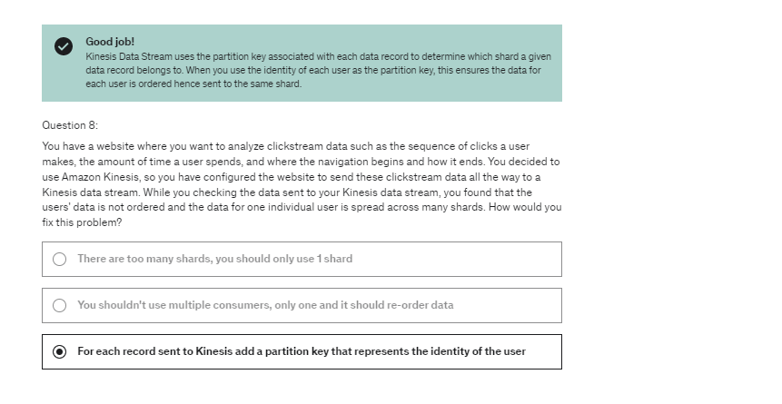

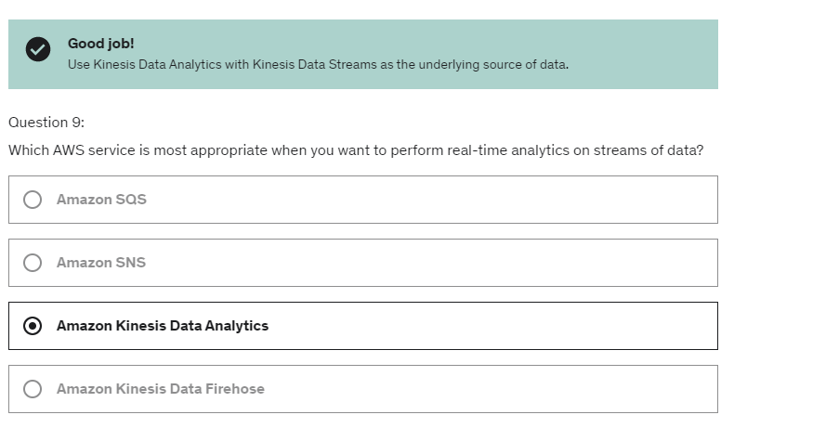

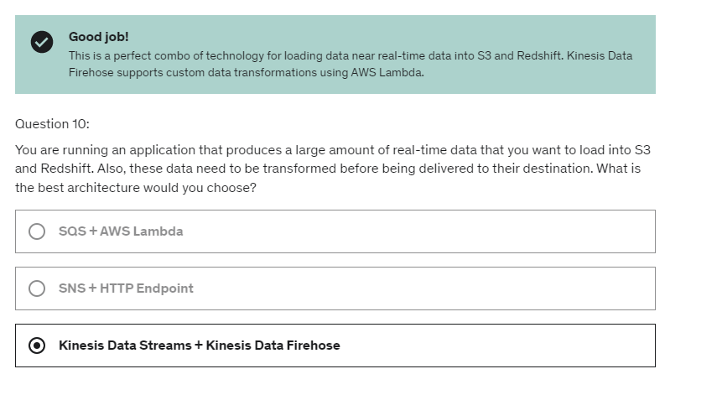

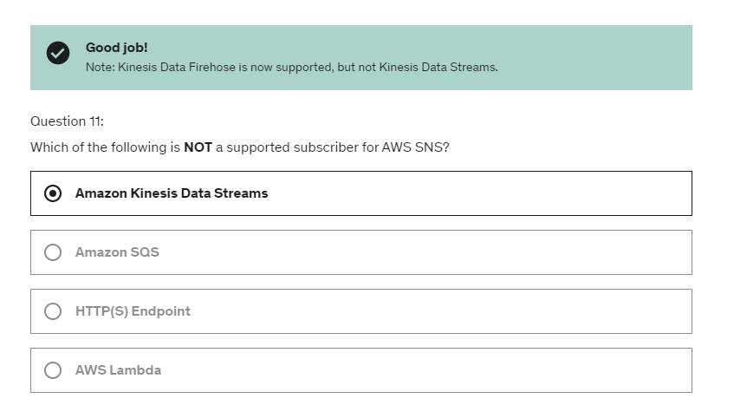

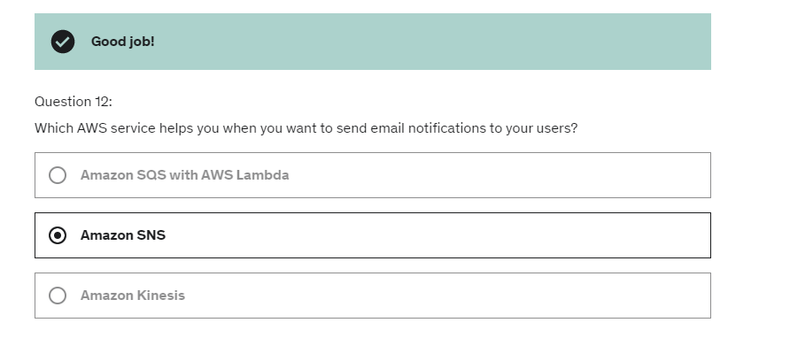

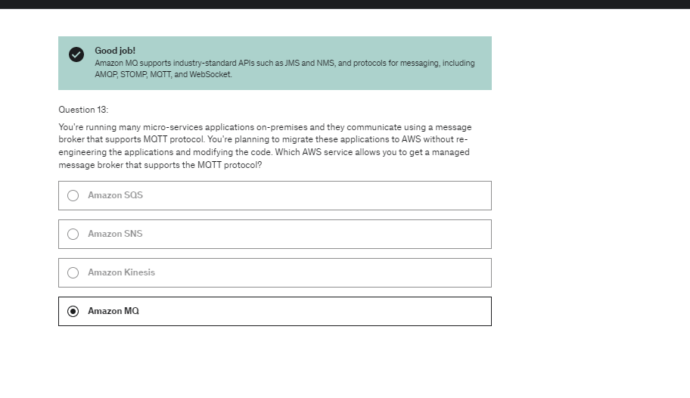

Docker containers are placed on Amazon

EC2 instances that we provision in advance

in the Fargate type,

if we have an ECS Cluster

we just create task definition to define our ECS tasks.

And then AWS will run these ECS tasks for us

based on how many CPU and RAM we need.

when we want to run a new Docker container,

simple as that, it's going to be run,

without us knowing where it's run

and without an EC2 Instance to be created

in the backend in our accounts for it to work.

The first one is Fargate,

that means that we can launch Fargate task

onto our ECS cluster.

The second one is Fargate Spot,

that means that we can launch Fargate task in spot mode,

so like spot instances for EC2.

And the last one is a ASG Provider,

and this one means that we can launch EC2 instances

in this cluster directly through this ASG.

That means that when we create an ECS task,

it can either be launched on a Fargate,

or Fargate Spot capacity provider,

or it can be launched on the container instances

that I will have launched as part of this ASG.

So next what I want to do is

to actually run this task definition in a service

behind a load balancer

2 sec groups

1 for ALB(allow traffic from anywhere) and second for ECS task(allow traffic from ALB)

 now that I've created two security groups,

we can go ahead and create our first service.

Remember, that scaling your service, your ECS Service,

at the task level is not equal to scaling your cluster

of EC2 instances if you are in the EC2 launch type.

And with this one, the Capacity Provider is very smart.

And as soon as you lack capacity to launch new tasks,

it's going to automatically scale your ASG.

So the Capacity Provider is paired

with a Auto Scaling Group.

And then when you're missing RAM or CPU,

there you go, EC2 instances are created.

And so the second option is the smarter way of doing things.

So if you have to choose between Auto Scaling Group Scaling

and ECS Cluster Capacity Provider,

please use ECS Cluster Capacity Provider

for your EC2 launch type.

So we have a Service A with two tasks.

And we have CPU Usage.

And it's going to be auto scaled

by the AWS Application Auto Scaling.

But let's assume we have more users,

and therefore your CPU usage goes really up,

then your CloudWatch Metric,

which monitors the CPU Usage at the ECS service level again,

is going to trigger a CloudWatch Alarm,

which will trigger a scaling activity

in your Auto Scaling for your ECS service.

The desired capacity will increase

for your ECS Service, and a new task will be created.

And optionally, if this service is running

on the EC2 launch type,

then the ECS Capacity Providers

can help you scale your ECS cluster

backed by EC2 instances.

Now ECR is fully integrated

with Amazon ECS,

which is great.

And your images

are behind the scenes stored

by Amazon S3.

then your

containers are going

to be started

on your EC2 instance

after they are pulled

by your EC2 instance.

And this is how ECS

and ECR ECR work together.

ECS is definitely not open source,

whereas Kubernetes is open source

and used by many different cloud providers

which gives you some sort of standardization.

So the use case for using EKS is that your company

is already using Kubernetes on-premises

or already using Kubernetes in another cloud

or they just want to use the Kubernetes API

and they want to use AWS to manage their Kubernetes cluster,

then it would use Amazon EKS.

so you would create EKS worker nodes.

They would be EC2 instances for example.

And each of these nodes will be running EKS Pods.

So they're very similar to ECS tasks

but from a naming perspective,

anytime you see pods, it relates to Amazon Kubernetes.

if we wanted to expose EKS service on a Kubernetes service,

we could set up a private load balancer

or a public load balancer to talk to the web.

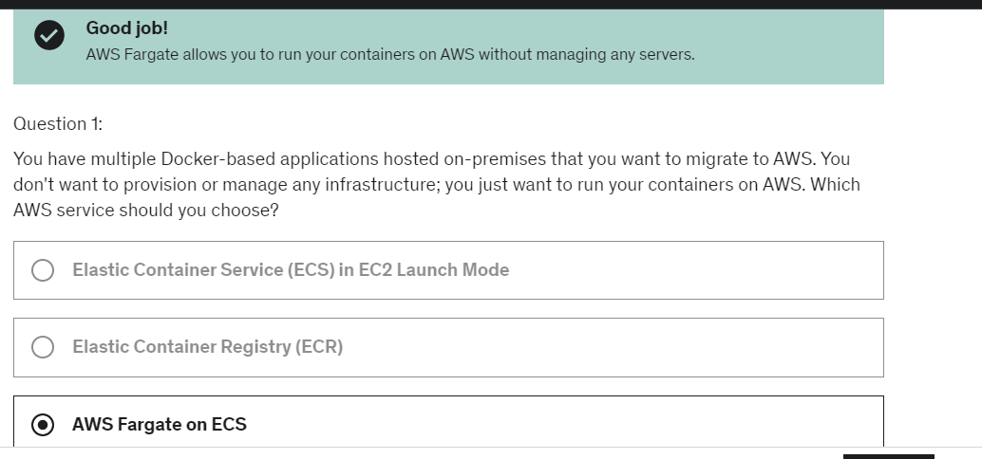

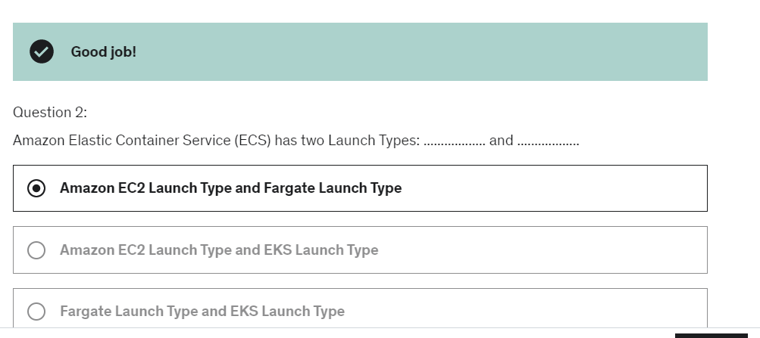

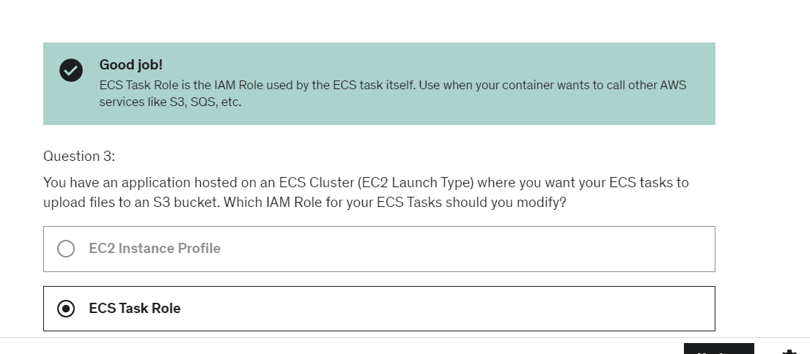

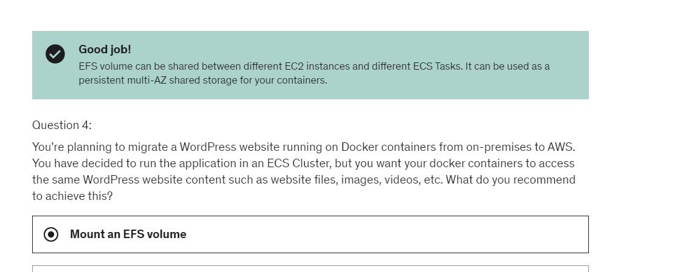

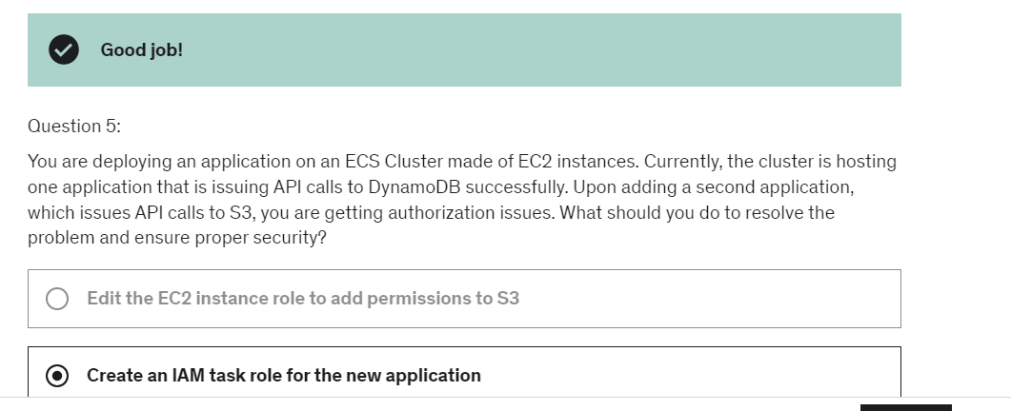

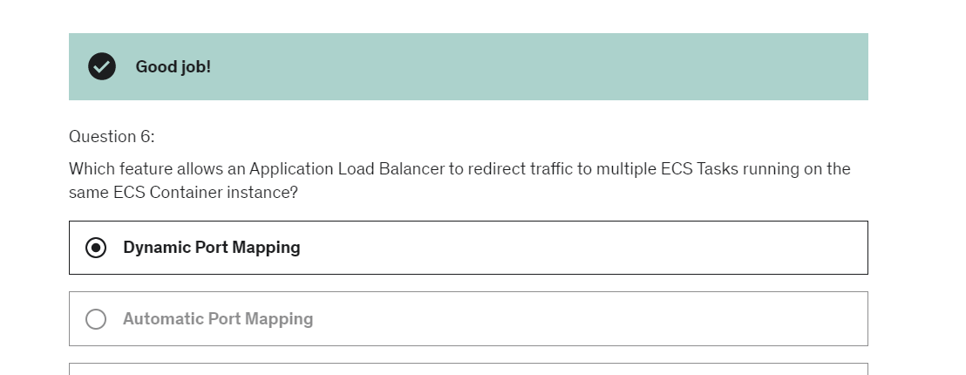

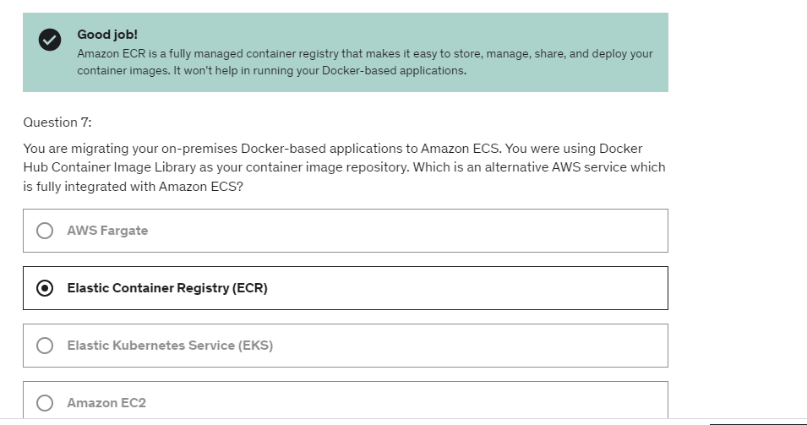

So in the beginning,

serverless was pioneered by AWS Lambda

that we'll see in the section,

but now also includes anything that is remotely managed.

So databases, messaging, storage,

as long as you don't provision servers.

we did not manage any servers for SQS and SNS

and it was scaling on its own.

So that fits the serverless use case

Kinesis Data Firehose, because again

it scales

based on the throughput you have

you just pay for what you use

and you don't provision servers,

Aurora Serverless,

when your Aurora database

scales on demand

without you managing servers,

step functions and fargate

because fargate was a serverless function of ECS,

where we didn't provision the infrastructure

to run our Docker containers.

CloudWatch Events or EventBridge.

This is whenever things happen in our infrastructure on AWS,

and we want to be able to react to things.

For example, say we have a cut pipeline,

state changes and we want to

do some automations based on it,

we can use a Lambda function

And then finally they run on-demand.

So that means that when you don't use Lambda,

your Lambda function is not running,

and you only are going to be billed

when your function is running.

And it will run on demand when it gets invoked,

which is a huge shift from Amazon EC2.

So this Lambda container image is quite special.

The container image itself must implement

the Lambda runtime API,

so it's not any container image that can run on Lambda.

There needs to be some prerequisites

about how that container image is built.

And then ECS and Fargate is going still to be preferred

for running arbitrary Docker images.

So the exam, if they ask you to run a container on Lambda,

unless that container does implement the Lambda runtime API,

you will run to run that container on ECS or Fargate.

So API Gateway is to create a REST API,

and they will invoke our Lambda functions.

Kinesis will be using Lambda

to do some data transformations on the fly.

DynamoDB will be used to create some triggers,

so whenever something happens in our database

a Lambda function will be triggered.

Amazon S3, we've seen this already.

A Lambda function would be triggered anytime,

for example, a file is created in S3.

CloudFront, this will be Lambda@edge,

and I have a lecture dedicated to this in this section.

CloudWatch Events or EventBridge.

This is whenever things happen in our infrastructure on AWS,

and we want to be able to react to things.

For example, say we have a cut pipeline,

state changes and we want to

do some automations based on it,

we can use a Lambda function.

CloudWatch Logs, to stream these logs,

wherever you want.

SNS to react to notifications and your SNS topics.

SQS to process messages from your SQS queues.

And finally Cognito to react to whenever,

for example, a user login to your database.

So, these are just the main ones.

There are tons of Lambda integrations.

we have more load automatically Lambda will scale

with our load.

And that is a whole power

of using Lambda as a compute platform.

And this is why Lamda that is serverless

and it scales really well.

Second time when you run lambda function, there is no initiation

because my lambda function was ready to be used.

Environment variables,

we can only have up to four kilobytes

of environment variable,

so a little bit amount of space.

But there is a temp space

if you want to pull in some big files

while we create another function.

And so this is this capacity in the /tmp folder

and we have 512 megabytes there.

Finally, for deployments,

the max size for your compressed zip is 50,

uncompressed, it is 250 megabytes.

So anything above that, for example, big files,

you should use a /tmp space instead.

Lambda@edge-

 you have deployed a CDN using CloudFront.

What if you wanted to run a global Lambda function,

alongside each edge locations,

or how would you implement request filtering

before reaching your application.

Well for this, you can use Lambda@Edge,

Lambda@Edge is that you deploy Lambda functions,

not in a specific region, but alongside

each region around the world

with your CloudFront CDN.

Lambda@edge  is used whenever you need to integrate

a Lambda function with your CloudFront

distribution to modify these four kinds

of requests we've seen.

DynamoDB is

a global database

for your serverless applications.

DynamoDB is good to scale to massive workload.

It's a distributed database, so it scales horizontally,

You use On-Demand Mode

when you very unpredictable workloads.

For example, it scales from like a few reads during the day

to millions of reads at any point of time very quickly.

Or for example, when you have no usage in the morning,

or no usage at night, or it's a development table

these kind of things, On-Demand is great

because while when the table is inactive,

you're not going to pay anything.

And then when it gets truly active,

you have this read and writes

that scale automatically for you.

DynamoDB Streams is to get a change log

of all the changes in your table,

and then it can be picked up by Kinesis, Lambda,

or an application running on Ec2 instance, for example.

 Transaction DynamoDB.

It's a way to be able to write to either multiple tables

or to none of them as part of one specific write.

lambda functions can use DynamoDB as a database for our API,

and we can do create, read, update, delete on our tables.

But we'd like our clients to be able to invoke

this lambda function in some way.

So, there are multiple ways of doing it,

we can have the client directly invoke the lambda function,

that means that the client would need IAM permissions,

or we see we can use an applicational load balancer to have it

in between the client and the lambda function,

and that would expose our lambda function

as an HTTP endpoint.

There's one last way we can use,

it's called the API Gateway,

and this is a serverless offering from AWS,

which allows us to create REST APIs

that are going to be public and accessible for clients.

So the clients will talk to the API Gateway,

and the beautiful thing is that the API Gateway

will then proxy the request to our lambda functions.

So we would use an API Gateway because it provides us

more than just an HTTP endpoint, it will provide us a lot of features,

as we'll see in this section, such as authentication,

such as usage plans, development stages,

and all that kind of things.

We have the ability to create API keys,

do request throttling,

in case some clients are doing too many requests on

their API Gateway,

and we can also use some common standards,

such as swagger, or Open API 3.0,

to import quickly defined APIs,

and also we can export them as swagger and Open API.

you're going to pay per Lambda invocation

but you can use caching to limit the number

of calls you do to your Lambda function

for authorizing, which if you have one million users

then you'll have to call your Lambda function

one million times every time the cache gets invalidated.

Now, let's start by User Pools or CUP.

So, this is basically a serverless database of users

for your mobile apps.

And, so it's a simple login.

Can be username or email and a password combination,

and you can verify emails or phone numbers.

You can add multifactor authentication.

You can have password policies.

And, you can also enable Federated Identities,

and this is where the confusion comes.

This is basically saying

you can allow your user to login

through Facebook, Google, and SAML

and get an identity into your User Pool.

Do not mistake this for Federated Identities,

which is different.

But you can still use the Facebook login

or Google login to log into your user pool.

What we get back out of it

is a JSON Web Token, or JWT,

and this token can be used to verify

the identity of someone.

remember, CUP is a database of users

you can have email passwords,

username passwords,

or you can even can have Facebook or Google login.

Federated Identity provider –

And, from this we get temporary AWS credentials

back from the Federated Identity Pool.

And, then these credentials

come with an IAM policy attached to it,

and so we can do stuff based on this IAM policy.

Here's our app.

And, our app is able to login to an identity provider.

The identity provider can be whatever you want.

It an be Google, Facebook, Twitter, SAML, OpenID.

And, even the Cognito User Pools

we have created from before.

So, from there our app gets to login

and gets a token.

Nothing new.

This is a basic login.

But, now using this token,

we are going to pass it on to our Federated Identity Pool.

So, we authenticate using that token to our FIP,

and it will verify the token with our identity provider

just to make sure we are who we say we are.

Once the token has been verified,

the Federated Identity will talk to the STS service

to get temporary credentials for AWS.

Once it has that,

it will pass on the temporary credentials

back to our application,

and now that our application

has these temporary AWS credentials,

it is, for example,

able to interact directly with our S3 bucket.

And, we have an IAM policy

which allows us to do certain things

and not do other things.

the idea is that we trade in a login

for an identity provider,

and we get, in the end,

temporary AWS credentials.

The first one(Cognito user pool) was just you provide an identity

and to integrate with the API Gateway

while this one (Cognito Identity Federated pool)is more to directly allow us

to interact with AWS for our app users.

What is Cognito Sync?

It lets you store user preferences,

configuration, and the state of our application,

and it has a cross device synchronization capability.

Any platform, could be iOS, Android, etc.

You can do offline stuff.

So, if you were to change your preferences offline

and then you go back online,

then they're synchronized automatically.

So, it's a good feature.

And, then to have it working well,

you need to use Federate Identity Pools

in Cognito not User Pools.

Just something to know.

The data is stored in data sets,

and each data set could be up to one megabyte,

and we can have up to 20 data sets to synchronize.

SAM

So on top of this, on top of helping you deploy

all these applications to the AWS Cloud in a natural way,

SAM can help you run your Lambda functions,

your API Gateway, and your DynamoDB tables locally on your computer so you can do some debugging.

Finally, SAM allows you to quickly

deploy your Lambda functions

using the integration with Code Deploy.

SAM at a high level is a framework

to manage your applications, your serverless applications,

and it allows you to deploy your Lambda functions,

and DynamoDB tables, API Gateway, and Cognito User Pools.

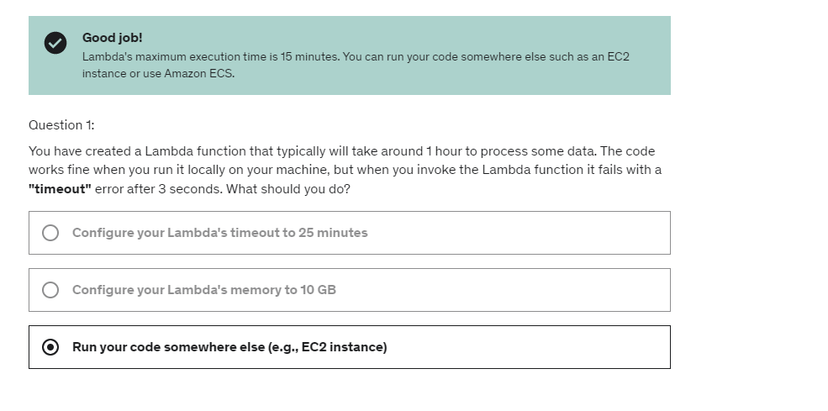

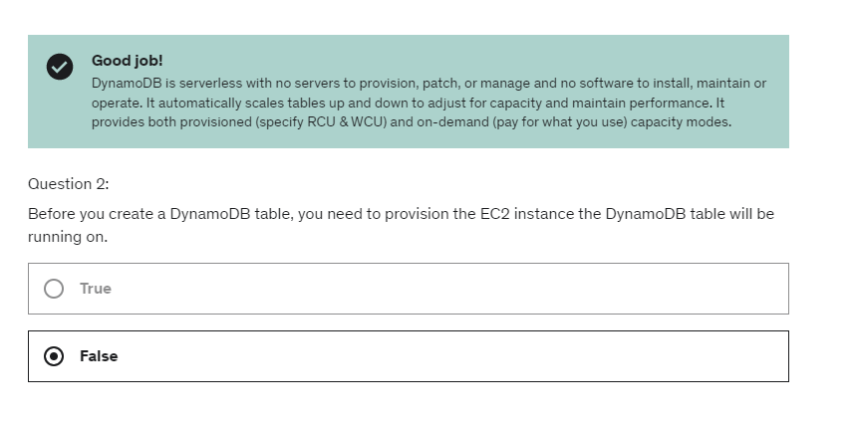

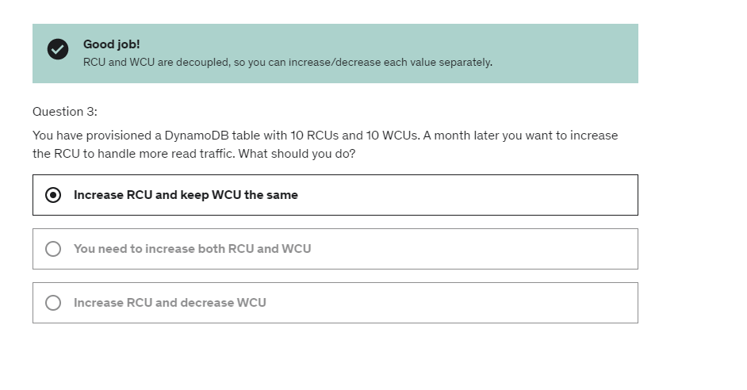

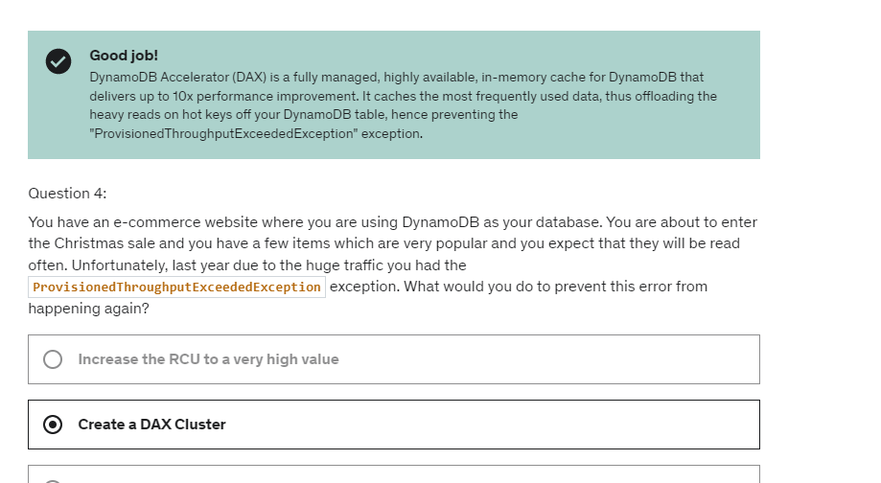

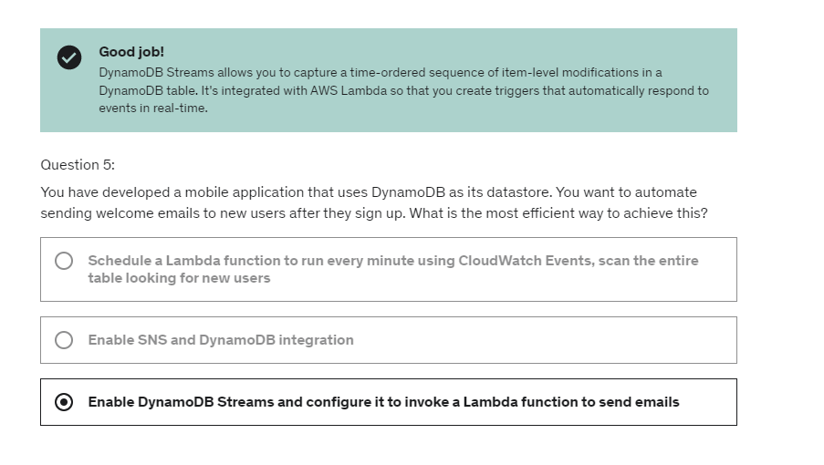

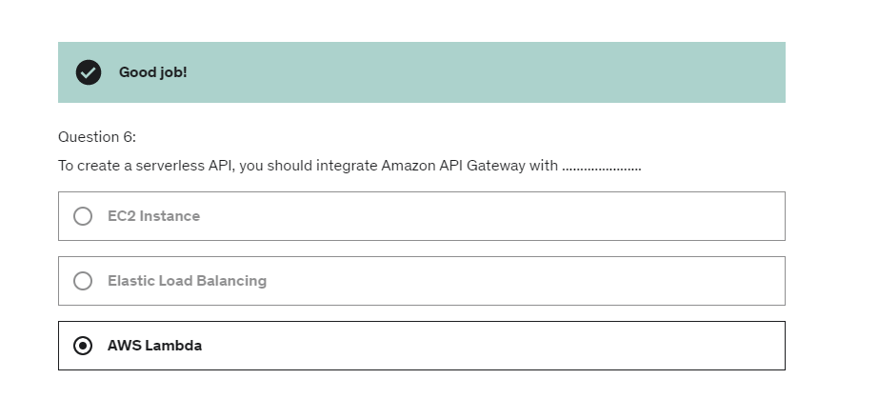

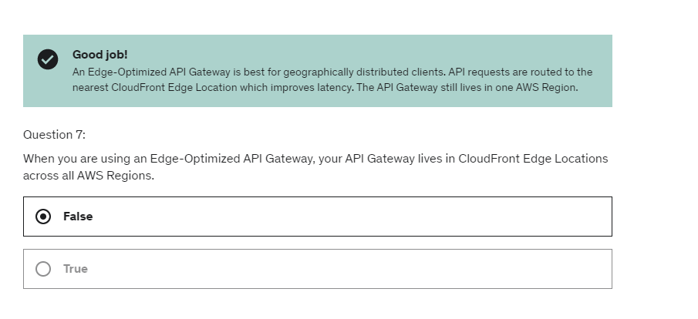

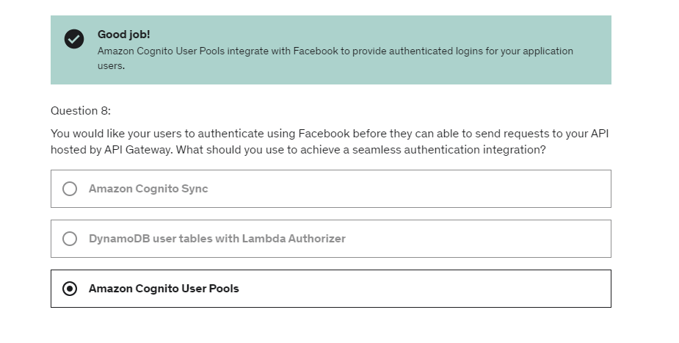

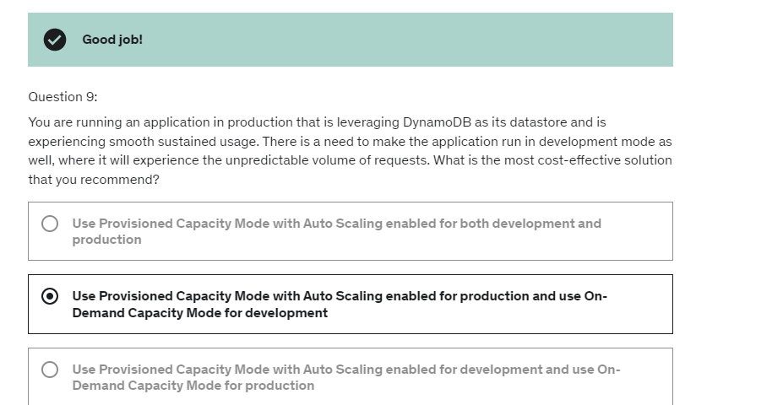

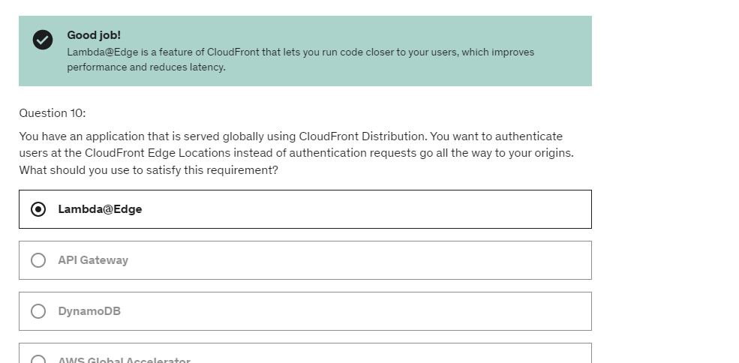

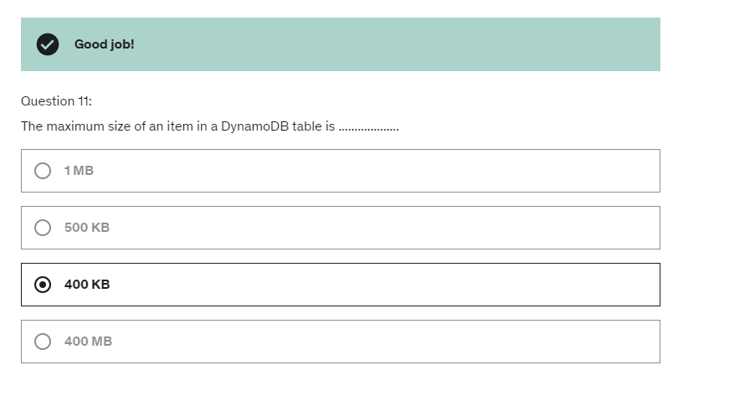

That one purpose is that Lambda Function

is to create a signed URL and for this,

first, it's going to have to verify if

the users that invoked this API is a premium user

by looking up into Dynamo DB,

and then, if it is a premium user,

then it's going to use the CloudFronts API

using the AWS SDK and it's going to generate a signed URL,

and maybe the signed URL will have an

expiration of five minutes.

And, you could've asked me, what about S3 signed URLs?

Can we use those?

Well they're not efficient for global access

because CloudFront is more efficient

for distributing stuff globally

and on top of it because we have an OAI

and only allow cloudfront to access S3

then S3 pre signed URLs would have not worked..

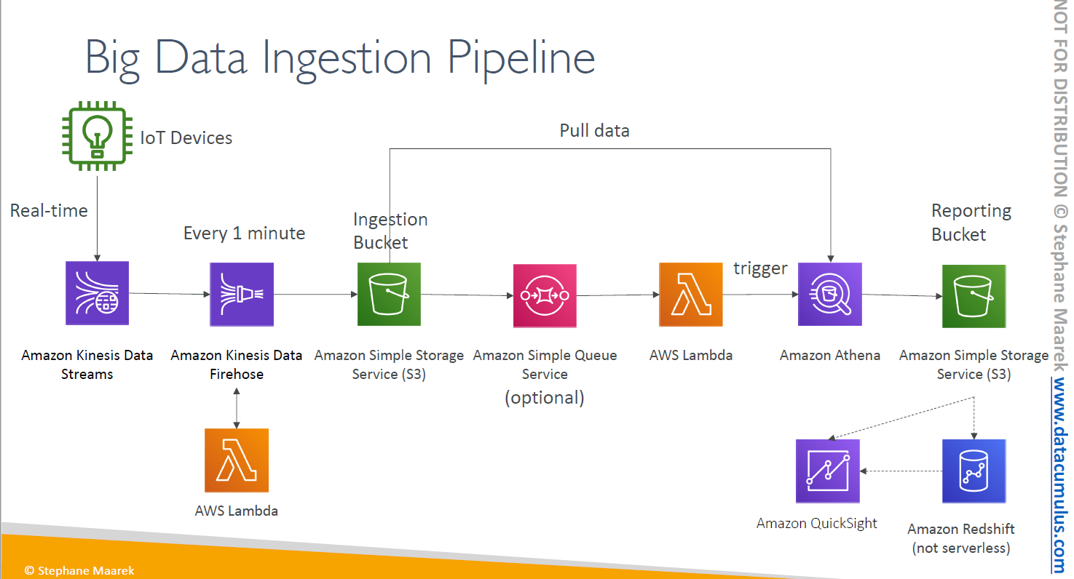

IoT Devices, let's assume that the producers of data

are IoT Devices. And so there is this really cool services

in Amazon Cloud services and it's called IoT Core,

and IoT Core helps you manage these IoT devices,

so remember this if you go into the exam.

Now these devices can send data in real-time,

to IoT Core and IoT Core directly into a Kinesis Data Stream

So data stream for Kinesis, remember,

it allows to basically pipe big data, in real-time,

very fast into this Kinesis service.

Now Kinesis can be talking to Kinesis Data Firehose

and Firehose allows us to, for example, every one minute,

put and offload data into an Amazon S3 Bucket

and that will be an Ingestion Bucket.

So here, what we've done here

is that we've had a whole pipeline to get a lot of data

from a lot of devices in real-time,

and put it every one minute into an S3 Bucket.

On top of it, it's possible for us to cleanse

or really quickly transform the data,

using an AWS Lambda function,

that is directly linked to Kinesis Data Firehose.

So now we have that Ingestion Bucket,

what can we do with it?

Well for example, we can trigger and SQS topic,

an SQS Queue, sorry, and it's optional

and maybe the SQS Queue can trigger an AWS Lambda function.

I say optional because Lambda can be directly triggered

by our S3 Bucket, but I just wanted to show you

the possibility of invoking SQS for that slide.

So, Lambda will trigger an Amazon Athena SQL query,

and this Athena query will pull data

from the Ingestion Bucket and will do an SQL query

that's all serverless and their outputs

are this serverless query, will go into

a reporting bucket, maybe again in Amazon S3

as different Bucket.

So from this we have the data, it's been reported on,

it's been cleansed and analyzed,

we can either directly visualize it, using QuickSight.

QuickSight is a way for us to visualize the data

into an Amazon S3 Bucket, or we can load our data

into a proper data warehouse for analytics,

such as Amazon Redshift.

Now please not that Redshift is not serverless,

and so this Redshift data warehouse can also serve

as an end point for QuickSights.

But this shows you, overall, what you can expect

in a Big Data Ingestion Pipeline at a high level,

including real-time ingestion, transformation,

serverless Lambda and some data warehousing using Redshift

and visualization using QiuckSight.

So, let's discuss about this pipeline.

IoT Core allows you to harvest many data

from many IoT devices.

Kinesis is great real-time data collection,

and Firehose helps you with data delivery

to S3 in near real-time,

so one minute is the lowest frequency you can choose.

Lambda can help Firehose with data transformation,

and then, Amazon S3 can trigger notifications to SQS,

SNS or Lambda.

Lambda can subscribe to SQS, but we could, as I've said,

connected S3 to Lambda, and Athena is a serverless

SQL service, and we can store the results

of Athena directly back into S3.

And the reporting buckets contain analyzed data

and we can use reporting tools, such as QuickSight,

for visualization or Redshift,

if we want to do more analytics on it.

So that's it for Big Data Ingestion Pipeline

but at a high level from a Solution Architecture perspective

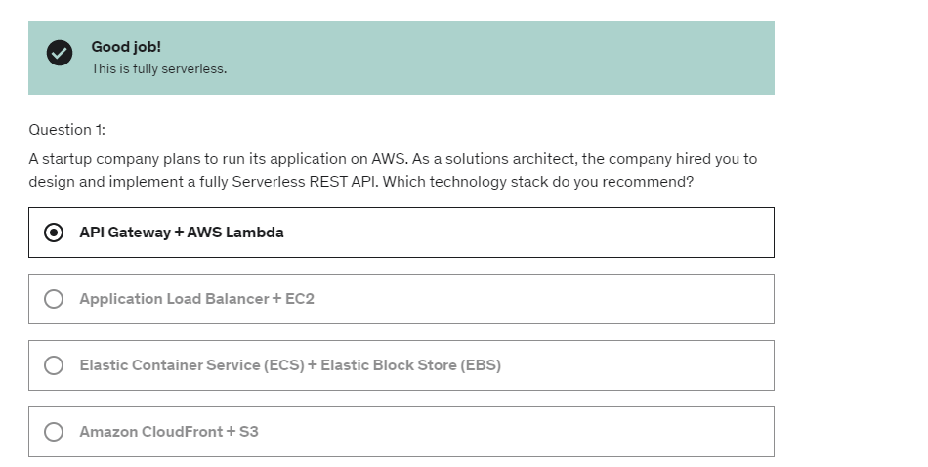

Amazon DynamoDB Accelerator (DAX) is a fully managed, highly available, in-memory cache for DynamoDB that delivers up to a 10x performance improvement – from milliseconds to microseconds – even at millions of requests per second. DAX does all the heavy lifting required to add in-memory acceleration to your DynamoDB tables, without requiring developers to manage cache invalidation, data population, or cluster management.

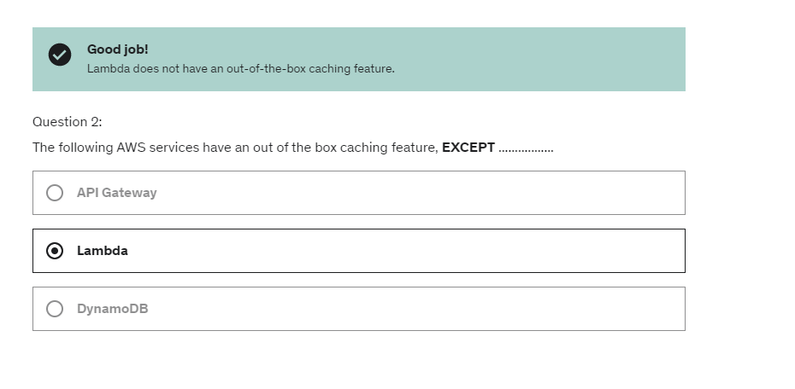

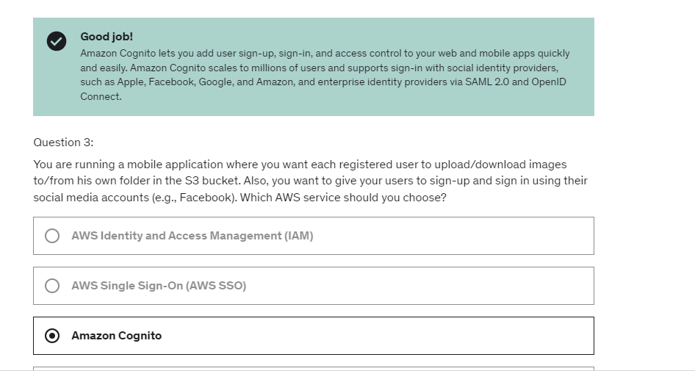

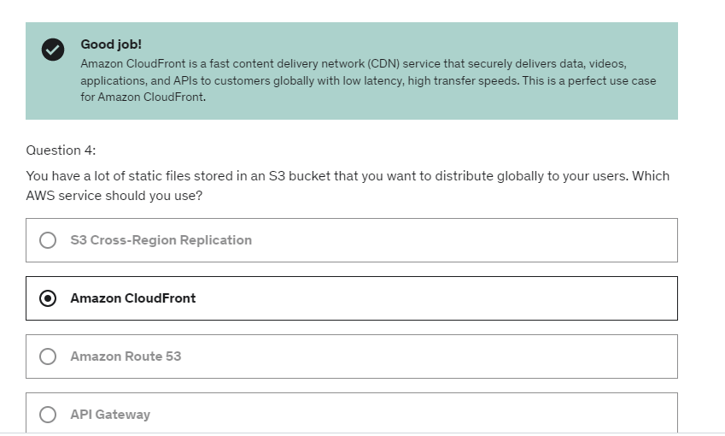

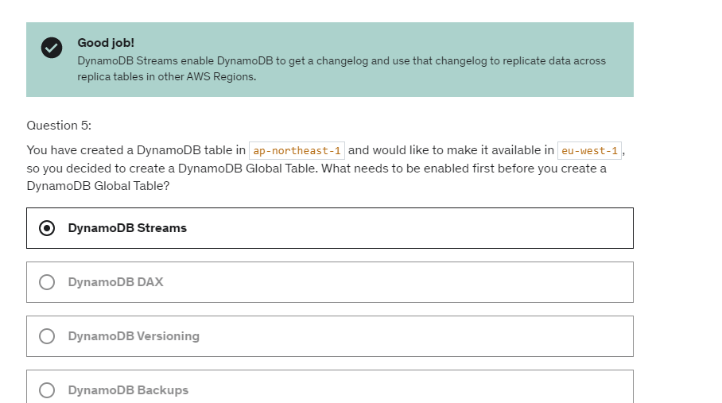

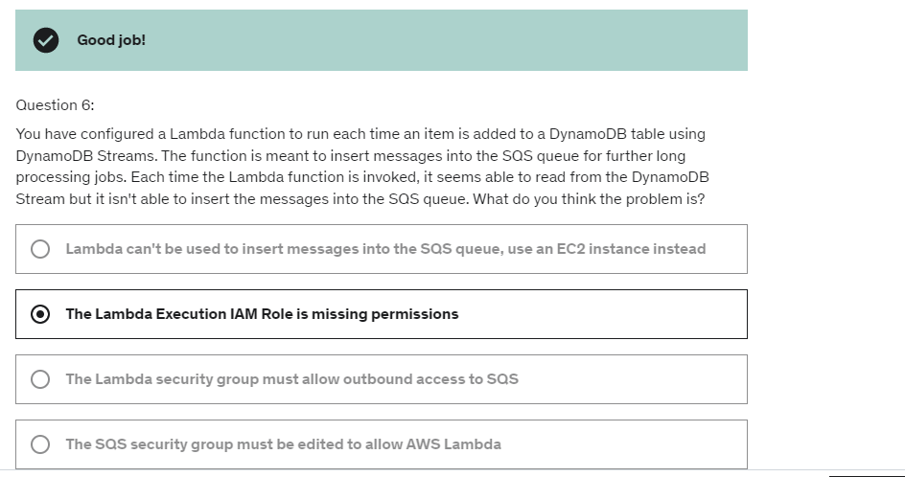

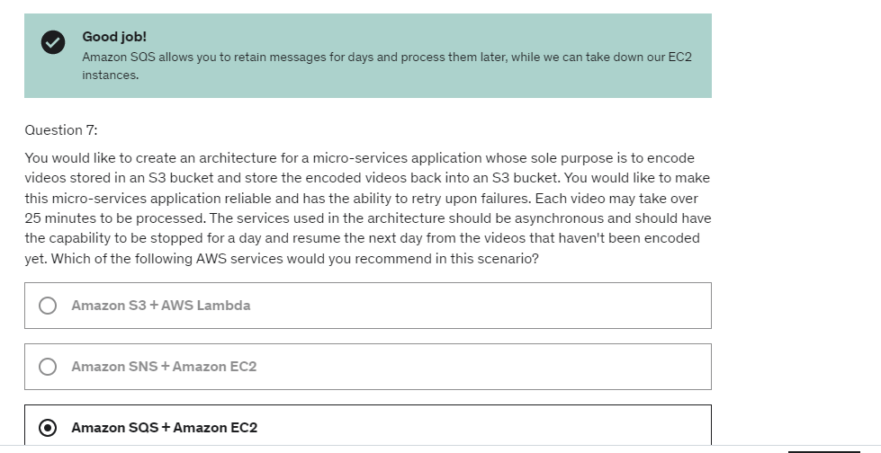

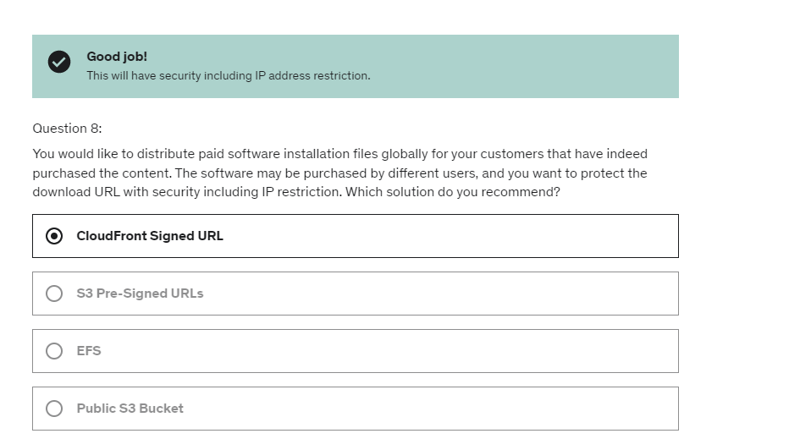

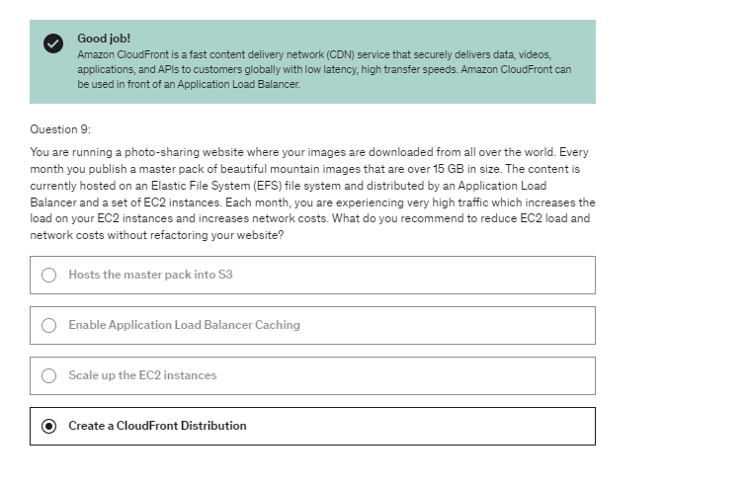

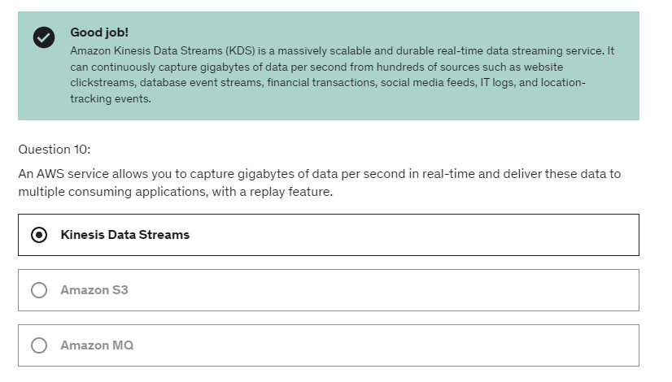

There's what I call RDBMS, that means you're using SQL

and its OLTP so online transaction processing

and this is usually going to be your principal database

like RDS if you going to use Postgres, MySQL,

MyRDB, MySQL server, Oracle and Aurora

if you wanted to jump to a more enterprise grade database.

And so theses databases are great to power a website,

they're great for joins, they're great for normalized data.

Basically any time you see data in a tabular form,

RDS and Aurora are gonna be the way to go.

so S3 is gonna be here for big objects so on DynamoDB

you can only store maybe 400 kilobytes of data per row

whereas on the S3 you can go up to five terabytes

of data per object so its really really big.

Then we have data warehousing so this is when you wanna do

analytics and BI based on SQL and so for this

we can use Redshift, Redshift is going to be an OLAP

so online analytical processing and so this is basically

helping you doing your data warehousing and all that stuff.

And Athena, people don't think it's a database,

I think it's a database, it can be used to query your data

in S3 and so I think that's a great candidate as well

to be considered as a data warehouse

for analytics and BI purposes

RDS:

And security we've seen it, it's done through IAM,

Security Groups, KMS for encryption at rest,

and SSL for encryption in transits.

And sometimes, Postgres and MySQL will have

IAM authentication as a feature.

Aurora:

And when we have this auto scaling

it grows as the usage grows,

so we don't need to provision it in advance.

Then we have EC2 instance type for our aurora instances.

And so if we have different types of EC2 instances,

we've seen that what we could be doing

is defined some custom endpoints,

for example, for analytical queries.

We have Aurora Multi-Master

if we want to have continuous write failover

by writing to multiple aurora instances at a time.

In terms of **reliability** we have Multi AZ,

it's highly available, possibly even more than RDS,

thanks to this distributed storage layer,

with six replicas of each data.

For **performance**, according to AWS,

we get five times the performance

of an RDS database due to architectural optimizations.

And we can get up to 15 Read Replicas

for a RDR database in a single region

which is different from the five Read Replicas

we get for RDS.

It can be a replacement for ElastiCache,

for storing key value stores.

So for example, if you want storing session data,

you could use that DynamoDB.

The advantage that you would get,

is that it's serverless,

so you don't have to worry about

provisioning ElastiCache and maintaining it.

Here at DynamoDB, it's all managed

and serverless for you.

What you get is, is you don't get

sub-millisecond performance on DynamoDB,

you get single digit, so between

1 and 9 millisecond of performance,

which is still really good,

and that makes it a very acceptable

keyvalue store for storing session data for example.

Reads, you have two options,

because it's a distributed database,

you have two options,

either you choose eventually consistence,

or strongly consistence.

So that means, are you willing to accept all data,

stale data or do you want to get

always the newest data.

That's what it means.

one downside of DynamoDB though,

is that you can only query on primary key,

sort key or indexes.

So what does that mean?

That means that you need to be very careful

when you start designing your DynamoDB tables,

and it does require some practice as a developer.

From Nov 2018, Dynamo DB can do transactions, it has on demand capacity. So it really scales,

based on your workload,

and really gives you the

optimal pricing and performance that you need.

Well, number one, **operations**.

You don't need to do any operations,

if you enable auto scaling

or if you enable on demand,

and it's serverless, so don't you worry about managing servers whatsoever,

it's made so that performance

won't degrade if your application scales.

So DynamoDB can scale to hundreds of terrabytes

in your database, and you will still get

that really good, single digit millisecond performance.

In terms of **cost**,

well here you're going to pay for the provision capacity

and storage usage,

and so if you use auto scaling,

you don't guess in advance the capacity.

It will scale down if you don't need it,

and scale up if you do need it,

so in the end, you can expect

a cost to be paid for exact usage,

which is really nice,

because if you have an application

that does nothing, you don't pay much,

if it does a lot, you pay more,

but at least you don't need to think about

provisioning in advance, which is great

from a Solutions Architect's perspective.

S3:

the recommendation on S3

is that it's great for big objects,

big files, because there is more latency.

It's not so great if you have many small objects,

so in that case S3 does not replace RDS,

or it dos not replace DynamoDB,

because in RDS and DynamoDB you get small objects.

But if you want to have infinite storage,

serverless, and you want have object size,

you know values, to be up to five terabytes,

then S3 is a great database for these things.

So you're gonna query maybe a movie,

so you're gonna store all your movies there.

It's gonna be your movie database,

and maybe each movie's gonna be 500 megabytes,

S3 is the place to put your movies,

it's where you store your movies in the database.

We get strong consistency for every single types

of operations in Amazon S3 including list and overwrites

**Performance** is amazing, you can scale

to thousands of reads and writes per second.

You can get transfer acceleration

if you use CloudFront, and you use multi-part

for big files to make sure they're reliably put into S3.

Finally for **cost**, you're going to only pay

for the storage you actually use, so you don't need

to think about how much storage you want to provision.

That makes S3 an infinite storage store,

and then you're only going to pay as well for network cost,

so the bandwidth to transfer and retrieve the data,

and then finally, if you do a lot of requests

on S3, you're going to get billed for that as well.

Athena:

 So, Athena is not a database in the terms that

it holds data,

but it does provide a query engine on top of S3,

so you can see it as the SQL layer on top of S3.

So, AWS advertises it as a fully serverless query engine,

I like to call it database

and has SQL capabilities so you can start querying

your data in S3.

So, you're going to pay per each query you run

based on how much capacity you're using and how much data

you're analyzing et cetera, et cetera

and you can output the results back optionally to S3.

So, in that way it's a good query engine.

It's all secured through IAM

so which it makes it really nice to make sure

that you have access to the

bucket you're querying or the data you're querying

and so the Use Case is going to be for one time SQL query

so exploratory work and maybe serverless queries on S3

or log analytics, that kind of stuff.

So, in that way I think it's if you do light weight queries

or not too complicated, not too many joints,

Athena is a great candidate

and so as such, I want to have this,

a technology in the database sections on this course.

Now from a Solutions Architect's perspective.

Well, **operations**: It's serverless so this is the holy grail

in AWS, you don't have any operations.

**Security** is IAM + S3 security, so you need to remember that

there is an S3 security component in there,

usually through bucket policies.

**Reliability**: Well, it's a managed service and it uses

Presto as an engine, which is a very high performance engine

and on top of it, all the queries are done in a

highly available fashion, so you're pretty much sure that

they will succeed.

And then **performance**: Well the queries will scale based

on the data size, so you expect a big data chunk to be

analyzed and Athena will basically scale accordingly

and in terms of **cost**, you're going to pay per query

or per terabyte of data scanned,

so that means that you only pay only for the actual usage

and that's what makes it as well, a serverless offering.

So I hope Athena makes sense in your head

where you can use Athena to analyze S3 logs,

ELB logs, UBC vlogs, all that stuff

and so as such it's quite a cool query engine to use SQL

on top of S3.

Redshift:

There is backup and restore capability,

security because you're Redshift cluster

can be deployed in your VPC, IAM for security

as well for the APIs at the Redshift level and KMS.

And also you get monitoring for your database

obviously like everything else in AWS.

Copy command and the Unload command

that go through S3 instead of going

into the public internet there would go directly

through the VPC.

Now let's talk about how we ingest data into Redshift.

So we have three ways I'm going to describe to you.

The first one is to use Amazon Kinesis Data Firehose.

So we have Firehose that will be receiving data

from different sources,

and then it will send it into Redshift

and to do so it will first write the data

into an Amazon S3 buckets,

and then Kinesis Data Firehose will issue automatically

an S3 copy commands to load the data into Redshift.

A cool feature of Redshift

is Redshift Spectrum.

The idea is that you would have data in Amazon S3

and you want to analyze it using Redshift,

but you don't want to load it into Redshift first.

And on top of it, you want to lose a lot more,

use a lot more processing power.

So you use Redshift Spectrum

and you must have a Redshift cluster already available

to start the query.

And then once you start the query,

the query will be then be submitted

to 5,thousands of Redshift spectrum nodes

that will perform the query onto your data in S3.

So let's go for an example, you have your Redshift cluster

with a leader node and a bunch of compute nodes

as we've seen.

And the data you want to analyze is in Amazon S3.

So in this case, we're going to run a query on to

our Redshift cluster, as we can see what we want to do

is that the table we want to query is living in S3.

So we have “select * from S3.ext_table” e.g

In that case, spectrum will launch automatically,

and so the query is going to be submitted

to thousands of Redshift Spectrum nodes,

who are going to read the data from Amazon S3

and perform some aggregations.

And when they're done, they're going to send back

the results into your own Amazon Redshift cluster,

and then you will give back into

whoever initiated the query.

But with this feature we can leverage

a lot more processing power from Redshift

than the one we have provisioned into our cluster

without, in the first place loading the data

from Amazon S3 into Redshift.

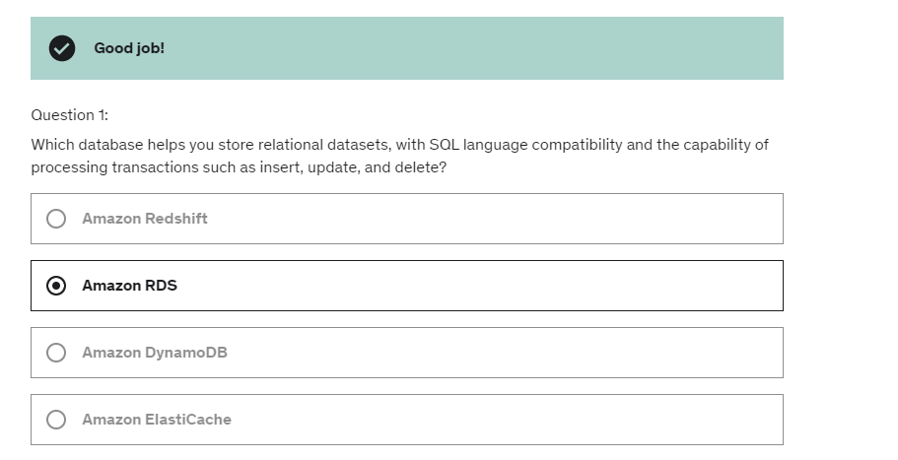

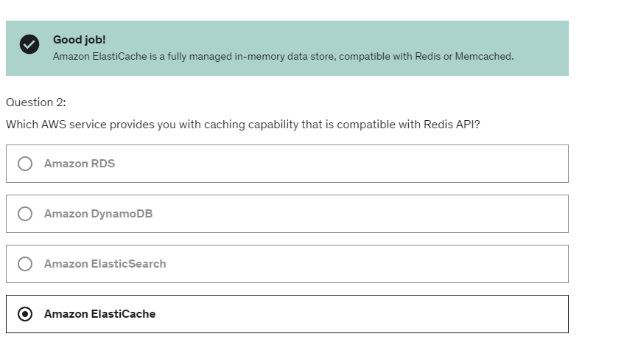

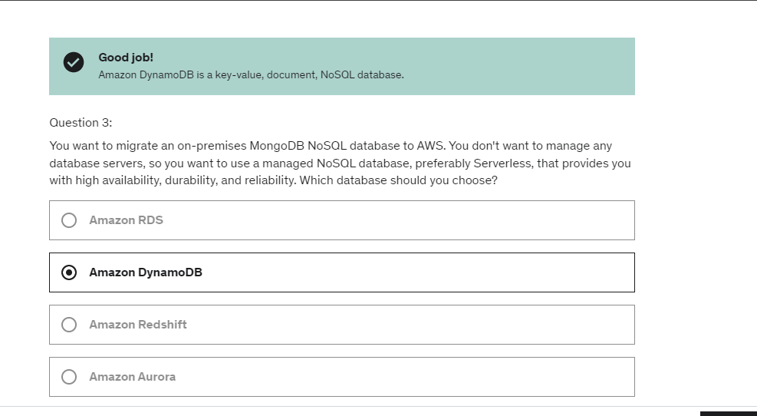

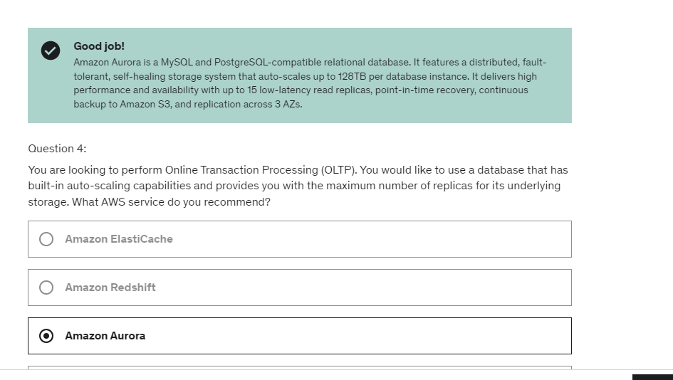

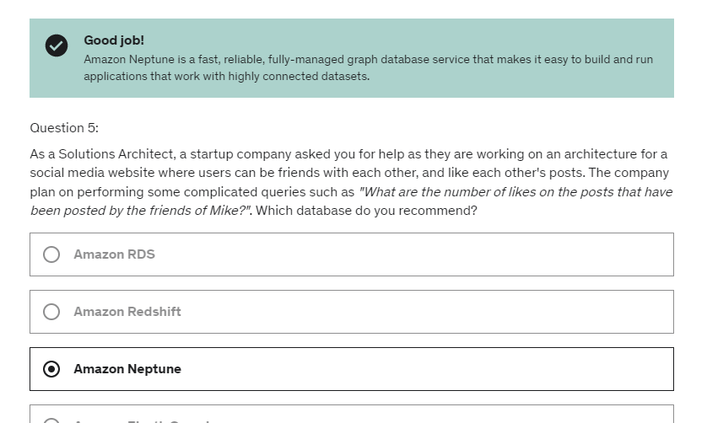

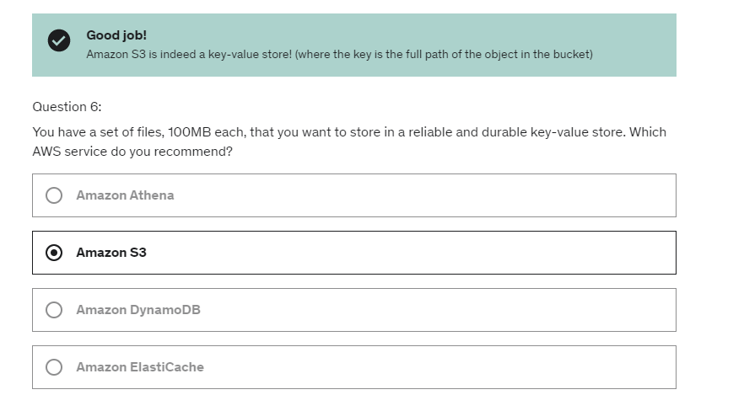

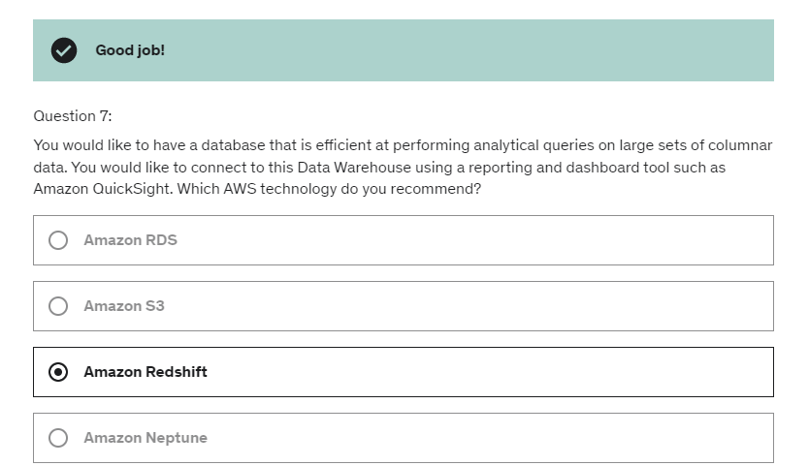

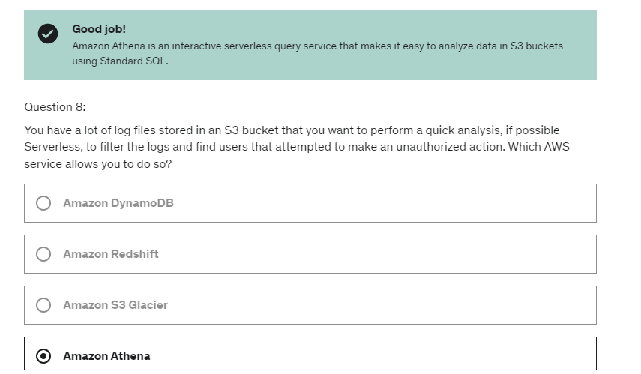

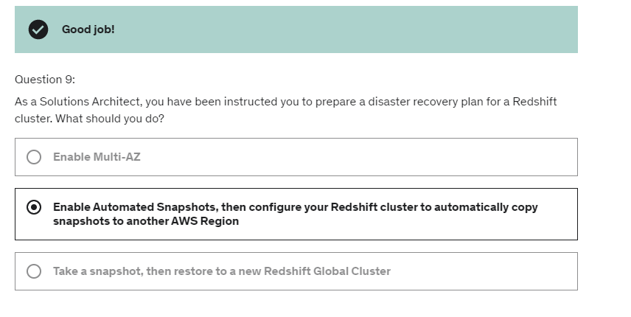

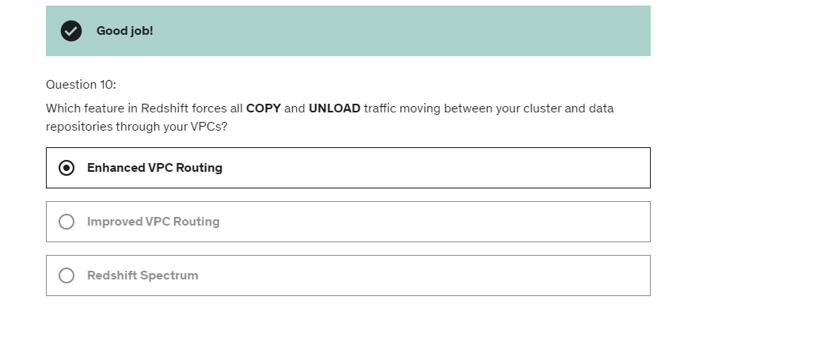

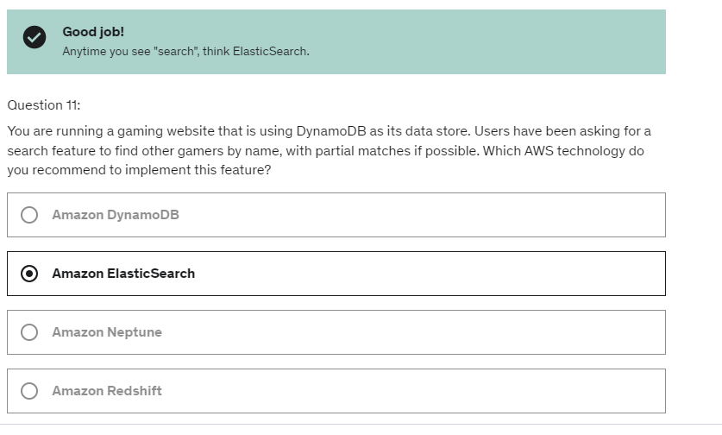

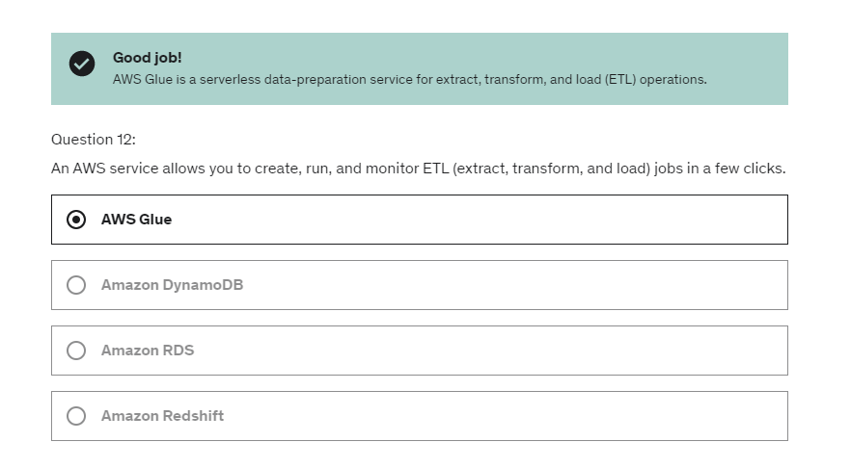

the unified agent for CloudWatch,

what it does is that it does use this put metric data API

call to push metrics into CloudWatch regularly.

So by default, no logs are going

from your EC2 instance from CloudWatch.

For this, you need to create and start an agent

which is a small program on your EC2 instances

that will push the log files that you want.

Whereas the Unified Agents,

will collect additional system level metrics

which has RAM, processes.

I'll show you this in the very next slide,

and also send the logs into CloudWatch Logs.

Now it's unified.

It's better because it can do both metrics and logs.

Hence, the name Unified Agent.

But also you can configure that agents very easily

using the SSM Parameter Store,

which is a feature that the previous agent did not have.

So you can do centralized configuration,

for all your Unified Agents.

As a reminder out of the box for EC2,

you get some information on disk, CPU,

and network not memory

not swap, but all of this at a high level, okay?

If you want more granularity

think CloudWatch Unified Agents, okay?

So, let's talk about EC2 Instance Recovery.

We've already seen it,

but there's a status check to check the EC2 VM

and the system status check

to check the underlying hardware.

And you can define a CloudWatch Alarm

on both of these checks.

Okay, so you will monitor a specific EC2 Instance

and in case the alarm is being breached,

then you can start an EC2 Instance Recovery

to make sure, for example,

that you move your EC2 Instance

from one host to another.

When you do a recovery,

you get the same private, public,

and elastic IP, the same metadata,

and the same placement group for your instance.

And you can also send an alarm and alerts to your SNS Topic

And so if you want it to test alarm notifications,

you can use a CLI Call called set alarm state.

And this is helpful when you want to trigger an alarm,

even though it didn't reach a specific specific threshold,

because you wanted to see whether or not the alarm being

triggered results in the correct action

for your infrastructure.

Amazon event bridge is extension to AWS cloudwatch:

As mentioned, we can extend our event buses to

have custom applications or third party SaaS apps

and event bridge has these schema registry capability

as well as replaying and archiving

and resource based policy.

And if you wanted to centralize all your events

in your accounts across accounts,

then you would choose All events

and then you will send that into a central event bus

thanks to resource-based policy.

So the targets could be either an EventBridge event bus,

which is when you wanna centralize destinations

or an API destination, or you could choose

one of the following AWS services.

And you can see,

you have a lot of possible targets or actions.

But the one that's interesting to me is the SNS topic

because I wanna send into my demo topic,

You can create the trail to be applied

to all regions or a single region,

if you want to accumulate all these history

of events accumulated across all the regions

into one specific for example, S3 Bucket.

Cloud trail events-

1)Management events2)Data events 3)Cloud trail Insight events

Data events are either S3 or Lambda events.

e.g of data events in cloudtrail:

Another kind of event you can have in a CloudTrail

are AWS Lambda function execution activities

so whenever someone uses the Invoke API

so you can get insights about how many times

the Lambda functions are being invoked.

And again, this could be really high volumes,

if your Lambda functions are executed a lot.

So when we have so many management events

across all types of services

and so many APS happening very very quickly

in your accounts,

it can be quite difficult to understand what looks odd,

what looks unusual and what doesn't.

And so this is where CloudTrail Insights comes in.

AWS Config:

It doesn't replace security mechanisms such as IAM.

Okay, but what it does give you is a overview of your

configuration and the compliance of your resources.

 although you cannot deny any action from happening

from within the config,

you can do remediations of your non-compliant resources

using an SSM Automation Documents.

So the idea is, for example,

you are monitoring whether or not

your IAM access keys have expired.

For example, they are older than 90 days.

In which case you want to mark them as non-compliant.

So this will not prevent them from not being compliant,

but you can trigger whenever a resource is not compliant,

a remediation action.

For example, there's an SSM document

named RevokeUnusedIAMUserCredentials, okay.

Maybe you want to use this one

and then is going to be applied

to whatever resource you have, okay?

And in this instance,

it's going to deactivate your IAM access keys.

So the idea is that's either using either using

AWS-Managed Documents

or creating your own automation documents,

you can have remediations

of your non-compliant resources,

And if you want it to and go all the way through

with the scripting,

you could create a document

that will invoke a Lambda function

Well, we can use if EventBridge to trigger notifications,

whenever our resources are not compliant.

So, for example,

we monitor our security group, it becomes not compliance.

Then we can trigger an event in EventBridge,

and then pass it on to whatever resource you wants.

OR you can also pass on all the changes

and all the compliance state notifications

of your resources to SNS from Config.

So one configuration item,

and then if you want it to just filter

for only for some events,

you could use an SNS filtering to have a filtered SNS topic,

and then you can send it these notifications, for example,

to an admin email or to a slack channel and so on

to get all these notifications in one place.

Finally, CloudTrail will be to track who made any changes

to the load balancer with API calls.

So, in case someone changes the security group rules

or someone changes the SSL certificate,

or removes it, or whatever,

then CloudTrail will be how we know who made these changes.

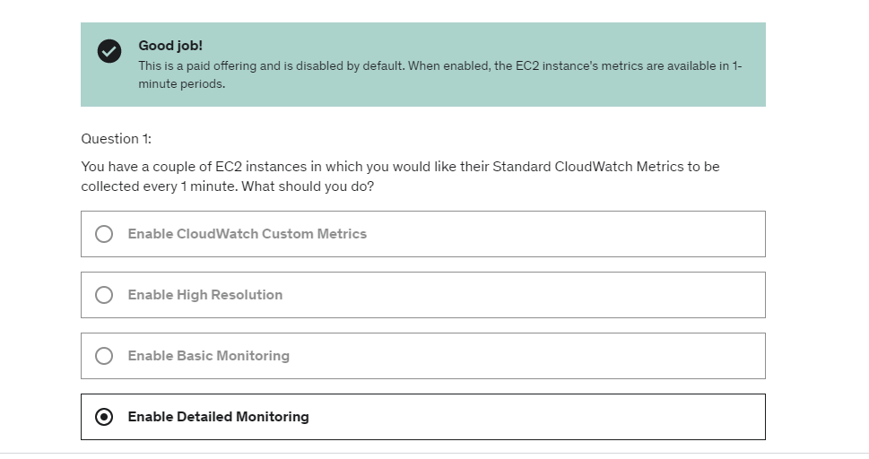

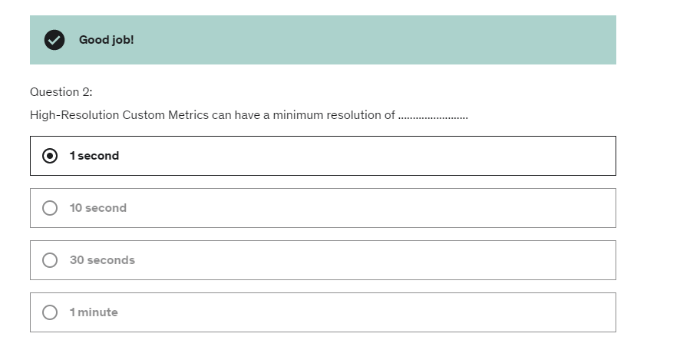

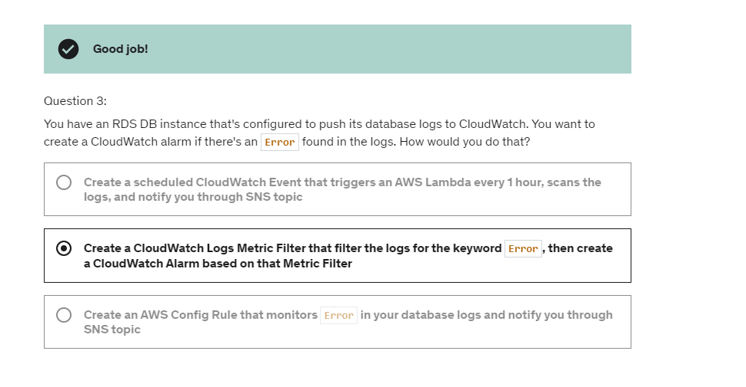

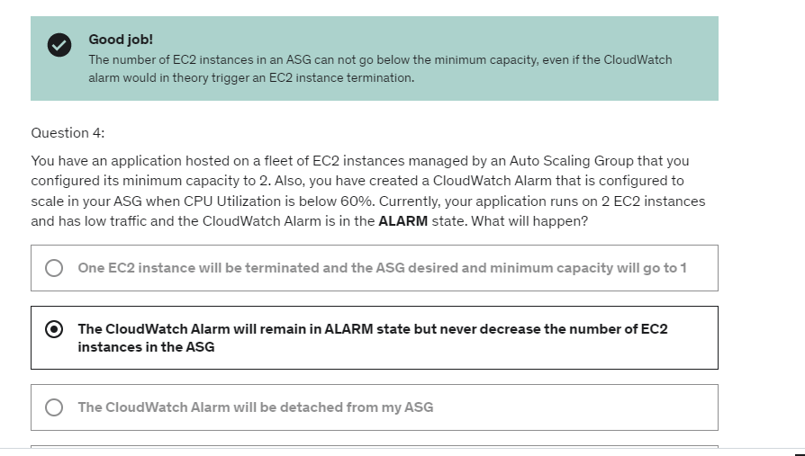

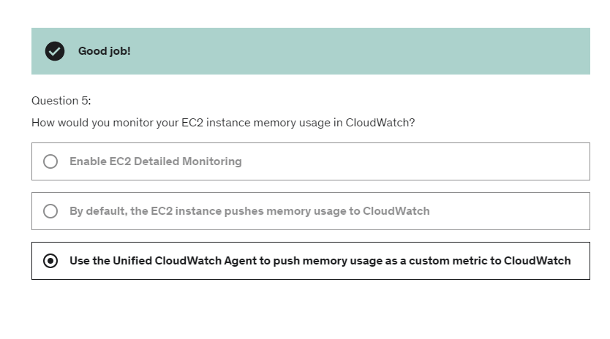

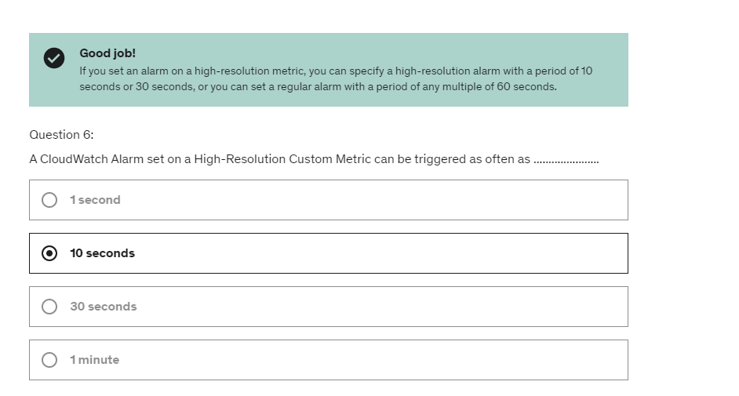

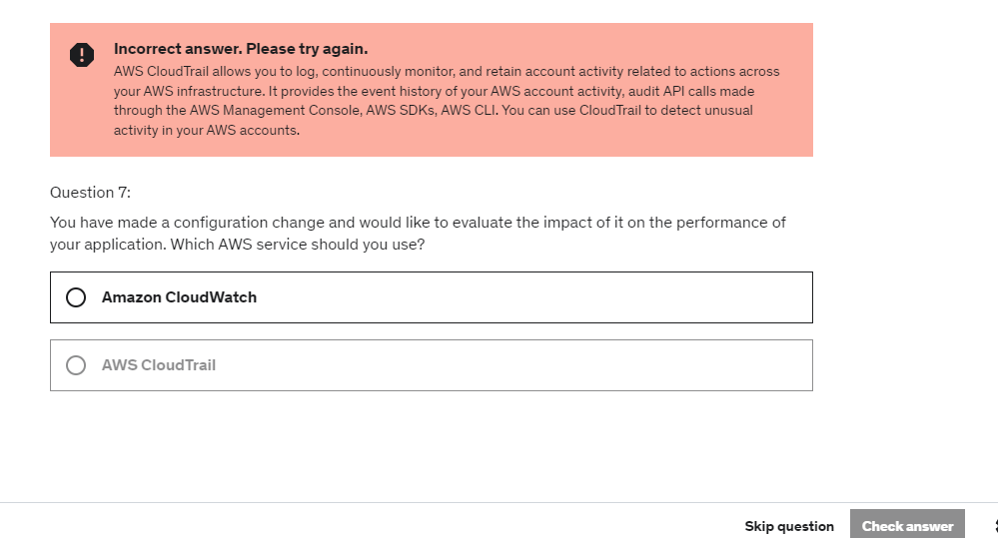

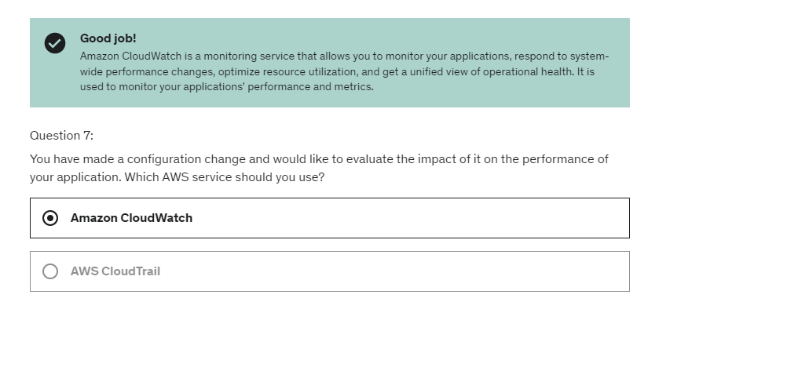

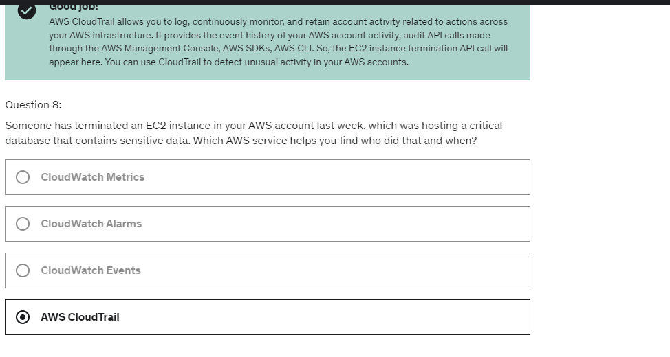

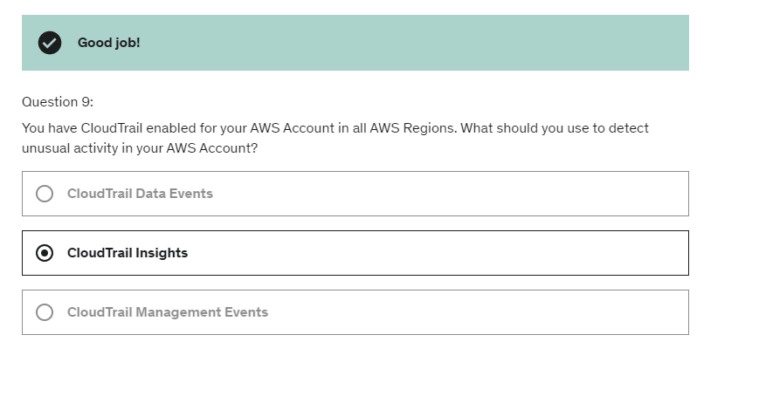

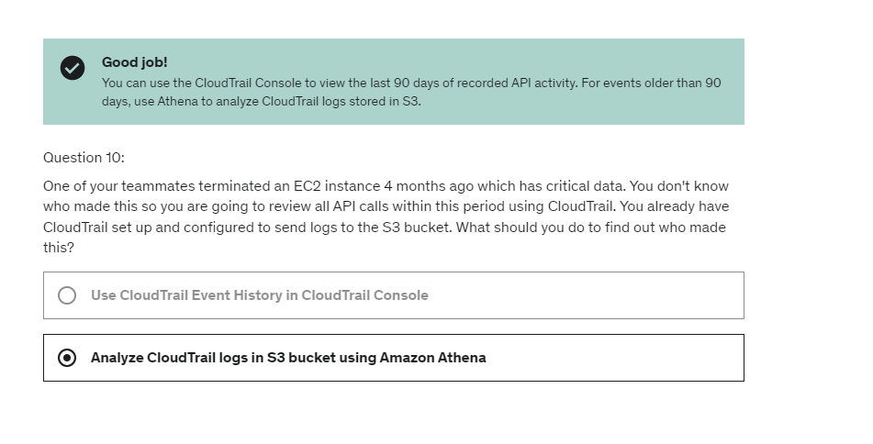

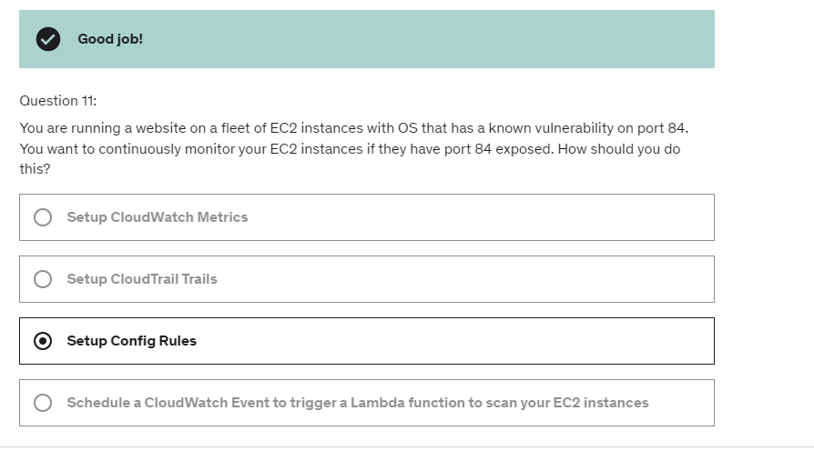

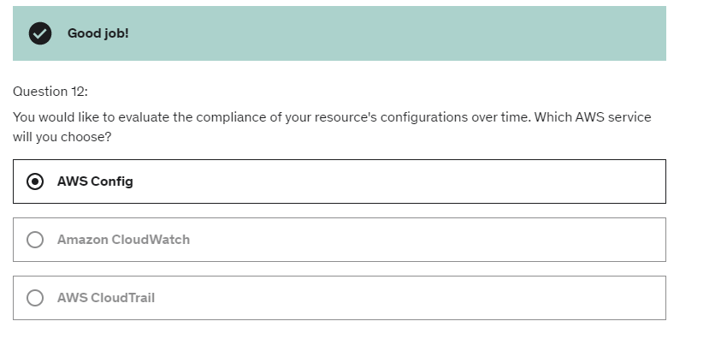

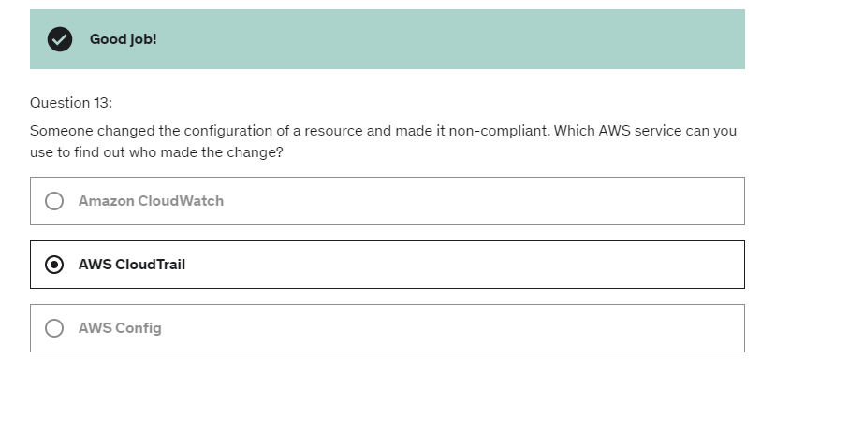

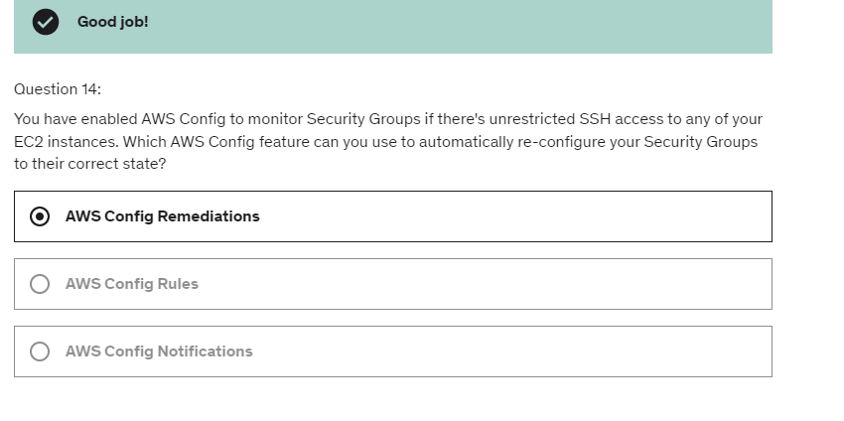

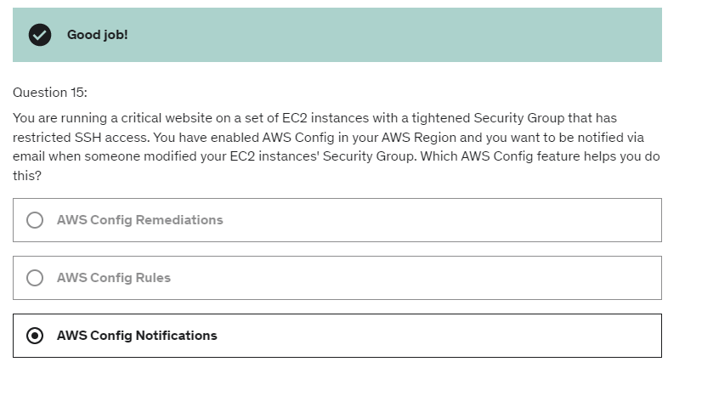

Security Token Service:

The token will be temporary, valid up to one hour.So if you want to reuse that token,

you must be refreshed, and so the credentials

must be re-verified before you have a new token

that allows you to access your AWS resources.

AssumeRole API in STS:  .

So you can use the AssumeRole **within your own account**

for enhanced security, for example you have your

users assume a role that allows them to EC2 instances, so the reason we do this is that we want to have an extra layer of security,

such as they don't accidentally delete EC2 instances.

They just have to assume a role first to do that.

Or you can use AssumeRole for **cross account access**. And in that case, we assume a role in a target account,

which is not our account, and because we have assumed

a role there, we can perform actions

on the resources of that account.

STS is really at the center of providing

our users our applications, tokens that allow them to

talk to our AWS resources.

So we have the user, and it wants to assume a role within

the same or another accounts,

so it's going to say "Okay, I want to assume that role,"

so I'm going to use that AssumeRole API, okay,

and invoke STS.

STS is going to check with IAM

if we have the permissions to do so,

then it will return us temporary credentials,

and these credentials can be used to access

that role in our account.

So we can see the whole process,

we first ask stuff from STS who checks with IAM,

returns us security credentials,

and then we are able to assume that role and endorse it.

So we have a production account on the left hand side,

and a development account on the right hand side.

And as we can see, the first thing to do is that the admin

will create a role in the production account.

Then the admin in the development account will create a

developer's group with the permission to access

this UpdateApp role.

Then the user will request access to the role.

STS will return the role credentials,

so now we have the credentials to use that role

in this account, and then the user using these new

credentials can access, for example,

an extra bucket in the other account.

So this is a process for cross account access

and this is done using STS so you never share credentials

across accounts, you never ever do that,

like create a new user and send the credentials, no.

You create a role, and you make sure that your user

assume that role, and STS will return to you,

role credentials that are temporary so even if you

somehow lose them, then it is not as bad as

leaking entire credentials of an account.

Identity Federation in AWS:

Because you don't want to manage

all you users within AWS.

You want to have an external source

of truth for users and allowing them

through that source of truth to access

your AWS resources.

SAML2.0 Federation:

 you create your users on Active Directory

and they will be able to access AWS

thanks to SAML 2.0 federation.

1. If ADS/identity provider is compatible with SAML2.0 – OK
2. If Identity provider is not compatible with SAML2.0, then you should use custom Identity broker Application.

Custom Identity Broker:

But, this time it's not AWS that gives us credentials

it's the Identity Broker that will talk to STS

to request some credentials for some specific

action and the Identity Broker,

we have to write ourselves

will return these credentials to us

and then we can access the console

or access the AWS APIs.

So, the difference here is that the Identity Broker

itself is the one talking to STS

and giving us back some credentials.

So, there's a lot of power into our

Identity Broker.

But, this is the only way to do it

if you don't have a SAML 2.0 implementation.

Okay, so we have seen how to have our users

on premise within our company

access AWS through Identity Federation.

But, what about if we want to have users of our

applications access AWS?

Then, we have to use

Web Identity Federation.(API – AssumeRoleWithWebIdentity)

 in this example, our mobile client

which is a app is going to login.

Maybe, could be Facebook, it could be Google,

it could be Amazon.com, whatever you want.

And then it's going to get back some credentials,

a token.

And that token is going to be exchanged with STS

using the AssumeRoleWithWebIdentity.

So, STS is going to look at this,

say yes, I trust this login, let me return to you to back

some AWS credentials.

And now, the mobile client has some AWS credentials

and can access a different IAM policy

and then maybe a data multi table

which is your GameScores.

So, the idea here is that its a 3-way process,

we first login with our identity provider,

we then exchange it with a STS,

and then we have access to AWS.

So, very similar process to what we seen before,

but now this is for Web Identity Federation.

But as I said, the recommended way

is to use Cognito.

So, we login with it and we get back a token,

so think the login is user name, password right.

We get back this token, and this token

can be exchanged with Cognito Federated Identity.

Which is going to verify the token first,

then get credentials from STS in the backend.

And, give us back some temporary AWS credentials.

And, these credentials themselves can be used

to access our Amazon S3 bucket thanks to the policy

we have attached to this role.

what Microsoft AD is,

it is a software that is found

on any windows server with AD domain services.

So all your users manage

within your entire Microsoft ecosystem

on premise is going to be managed

by Microsoft active directory.

TRUST b/w aws managed AD and on premise AD.

And so that means that if your users authenticate it

to the rights, use an account that is not managed by AWS,

It can go and look

up the accounts into the on-premise active directory.

And, similarly, if an on-premise directory user goes

and authenticate to your

on premise AD using the a AWS accounts,

it can be trusted to go and look it up.

AD Connector:

So if the users to you authenticate

with our AD connector, it's going to proxy the request back

to our on-premise AD and look it up.

So the idea here is that, in the first case

with Microsoft manage Microsoft AD, we have users sitting

in AWS manage AD and users sitting in on-premise AD.

Whereas, with AD connector,

as the name indicates, it connects

the proxies, the queries, the, the connection request back

to our on-premise active directory

and the only place where we can manage users is going to be

on the on-premise AD.

Simple AD:

it's an AD compatible managed directory on AWS.

It doesn't use Microsoft directory.

And it cannot be joined with a non-premise active directory.

So, the idea is that if you don't have an on-premise

AD and you need an active directory for your AWS cloud,

then you can have just a simple AD as a standalone thing.

And the idea here is that, using active directory,

you can create EC 2 instances that are going

to be running windows.

And these windows instances can join the domain

controllers for your network and share all the

logins and the credentials and so on.

So this is why we want to have a directory in AWS to have

a directory closer to your EC2 instances running windows.

And hopefully that makes sense.

 AD connector,

which is a proxy for redirecting directory request

to your existing Microsoft active directory on premise

and is designed for you have two levels.

You have a connector for up to 500 users

or you have a connector for up to 5,000 users.

Organization

So, it's really great to federate

all these accounts into one organization

to pay less and simplify your billing methods.

And there's a really cool API

that allows you to automate the AWS account creation.

So, you can create AWS account on demand

using an API through organization

and make sure that the billing of that account

will be rolled back into the bigger accounts.

So, you want to make sure that you don't have resources

that can talk to each other within the same VPC.

So, you create two accounts

and you don't pair them together.

And so, the resources are virtually-isolated.

There's also good to have per-account services limits

and also, isolated accounts for logging.

 if you wanted to administer all of the accounts,

then you can establish Cross Account Roles

for admin purposes,

 so how do we organize all these accounts?

We organize them using Organizational Units or OU.

So, the SPCs can be applied to only the users

and the roles of the account,

including the root.

So, if you apply an SCP onto your account within an OU,

and you say you cannot use EC2,

even an admin within that account cannot use EC2.

Well, the Master account can do anything

because it inherited the Full Access SCP from the root OU,

and even though we have attached to DenyAccessAthena SCP

to the Master account,

because it is the Master account of your route OU,

no SCP apply and therefore this SCP apply

to the Master account is completely not taken into account.

IAM conditions:

So what are IAM conditions?

They're what you make your IAM policies

a bit more restrictive based on a condition.

1) So what you have to remember here is that the aws:SourceIP

is renaming the IP of the clients

making the API call into aws okay?

So this is what it means,

the IP of the clients where the risk calls are being made.

2) we have Aws Requested Region which is to restrict

the region the API calls are made to.

For example, you can specify the regions your developers can launch new EC2 instances, create databases in RDS, and create Lambda functions by using the single global condition key in your IAM policy.

1. EC2:ResourceTag
2. Aws:principalTag
3. aws:MultiFactorAuthPresent

Option number one is to create a role in the Account B,

assume that role using STS and then by assuming that role

in Account B we will be able to issue API calls against

the Amazon S3 bucket in Account B.

The other option is to use the same bucket

and create an S3 bucket policy that allows directly

the user accounts from account A to access

the Amazon S3 Bucket.

When you assume a role, would be a user, an application

or a service, you are going to give up

your original permissions and you're going

to take the permissions assigned to the role.

And when using a resource based policy,

your principal doesn't have to give up his permissions

and he can just use, go through that resource bucket policy

and not loose their permissions,

so you can do both actions in Account A and Account B.

slide 609:

So first question is,

can you perform sqs:CreateQueue?

The answer is no, you cannot

because there is a Deny star on SQS,

and CreateQueue belongs to that block

and there's a deny on it,

so it's definitely going to be denied.

Now, can you perform an sqs:DeleteQueue?

So there's a deny on the top part

and there's an allow on the bottom part

and they conflict.

There's a deny and allow.

But what did I just tell you?

I told you that as soon as you have an explicit deny,

then the decision is going to be denied.

So because there is an explicit deny on sqs:*,

and sqs:DeleteQueue is within that sqs:*,

then no matter what, even there's an allow here,

this is going to be denied this action.

So you cannot perform sqs:DeleteQueue,

even though you have allowed it explicitly

in the second block.

So very important to know.

And finally, can you perform ec2:DescribeInstances?

So as we can see, there's nothing on EC2 in this thing.

And this is an IAM policy.

And so, because there is no explicit deny

but also there's no explicit allow,

then you cannot perform ec2:DescribeInstances

with this IAM policy.

So if look at this diagram,

we have the effective permissions

to be in the middle of your identity-based policy,

so whatever is attached to your user or your group.

The permission boundary, which by the way,

only applies to a user or a role and not a group.

And your organization SCP,

which applies to every single IAM entity in your account.

So in the middle lies what the users can do.

* [**Identity-based policies**](https://docs.aws.amazon.com/IAM/latest/UserGuide/access_policies.html#policies_id-based) – Attach [managed](https://docs.aws.amazon.com/IAM/latest/UserGuide/access_policies.html#managedpolicy) and [inline](https://docs.aws.amazon.com/IAM/latest/UserGuide/access_policies.html#inline) policies to IAM identities (users, groups to which users belong, or roles). Identity-based policies grant permissions to an identity.
* [**Resource-based policies**](https://docs.aws.amazon.com/IAM/latest/UserGuide/access_policies.html#policies_resource-based) – Attach inline policies to resources. The most common examples of resource-based policies are Amazon S3 bucket policies and IAM role trust policies. Resource-based policies grant permissions to the principal that is specified in the policy. Principals can be in the same account as the resource or in other accounts.
* [**Permissions boundaries**](https://docs.aws.amazon.com/IAM/latest/UserGuide/access_policies.html#policies_bound) – Use a managed policy as the permissions boundary for an IAM entity (user or role). That policy defines the maximum permissions that the identity-based policies can grant to an entity, but does not grant permissions. Permissions boundaries do not define the maximum permissions that a resource-based policy can grant to an entity.
* [**Organizations SCPs**](https://docs.aws.amazon.com/IAM/latest/UserGuide/access_policies.html#policies_scp) – Use an AWS Organizations service control policy (SCP) to define the maximum permissions for account members of an organization or organizational unit (OU). SCPs limit permissions that identity-based policies or resource-based policies grant to entities (users or roles) within the account, but do not grant permissions.
* [**Access control lists (ACLs)**](https://docs.aws.amazon.com/IAM/latest/UserGuide/access_policies.html#policies_acl) – Use ACLs to control which principals in other accounts can access the resource to which the ACL is attached. ACLs are similar to resource-based policies, although they are the only policy type that does not use the JSON policy document structure. ACLs are cross-account permissions policies that grant permissions to the specified principal. ACLs cannot grant permissions to entities within the same account.
* [**Session policies**](https://docs.aws.amazon.com/IAM/latest/UserGuide/access_policies.html#policies_session) – Pass advanced session policies when you use the AWS CLI or AWS API to assume a role or a federated user. Session policies limit the permissions that the role or user's identity-based policies grant to the session. Session policies limit permissions for a created session, but do not grant permissions. For more information, see [Session Policies](https://docs.aws.amazon.com/IAM/latest/UserGuide/access_policies.html#policies_session).

The permissions boundary for an IAM entity (user or role) sets the maximum permissions that the entity can have. **Identity-based policies with boundaries** – Identity-based policies are inline or managed policies that are attached to a user, group of users, or role. Identity-based policies grant permission to the entity, and permissions boundaries limit those permissions. The effective permissions are the intersection of both policy types. An explicit deny in either of these policies overrides the allow.

RAM(Resource Access Manager)

So you share the underlying VPC

but you don't share the resources within the VPC.

So that means that the application

can access each other using their private IP.

They don't need to access each other over a public IP,

and that could be a huge security benefits.

So even though on top of things,

we can even reference security groups

to have a maximum amount security across accounts,

so that means that if we modify the security group

of an Amazon RDS database to allow the security group

of our EC2 instances from account one,

then our EC2 instance, is going to be able

to access our Amazon RDS database

from the VPC owner accounts. And if we allow again from the ALB in account one access

to the EC2 instances in account two,

then the EC2 instances in account two

can access our ALB directly using its private IP,

or private DNS.

And so this is extremely helpful, because now we have shared an entire networking layer

across multiple accounts,

and we have simplified a massive challenge,

which is how do we make these resources talk to each other.

SSO:

the really cool thing is that it is integrated

with AWS organizations so if you have a tons

of accounts within your organization,

you just set up AWS Single Sign-On and you will have access

to log in to all the accounts within that organization.

So, one login for all the accounts.

So, in the center we have Single Sign-On,

so SSO, and we set up a connection

to maybe our on-premise Active Directory,

so we'll have an Active Directory on-premise,

but we could also use Managed Services by AWS

or we can use Microsoft Managed AD by AWS

to also manage our users from there.

So we set up that trust and then,

Single Sign-Ons know how to get the users from there.

Then the users can connect to Single Sign-On

and from Single Sign-On, we can integrate it

with different OUs and accounts within our organization.

So, once we log in to Single Sign-On,

we can access any organization accounts in here,

but also we can access business cloud application

that have deep integration with SSO

such as Office 365, Dropbox and Slack,

or we can even configure our own

custom 2.0 compliance application, okay?

So the idea is that we log in once with SSO,

it checks our login with our on-premise AD or our managed AD

and then, we have access to AWS,

business cloud applications and custom SAML application.

But with SSO, a browser interface will log in

through the login portal of SSO so we don't have to set up

that login portal ourselves, this is the SSO service,

and SSO is already integrated with your identity store

so we don't have to run anything here.

They just talk to each other,

they generate credentials for you,

and you get credentials back right away,

so it's one less piece of integration to do.

The really cool thing is that this SSO portal

can give us credentials for one AWS account,

but also many others.

So, as soon as you wanna scale

with a number of multiple accounts you wanna connect to,

then SSO becomes an obvious choice.

Once SSO is enabled, we have three steps to do.

The first is to choose our identity source- we can have SSO itself as in identity source,

or active directory, or an external identity provider,

each with its own setup.

This is the place where we are going

to administer our user end groups

and it's going to be our active directory.

The second one is configure SSO

to access all your AWS accounts

that would be within your organization.

And then, use SSO to access your cloud application

or anything that is going to be SMAL 2.0 compatible.

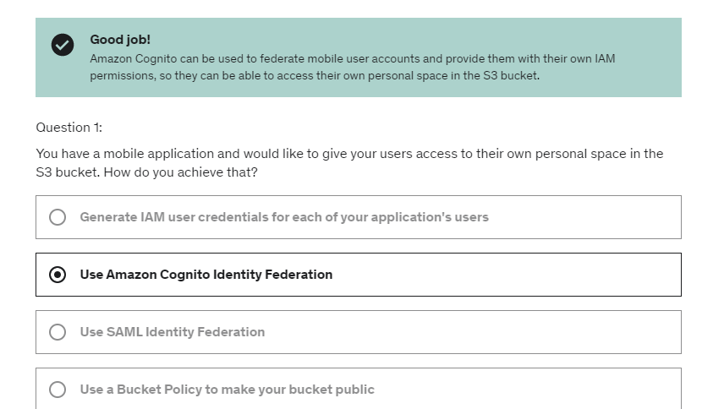

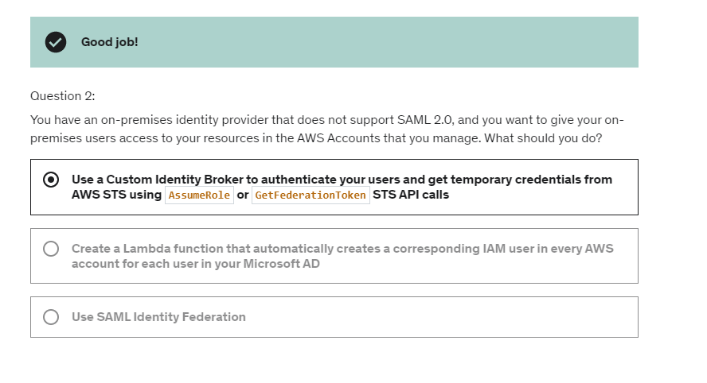

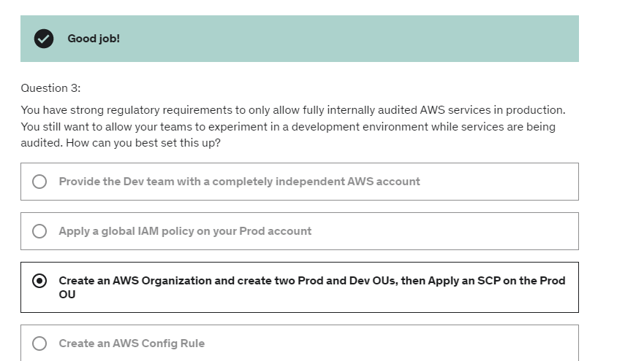

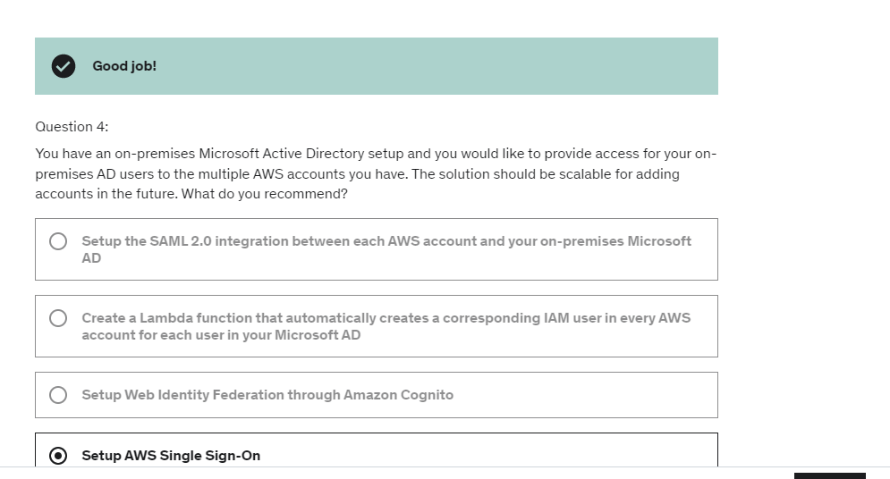

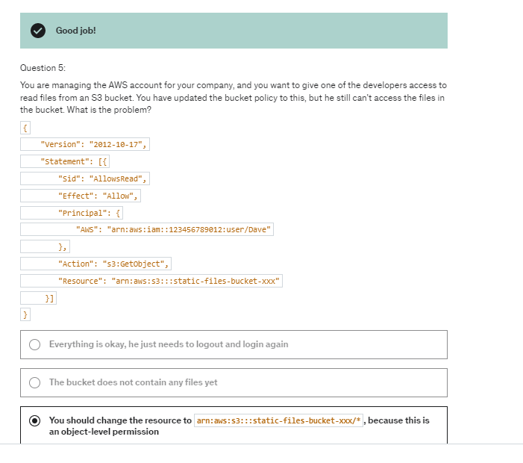

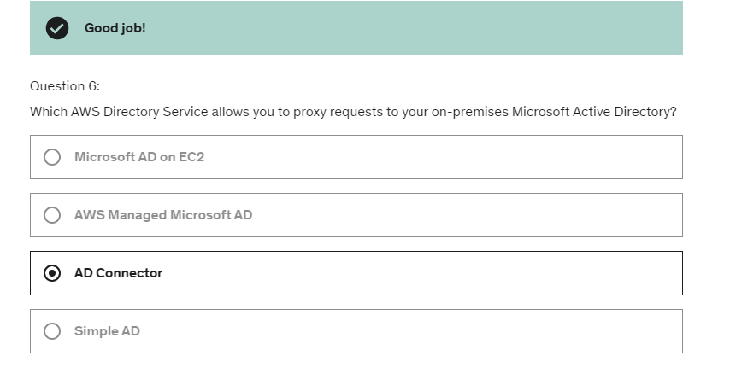

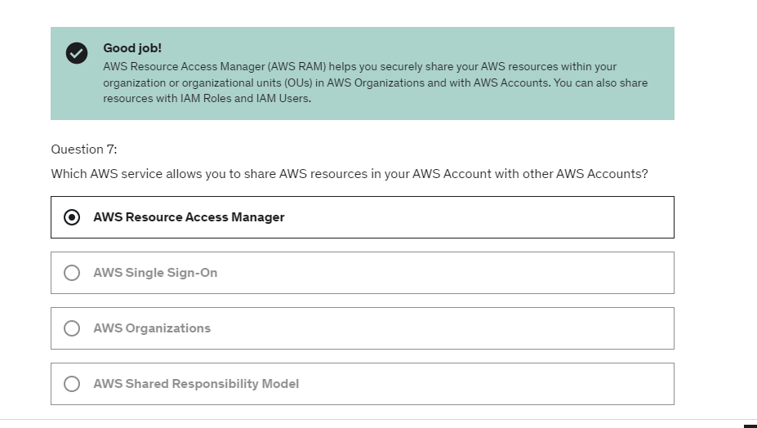

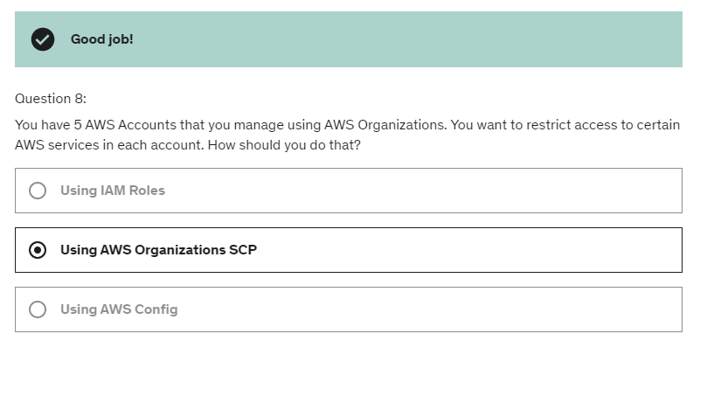

Encryption at rest:

The encryption and decryption keys

must be managed somewhere,

usually called a KMS, or key management service,

and the server must have the right to talk to

that key management service.

Slide 618:

There are three types of customer master keys.

There is the AWS managed

service default customer master key, which is free

so this is the idea when you go into EBS volume

and use the AWS/EBS key, this is going to be free.

Then, if you create your own keys, this is $1 per month

and there is no free tier

and if you import your own keys,

so if you have to generate them outside of KMS,

even though it's not very recommended,

then it's also going to be $1 per month.

And then, for KMS,

you're going to pay for each API call done to KMS

so we're talking about 3 cents per 10,000 calls.

Now, the idea is that with KMS,

the real value is that we actually don't see the keys

to encrypt the data or decrypt

so the whole security belongs with AWS.

To use that key we're able to,

where we can use we can send data to KMS

to decrypt and encrypt

and so that's the real value of KMS.

On top of it, KMS can rotate these keys for extra security.

to give access to KMS to someone,

they need to make sure that the key policy

allows the user to access the key

as well the IAM policy to allow the API call

and when these two things are together,

then you get access to KMS key.

KMS keys

are bound to a specific region.

So that means that when you create a KMS key in region A

it cannot be transmitted over to region B.

Now, let's talk about key policies.

To control access to KMS, we saw there was IM policies

and key policies.

So **key policies** are similar to S3 bucket policies

and or any kind of resource policies we've seen in this course

but the difference is that

you cannot control access without them.

So if you don't specify a key policy,

then no one can access your key.

In so as such, the **default KMS key policy**, by default,

is very permissive, it's created by default

if you don't provide a specific KMS key policy

and it's going to give access to the root user

which means that your entire AWS account

has the right to use this KMS key, on top of

only if they have the IAM policy available obviously.

So to give users access to KMS keys

using this default KMS key policy

very simple, you just create the correct IAM policy and attach it to the user.

 let's finally talk about

**cross-account copying of snapshots**

now that we know about key policies.

So when you create a snapshots

it would be encrypted with your own CMK,

then you would attach a key policy

to authorize cross-account access on that key.

This would be an example key policy

in which we allow the target account to read our KMS key

then we would share the encrypted snapshots

and in the target account,

we would create a copy of the snapshots

which would be possible

because we have access to the KMS key

in our original accounts

and then finally,

we would create a volume from that snapshots

and this is how we was create and copy

a snapshot across accounts.

While creating symmetric key, key policy can be either default or custom:

“But if you want to have a more tailored key policy,

then in here you would choose what services

or what users and roles can administer

this key through the KMS API.

So I'm not going to do this right now,”

default key policy,

which is to allow the root user

of my account to use this KMS key.

And by allowing the root user of my account,

this allows any user enrolls within my accounts

to access this KMS key, which is the most promising thing.

So this is great.

So what you need to remember from an exam perspective

is that if you want to have automatic key rotation,

the period is one year,

but if you want to have manual key rotation

then you can go to 90 days or 180 days

based on the requirements.

For manual rotation-and you're going to issue an UpdateAlias API code

and this updated alias will have

the alias point to the new key

and therefore from the application perspective

the change will not be detected.

It will just be transparent, okay.

ACM

So now let's talk about

the AWS Certificate Manager service also called ACM.

So with ACM, you can easily provision,

manage and deploy TLS certificates on AWS.

What are TLS certificates used for?

And they sometimes say SSL.

So they're used to provide

in-flight encryptions for websites.

You know, when you go to websites and it says

HTTPS, the S stands for secure,

and therefore this is where you know that

there is a TLS certificate involved in the transaction.

So how does that work while you have an ALB, for example,

connected to your Auto Scaling group

but you want to expose your application balancer

as an HTTPS endpoint.

Therefore you would integrate it

with a certificate manager to provision

and maintain TLS certificates

directly on your application balancer

and your users will access your websites

or your API using the HTTPS protocol.

So ACM supports both public and private TLS certificates

and it's free of charge if you want to use

public TLS certificates.

There is also a feature

to automatically renew these certificates.

We will see this in a second on other slides

and you have integrations with many AWS services.

So you can load TLS certificates on Elastic Load Balancers.

For example, the Classic one, the Application Balancer

or the Network Load Balancer.

CloudFront Distributions

or any APIs on the API gateway.

One thing you cannot use

the AWS Certificate Manager with is EC2 instances.

So for public certificates and only for public certificates

they cannot be extracted.

And so you cannot create public certificates

for your EC2 instances through ACM.

So what's the process to request a public certificate?

First of all, you need to list the domain names

that are going to be included in your certificates.

So there could be a fully qualified domain name

FQDN such as corp.example.com,

or it could be a wildcard domain,

for example, star.example.com.

And you can include as many domains as you want.

Then you select the validation method.

Would it be through DNS validation

or through email validation?

And for automation purposes,

when it comes to automatically renewing

your SSL certificates,

DNS validation is going to be a preferred method.

And for email validation,

what's going to happen is that ACM

is going to send emails to contact addresses

in the registrar for your domain

and verify that you did request that certificates.

And if you decide to do DNS validation,

then you will have to create a CNAME record

in your DNS configuration

to verify that you own the domain.

And so if you have Route 53, for example,

then it's automatically integrated with ACM

to do this for you.

Next, you have to wait a few hours to get verified

and then your certificate will be issued.

And these public certificates will also be enrolled

for automatic renewal.

That means that automatically

ACM will renew any ACM-generated certificates,

60 days before expiry

which gives you a lot of peace of mind.

So when it comes to ACM,

what if you import a public certificates?

So you have the option to actually generate a certificate

outside of ACM and then import it into ACM.

But in that case, because it's been generated

outside of ACM, there is no automatic renewal.

And so therefore, before your existing certificate expires

you need to import a new one.

And how do you know when a certificate is going to expire?

Well, the ACM service is going to send

daily expiration events,

starting 45 days prior to expiration

into your event bridge service.

And the number of days can be configured.

You can set 45, you can set 30, whatever you want.

So that means that daily,

you will have an event in EventBridge

for expiring certificates

and that's one way of doing it.

And then from EventBridge

then you can trigger Lambda functions

or SNS topics or SQL, SQS.

There's another way to use AWS Config.

And there is a managed rule

in Config called the ACM-certificate-expiration-check.

And it's going to check for expiring certificates.

You can configure the number of days again.

And so the Config service is going to have

a rule that will check the ACM service.

And then if any certificate is deemed not compliant

then the event of non-compliance

will be sent to EventBridge.

And yet again, we can trigger Lambda, SNS or SQS.

So two ways of getting these automatic alerts.

Now, how does the ACM service integrate with the ALB?

So we've seen kind of an ALB

with an Auto Scaling group in the backend,

and we can provision and maintain a TLS certificate

through the ACM service.

But there is a very good specificity.

On your ALB, you can set a redirect rule from HTP to HTTPS.

That means that if your user is accessing

your Application Balancer on the HTP protocol

the ALB will return with a redirect

and say you need to redirect to HTTPS.

So the user comes back to the Application Balancer

now on the HTTPS protocol,

and therefore it will leverage

the TLS certificate coming from the Certificate Manager.

And then once a request is going through the HTTPS protocol

then it will be directed into your Auto Scaling group.

So let's look at how **ACM integrates with the API gateway**.

But first we have to remember the end point types.

So we have the Edge-optimized endpoint type for API gateway.

This is when your clients are global

and the requests are going to be routed

first through CloudFront Edge locations

to improve the latency and then sent to an API gateway

that still lives in only one region.

You can also have the Regional type of endpoint

in which clients are within the same region

as your API gateway.

In this case, we don't have CloudFront available

but we could still, if you wanted to,

create our own CloudFront distribution

to have more control over the caching

and the distribution strategy.

And then we have the private API gateway endpoints

that can only be accessed from within our VPC

using an interface VPC endpoint

and we need to use a resource policy to define access

to this API gateway in a private mode.

So ACM makes sense for Edge-optimized and regional endpoint.

So let's have a look at that.

So to **integrate ACM with the API gateway,**

first we need to create a resource

in the API gateway called a Custom Domain Name

and then we need to configure it.

So for Edge-optimized endpoints,

then because the requests are routed through CloudFront

then the **TLS certificates**

**are going to be attached to your CloudFront distribution**.

And therefore the TLS Certificate

must be created in the same region as CloudFront,

which is us-east-1.

So therefore your API gateway lives in one region

but then everything is distributed through CloudFront

and your ACM certificates must live

in the us-east-1 region

because this is where CloudFront is located.

All the certificates for CloudFront are in us-east-1.

So then we set up a CNAME or an alias record

in Route 53 to be done.

And the regional endpoints,

there for clients in the same region as your API gateway,

and therefore, because we only have an API gateway

then the **TLS certificate must be imported on API gateway**

in the same region as the API stage.

And therefore, in this example

my ACM is only in the ap-southeast-2.

And then we set up a CNAME or an alias record in Route 53,

to point to your DNS.

Aws ssm get-parameters with-decryption

 it's called with-decryption,

so I'll do with-decryption.

And so this will check whether or not

I have the KMS permission to decrypt

this secret that was encrypted with the KMS tutorial key.

So press Enter.

And now this time, for my SecureString,

the value has been decrypted

because I specified the with-decryption parameter.

it turns out that because we haven’t given KMS access

to my IAM role we're not allowed to decrypt the secrets,

so this is a good proof that even though

I have access to this database password,

because it's encrypted and I don't have access to KMS

I'm not able to decrypt it,

So in the IAM role one iam policy is added to get read access to SSM(get-parameters*) and another policy to have write access to KMS in order to decrypt things

AWS secret manager

On top of it you can integrate secrets manager with RDS to synchronize your secrets between your

databases and secrets manager.

And so when you go into the exam anytime you see secret storing rotation of secrets integration with

RDS think secrets manager

So the idea is that with these special integrations with RDS or redshift or document DB you would have

to select a database to integrate this with.

So that makes it a little bit more powerful because now the secret's manager will hold the value of

the username and password.

But on top of it it will also set these values on the linked RDS database automatically.

And you can also enable rotation as well to make sure that the secret rotates every so often.

Cloud HSM:

So with KMS, AWS will manage the software for the encryption

and we'll have control over the encryption keys.

But with CloudHSM,

AWS will provision some encryption hardware.

It's called an HSM device.

So a dedicated hardware,

which is a Hardware Security Module.

And then we are going to manage

our own encryption keys entirely, not AWS.

The HSM device is going to be set up

within the cloud of AWS,

but it is tamper resistant

with FIPS 1042 Level 3 compliance,

So with the CloudHSM,

AWS will manage your hardware,

whereas the service itself can be used on your own.

The CloudHSM Clients is something you have to use

to establish a connection into the CloudHSM service,

and then you are going to manage the keys overall.

So the IAM permissions are going to be used to do a create,

read, update, delete of an HSM Cluster at a high level,

but then you're going to use a CloudHSM software

to manage the keys and manage the users

and their permissions to access the keys,

which is different from KMS

because in KMS, well, everything is managed using IAM.

The master keys are three kinds on KMS.

They're AWS Owned, AWS Managed

and Customer Managed CMK,

whereas for CloudHSM

it's only Customer Managed CMK

because AWS can not access your HSM device.

The only thing that you need to note is that right now

if you wanted to import an asymmetric key,

you can only do it in CloudHSM.

So if you have an on-premises a key management system

that uses asymmetric keys,

and you wanted to import it into AWS,

the only option would be to use AWS CloudHSM.

In terms of key accessibility,

well, KMS is accessible in multiple regions,

but because CloudHSM is deployed in a VPC,

you can share it across VPCs using VPC for sharing.

And so that means that it's going to be accessible

across multiple regions if you want it to.

because you have a Load Balancer and those kind of groups

that scales a lot and so on,

because you have a DDoS,

then all the higher fees are being waived

because you are updated to choose for AWS Shield Advanced.

All that we need to remember is that there's Shield **Standard**

by default free, and protects you against DDoS

on EC2, ELB, CloudFront, Global Accelerator, and Route 53.

And then there's Shield **Advanced**

if you want to have a team to help you with the DDoS,

and you wanna protect yourself against higher fees.

So for example, we could create a firewall rules

which will restrict an IP address from accessing

our websites that is deployed on

an application Load Balancer.

Then you can also put some constraints

around the size of a query.

So maybe you don't want a query to be bigger

than five megabytes, in which case,

a size constraint ACL will really help

decrease the amount of load your website can have

due to miss forms or bad queries.

You can also have geo-match to block specific countries

from accessing, for example, your API gateway

by attaching a web ACL on to your API gateway

and blacklisting a country you don't want it to be

going onto your website.

Finally, WAF can also be used to protect yourself against

DDoS and so it can give you DDoS protection.

How by including some rate-based rules.

So in these cases,

we don't look at each request individually,

we look them in bulk.

And so we're going to count the occurrences of events,

for example, per IP and we want to say, okay

an IP should not do more than five requests per second.

Otherwise, it looks like it's an IP, that's a bot,

and it's going to attack our infrastructure.

And so in this case, using rate-based rules

can help for DDoS protection directly within WAF

and so we can see WAF can help us with HTTP defense,

thanks to the fact that an HTTP request is more structured.

And we can defend ourselves again for IP addresses,

SQL injection, Cross-Site Scripting, geo-match,

rate-based rules and DDoS protection.

So this is great.

And Firewall Manager is to manage all the rules

of all your WAFs within an AWS Organization.

You define a common set of security rules

and the WAF rules applies to the exact same thing.

So ALB, API gateways and platforms,

but also Shield events, which applies to ALB, CLB,

Elastic IP and platforms,

your security groups for EC2 and ENI resources in VPC.

So it's a centralized way

to manage all these things together

within your organization.

we have the users that go through route 53

for the DNS service, which is protected by Shield.

And then they go for cloudFront Distribution,

again, which is protected by Shield.

And we can also install WAF to control the type of request,

that get to CloudFront and maybe deny them at the edge.

And if they all go through,

then they go to your Load Balancer,

which is also protected by Shield.

And finally, to your auto scaling group

that hopefully scales if you're experiencing an attack.

So this is the very common simple architecture

for protecting yourself against attacks and DDoS.

I hope that makes sense and in the next lecture,

we'll just do a quick hands on

to see how Shield and WAF work.

GuardDuty can also help you be protected

against CryptoCurrency attacks

because it has a dedicated finding for it.

 Amazon Inspector allows you to do automated

security assessments for your AWS infrastructure.

That means it's going to look at two things.

Number one is EC2 instances.

And for these EC2 instances it's going to run

in the backend the AWS systems manager agent

and then it's going to analyze

against unintended network accessibility, number one.

And number two, it's going to analyze

the running operating system against non vulnerabilities.

That means that automatically you're going to detect

if you have issues on your EC2 instances.

And then the second type of workload

that is supported by Amazon Inspector

is to analyze containers that are being pushed to Amazon ECR

and Amazon ECR stands for Elastic Container Registry.

This is where you store your container images.

So you're going to get assessments of containers

as they are being pushed into Amazon ECR.

Now, all these reports are going to be delivered

into the AWS security hub

and these findings are going to be sent

to Amazon EventBridge as well.

to summarize

we have an EC2 instance example, running the SSM agent.

And then the inspector service is going to run

assessments continuously and automatically.

The findings are going to be sent to security hub

and also Amazon EventBridge.

After that you're going to get a risk score

that is going to be associated with all the vulnerabilities

and you're going to have to prioritize for them.

Macie:

So, very simply, your PI data will be in your S3 buckets

and will be analyzed by Macie which will discover

what data can be classified as PII

and then will notify you through CloudWatch Events

or EventBridge of the discoveries.

Then with the integration with CloudWatch Events

you can have integrations

into an SNS topic, Lambda functions, and so on.

Shared Responsibility model:

So in the instance of EC2 instance, your customer,

so you, is responsible for the management of all the

operating system that includes patching the operating system

and making updates to it.

You must configure the firewall,

so that means that's you must configure, for example,

the network ACL and the security group,

and also you need to make sure that your EC2 instance has

the correct IAM permissions through the use of,

IAM instance role.

Then, we also need to ensure that we

encrypt the application data,

according to our compliance requirements.

Shared controls:

For example, for patch managements,

if using something like RDS,

then AWS will do the patch management for us.

And if we are using something like EC2 then we have to

patch our operating system,

so the shared control is here.

For example, for awareness and training,

AWS has to train their employees

to use their facilities correctly,

and to make sure they adhere to their security guidelines.

And you have to make sure to train your employees correctly,

to use the cloud,

and doing this training is one of these ways, obviously.

RDS example:

And if you wanted to configure a database you could use

parameter groups, for example,

to force only encrypted connections.

Finally, if you wanted to encrypt the data

within the database, it is again,

your responsibility to enable.

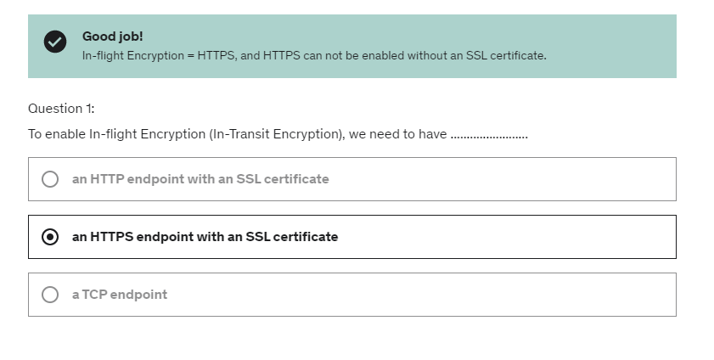

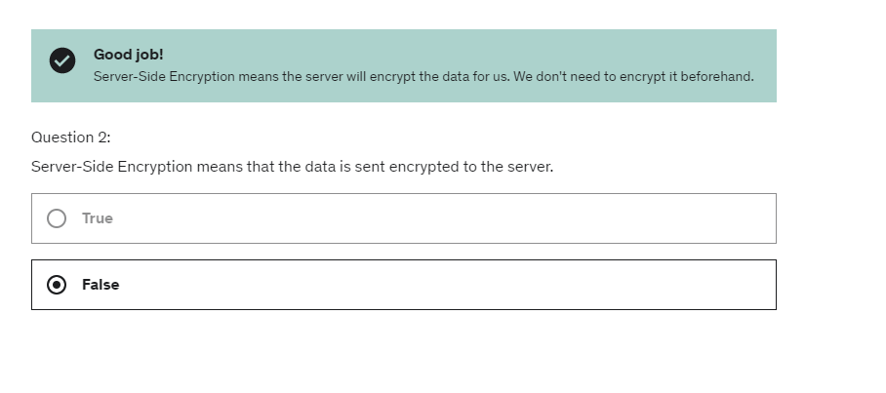

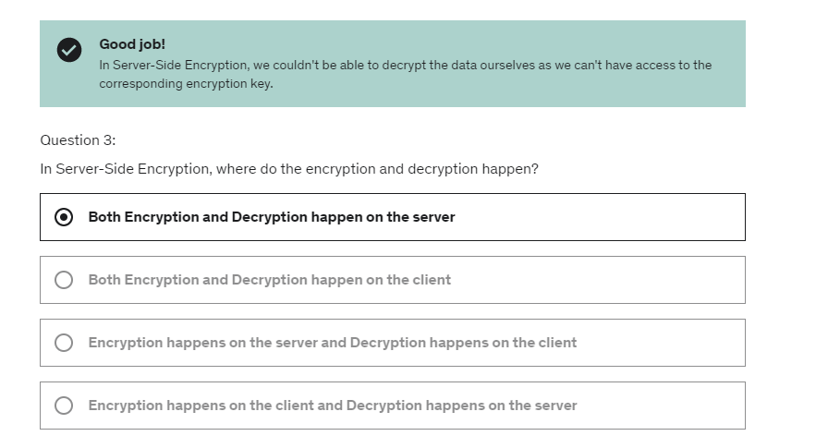

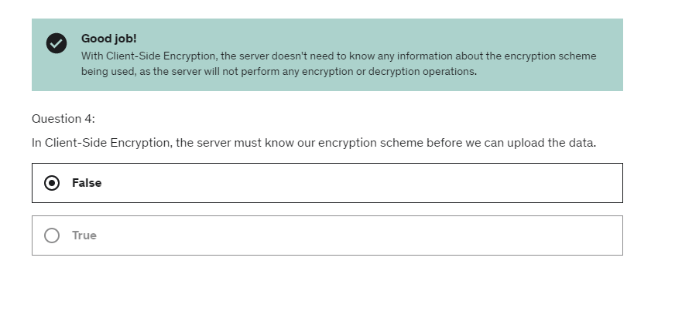

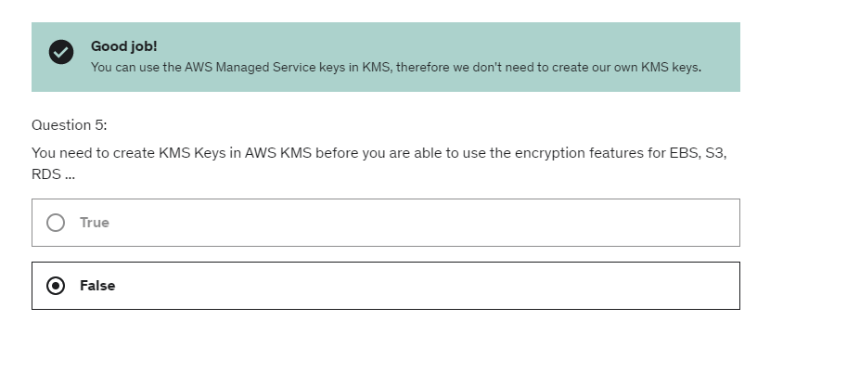

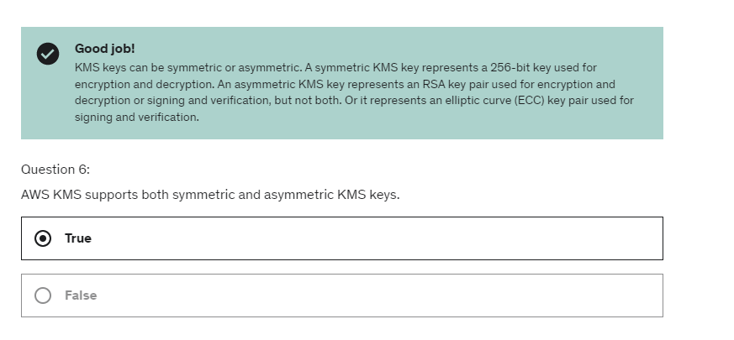

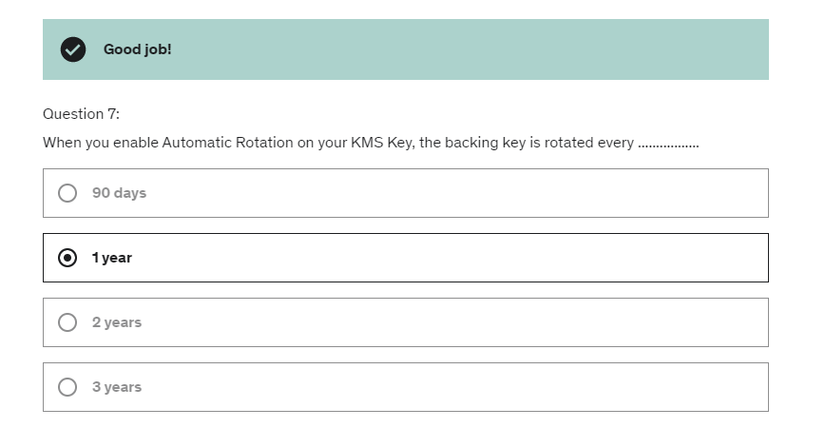

Revise:

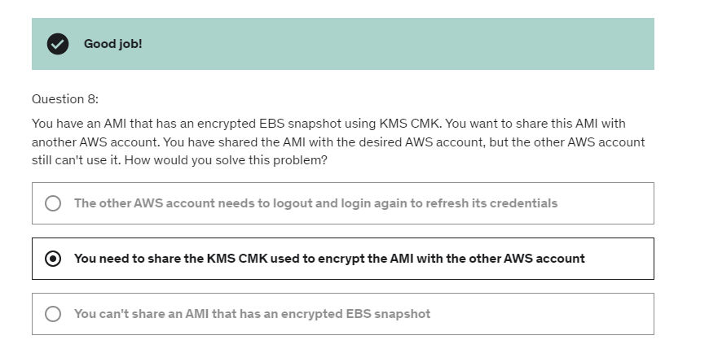.

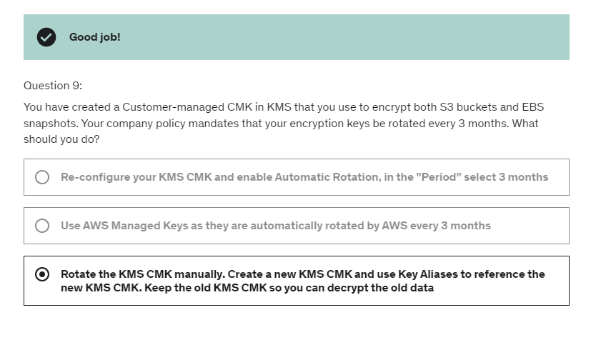

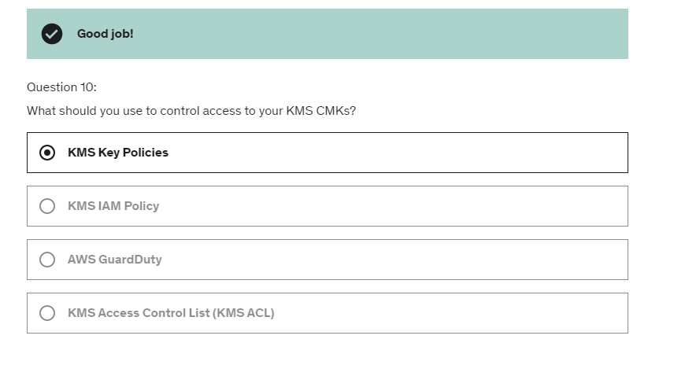

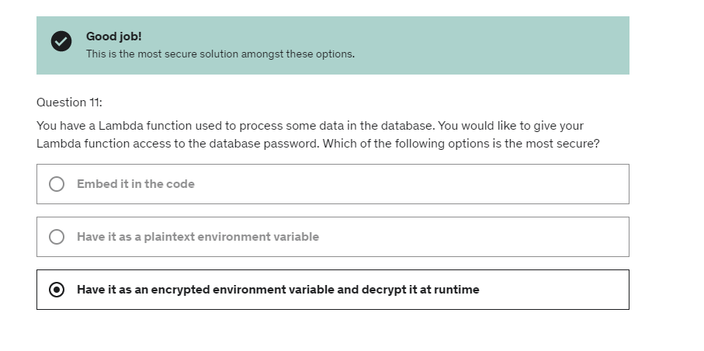

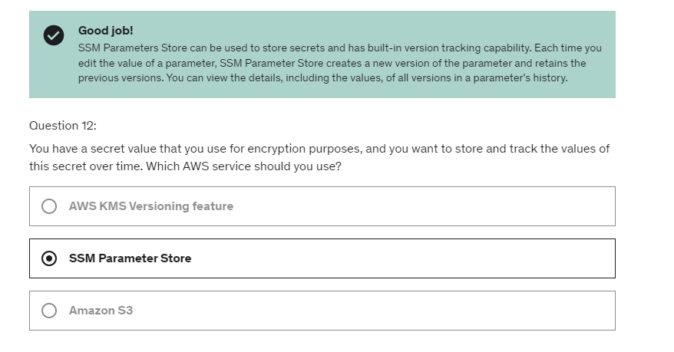

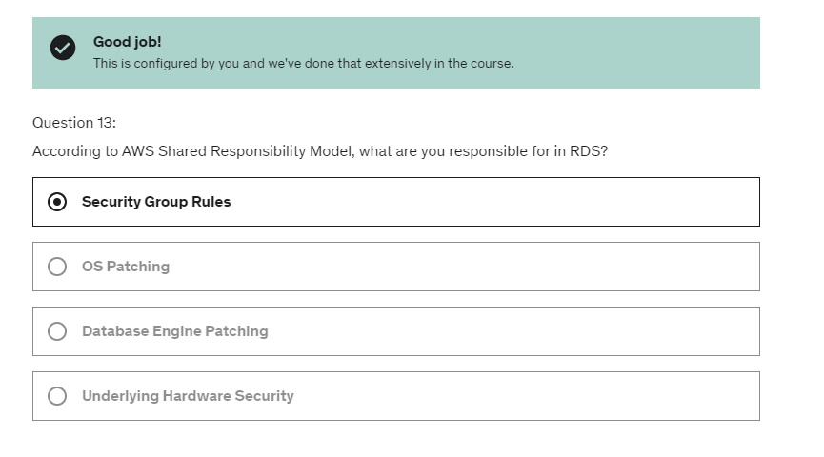

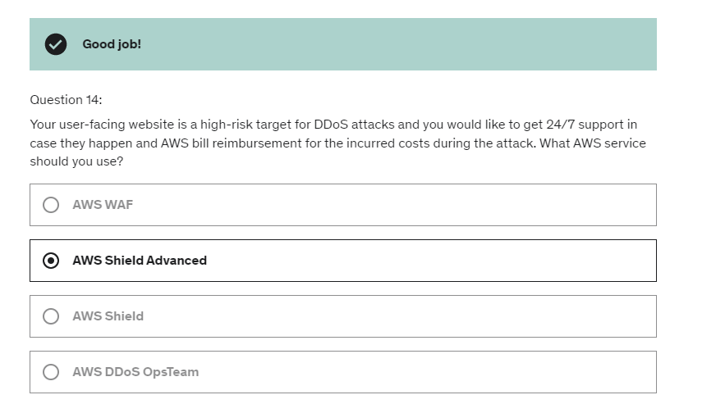

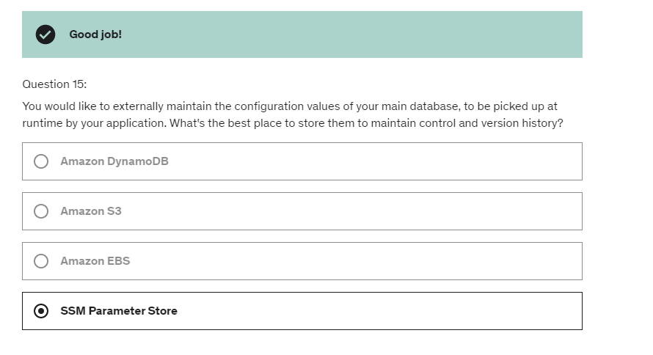

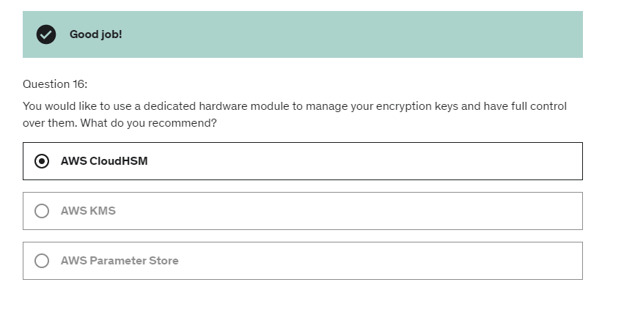

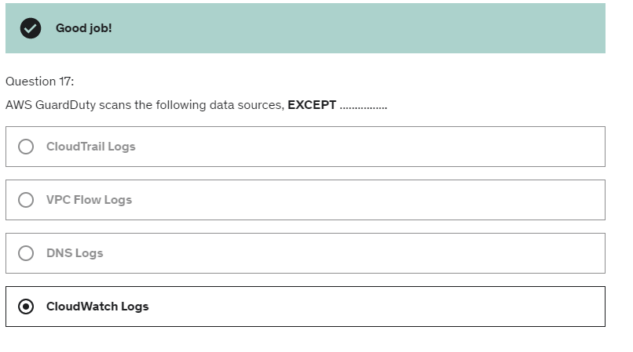

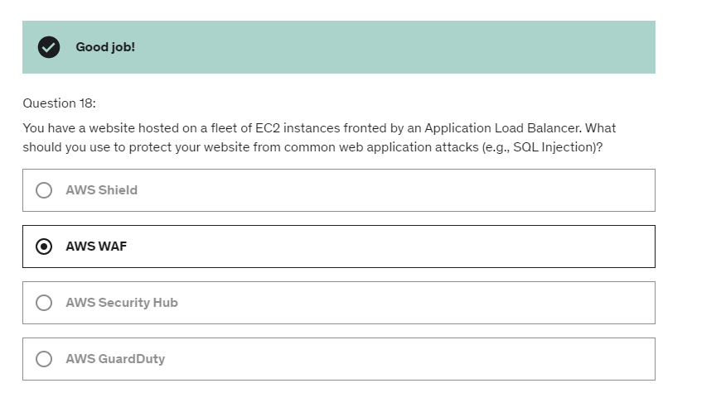

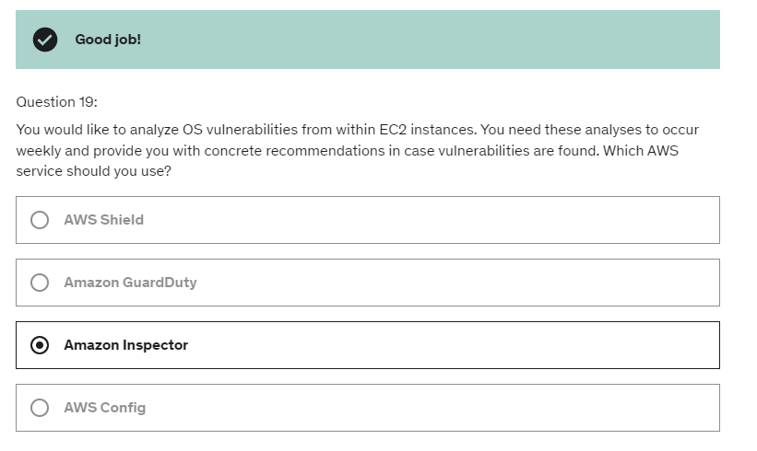

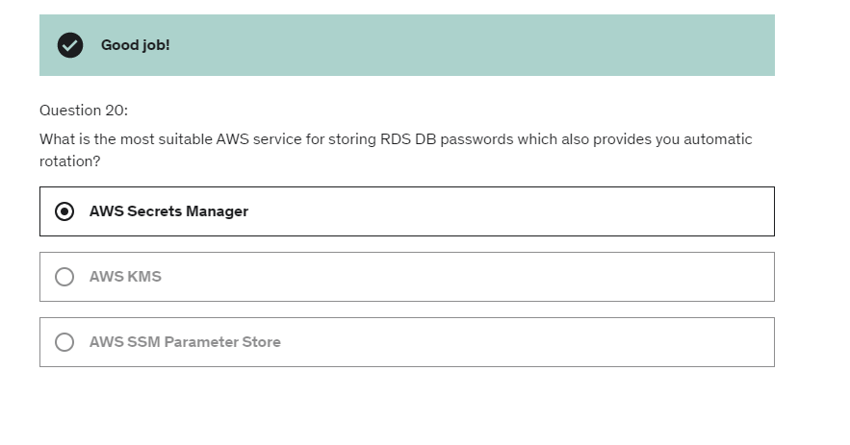

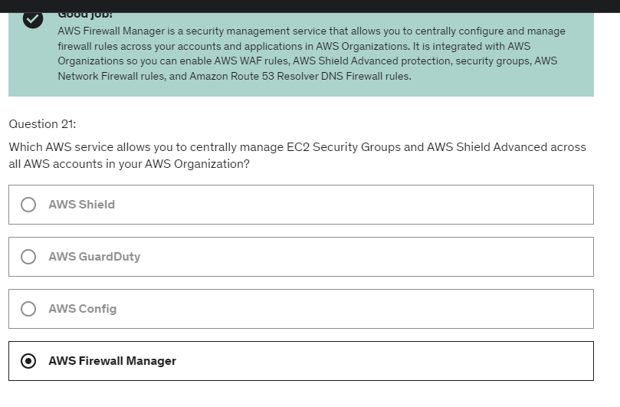

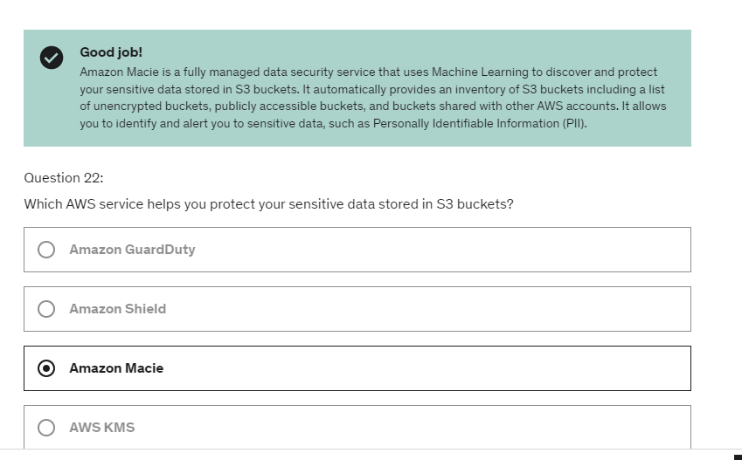

Then we have the 172.16.0.0/12,

which is another sets of private IP addresses.

And when you create an account

it will provide you with a default VPC

and it turns out the default VPC

will be included in that networking space.

And then finally,

another one you may have seen before is 192.168.0.0/16,

which represents your home network.

So, this is very common when you have an internet router

to have your own devices,

have an IP that starts with 192, okay?

you create your own VPCs

in your production accounts

instead of using the default VPC.

 the route table is helping your traffic

being routed through your VPC.

Default VPC -> 3 subnets

Each subnet has its own IPV4 CIDR.

3 subnets, one in each AZ.

we got three subnets across three AZ

to have a highly available architecture if we needed to.

Each subnet has a route table and n/w ACL.

And as you can see there is a default subnet

and we have the setting auto-assign public IPv4 enable

that means that any EC2 instance created

into these default subnets will have a public IPv4, okay?

And then there is network ACL-

But it turns out that's all traffic on all protocols

from everywhere is allowed for inbound and for outbound.

So, that means that anything launched

into these subnets, okay.

Will be having network connectivity, which is good.

And if you look at the subnet association,

this route table is not explicitly associated

with any subnets, but it is implicitly associated,

because these subnets do not have a route table

assigned to it.

So, the main route table is by default going to be assigned

to them implicitly, okay?

In terms of tenancy,

we have Default or Dedicated.

And this is to define how EC2 instances launch

within this VPC.

We'll have either dedicated hardware or shared hardware.

Now, dedicated hardware is very expensive.

So we are going to have shared hardware by default.

So tenancy is Default.

So a subnet is going to be, again,

a sub-range of IPv4 addresses within your VPC.

And it turns out that's in this range,

AWS will reserved the five IP addresses in it

In a public subnet,

you wanna choose not too many IP addresses.

Usually, this is reserved for your load balancers

or your front-facing infrastructure.

So, a smaller subnet size is good.

We're going to create an Internet Gateway in this VPC,

and this enough will not give internet access

to our subnets.

What we need to do is to also edit the Route Tables.

So we'll create a Public EC2 Instance in our Public Subnet

and then we will have to edit a Route Table so that

the EC2 Instance can connect to the Router,

then connect to the Internet Gateway,

and then from the Internet Gateway connect to the internet.

So if you have a look at the route right now

in our route table, it turns out that we have a traffic rule

for 10.0.0.0/16 to go to local.

That means that any IP within our VPC,

so this is the VPC CIDR,

already corresponds to the VPC.

So it should be routed from within the VPC

hence the target is local.

But we can edit the routes and saying,

hey, I want to have a second route

and I'll take the first one.

So any IP, so this represents any IP.

So any IP that does not match this rule,

the target should be going to,

and as you can see there are a lot of different options

but for now it's an internet gateway

and we'll choose the internet gateway we just created.

So we're saying, hey, if this is a local IP in our CIDR,

just please make sure you route locally.

But if this is anything else,

including obviously public IPs,

then target is going to be the internet gateway.

So send traffic to the internet gateway.

But also we can create instances into private subnets,

and we cannot SSH into them

because if we were to give the private subnet

access to the internet gateway,

then you would actually make these EC2 instances

public and that would defeat the point.

So the question is how do we connect to these instances

in our private subnets?

And the way to do so is to use the Bastion Host.

So a Bastion Host is an EC2 Instance in a public subnet,

And what we have to do is edit the security group

rules of the EC2 Instance in the private subnets.

And what we have to do then is to allow the users to SSH

directly into the public subnet's Bastion Host,

the EC2 Instance,

and from the Bastion Host,

we're going to SSH

into the EC2 Instance of the private subnet. So there's a concept of the hop.

To hop through the bastion host into the private subnets.

you need to also ensure that your EC2 instances

security groups are properly configured

to allow traffic from the Bastion Host.

So NAT means Network Address Translation,

and these NAT instances allow EC2 instances

in private subnets to connect to the internet.

To do so, the NAT instance must be launched

in a public subnet and then will connect the public subnet

and the private subnets.

And the default route table

is going to be associated with subnets

that don't have an explicit route-table association.

So currently this default route table,

main route table, is associated with four subnets,

but I don't like it.

I think there's much better

to have explicit subnet associations.

So what I'm going to do

and I'm going to create two route tables.

So I'll call it PublicRouteTable

and then we'll assign it to this VPC.

And the reason we do so is that I want to assign my subnets

to the right route table.

So the public route table should have subnet associations.

We're going to edit then.

And we're going to add all the public subnets

into my public route table.

So I click on save.

And then my PrivateRouteTable,

again, I will edit the subnet associations

and I will assign them the private subnets, A and B.

And it turns out that my main route table,

this one, does not have any subnet association

because all subnets have been assigned.

So this is better.

NAT instance:

So then the IP at the instance wants to access the server,

the public server,

but it has to go through the NAT instance.

So the request is seeing that the source IP is 10.0.0.20,

which is true, which is a private IP,

and the destination is 50.60.4.10 which the NAT instance

is smart enough to say, hey, I know you're trying

to send traffic to something else,

so let me send the traffic over to that server.

But that server has something different.

So the destination is still this IP,

but now the source IP is 12.34.56.78,

which is corresponding to the public IP of the NAT instance.

So as you can see, this network packet gets rewritten

by the NAT instance, this is what NATs do,

they rewrite network packets,

and the source IP has changed.

The server now says, hey, I know how to reply to you

because the source is me and the destination

is the public IP of your NAT instance,

and then the NAT instance will reply back the traffic

to the EC2 instance, it's smart enough to know which one

to go to, and say, hey, the source is the public server

and the destination is your private IP.

And this is why,

because there's some IPs are being rewritten,

this is why the source and destination check

must be disabled on the EC2 instance for your NAT instance.

And then if you select a small instances,

then you're going to get less bandwidth

than a bigger instance.

Nat instance SG:

and we're going to create a new security group.

So rules wise, we're going to create a few things.

So SSH from anywhere, yes.

Then we have to add more rules.

So HTTP,

and then the source is a CIDR

and the CIDR block is the same as our VPC.

So 10 0 0 0 slash 16.

And then we're going to do the same, but for HTTPS

so to allow HTTPS traffic out as well

from the same CIDR block.

And then the last thing to do is to, of course

edit the VPC setting to be in my demo VPC.

And we deploy this NAT instance in the public subnet

for example, public subnet A.

So we have to redo this.

So NAT instance, SG is the name of the security group.

And actually my roles are kept.

So make sure to name it, NAT instance SG.

Okay, so we are good to go.

because if this is NAT instance

you must stop the source destination checking

because the NAT instance must be able to receive

and send traffic when the source

or destination is not itself.

So I'm going to re SSH into my private instance

so to do so I have to go through the Bastion Host.

So I will use EC 2 instance connect.

Great. I'm connected into Bastion Host

and then I will use the SSH command.

So EC2 user @, and then I need to have the private IP

of my private instance in here.

So I will copy this and I will paste it

minus I demo keypair.PEM.

Okay, so I am in my private instance.

And again, remember if we did PING Google.com

we're not getting any reply.

So this doesn't have internet access.

Now let's give internet access to the private subnets.

And to do so in my private route table, on the routes

we need to edit the route.

So let's edit them.

And currently we have this one for local rules

but we're going to have one that says, if you want to talk

out to the internet, then please go through your instance.

And the instance has to be the NAT instance, save.

And what we've done effectively is saying, 'Hey

for any EC 2 instance within this subnets

because it's associated with this route table

if you send traffic to the internet

so anywhere then go through my EC 2 instance

which is exactly what a NAT instance is for.'

we need to also enable one specific port

on the NAT instance.

So let's go to security and the security group rules

and we need to enable a specific port for PING.

So let's edit the inbound rule

and I will add a rule for PING.

So it's ICMP.

So all ICMP, IPV4, from this subnets

from the CIDR that we have right here.

Okay, and then click on save.

Now, if we try again, the PING command.

So what we've done effectively is

that we've given internet access to the instances

in my private subnet without exposing them to the internet.

As we can see my private subnet instance still

doesn't have a public IP.

We need to use the, the Bastion okay?

But it is quite natural to use the managed services in AWS.

So when you enable the DNS support setting,

then you can leverage route 53 to resolve the public DNS

names within the internet.

And if DNS Hostname is true,

that means that your EC2 instance will get a public

public host name.

If it also has a public IP for as we'll see in the next

lecture.

So without it, so without the DNS host I'm setting,

as you can see, EC2 Instance just has a private DNS,

even though it sits in a public subnets,

but with DNS support and DNS Hostanme my EC2

instance, has a private DNS of course,

but also has a public DNS that corresponds to its public IP.

So this is what the DNS host name setting does.

And why do we want to enable both of these settings?

Well,

if you have a custom DNS domain name in a private hosted

zone in Route 53,

and you said to both of these attributes to true,

then you can create this private hosted zone as we'll see in

the hands-on for example,

web.mycompany.private as a record of type A

and the value 10.0.0.10.

And the reason we do so is that now an EC2 Instance in

the private subnets can have a private DNS name associated

with a private IPv4.

And you're EC2 Instance when requesting that private DNS

name, we'll look it up to the Route 53 resolver,

which we'll look up the private hosted zone and say, yes,

I know what this is. This is 10.0.0.10.

And then the EC2 Instances will know how to reach out to the

other EC2 Instance. Okay.

So, we need to enable DNS hostnames.

And this is to indicate whether instances with public IP

addresses get corresponding public DNS hostnames.

So that means that now we can go to the next stage and look

at Route 53 hosted zones.

So now we can create a private one.

So what I'm going to do is going to host the zones,

and I'm going to create a hosted zone.

Now this one is going to be called demo.internal.

And as you can see,

this is a domain name that I don't own,

but because this is a private hosted zone,

I don't need to own this domain.

This just allows my EC2 instances to resolve it.

So I'm going to select a private hosted zone,

and because this is a private hosted zone,

we need to associate it with a specific VPC. So the region

I'm in is EU-Central-1 and the VPC ID is my demo VPC.

So as you can see for each VPC that you associate with the

private hosted zone, you must set the Amazon VPC setting,

enabled DNS host name and enableDnsSupport to true,

which we did in a few minutes ago.

So just remember that if you create this hosted zone is

going to cost you 50 cents per month, just so you know.

So let's create this hosted zone, okay.

It is created. And within they have two records,

but let's create a new record.

And this one is going to be a google.demo.internal,

and it's going to be a C name.

And the value of it is www.google.com.

And this is just to demonstrate as creating a quick record.

So we'll choose a simple routing. Everything is good.

Let's create this record. So this was created successfully.

And now we need to see with our not instances within our

VPC can resolve this hostname.

So let's go into the EC2 management console,

and then I'm going to connect to my bastion hosts and

connect to it. So this is an instance in my public subnets,

so I can directly SSH into it and I need to install the

dig command. So the dig command is already installed.

So it's it perfect.

And then just dig and then google.demo.internal.

Press enter. And as we can see, we get an answer.

So google.demo.internal is a C name and the value of it

is Google.com and Google.com then corresponds to

Google. And it's an area code with this IP address.

So the really cool thing is that now we are able to create

internal private records for our DNS, thanks

to this things we enabled. And this is Tasha VPC,

and this is really,

really powerful because now we can start creating some very

interesting domain names for our internal applications.

And the client does not have any open port by default.

So what it does that when the client

is connecting to a server,

the client will open a specific ports on itself.

And this port is ephemeral

because it's just a port that will be

as long lived as the connection is

between the clients and the server.

Now, here's the tricky part.

When the database sends back the request

to the clients, what do you think needs to happen?

Well, the client has an ephemeral port, right?

And so as such, they will be a random ports

being assigned for this request.

And so therefore,

the DB NACL must allow outbound TCP

on ports and, on ephemeral port,

so, maybe from 1024

to 65,535

to web subnet CIDR,

and then the web NACL also needs to allow inbound TCP

on this range of ephemeral ports

from the DB subnet CIDR.

And this is why ephemeral ports

are super important to configure well.

Another thing about NACLs you need to know

is that if you have multiple NACLs and multiple subnets,

then each NACL combination

needs to be allowed within the NACL,

because you're using CIDRs

and each subnet will have its own CIDR.

So it's super important for you to realize that,

if you add subnets into a NACL,

you need to also update all the NACL rules

to make sure that the combination of connections

is possible.

VPC_ Reachability Analyser:

So instead of having to dig through

the network configuration

and understand where the error is happening,

this builds a model of network configuration

between these two end points,

and then it will build and check the reachability

based on the configuration within your AWS accounts.

It doesn't not actually send back it

from source to destination.

It just analyzes your configuration

and tell you what's happening, which is very, very powerful.

So if we take an example of two EC2 instances, okay,

it says A and B.

They may be in different VPCs,

they have different ENIs

and they may have different security groups, okay?

And we're trying to figure out whether or not

Instance A can talk to Instance B.

So there's a bunch of things that need to happen, okay?

So first it goes from the Instance A to the ENI

then to the security group,

then to the network SCLs maybe,

and then to the security group

and through the ENI to Instance B,

and so all along the way,

this Network Reachability Analyzer Tool

from the VPC function is going to check

whether every single point is configured properly.

And in which case it will say, yes,

these two can communicate, they are reachable,

but in case they're not reachable,

for example, because of security group issue,

then it will automatically detect that one security group

will not allow traffic in.

And therefore your Instance B will not be reachable

from Instance A but all of this is done

by just analyzing network configuration,

not by sending packets.

So this is the idea,

and this is why it's super cool,

So again, this is very important, even though there's VPC

peering connections we need to still modify the route table.

So let's consider Amazon DynamoDB as a service.

So Amazon DynamoDB is a public service on the AWS.

And so therefore, your instances can access DynamoDB

directly through the public web.

So, an Institute instance in a public subnet, for example,

can talk to the internet gateway,

the internet gateway will route the request

to the public endpoint of DynamoDB.

And this works fine.

And if you want to have a private instance,

it could go through the NAT gateway,

then through the internet gateway,

and then to DynamoDB, this works fine as well.

But these services in AWS,

you know, they live within the AWS cloud.

So there should be a better way of accessing them,

which you access them privately.

And the answer, our VPC endpoints.

So VPC endpoints are private endpoints within your VPC

that allow you to initiate a private connection

to the AWS services.

So for example, here in my private subnets,

my EC2 instance can connect to the EC2, VPC endpoints

and then to CloudWatch or Amazon S3,

or whatever you want using a VPC endpoint.

But all this without traversing the public internet.

Well, if we consider VPC endpoint also,

they're called private link.

They're powered by private link.

So there are two types of endpoints in AWS.

There is the **interface endpoints,**

and there is the **gateway endpoints.**

We're going to create a VPC endpoint of type interface,

which is going to create an ENI within our private subnets.

And then our EC2 instance can connect to the ENI

if the security groups, rules allow,

and then from the ENI to Amazon SNS.

Now **gateway endpoints**, provision a gateway.

And these gateways are a bit more complicated because they

must be used as a target in a route table.

And gateway endpoints where only two services

you need to remember,

they support Amazon S3 and DynamoDB.

That's it.

So, you use

CloudWatch logs,.

If you want to have like some kind of metrics filter

to do some like real-time analysis

in case you're being attacked,

a lot of traffic is being rejected and so on.

So, this is very helpful.

And you use Amazon S3.

If you wanted to do some more bigger analysis,

for example, using Athena.

So the idea is that, now we have a VPC

but we may have also a structure

within the corporate data center,

and we wanna connect AWS to our corporate data center

using a private connection.

So for this, we'll have a customer gateway

on the corporation side,

and a VPN gateway on the VPC side.

And we're going to establish,

through the public internet,

a private site-to-site VPN connection.

So it's a VPN connection, so it's encrypted.

It goes over the public internet, though.

And using this, we have linked effectively

the network of our VPC

to the network of our corporate data center.

So, how do we set up the customer gateway device

that is on premises?

Which IP address should we use?

Well, if your customer gateway is public,

there is a public internet-routable IP address

for your customer gateway device.

Then you would use this one,

and you would establish the connectivity

between your VGW and your CGW

using the public IP of the customer gateway.

But it's possible for your customer gateway

to also be private and have a private IP.

In which case, then it is very common for it

to be behind a NAT device that has NAT-T enabled.

And then, that NAT device has a public IP, in which case,

the IP address you should use for the CGW

is the public IP of the NAT device.

And then, the site-to-site VPN connection

can be established.

I'm saying this because this can come into the exam.

And then, the second question that can come up

to the exam is that,

even though this is set up,

this site-to-site VPN connection will not work

until you enable route propagation in your VPC

within your subnets.

And then, when this is done,

then the connectivity will work.

Finally, another exam question that can come up

regarding site-to-site VPN.

If you need to ping your EC2 instances

from on-premises to AWS,

then make sure that the ICMP protocol on the inbound

of the security group is enabled.

Otherwise, I would say the connection will not work.

This is just a security group question, obviously.

But they mix it up with the site-to-site VPN

and that can be confusing, so here is some help.

It's a low-cost hub-and-spoke model

for primary or secondary network connectivity

between different locations,

but only using the VPN.

So you would establish a site-to-site VPN

between the CGW and the one single VGW within your VPC.

And then, thanks to this connection,

then your customer networks can now communicate

with one another through that VPN connection.

Now, because it's a VPN connection,

all the traffic goes over the public internet.

So they're not connected through a private network.

They're connected through public network

but the VPN connection is encrypted, obviously.

And to set it up, super simple,

you set up multiple site-to-site VPN connection

on the same virtual private gateway,

and then you enable dynamic routing

and you configure your route tables, and you're good to go.

So that's it.

That's all you need to know for site-to-site VPN.

Direct connect (DX)

The idea is that on the same connection

you can access both public resources

such as Amazon S3 and private resources,

such as EC2 Instances using the the public VIF

and the private VIF.

we'll using Direct Connect

you get a more consistent network experience,

again because it is private.

So this is especially helpful

if you have applications using real time data feeds.

So let's look at a diagram of Direct Connect.

So we have a region

and we want to connect it into our corporate data center.

So for this, we're going to commission

an AWS Direct Connect location,

their physical locations that you have to find

but it's all obviously on the website of AWS,

and there's going to be a Direct Connect endpoints,

and there's going to be a customer or partner router

that you have to rent from a customer or partner cage.

So you have two cages in this Direct Connect location,

and then on your on-premise data center,

you're going to set up a customer router with a firewall.

Now you're going to set up a private virtual interface,

so private VIF first to access your private resources

into your VPC.

So to do so, you set up the private VIF

in between all these locations

into a virtual private gateway.

And this virtual private gateway

is attached to your VPC.

And through the private VIF,

you are able to access your private subnets

with your EC2 Instances.

And as you can see,

all these things happen privately,

so you need to set up that connection manually,

it can take a month to set up,

but none of this goes over the public internet,

it is all a private connectivity.

So what if you want to connect

to one or more VPCs in different regions?

For this, you must use a Direct Connect gateway.

So we have an example

where we have two regions,

and they have two different VPC,

we have two different CIDRs

and we want to connect our on-premise data center

into both VPC.

So we're going to establish a Direct Connect connection,

then using the private VIF,

you're going to connect it to Direct Connect gateway.

And this gateway will have a private virtual interface

into a virtual private gateway

in the first region and another one in the second region.

So using the setup, we can start connecting to multiple VPCs

and multiple regions.

Direct Connect – encryption

So to set up is to get the Direct Connect location,

but then on the connection,

you're going to set up a VPN connection on top of it,

to have encryption for your Direct Connect

and therefore all the traffic

between your corporate data sensor to AWS

is going to be encrypted.

Resiliency:

So we have two modes of resiliency and architectures

and you need to know them both

because they will be coming up at the exam.

You have a high resiliency for critical workloads

where we set up multiple Direct Connects.

So we have two corporate data centers

and we have two different Direct Connect location,

and this gives us some redundancy.

So in the first case,

we have a private VIF here and we have a private VIF here.

And so here we get one connection and multiple locations,

and so if one of the Direct Connect location goes down,

then at least we have some backup

Direct Connect location somewhere else

and so this gives us high resiliency,

and this is good for critical workloads.

But if you want to get to maximum resiliency

for critical workloads

and I emphasize the word maximum

because it can come up in the exam,

then you're going to have to set up

again two Direct Connect locations,

but this time each Direct Connect location

will have two connections

independent to give you maximum resiliency.

So in this use case, we have four connections

across two locations,, going into AWS.

And so a maximum resilience is achieved

by using separate connections,

terminating on separate devices in more than one location.

Option number two,

you may think of based on what you've seen in this section

is to use VPC peering.

And in this case,

in case you need to

have one VPC connected to multiple customers VPCs

you need to set up if you're peering connections

between all these VPCs together

and that's a lot.

And on top of it,

when you set up a VPC incorrect peer in connection,

you open up the whole network

of one VPC to another

Whereas all you wanted was just to

externalize one application service.

o a way you could set us up, for example,

just to show you how everything can be used

is for using PrivateLink with ECS.

So we have an ECS service with multiple tasks.

They're exposed to an application about an answer, okay,

but we know that we need a network load balancer

to expose this. So how do we do it?

Well, we connect a network load balancer

to the application load balancer,

because the ALB can now be a targets of the NLB.

The PrivateLink can be established directly into your NLB.

And so for other VPCs

it could be an ENI directly into PrivateLink.

And for your corporate data center,

it could be a private connection, for example,

going over direct connect

or a VPN connection.

So it's a more secure and scalable way

to expose the service, say to thousands of VPC,

either in your own or other accounts.

And this is what the exam will test you on.

You want to expose the service to thousands of VPC?

What do you use, all the answer is PrivateLink.

So it does not require a VPC peering

or internet gateway,

or NAT or route tables.

And so when we wanted to have a link

between your VPC and your EC2-Classic instances,

you would need to create a Classic link.

So for this you must associate a security group,

and then that enables your instances

to communicate privately

from EC2-Classic to your VPC instances

using IPv4 private addresses.

And so before you had to use public IPv4,

but thanks to ClassicLink,

you can use the private network.

Transit Gateway:

We have transit gateway in the center

and you can connect multiple VPCs through

the transit gateway.

So in this example, we don't need to peer the VPCs together,

they are connected transitively through the transit gateway.

So in this example, all the VPCs can talk to each other.

But also, you can connect a direct connect gateway

to the transit gateway,

so it shows you have a direct connect connection

directly in to many different VPC.

Or if you are preferring site-to-site VPN

and VPN connections, you can connect your customer gateway

and your VPN connection into your transit gateway.

Again, one more time, giving you access to all these VPC

as part of the transit gateway.

So this really solves some network problems.

So, how do you define who can talk to what?

Well, you need to create route tables

for your transit gateway to limit which VPC

can talk to another, which connection have access

to each other and so on.

So, you get full control over the routing of all the traffic

within the transit gateway to give you network security.

So, as I said, it works with direct connect gateway

and VPN connections, and it is the only service in AWS

that supports IP multicast, so if you see IP multicast

at the exam, just know that it is transit gateway

you have to use.

So, another use case for transit gateway is to increase

the bandwidth of your site-to-site VPN connection

using ECMP.

So when you establish a site-to-site VPN connection

there are actually two tunnels, one going forward

and one going back.

When you are connecting such a VPN into a VPC directly,

both of these tunnels are used as part of one connections,

but when using the transit gateway

two tunnels can be used at a time,

so this is why you see two lines in this diagram.

But with transit gateway,

you can have multiple site-to-site VPN

so you can create a second site-to-site VPN attachment

and into your transit gateway,

so this creates four tunnels.

Obviously when you do the setup,

you're going to have to pay for each GB of data

going through the transit gateway,

so there's an added cost to this performance optimization.

Our EC2 instance is accessing the internet

and is being accessed.

And so we get a lot of inbound and outbound traffic

on the ENI to the EC2 instance.

But we wanted to analyze our traffic.

So to do so we're going to set up a Load Balancer

and behind this Network Load Balancer,

we're going to have an auto scaling group of EC2 instances

that will have some security software on it.

Now we want to be able to capture

all the traffic from Source A

without disrupting the functioning of Source A.

So to do so, we're going to set up a VPC traffic mirroring,

and optionally, we can have a filter,

if you want you to get just some information,

not everything.

And with this traffic mirroring feature,

all the traffic sent to the ENI or Source A

is also going to be sent to our Network Load Balancer.

So our Source A,

our EC2 instance is still working fine.

It still doesn't know what's happening,

but on top of it,

the traffic is being mirrored.

So hence the name, Traffic Mirroring,

into our Network Load Balancer.

And from there, we can analyze the traffic itself.

And this applies not just to one source,

but to multiple sources.

So if you had a second EC2 instance with another ENI,

yet again, we can mirror the traffic

into our Network Load Balancer

So if we go into the security group right here

and then edit the inbound rules, and then we add SSH

but this time from anywhere IPv6.

Then we can do an SSH into our BastionHost

directly using the IPv6 address

provided at our own computer, of course has an IPv6 address.

So if we have a look at the public route table, for example,

and look at the routes,

as you can see, there has been a rule added

into my route table which is saying that anything

that is using this CIDR of IPv6 should be local.

So that means that my EC2 instances,

if they have IPv6 addresses can communicate with each other

using their IPv6 address.

And if in the CIDR,

then all the traffic is going to remain local.

It's not gonna go through the public internet.

Well, they allow instances in your VPC outbound connections

over IPv6 while preventing the internet

to initiate an IPv6 connection to your instances.

And to do so, you must update your route tables.

So let's have an example.

We have the internet,

our VPC with a public subnet or private subnet.

And so this EC2 instance can access

the internet through the internet gateway

and can also have the internet initiate a connection

to the instance using IPv6,

because it's connected to the internet gateway

and it's in the public subnet.

Now we don't want that.

What we want is just outbound connections.

So let's consider an EC2 instance in a private subnet,

so it doesn't have an internet gateway,

that makes the subnet private.

And we're going to create an **egress-only internet gateway**.

So what's going to happen is that now

the EC2 instance in the private subnet

will be able to access the internet over IPv6

through the egress-only internet gateway,

but the internet will not be able to initiate

a connection from the internet to the EC2 instance.

So why do we have a public subnets?

Well, we attach an internet gateway and then

we cut a route from from the public subnet to

the internet gateway, and this provides provides

IPv4 and IPv6 internet access if enabled.

Now route tables will then be edited to have

routes to the alternate gateway,

the VPC peering connections, the VPC endpoints,

and so on. And they're key to make sure

that the network flows within our VPC.

Net Instances was an EC2 instance deployed

, in a public subnet to

give internet access to EC2 instances in

the private subnets. It is old.

It is getting deprecated and you need to

disable the source destination check flag for it

to work and also edit your security group rules.

So if you want to have the private DNS using

Route 53, you need to enable DNS resolution and

DNS host name settings in your VPC.

So two settings to enable.

VPC endpoints are allowing us to get

private access to AWS services such as

Amazon S3, DynamoDB, CloudFormation, SSM,

whatever you want within a VPC.

We saw they were gateway end points for Amazon S3

and DynamoDB, and all the rest was

interface end points

VPC Flow Logs was the

way for us to get some level of metadata around

all the packets within our VPC, and we had

some information around the ACCEPT and

REJECT traffic. Now, VPC Flow Logs can

be created at the VPC subnets or ENI level,

and they can be analyzed and sent to Amazon S3

and then analyzing Athena, or they can be sent

to CloudWatch logs and then analyzed using

CloudWatch Logs Insights for example.

First way – site to site vpn connection

The second way to connect to our data center

was to use Direct Connect, so this time the

connection is completely private.

It does not go over the public internet,

but it takes time to establish.

You need to hook your own data center

to a direct connect location for it to work.

So it's more involved but it's more secure

and has more stability onto the connection.

We saw PrivateLink or VPC Endpoint Services,

which is to connect privately to services

within your VPC that you have created

yourselves to customer VPC, and the

cool thing about it is that it doesn't

require VPC Peering, or the public internet,

or NAT Gateway, or Route Tables.

It's only used, mostly used with a

Network Load Balancer and ENI,

and this allows us to expose a service with

an our VPC to hundreds or thousands of customer

VPCs without exposing your network.

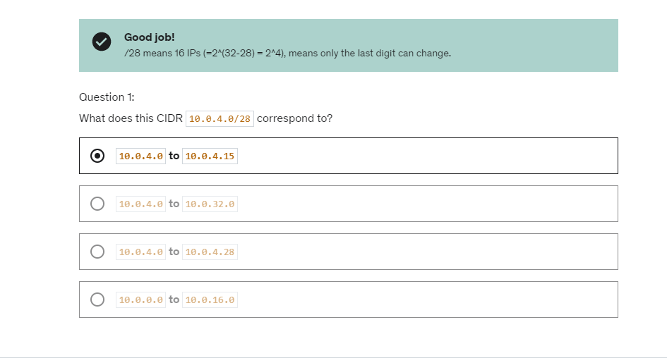

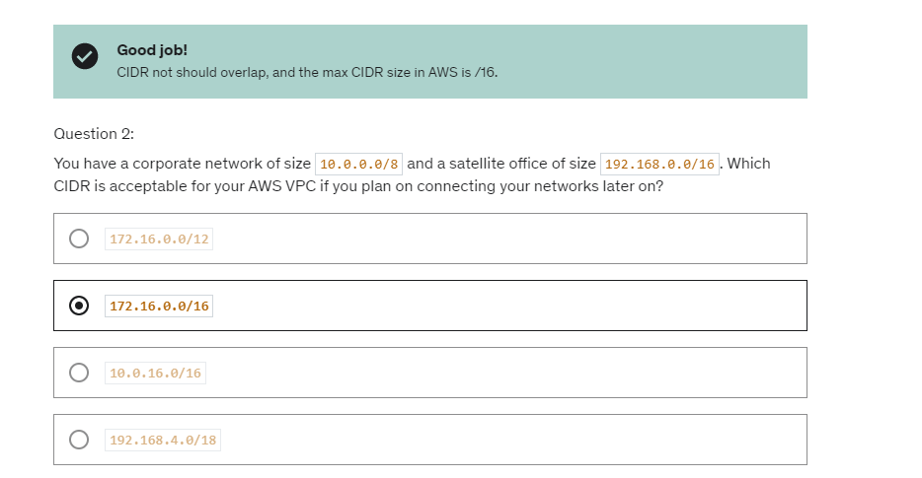

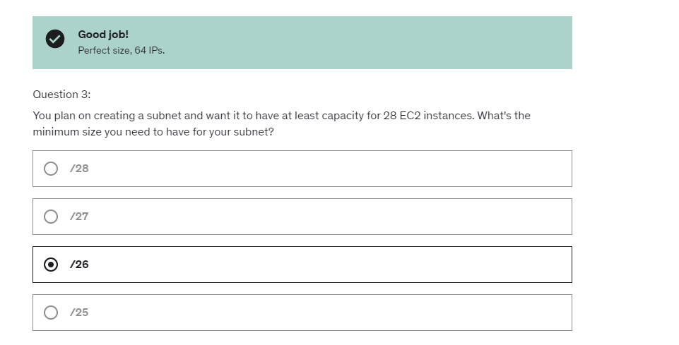

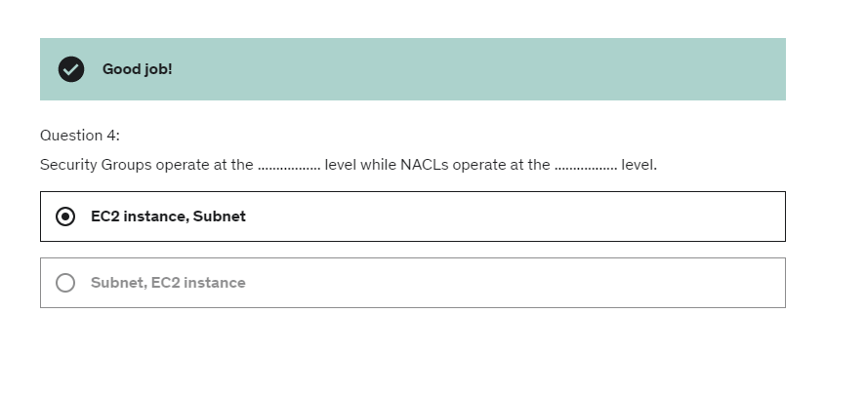

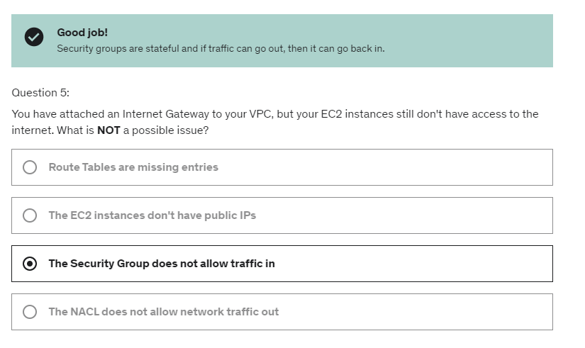

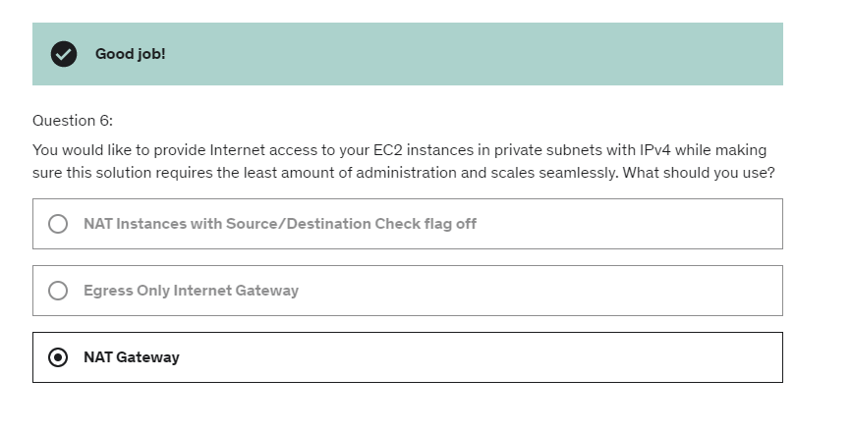

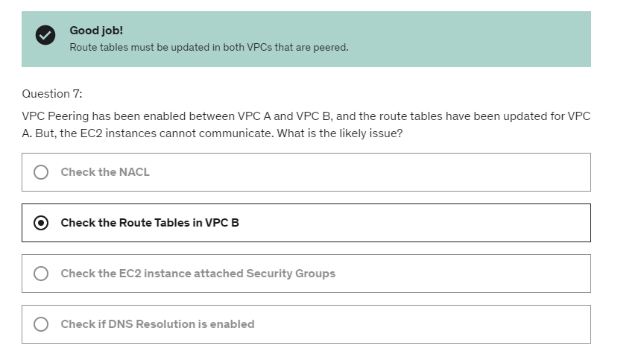

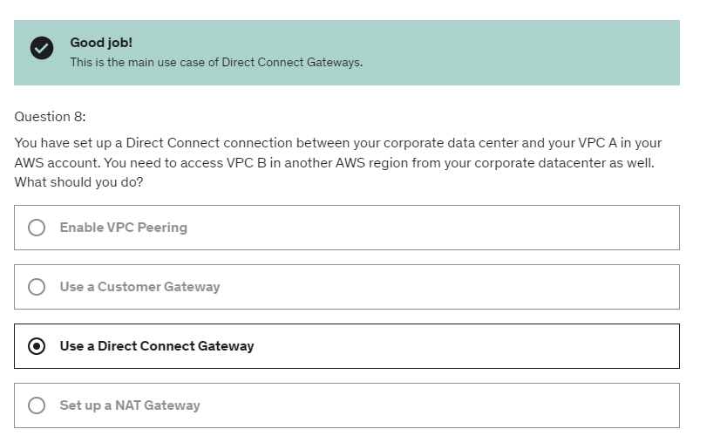

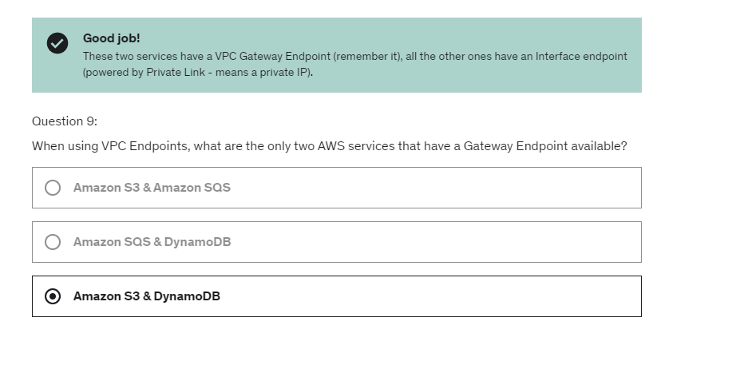

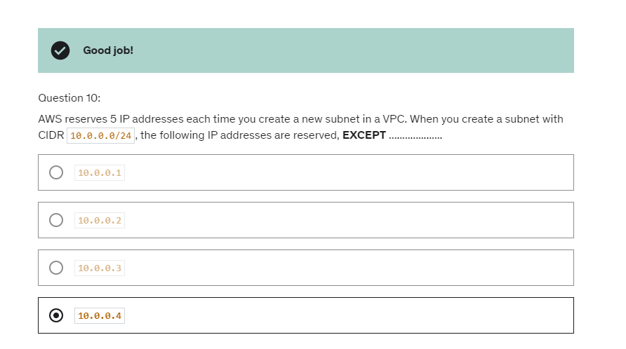

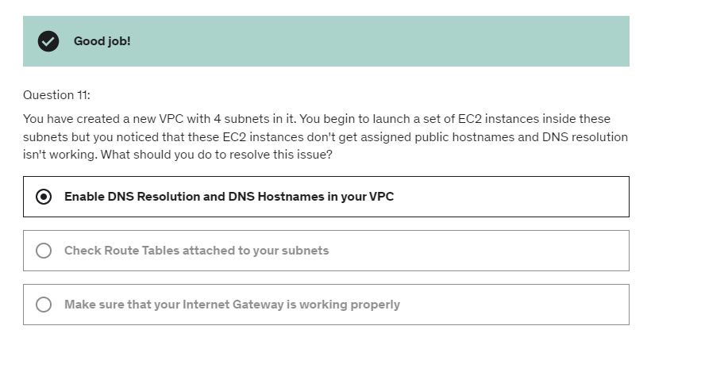

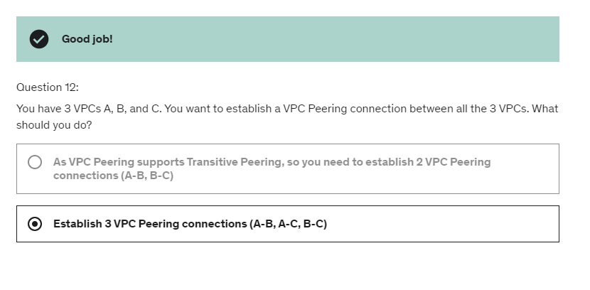

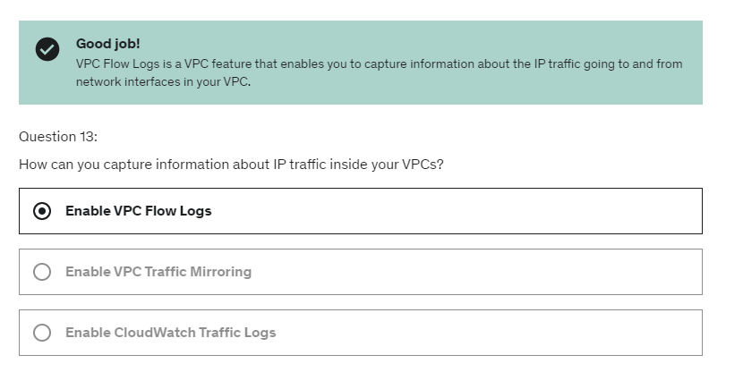

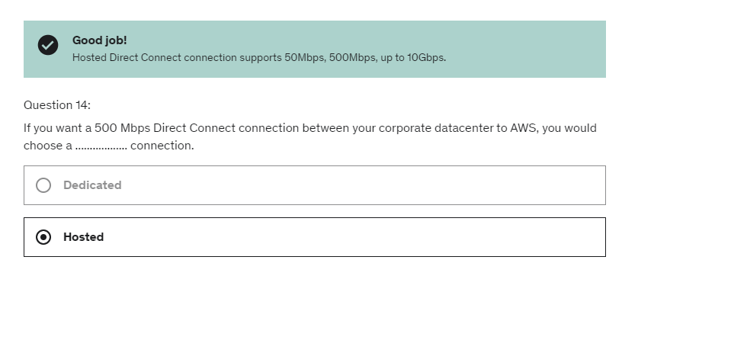

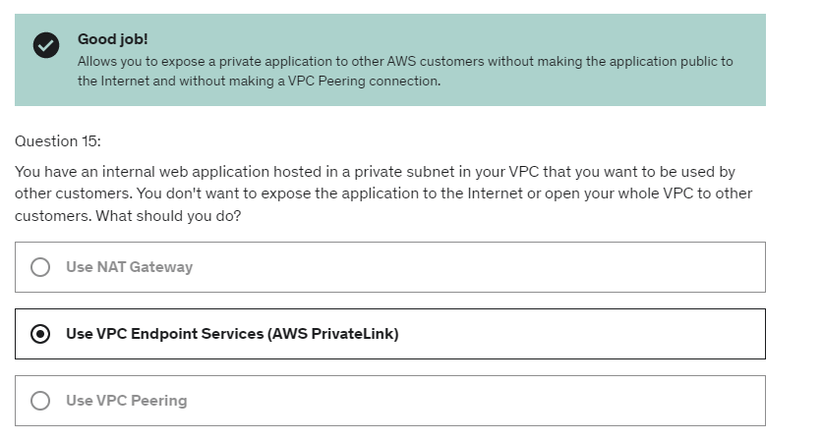

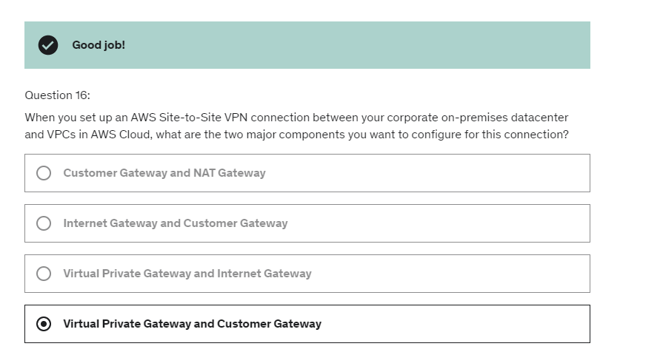

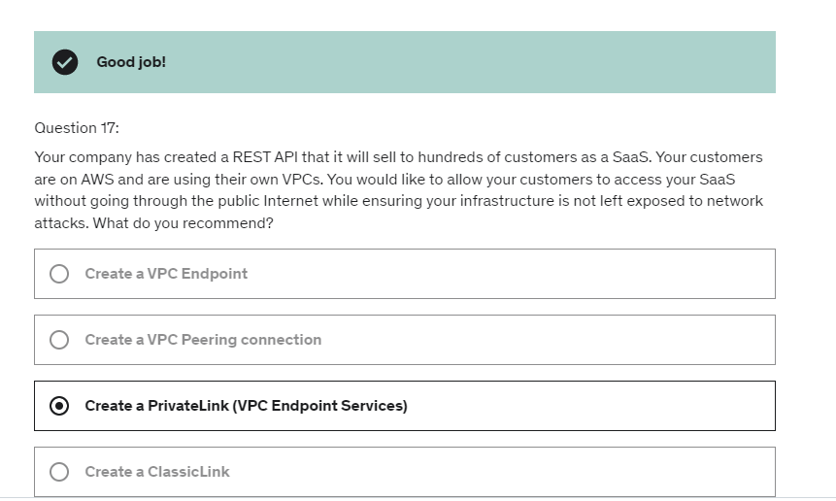

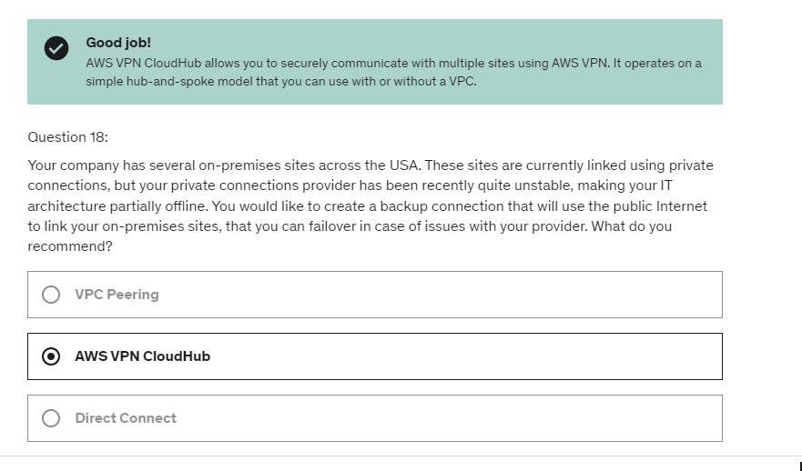

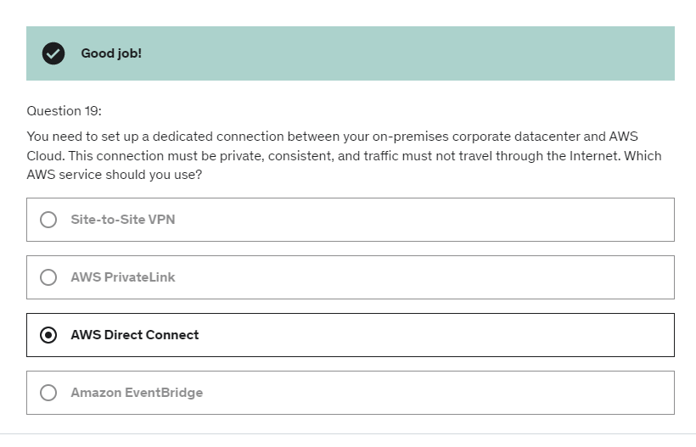

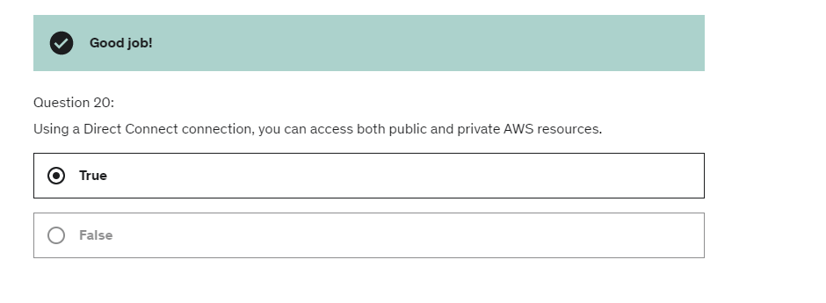

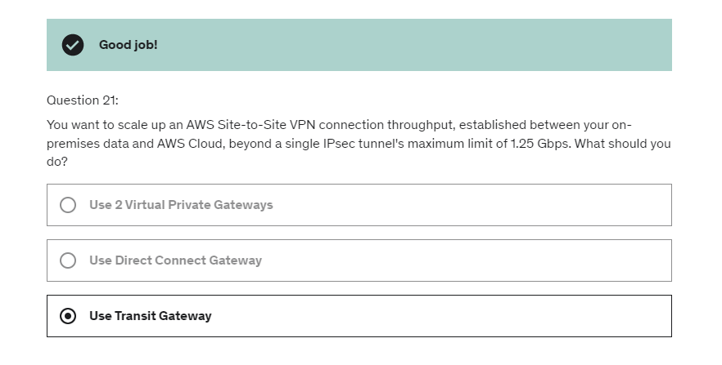

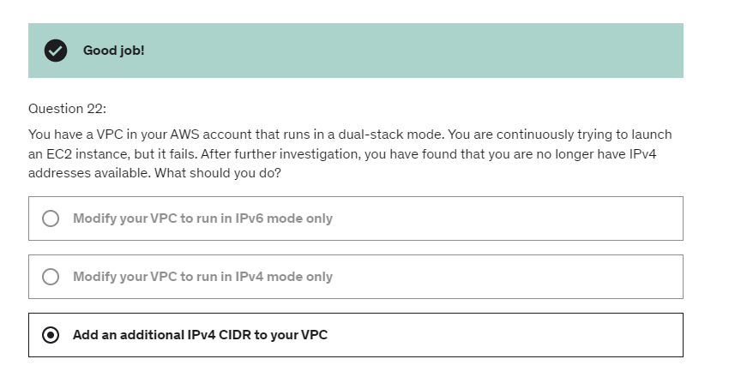

Now let's assume we have a second EC2 instance

and it is in the same availability zone, then in that case,

because an availability zone represents

a set of multiple data centers

that are geographically located within one another,

then any traffic between your two EC2 instances

will be free assuming that there are using

their private IP to communicate,

by using the private IP they will go over the network

that they are connected with.

So this is great.

But now that's include an EC2 instance in another AZ.

And this time we want you have these two EC2 instances

across two different AZ within the same region

to communicate with one another.

One approach would be to use a public IP

or an elastic IP.

And if we do so, we're going to pay 2 cents per gigabytes

if using a public IP or elastic IP.

Why?

Well, because the traffic has to leave via AWS network

and go back in for our two instances to communicate

and so AWS will charge us for that.

That obviously these cost savings come at a cost

and the cost is that you're not highly available anymore.

That means that if your AZ goes down,

then you don't have any fail over available.

So here you have to balance

between the high availability and cost.

So typical example of that would be,

hey, we have an RDS database

and we want you to create a read replica

and do some analytics on top of this read replica.

How do we create a read replica

for the cheapest amount of money?

Well, if you create that read replica in the same AZ,

then you're not going to be charged anything to replicate

the one database to another in terms of network costs.

But if you create that read replica in another AZ,

then you're going to pay 1 cents per gigabyte

of data transfer between the two databases.

**RPO** is how much of a data loss

are you willing to accept in case of a disaster happens?

And so, between the disaster and the **RTO**

is the amount of downtime your application has.

and obviously the smaller you want these things to be,

usually the higher the cost.

**Backup and restore**, very easy, not too expensive and you get high RPO, high RTO.

If you schedule regular snapshots and you back them up

then your RPO is going to be maybe 24 hours or one hour

based on how frequently you do create these snapshots.

And then when you have a disaster strike you

and you need to basically restore all your data

then you can use AMIs to recreate EC2 instances

and spin up your applications or you can restore

straight from a snapshot

and recreate your Amazon RDS database

or your EBS volume or your Redshift, whatever you want.

And so that can take a lot of time as well to restore

this data and so you get a high RTO as well.

But the reason we do this is actually

it's quite cheap to do backup and restore.

We don't manage infrastructure in the middle,

we just recreate infrastructure when we need it,

when we have a disaster and so the only cost we have

is the cost of storing these backups.

Pilot light:

So it's very similar to backup and restore,

but this time it's faster because your critical systems,

they're already up and running

and so when you do recover, you just need

to add on all the other systems that are not as critical.

Example: in case you have a disaster happening,

Route 53 will allow you fail over from your server

on your data center, recreate that EC2 instance in the cloud

and make it up and running, but your RDS database is already ready.

Warm standby example: And so if a disaster strikes you,

because we have a warm standby,

we can use Route 53 to fail over

to the ELB and we can use the failover to also change

where our application is getting our data from.

Maybe it's getting our data from the RDS Slave now,

and so we've effectively basically stood by

and then maybe using auto scaling,

our application will scale pretty quickly.

Multi site approach

So that means we have your On Premise data center,

full production scale, you have your AWS data center,

full production scale with some data replication happening

And so here what happens is that because you have a hot site

that's already running, your Route 53 can route request

to both your corporate data center and the AWS Cloud

and it's called an active, active type of setup.

And so the idea here is that the failover can happen.

Your EC2 can failover to your RDS Slave database if need be,

but you get full production scale running

on AWS and On Premise, and so this costs a lot of money,

but at the same time, you're ready to fail over,

you're ready and you're running into a multi DC

type of infrastructure which is quite cool.

Finally, if you wanted to go all cloud,

you know it would be the same kind of architecture.

It will be a multi region so maybe we could use Aurora here

because we're really in the cloud,

so we have a master database in a region

and then we have your Aurora Global database

that's been replicated to another region as a Slave

and so these both regions are working for me

and when I want to failover, you know,

I will be ready to go full production scale again

in another region if I need to.

Chaos Testing:

Then you create disasters, and so

and example is that Netflix, they run everything on AWS,

and they have created something called a

simian-army, and they randomly terminate

EC2 instances, for example.

They do so much more, but basically

they just take an application server

and terminate it randomly.

In production, okay? So they want to make sure that their infrastructure

is capable to survive failures,

and so that's why they're running

a bunch of chaos monkeys that just terminate stuff randomly

just to make sure that their infrastructure

is rock-solid and can survive any types of failures.

DMS:

the idea is that you can transform a source,

which is On-Premise,

to target, which is usually AWS,

and these targets are all the common databases on AWS.

So, we setup the server with AWS SCT installed

and we can setup on-premises.

This is the best practice.

And then, we will do the schema conversion

into our Amazon RDS database running MySQL.

Then we can setup a DMS Replication instance

that will do the full load and the change data capture (CDC)

to have consider this replication,

and so it will perform the data migration

by reading the database on-premises,

the source, Oracle database,

and inserting the data into your private subnets.

So the idea it that if you have a big source database

you may want to have a big instance class in the middle

to perform all the replication continuously fast enough.

So we have the ability to download the Amazon Linux 2 AMI

as a virtual machine and that will be in the ISO format.

And you can load this ISO image

into the common software used to create VMs.

So that includes VMWare, KVM, Virtual Box,

which is Oracle VM or Microsoft Hyper-V.

And this would allow you

to run Amazon Linux 2 on your on-premise infrastructure

directly using that VM.

So that means that you can make it work

with some user data and so on.

So quite cool to think about.

Linux2 on onpremise is possible, we can do VM import and export for on-premise and EC2,

we can have migration services

such as application Discovery Service,

AWS Migration Hub, Database Migration Service

and Server Migration Service, DMS and SMS.

So let's go into the first use case where we replicate data

from our servers into AWS using the NFS or SMB protocol

and the target is S3 EFS or FSX.

So on premises we'll have our NFS or SMB server

and on AWS we'll have the AWS data sync service running.

So as mentioned, we need to install the data sync agents

on premises that will establish a connection using the NFS

or SMB protocol directly onto our server.

Then there will be a secure, encrypted

TLS connection between the agent

and the service on AWS and with a schedule.

Okay? So not continuously, but with a schedule.

It will replicate data either into Amazon S3

and the different storage classes

or the AWS EFS or Amazon FSX.

Another use case for data sync is to do EFS to EFS.

So we want to synchronize, for example,

an EFS file system across two regions.

So we're going to have our first EFS file system

in the first region and then a destination region.

And so in this case, we're going to create an

EC2 instance that has the data sync agent installed

on it and connect to our Amazon EFS drive on their source.

And then the data sync service endpoint

on the other destination will synchronize the data

into the other EFS file system.

Now, if I use Snowball, how long do I need?

Well, first of all, I need to order in my snowballs,

and then I need to get about two to three snowballs,

and I can order them in parallels,

so they will arrive at my facility at the same time.

And then it takes about one week, all in all,

from the snowball to being delivered,

to being loaded, to being packed,

sent back to AWS, and to the end being transferred,

it will take about one week for the end-to-end transfer.

And, on top of it, if there was a database

that was being transferred through Snowball,

it could be combined with DMS to transfer

the rest of the data, aferwards.

snowball is for one-off transfers,

So, finally, for ongoing replications,

we could use techniques

such as Site-to-Site VPN, again, because we'll have

less data to transfer on an ongoing basis.

Or use direct connect, or use DMS,

or use a service like we just saw, like DataSync.

So all these things would allow us

to transfer the data, ongoing,

on the ongoing basis, continuously or not,

through some more reasonable internet's lines,

such as Site-to-Site VPN or direct connect.

Snowball is going to be used

more for one-off, large transfers,

and as we can see, Snowball, in this case,

is really, really helpful into speeding up

our fist data transfer into AWS.

AWS Backup:

So it supports cross-region backups.

means that you can have

your backup pushed to another region

for disaster recovery strategy,

all in one place.

And also supports cross-account backups,

if you are using multiple accounts

in your AWS strategy.

That means that all your backup

that you store in your Backup Vault

cannot be deleted.

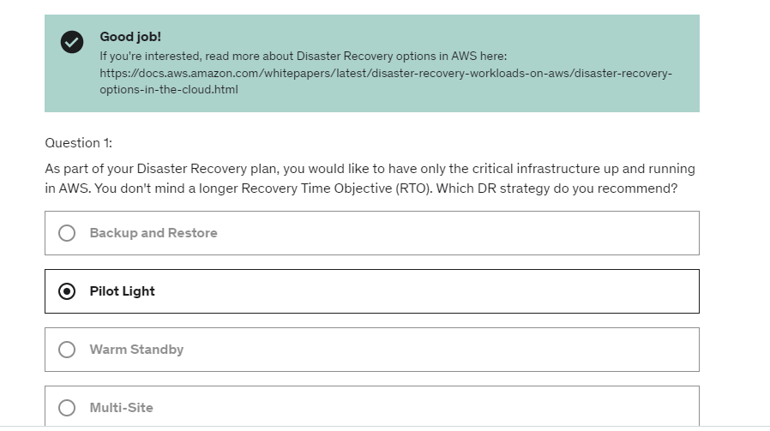

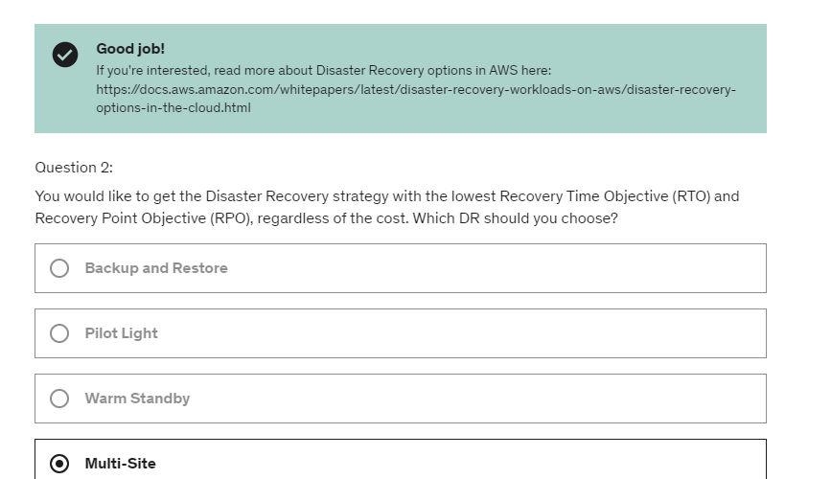

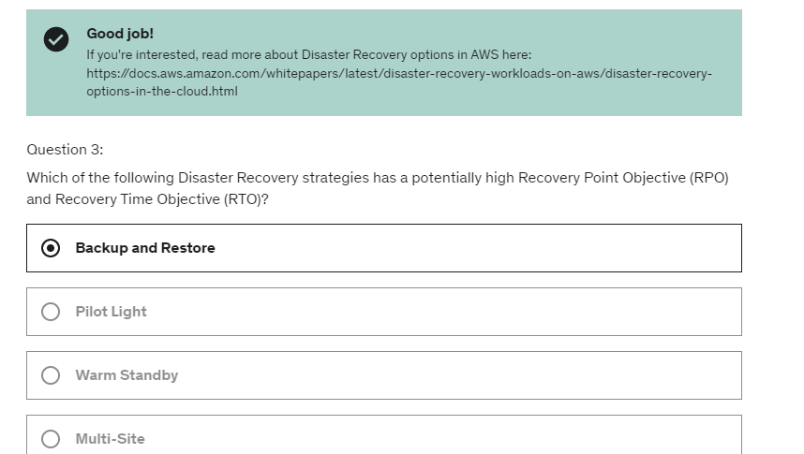

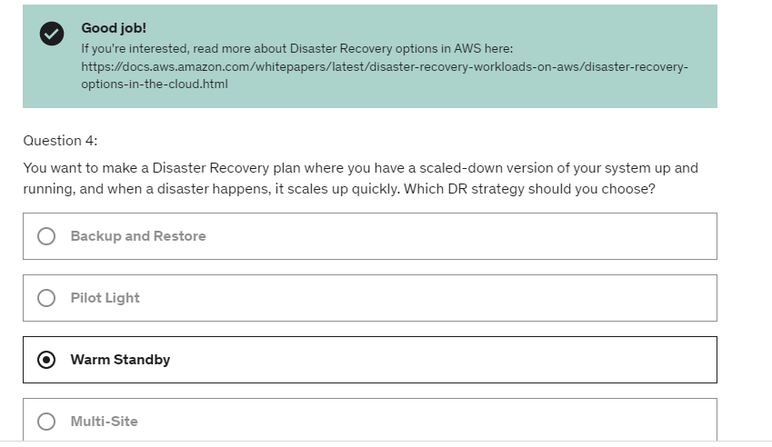

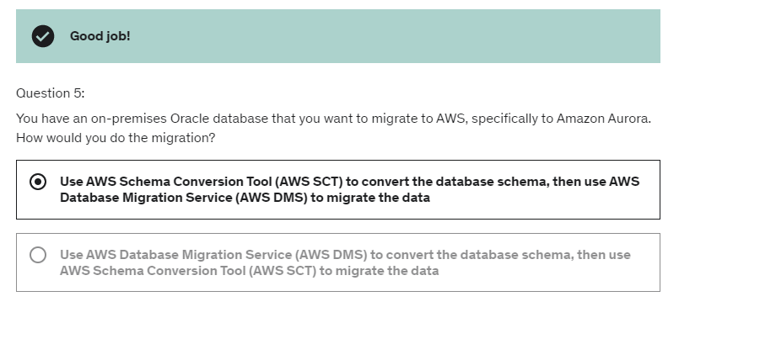

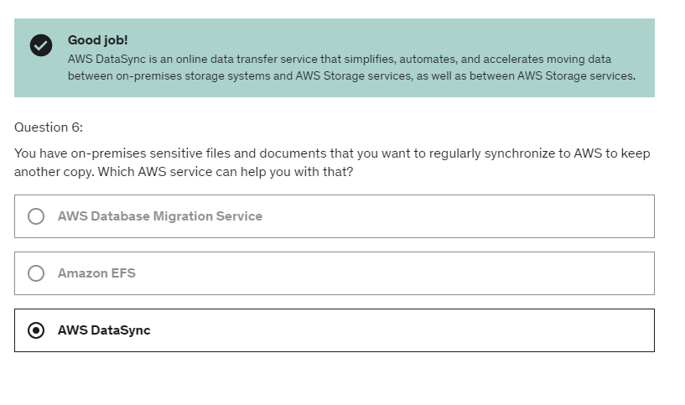

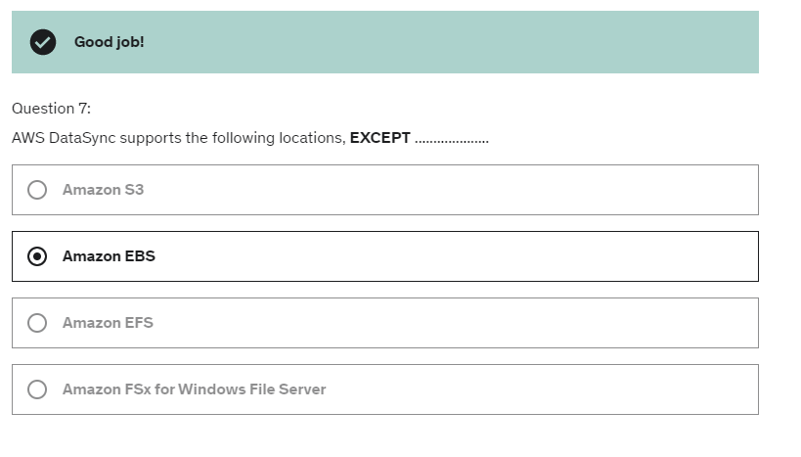

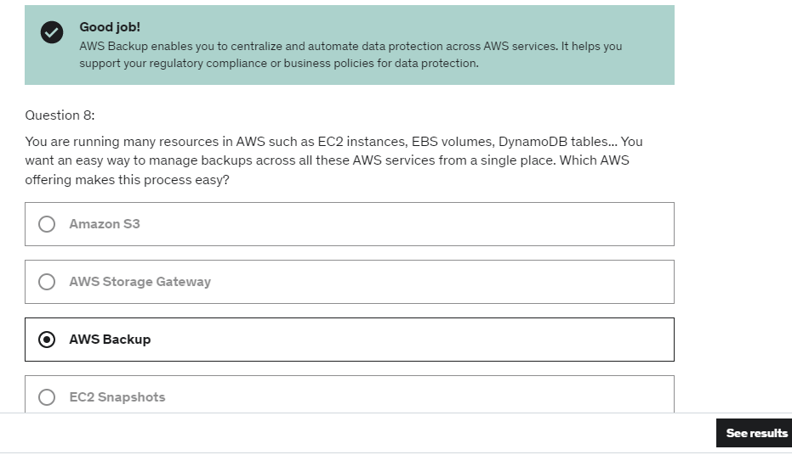

So, from an exam perspective, remember that,

any time you need to build chatbots,

you think of Amazon Lex, and anytime you need

to build a virtual cloud contact center,

you use Amazon Connect,

and these two things integrate together really well.

Comprehend is NLP – Natural Language Processing ( NLP)

So, Comprehend is really about getting a lot of data in

and then Comprehend will do the rest

to try to understand the meaning of that data.

So it's about taking text or unstructured data

and structuring it around these features.

So imagine you have a lot of articles

and you want to group them together instead

of going to them one by one, you would feed them

into Comprehend and then it would output you

the topics you need to group them by.

Now, when you want to do this kind of processes

to build a machine learning model,

you have to do a bunch of steps that I will show

you in a second,

and all these are quite difficult to do

in one place,

plus you need to provision some servers

to perform these somputations to create these models,

and that can be cumbersome as well.

So this is where SageMaker comes in.

So SageMaker will try to help you all along the way for the process..

this whole process,

of labeling, building the model,

training it, tuning it,

applying it can be all done within SageMaker.

So how does it work?

Well, you take your historical time-series data,

for example, and you also add your product features,

prices, discounts, website traffic, store locations,

basically, any kind of data you can

to then enhance your model.

Then you upload this into Amazon S3.

You then start the Amazon Forecast service

which will create a forecasting model.

And you can use that forecasting model, for example,

to say that your future sales

of raincoats are going to be $500,000 next year.

So from an exam perspective,

whenever you see a document search service,

think Amazon Kendra.

So this one is a fully-managed document search service

that is powered by machine learning

and it allows you to extract answers from within a document.

That document could be text, PDF, HTML

PowerPoints, Microsoft Word, FAQs, et cetera, et cetera.

So you have a lot of data sources

where these documents may be

and you see some of them right now in the screen

and they're going to be indexed by Amazon Kendra

which is going to build internally

a knowledge index powered by machine learning.

And how does it help from an end-user perspective?

Well, we get natural language search capabilities

just like you go on Google.

So for example, if a user says,

Hey, where is the IT support desk into Amazon Kendra?

Kendra can reply, 1st floor.

And this could be due to the fact that Kendra knows

from all the resources that it took

that the IT support desk was on the 1st floor,

Amazon Personalize

So what could be a recommendation?

For example, a personalized product recommendation,

or re-ranking, or customized direct marketing.

For example, a user has bought a lot of gardening tools,

and you want to provide recommendations

on the next one to buy based on a personalized service..

So from an exam perspective,

anytime you see a machine learning service

to build recommendations and personalized recommendations,

think Amazon Personalize, that's it.

So Personalize is how you access this from within AWS.

So, you read your input data from Amazon S3.

For example, it could be user interactions,

those kind of things.

Also, you can use the Amazon Personalize API

to have real-time data integration

into the Amazon Personalize service.

And then this will expose a customized personalized API

for your websites and applications,

your mobile applications.

Also, you can send SMS or emails

for personalization as well.

So you have all these integrations.

Amazon Textract:

So we have, for example, a driver license,

and then we upload it into Amazon Textract,

and then, automatically, will be analyzed,

and the results will be given to you as a data file,

and so you'll be able to, for example,

extract the date of birth, document ID, and so on.

SageMaker is a fully featured machine learning service

that is accessible to developer and data scientist.

Textract is used to detect text and data,

and extract them from various documents.

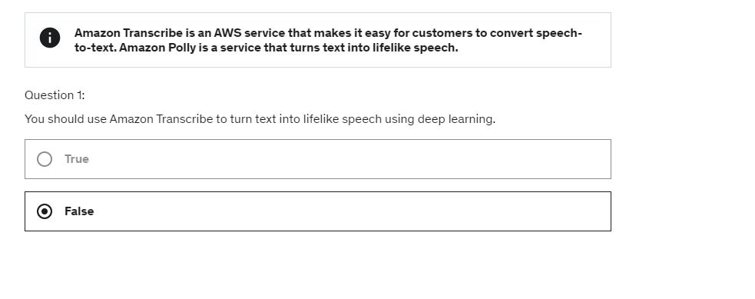

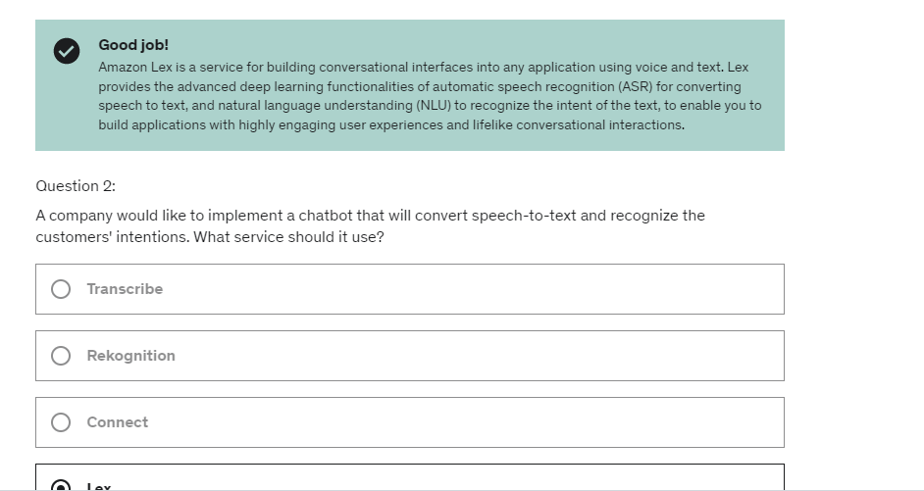

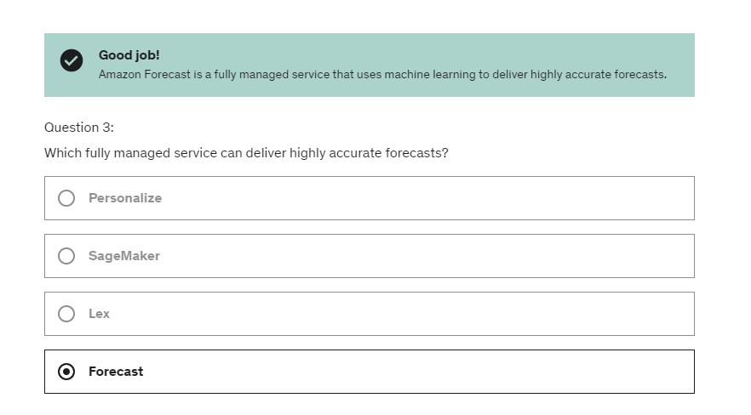

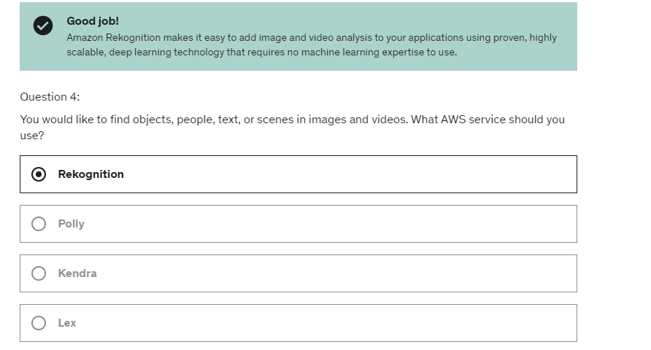

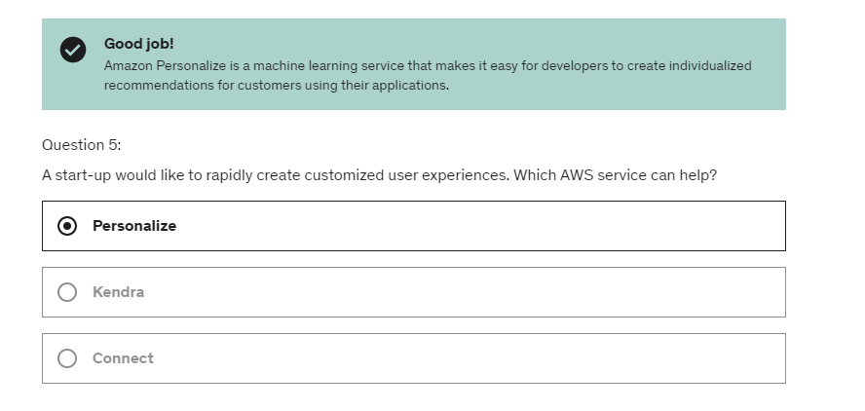

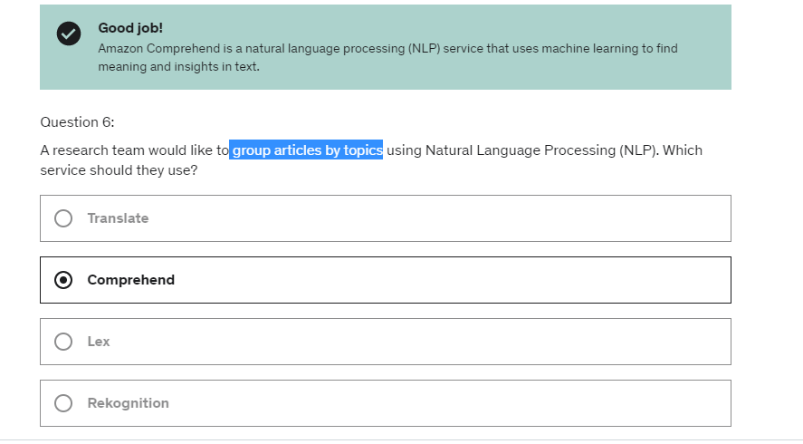

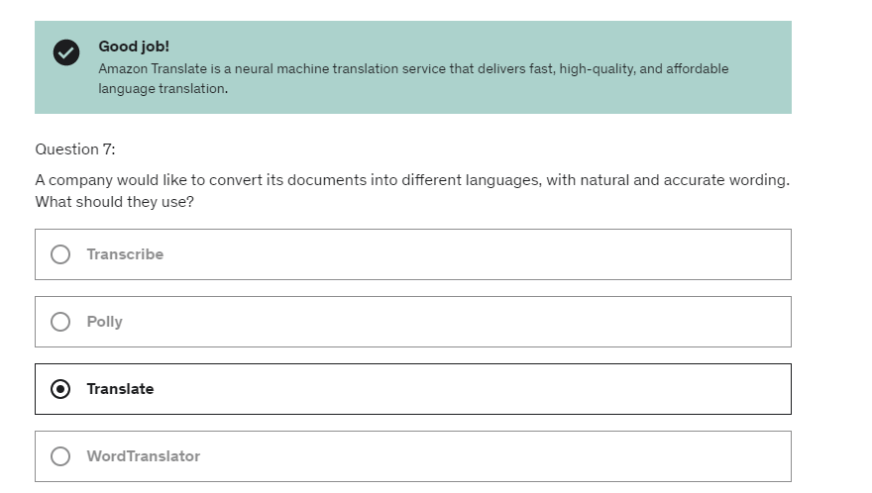

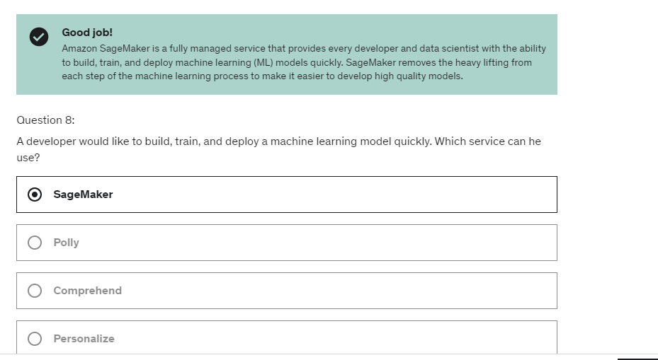

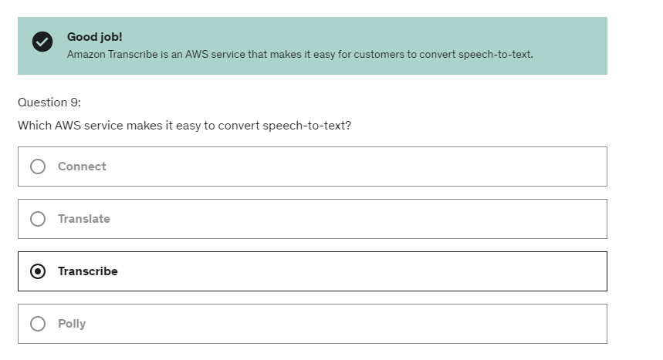

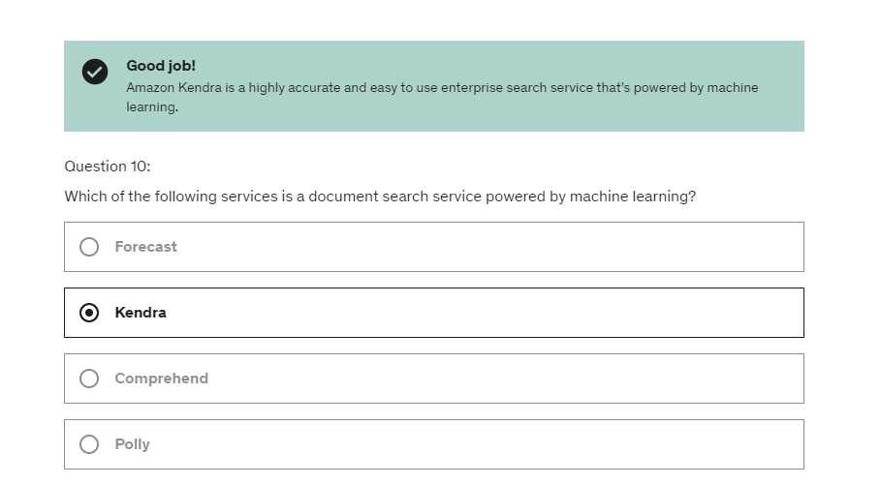

Slide 763:

So the first one, is to use SQS and Lamda.

And if you use SQS Lambda, with our SQS queue

and their Lambda function.

And so the events are going to be inserted

into our SQS queue and the Lamdda service is going

to pull the SQS queue.

And in case there are issues, it's going

to put back the messages into the SQS queue

and try and retry to pull that, okay?

And this can go into some sort of infinite loop.

So in case there is a big problem of one message,

what we can do is set up SQS to send the message

to a dead letter queue after say five tries.

This will be a way out of it.

SQS FIFO + Lambda

So now our Lamda function is going to try and retry

to get the messages from the queue,

but because it just to process them in order

in case one message doesn't go through,

is going to be a blocking never ending process

and the whole queue processing will be blocked,

in which case yet again, we can set up a dead letter queue

to send these messages off to SQS queue

and allow our functions to keep on processing it.

So as we can see, this is a different kind of architecture

with SQS, the DLQ is set up on the SQS side.

And for Lambda, the DLQ is set up on the Lambda side.

W/o fanout only SQS disadvantage:

Because for example, if our application crushes

after we send a message to the second queue,

then the third queue will never receive the last message.

And the content of each queue will be different.

So while this works, this is not very reliable

and this is not pretty.

With fanout pattern:

So from our application perspective now,

we just do a PUT into our SNS topic

and automatically the SNS service will fan out that message

into your other SQS queue.

So we have events happening in our S3 buckets

and we want to react to them happening in real time.

And you can even have a filter to just be able to react

to certain name in particular.

For example, you wanna say, I want to filter

so that all the events that are created correspond

to a JPEG file so image.

And the **use case** for this would be, for example,

to generate thumbnail images of images

that have been uploaded to Amazon S3 in real time.

So we can send a notification directly into an SNS topic,

thanks to S3 events,

or we can send a message into an SQS queue,

or we can asynchronously invoke a Lambda function.

And so these are the only three possible destinations

for your Amazon S3 events.

So using one S3 events, in one SNS topic,

we could send the data out to say 10 SQS queue.

Very cool,  if we have an SQS queue,

we can also, for example, create a Lambda function

or an EC2 instance to read the messages

of that SQS queue, and the benefit we get out of using

an SQS queue would be, for example,

that if the Lamda function fails,

then our message remains in our SQS queue

and can be processed by another application.

And finally, if we are taking into Amazon Lambda,

then we've learned that we can do whatever we want really,

it's free, but in case our Lambda fails

because it has been asynchronous invocation,

then we can define a dead letter queue

on a lambda function,

such as if it fails to process it three times,

then we can send the message to SQS, for example,

for later processing.

“any object created, removed, restored, or replicated

in S3 can generate an event in its own

and can be sent to SNS, SQS or Lambda.

”

But, we have something that we know of.

So we have CloudFront in front of an API Gateway,

which is in front of our application logic,

could be EC2, could be Lambda.

Our application stores and uses data from the database,

and maybe you will use an internal cache

such as Redis, Memcached and DAX.

And then, that's where the dynamic routes,

or all the dynamic content.

And there be will an static content route,

in which our client goes through a CloudFront

and the CloudFront will source data from S3.

So this is something we've seen, this is not very new.

So, if we look at CloudFront,

these two CloudFronts right here

they're doing caching at the edge.

That means that they're doing caching as close as possible

to our users.

So that means that if we enable caching in CloudFront,

and the users do hit the cache, then they get a response

right away, it's very very quick.

But because it's at the edge, there is a chance

that things have changed in the back end,

and obviously that the thing is outdated here.

So we can use a TTL to make sure

the cache is often very renewed,

And so we have a balancing act to do between

how much more to cache at the edge,

versus how much we want to cache in the app logic.

And so the API gateway is a regional service

and so in case we do use the cache at the API gateway,

then the cache will be regional.

So that means that where there's going to be bit more network lag

between the clients and the API gateway,

if the cache is hit here.

Then we have our app logic.

And our app logic usually doesn't do any caching,

but it will do caching in a cache that we could use

such as Redis, Memcached, or DAX if we have DynamoDB.

And the idea here is that we don't want to repeatedly hit

our database, which does not have any caching capability.

We want to make sure that the frequent queries

or the complex queries, the result is stored into

a shared cache that can be accessed

by your app logic more easily.

And so here, we are saving by using caching here.

We are saving pressure on our database,

and we are augmenting the read capacity.

Finally, I want you to notice that

there is no caching capability in your database

in Amazon S3 and so on.

And so, as we move along this line of caching,

the more we move alongside, the more there's gonna be

a computation to cost and it's gonna be a latency.

So it's really up to you, there's no right way

or wrong way of doing caching.

It's all up to what you want to achieve

and how you want to set up your application

to achieve that behavior.

So it's all about choosing where do we want to cache content

how do we want to cache content,

how long do we want to cache content,

and then, are we okay with some latency,

and which content actually do we want to be cached?

So, this lecture again is not a "you should do this",

it's just to hopefully show you that

there's a lot of different ways to do caching on AWS,

and it really depends on what the scenario is

to figure out where the caching

is going to be most appropriate and most efficient.

**Blocking an IP address:**

So sometimes we may want to block an IP address

from a client because it's going to be a bad actor,

maybe it's trying to access our application

and so we want to know the line of defenses

so let's start from this very simple solution architecture

in which we have an EC2 Instance,

in a security group, in a VPC, and that instance

has a public IP so is publicly accessible,

and this is how our clients get into our EC2 Instance.

**So say you wanted to block that client,**

**the first line of defense would be**

**the network ACL in our VPC, which is at a VPC level,**

**and in this network ACL, we can create a deny rule**

**for this client IP address, very simple, very quick**

**very cheap and the client will just be rejected.**

Then for the security group of the EC2 Instance

we can not have deny rules we can only have allow rules,

so if we know that only a subset

of authorized clients can access our EC2 Instance,

then it is good in our security group

to just define a subset of IP

to allow into our EC2 Instance.

But if our application is global

we obviously don't know all the IP addresses

that will access our application

and so the security group here will not be very helpful.

Finally, you could run an optional firewall software

on your EC2 to block from within your software

the request from the client.

Now obviously, if the request has already reached

your EC2 Instance, then it will have

to be processed and it will be a CPU cost

to processing that request.

Now lets push this one step further,

we introduce an Application Load Balancer,

so again this **ALB** is defined within our VPC

and we still have our EC2 Instance,

but now we have two security groups;

we have the ALB security group

and we have the EC2 security group.

And so in this case our Load Balancer

in this architecture is going to be

in between our clients and our EC2 and it will

do something called **Connection Termination**

So the clients actually connects to the ALB

which will terminate the connection and initiate

a new connection from the ALB into our EC2 Instance.

In this case, our EC2 security group

must be configured to allow the security group

of the ALB, because the EC2 Instance

can be deployed in a private subnet

with a private IP and the source of

the traffic it sees comes from the ALB, not the client,

so from a security group perspective here,

we only allow the ALB security group

and we're safe on this side.

Now for the ALB of the security group...

The security group of the ALB,

we need to allow the clients and again

if we have a range of IP we know

that we can configure the security group,

if it's a global application, we have

to allow everything and **in their line of defense**

**is going to be at the Network ACL level.**

NLB does not do connection termination. so that means that

the clients originating IP is going

to go all the way to our EC2 Instance

even if our EC2 Instance sits within

a private sublet and has a private IP.

So this can be complicated, but the idea here

is that if we again know the source IPs of all the clients

we can define it in the EC2 security group

but if we are trying to deny one IP address for our clients,

the only line of defense here we have is our Network ACL.

something we can do

to deny an IP is to install **WAF**, or Web Application Firewall

now this WAF is going to be a little bit more expensive

because this is an additional service and a firewall service

WAF is a service we have installed

on the ALB and we can define a bunch of rules.

So this is one more line of defense.

Similarly if we use CloudFront in front of the ALB,

CloudFront sits outside our VPC, okay?

So as such, our ALB needs to allow

all the CloudFront's public IPs coming from

the edge locations and there's a list of it online,

but that's it, so coming from the ALB,

it does not see the client IP, what it sees

is the CloudFront public IP, and so as such

the Network ACL here which sits at

the boundary of our VPC is not helpful at all

because it can not help us block the client IP address.

And so in this case if we are trying

to block a client from CloudFront we have two possibilities:

**say we are attacked by a country; then we can use**

**the platform's geo-restriction feature to restrict**

**all the country from our clients to be denied on CloudFront.**

**Or if there's one specific IP that annoys us**

**we can again use WAF, or Web Application Firewall**

to do some IP address filtering just like we did before.

Well so as we can see, based on the architecture we have,

we have different lines of defenses

to block an IP address,

HPC: the idea here is that

we can have an extremely high number

of instances performing computation for us,

and then be done with it and just pay for what we used.

And then we **have data sync,**

where we have to install the data sync agents

and they will help us move large amount of data

between on-premise and FS or SMB systems

into S3 EFS or FSX for windows.

We can also leverage Spot instances

or Spot fleets for huge cost saving

and Auto Scaling to automatically scale our fleets

based on the computation we're doing.

So, ENA, is for EC2 enhance networking,

and gives you higher bandwidth,

higher package per second,

and lower latency.

Or **EFS**, where the IOPS is going to be scaled

based on the total size of your file system.

Or we can use provisioned IOPS mode on EFS

to get higher IOPS.

But we've seen there is a file system

that's dedicated to HPC,

which was called **FSX for Luster**.

And Luster was for Linux and cluster.

And it's gonna be HPC optimized,

gives you millions of IOPS,

and in the backend, it's backed by S3.

The first thing will be to use batch,

which is (indistinct) indicates,

a support service to perform multi-node parallel jobs

and enables you to run jobs

that span multiple EC2 instances.

There are Batch jobs,

and it's very easy to schedule these jobs

and launch the EC2 instance accordingly.

They will be managed by the batch service.

So batch is a very popular choice for HPC.

And we have AWS parallel cluster,

which is an open source cluster management tool

to deploy high performance computing on AWS.

So you configure it using text files,

and then you would deploy it on AWS.

And it's going to automate the creation for you of VPC,

Subnet, cluster types and instance types.

And it can come up in the exam

that you must use parallel cluster alongside EFA,

because there is a perameter in the text files

to enable elastic fabric adapters.

So EFA on the cluster,

and the impact of that is to improve the network performance

Then, from the Alarm or the CloudWatch Events,

you could go ahead and trigger a Lambda function.

And that Lambda function,

will allow you to do whatever you want,

and that lambda function,

for example, can issue API calls

to start the instance if it hasn't been started yet, okay,

if there's no Standby EC2 instance.

And then, issue an API call

to attach the Elastic IP to my Standby instance.

So now the Elastic IP will be attached,

and it will be obviously detached

from the other EC2 instance,

because an Elastic IP can only be attached

to one instance at a time,

and the other EC2 instance, can be terminated or disappear,

and we have effectively failed over

to a new Standby EC2 instance.

So now how should we configure our Auto Scaling Group?

What if we configure it this way,

we say the minimum amount of instances is one,

the maximum is one, and we want one desired,

and we specify over two Availability Zones.

So, what does it mean?

That means we're going to get only one EC2 instance,

and that EC2 instance may be in the first AZ.

And that's what we get out of these settings.

So why would we use these settings?

Well, for example, we can say that

the user data of the EC2 instance,

when it does come up,

its going to acquire and attach

this Elastic IP address based on Tags.

So this user data will issue API calls

and the Elastic IP will be attached

to our Public EC2 instance,

But now, let's discuss that this instance

is being terminated, it goes down,

and so what the ASG will do,

is that it will terminate the first instance

and create a Replacement EC2 instance in another AZ,

and thanks to that,

what we get is that, the first instance is terminated,

and the second instance will run it's EC2 user data scripts

and attach the Elastic IP.

And we have effectively failover, so in this case,

we don't need a CloudWatch Alarm or a CloudWatch Event,

the Auto Scaling Group as soon as it sees

that one instance has been terminated,

thanks to its settings,

will create a new EC2 instance in another AZ.

Finally, because our EC2 instance

does do API calls directly,

to attach this Elastic IP Address,

then we need to make sure that the EC2 instance

has an instance role, that allows it to issue API calls

to attach this Elastic IP Address.

So here we have a combo of using EC2 User Data

to attach the Elastic IP Address,

and also having an EC2 instance role

to make sure the API call will succeed.

But now, we also have an EBS Volume

attached to our EC2 instance,

let's imagine for example,

that EC2 instance is a database,

and we're trying to make that database highly available.

So, all of our data is onto our EBS Volume,

and we know an EBS Volume

is locked into a specific Availability Zone.

So let's imagine that our EC2 instance is being terminated,

and now what should we do?

Well, we know that on termination,

the Auto Scaling Group can use lifecycle hooks,

and thanks to this lifecycle hook,

we can create a script to take that EBS Volume

and create an EBS Snapshot from it.

Because, it will be triggered

as soon as the EC2 instance goes down,

and so we know that the EBS volume will be freed.

So we have an EBS Snapshot,

and we tag it properly,

and the ASG will be launching a Replacement EC2 instance,

we have the same settings as before,

and now, by properly configuring again

our Auto Scaling Group

to create a lifecycle hook on the Launch event,

then we can create an EBS Volume out of this EBS Snapshot

into the correct Availability Zone,

and then attach it to the Replacement EC2 instance.

And then the EC2 user data now can just check that

and also attach the Elastic IP address directly,

and we need to make sure obviously the API calls are correct

so we need to have an EC2 instance role,

which as we can see here,

we've done a combo of **EC2 user data,**

and also **lifecycle hooks**

to make sure that the EBS Volume

was first getting Snapshots

and then being restored from the Snapshot

into a different AZ.

And that makes it a highly available EC2 instance,

with an EBS volume.

So what we see here is that, because we have a bastion host,

we cannot use a, for example, a application load balancer

because an application load balancer works for HTTP level

traffic, but SSH is lower level is TCP.

And so we would need to use something like an NLB.

and to route to the bastion host, we have multiple options.

If we only have one Bastion host, then we could go back

to what we see before and just using the elastic IP

and then use a EC2, to use a datascript

to access your Bastion hosts.

Or if we have two Bastion hosts or more in once you have

a very highly available fleet of Bastion hosts

with multiple running in multiple AZ,

then it's a great idea to use a network load balancer

which is layer four deployed in multiple AZ

and then our clients will just connect directly

into the network load balancer.

And with it, actually what we can do

is making the bastion host

live in the private subnets directly.

So if we had a network load balancer, the bastion host

can be pushed into the private subnets

and that would even simplify our task

and make it even more secure.

But that's just a small detail or small,

real life tip I'm giving you.

Finally, note that we cannot use an ALB as I said,

because the ALB is layer seven, which is HTTP protocol.

And the SSH protocol requires you to be layer four

because it's TCP based only, okay.

So, we saw a great use case for an NLB, for an NLB

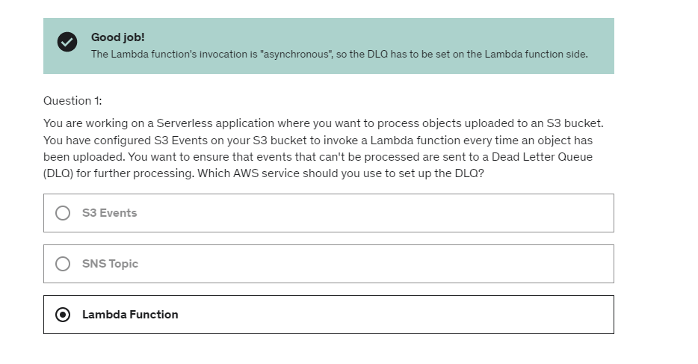

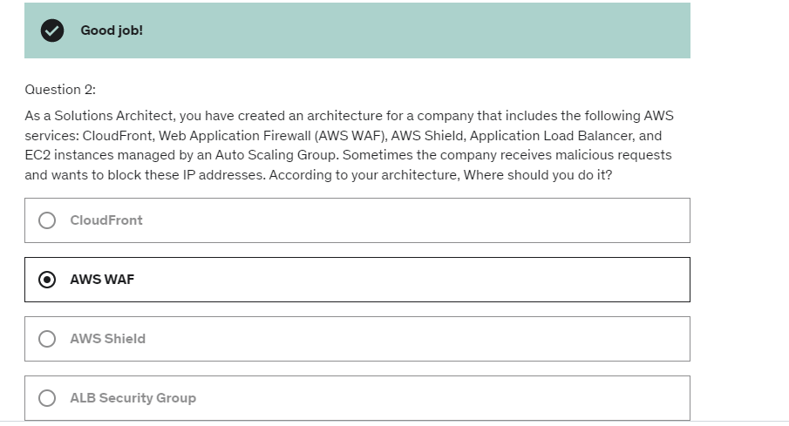

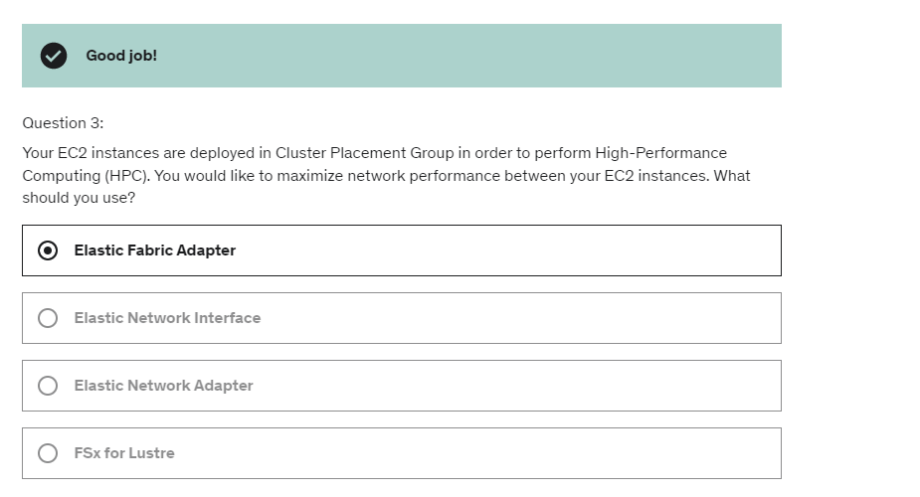

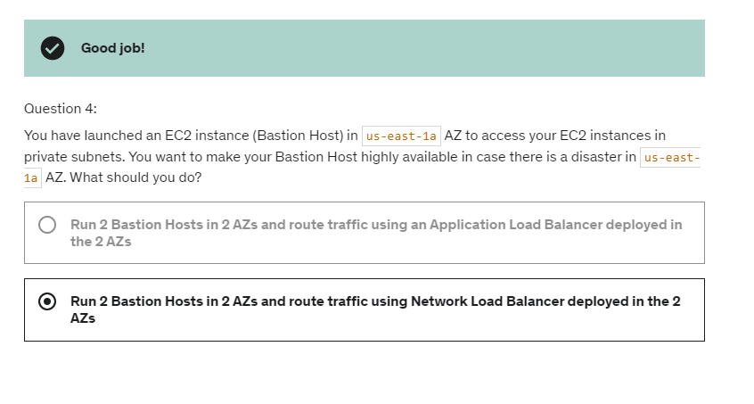

So now from AWS's perspective

where does all the technology go and play?

So we have code, build, test, deploy and provision.

To basically store codes, we have AWS CodeCommit

which is similar to GitHub or a third party code repository.

Then to build and test we use CodeBuild

and it's kind of similar to Jenkins CI

if you hear of Jenkins before.

Then for deploying and provisioning,

we have two options.

We have Beanstalk, which does kind of both.

You provision both the infrastructure

and then on top of it,

there is an API to deploy often.

Or you can manage your own EC2 fleet,

maybe using CloudFormation

and then to deploy to the EC2 fleet,

you would use something like AWS CodeDeploy.

Because you need to orchestrate

all these tools one after the other,

maybe you need something like a pipeline orchestrator

and this is called AWS CodePipeline.

So that's all you need to know.

Just remember this diagram. Remember **CodeCommit** equals checking code,

**CodeBuild** building and testing code,

**CodeDeploy** deploying code,

**CodePipeline** orchestrating everything.

CloudFormation:

So currently we've been doing a lot of manual work,

where we create everything and it's very tough to reproduce.

So if we wanted to do this in another region,

in another AWS account,

or within the same region but everything was deleted

it'd be really hard.

If we create too many EC2 instances, security groups,

row 53 routes, I mean so many things.

And the idea is what if we had our

infrastructure be in code?

You'll say, I want a security group,

I want two EC2 machines using this security group,

and I want two Elastic IPs for these machines,

and I want an S3 bucket,

and I want a load balancer in front of these machines,

and when you specify all of these things

in a CloudFormation template and run it on CloudFormation,

your CloudFormation service automatically creates

all of these things for us, in the right order,

with the exact configuration that we specify.

So it's a declarative way into doing AWS infrastructure.

The cool thing about CloudFormation is that

everything that CloudFormation creates

will be deleted by CloudFormation

when I select delete stack. That means you can have really clean

creating infrastructure, and then deleting it,

cleaning everything, and having

no leftovers on your cloud.

That's why CloudFormation is really recommended

when you need to fast log,

when you need to quickly

create a whole infrastructure into a new region,

or into a new account, or whatever you want, really.

**Cloudformation Stacksets:**

And so the administrators need to create a StackSet

and then you need to define trusted accounts

that can create, update or delete Stack instances

from StackSets and then finally,

when you update your StackSets,

all the associated stack instances are updated

in all the accounts and all the region.

So, here's an example, we have the admin account

where we define our StackSets

and it's going to deploy into the Account A

in us-east-1 but also in Account A in ap-south-1.

So this shows that we can have different regions

and also we can deploy to Account B in eu-west-2.

So we can have also different accounts.

anytime you see in the exam something

around deploying a CloudFormation stack globally

or across accounts,

think no more than just StackSets.

Don't think any script, don't think anything custom,

this is a feature directly coming from CloudFormation.

Step functions:

You can use sequence of Lambda functions,

parallel Lambda Functions, conditions, timeouts,

error handling, so you get a lot of flexibility.

The maximum execution time is one year,

so you get a lot of time to complete the workflows.

So any time it says workflow, state machine,

orchestration of Lambda functions, think Step Functions.

In visual slide:

 so all these little boxes may be Lambda functions

or a specific Step Function's features.

Step function and SWF(Simple workflow service):

So overall, I suggest that, at the exam

if you see SWF and Step Functions in the same question,

just ask yourself the question,

"Do I need external signals or child processes?"

Step Functions, is recommended by AWS,

and SWF is a bit older.

EMR (Elastic Map Reduce):

And, big data is used to basically analyze

and process a lot of data.

So, we are talking, you know, petabytes

or terabytes, like a lot of data.

And so, these clusters that you can create through EMR,

they can be made of hundreds of EC2 instances.

And, the benefit of EMR is that EMR knows how to coordinate

and configure all these instances to work together

so you don't have to worry about setting up a Hadoop cluster

which is something that's actually quite hard to do.

if you want to pay a lower price point for your

big data analysis, you can use Spot Instances

Upload->create->monitor

and so as you can see, we create cluster, then we **upload**

some data, maybe coming from S3.

Then we **create** all the information to input it,

and then we can **monitor** the health of our cluster

and see how the processing is going.

And, we can retrieve the output of our processing in S3

if you see Hadoop, if you see Spark,

if you see Big Data processing, think EMR and that will

all be, all you need for the exam, alright?

AWS OpsWorks=Managed Chef and Puppet

They're basically help managing configuration as code.

If you heard of this,

this is basically where all the stuff you run onto your VMs,

onto your machines,

is coded.

And that helps in having consistent deployments

because the same code can be applied

on many different machines.

But the idea of what you would use

to Chef and Puppet in AWS

is because they're open source products,

and they work across different clouds.

So if you have Amazon Cloud,

if you have Microsoft Azure,

and maybe Google Cloud,

you want to have one way of managing all your instances,

and maybe that way is Chef and Puppet.

And this is why it's offered on AWS as Opsworks.

**WorkSpaces** allow you

to just get On Demand a cloud desktop,(replacement of VDI machine on premise). and you're going to pay just for usage.

and it's integrated with Microsoft Active Directory.

That means that if you're using a Microsoft account

to basically access your VDIs

then you can use that same account

to access your secure cloud desktop with WorkSpaces.

Secure cloud desktop and replacement of VDI = AWS Workspaces

**AWS App sync:** It synchronizes data between your mobile and web apps

in real time. AppSync

is a managed GraphQL.

So, going into the exam, when you see synchronizing data

between mobile and web apps in real time it is

going to be either Cognito Synch or AppSync, and if

you see GraphQL, how do we do GraphQL on AWS, then it is

going to be AppSync for sure.

**Cost Explorer** – AWS Billing service

Here's a quick cheat-sheet to remember all these services:

**CodeCommit:** service where you can store your code. Similar service is GitHub

**CodeBuild:** build and testing service in your CICD pipelines

**CodeDeploy:** deploy the packaged code onto EC2 and AWS Lambda

**CodePipeline:** orchestrate the actions of your CICD pipelines (build stages, manual approvals, many deploys, etc)

**CloudFormation:** Infrastructure as Code for AWS. Declarative way to manage, create and update resources.

**ECS (Elastic Container Service):** Docker container management system on AWS. Helps with creating micro-services.

**ECR (Elastic Container Registry):** Docker images repository on AWS. Docker Images can be pushed and pulled from there

**Step Functions:** Orchestrate / Coordinate Lambda functions and ECS containers into a workflow

**SWF (Simple Workflow Service):** Old way of orchestrating a big workflow.

**EMR (Elastic Map Reduce):** Big Data / Hadoop / Spark clusters on AWS, deployed on EC2 for you

**Glue:** ETL (Extract Transform Load) service on AWS

**OpsWorks:** managed Chef & Puppet on AWS

**ElasticTranscoder:** managed media (video, music) converter service into various optimized formats

**Organizations:** hierarchy and centralized management of multiple AWS accounts

**Workspaces:** Virtual Desktop on Demand in the Cloud. Replaces traditional on-premise VDI infrastructure

**AppSync:** GraphQL as a service on AWS

**SSO (Single Sign On):** One login managed by AWS to log in to various business SAML 2.0-compatible applications (office 365 etc)

-------

**Remember, you should only get high level questions on these technologies**

**Hope that helps!**

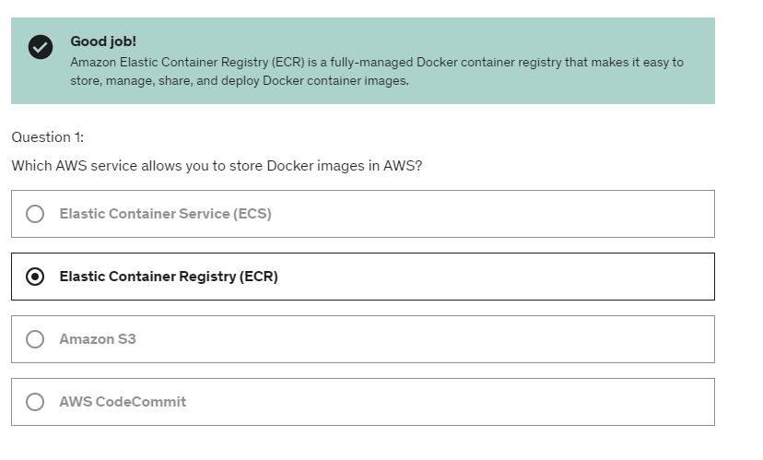

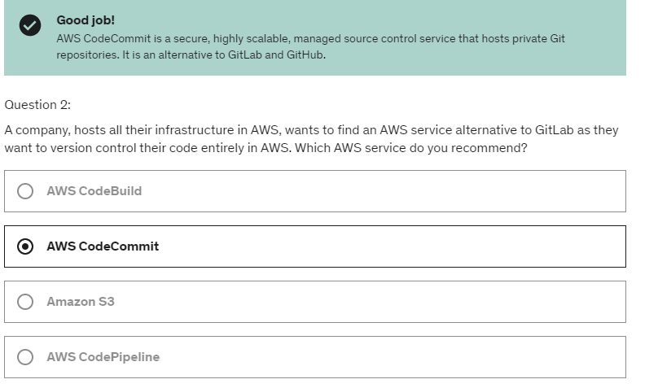

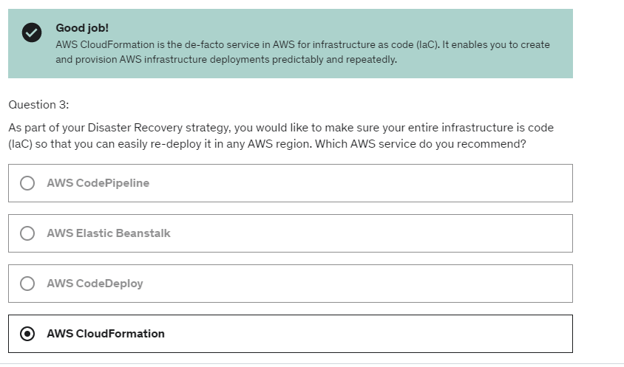

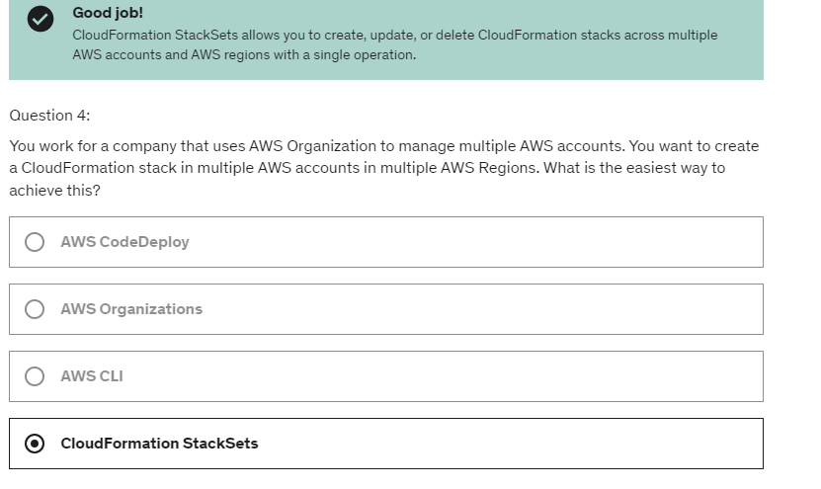

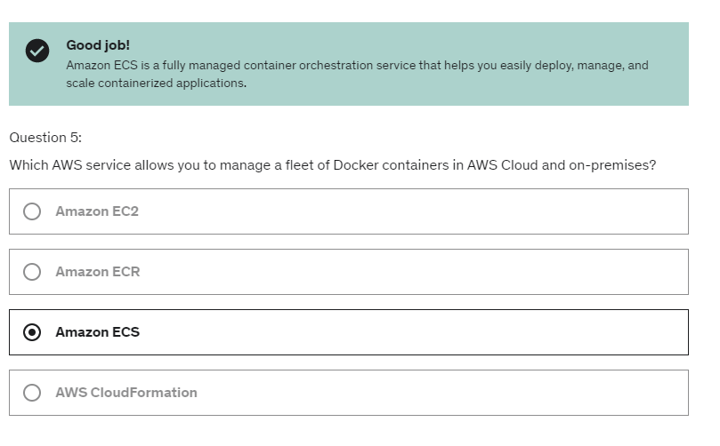

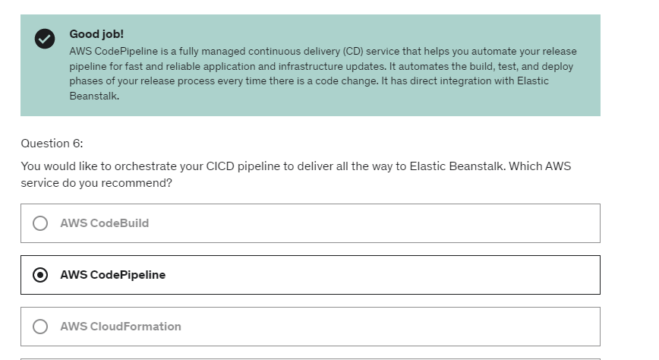

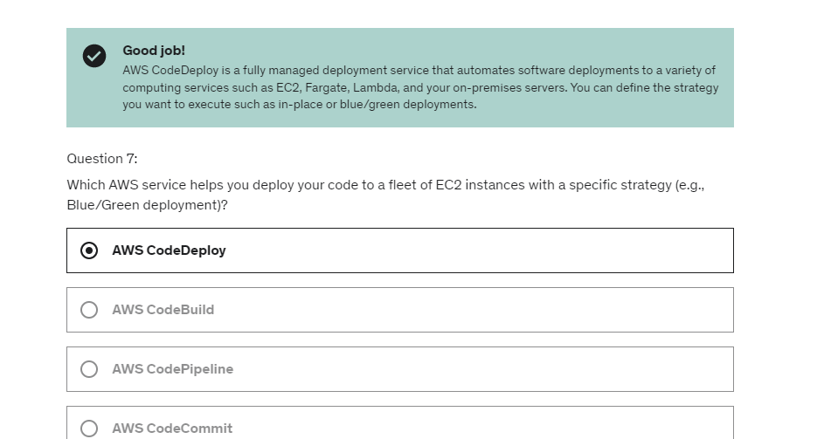

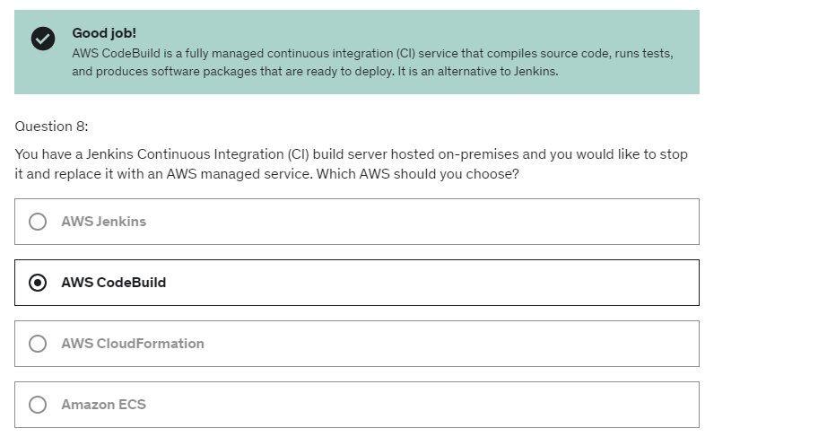

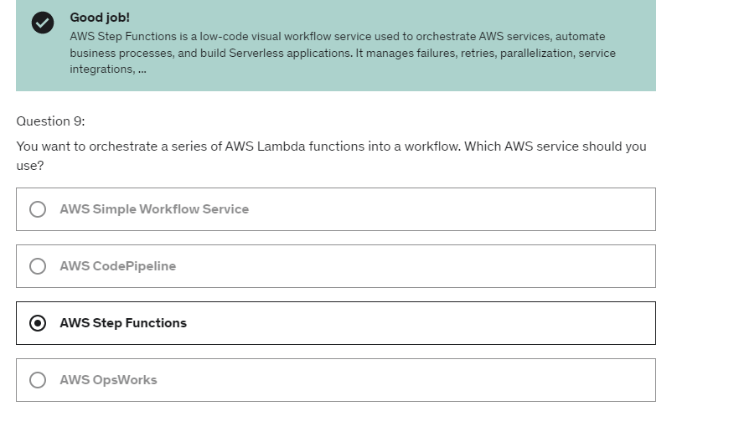

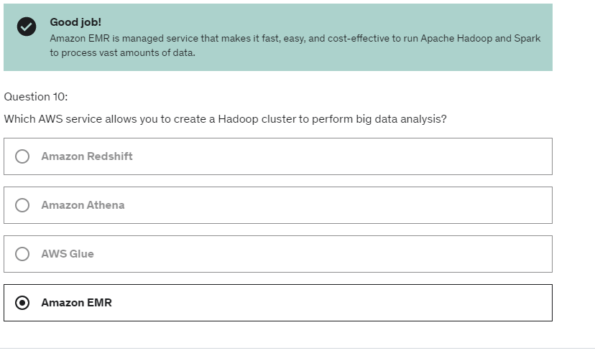

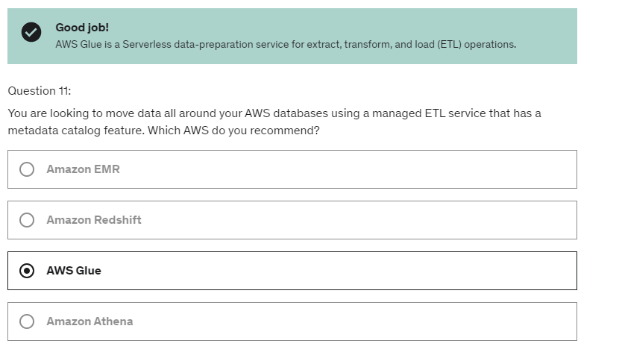

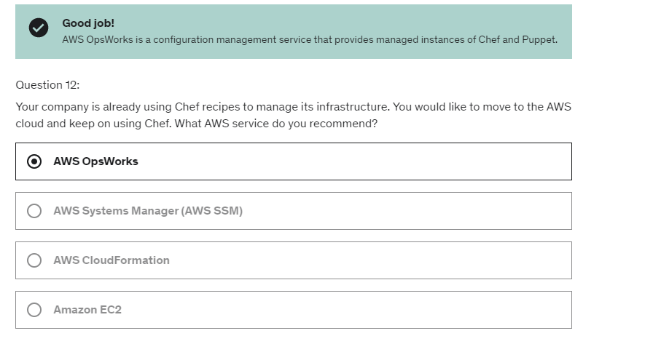

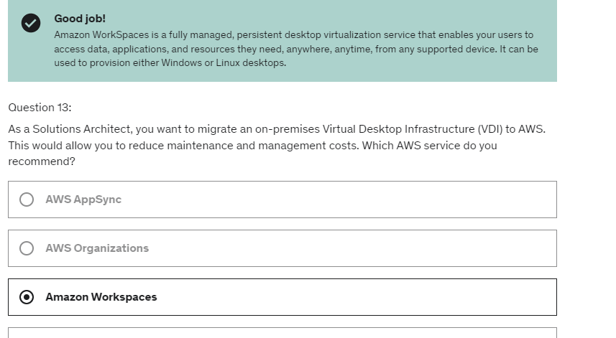

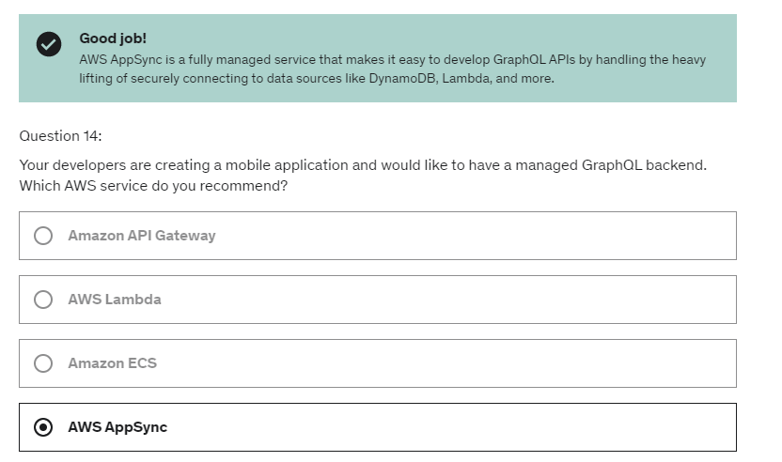

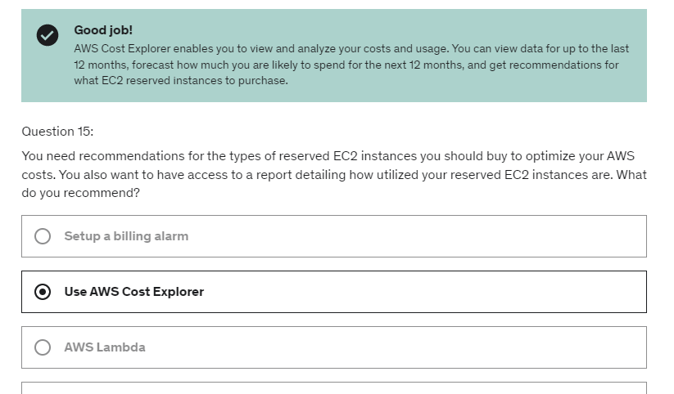

You can also allow for evolutionary architectures.

So your architecture can show over time it can start with

for example, EC2 instances and a load bouncer

and evolve towards a more serverless architecture such as

API Gateway and Lambda.

So design based on these changing requirements and so on.

we can use the **Trusted Advisor**.

It will analyze five categories

of problems on your accounts.

It could be around cost optimization,

performance, security, fault tolerance and service limits.

Now Trusted Advisor has two tiers.

The first tier gives you the **core checks**

and recommendations for all customers.

That are the basic checks

that will give you some information

about what you can do to improve your accounts.

remember that

with **business or support plans**, you will get access

to the full Trusted Advisor capability or beforehand

you will only get the core checks. if you don't use business and enterprise support lens,

then you do not have programmatic access to Trusted Advisor.

For **security**, you will get some information

on whether or not MFA is enabled on the root account.

If your IAM keys have been rotated recently,

as well as the exposed IAM access keys.

You get for example, if one of your employees

somehow happens to lose their access keys,

there on the internet.

Then there will be what's called exposed

and Trusted Advisor will let you know about it

because you definitely want to shut down these access keys.

They will also show you security issues

around S3 bucket permissions.

For example, if a bucket has public access,

or if your security groups

have unrestricted ports especially on SSH.

**For fault tolerance**, you will get some information around

the EBS snapshots age, the balance between

the different AZ as well as whether or not

your auto scaling groups, your RDS

and your ELB are both Multi-AZ.

Now for **service limits**, you will get information

whether or not you are reaching the service limit

for a specific service and therefore

increase that service limits

before you actually reach it.

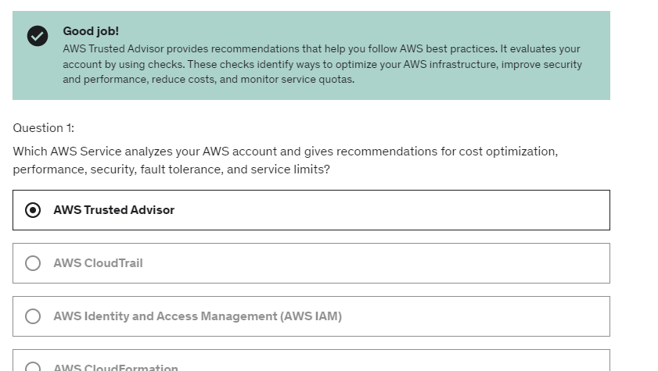

**Links to Whitepapers**

1. Architecting for the cloud: <https://d1.awsstatic.com/whitepapers/AWS_Cloud_Best_Practices.pdf> (Archived)

2. Whitepapers related to well-architected framework are mentioned here: <https://aws.amazon.com/blogs/aws/aws-well-architected-framework-updated-white-papers-tools-and-best-practices/>

3. Disaster recovery whitepaper: <https://d1.awsstatic.com/whitepapers/aws-disaster-recovery.pdf> (Archived)

AWS now recommends a well-architected framework whitepaper: <https://d1.awsstatic.com/whitepapers/architecture/AWS_Well-Architected_Framework.pdf>

,

Region/AZ bound services.

* AMI are built for a specific region (and can be copied across regions)
* EBS are always bound to AZ, there is a feature called multiattach for io1 and io2 but that is within single AZ Attach the same EBS volume to multiple EC2 instances.
* EFS can be multi AZ
* Amazon FIFO SQS -Limited throughput: 300 msg/s without batching, 3000 msg/s with
* Kinesis Data Streams- Retention between 1 day to 365 days
* Launch Docker containers on AWS =Launch ECS Tasks on ECS Clusters(EC2 Launch Type)
* AWS just runs ECS Tasks for you based on the CPU / RAM you need
* Free tier of 1,000,000 AWS Lambda requests and 400,000 GBs of compute time
* Easy to get more resources per functions (up to 10GB of RAM!)
* SQS – message siz e upto 256 KB
* Dynamo DB size of each record – 400 KB
* Lambda function – 15 minutes max
* Cloudfront is serverless
* Redshift is not serverless.
* Aurora- Auto scaling of storage from 10GB to 128 TB
* Aurora claims 5x performance improvement over MySQL on RDS, over 3x the performance of Postgres on RDS
* Up to 15 Read Replicas (only 5 for RDS)
* DynamoDB is multi AZ by default.
* Athena uses Presto engine
* Redshift is columnar storage of data
* Redshift is OLAP, MPP(Massively Parallel Query Execution).

Stream records can be:

• Sent to Kinesis Data Streams

• Read by AWS Lambda

* • Read by Kinesis Client Library applications
* Neptune is multi AZ and upto 15 read replicas
* Opensearch is also multi AZ
* Events are stored for 90 days in CloudTrail
* Nat Gateway has 5 Gbps of bandwidth with automatic scaling up to 45 Gbps
* Max 5 VPC in a region
* Max 5 CIDR in a VPC
* For each CIDR in a VPC min range is 16 IP addresses and max is 65536
* Direct connect – connectiontypes- hosted/dedicated. Hosted – 50 Mbps, 500 Mbps upto 10 Gbps whereas dedicated 1 Gbps, 10Gbps, 100 Gbps.
* Aurora Storage: data is stored in 6 replicas, across 3 AZ – highly available, self-healing, auto-scaling
* Aurora Global: up to 16 DB Read Instances in each region, < 1 second storage replication

Latest slides updates: slide 619

To set a delay period on an entire queue, rather than on individual messages, use [delay queues](https://docs.aws.amazon.com/AWSSimpleQueueService/latest/SQSDeveloperGuide/sqs-delay-queues.html). A **message timer** setting for an individual message overrides any DelaySeconds value on an Amazon SQS delay queue